Project Design Phase-II
Technology Stack (Architecture & Stack)

Date | 06 October 2026
Team ID | SWTID-2026-9818
Project Name | Script-Controlled Record-Level Security in ServiceNow using ACLs (Institution Details)
Maximum Marks | 4 Marks

Technical Architecture:
The Deliverable shall include the architectural diagram as below and the information as per the table1 & table 2
Example: Order processing during pandemics for offline mode
Reference: https://developer.ibm.com/patterns/ai-powered-backend-system-for-order-processing-during-pandemics/
Guidelines:
Include all the processes (As an application logic / Technology Block)
Provide infrastructural demarcation (Local / Cloud)
Indicate external interfaces (third party API’s etc.)
Indicate Data Storage components / services
Indicate interface to machine learning models (if applicable)


Architecture for this project: Script-Controlled ACLs in ServiceNow
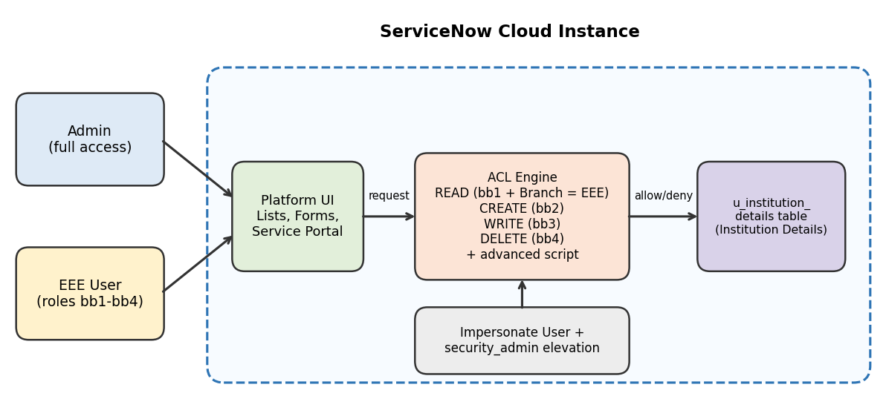
Table-1 : Components & Technologies:
S.No | Component | Description | Technology
 | User Interface | How users interact with the application: ServiceNow platform UI (Application Navigator, Student Records list and form) and Service Portal. | ServiceNow Next Experience UI, Service Portal
 | Application Logic-1 (User & Role Management) | Creation of the test user (EEE User) and custom roles bb1, bb2, bb3, bb4; all roles assigned to EEE User. | ServiceNow User Administration (Users, Roles)
 | Application Logic-2 (Access Control) | READ, CREATE, WRITE and DELETE record-level ACLs on u_institution_details; READ ACL uses an advanced script and the data condition Branch is EEE. | ServiceNow ACLs, server-side JavaScript (gs.hasRole)
 | Application Logic-3 (Security Testing) | Elevating to security_admin to configure ACLs, and impersonating EEE User and Admin to verify access. | security_admin role elevation, Impersonate User
 | Database | Custom table Institution Details (u_institution_details) with fields: Student Roll Number (Auto Number), Student Name and Faculty Name (Reference – User), Branch (Choice: ECE, EEE, CSE), Email, Phone Number (String), Description (Multi-line text). | ServiceNow table and field types (Auto Number, Reference, Choice, String)
 | Cloud Database | Records are stored in the database of the cloud-hosted ServiceNow instance. | ServiceNow cloud-managed database
 | File Storage | No separate file storage required for this project. | Not applicable
 | External API-1 | No external API used. | Not applicable
 | External API-2 | No external API used. | Not applicable
 | Machine Learning Model | No machine learning model used. | Not applicable
 | Infrastructure (Server / Cloud) | Application is configured and run directly on the ServiceNow cloud instance; no local server needed. | ServiceNow cloud instance

Table-2: Application Characteristics:
S.No | Characteristics | Description | Technology
 | Open-Source Frameworks | No open-source frameworks used; the solution is built with the ServiceNow low-code platform and server-side scripting. | ServiceNow platform, JavaScript
 | Security Implementations | Role-based access control with separate READ, CREATE, WRITE and DELETE ACLs (roles bb1–bb4), a Branch is EEE data condition, an advanced ACL script that always allows admin and denies everyone else, and security_admin elevation to manage ACLs. | ServiceNow ACLs, role-based access control (RBAC)
 | Scalable Architecture | Cloud-hosted platform; more roles, branches, fields and ACLs can be added to the table without redesigning the solution. | ServiceNow multi-tier cloud platform
 | Availability | The application depends on the availability of the hosted ServiceNow instance, so records and ACLs are accessible whenever the instance is up. | ServiceNow cloud hosting
 | Performance | ACL script is lightweight (simple role checks), so the Student Records list loads without noticeable delay. | ServiceNow ACL scripting

References:
https://c4model.com/
https://developer.ibm.com/patterns/online-order-processing-system-during-pandemic/
https://www.ibm.com/cloud/architecture
https://aws.amazon.com/architecture
https://medium.com/the-internal-startup/how-to-draw-useful-technical-architecture-diagrams-2d20c9fda90d

