Lab 1: N-layer atmosphere

### Introduction:

When comparing Earth’s surface temperature (288 K) with the theoretical value of a blackbody planet without atmosphere (254 K), we find a significant difference. This Lab explores some solutions to explain this gap by simulating the atmosphere. The approach chosen considers only radiative phenomena within a multilayer atmosphere.

Methodology:

We want to develop a radiative model of a multilayer atmosphere with a constant emissivity. To develop this model, I used the radiative equation, considering each layer of atmosphere as a grey body of emissivity ε, what’s more each of these layers is transparent to sun radiation. The Earth’s surface is considered as a blackbody absorbing all sun light (except the part that is reflected because of its albedo).

I first calculated the equation for a 4-layer atmosphere, so that I could derive the general equations for the N-layer model, and write it as a matrix equation.

Q2)

Then we can use the general matrix equation to write a code that will compute the model. I proceeded as suggested in the HW, populating the matrix and vectors, inverting the matrix and calculating the flux. I paid attention to the fact that the formula to derive the Earth’s surface temperature from its flux is different than the other one since the emissivity of Earth’s surface is always equal to one.

We have now a function to calculate the Temperature of the N layers called “solve_N_layer”. Before exploiting this model, we should verify that we did not make any mistakes. To do so I created a function called “validate_model” that compares, in two situations, the temperatures given by “solve_N_layer” with the temperatures given in the following website that computes the exact same model: <https://singh.sci.monash.edu/models/Nlayer/N_layer.html>

There are two possibilities to validate the model with my function,

* If you just want to know what the maximum difference between both model is, use validate_model(0)
* If you want to know what the difference for each layer is, use validate_model(1)

Thanks to this function I could validate the model. We can now start using it to answer the science questions.

Science questions:

*Q3) How does the surface temperature of Earth depend on emissivity and the number of layers?*

To answer the science question, we should try to plot the individual influence of each parameter.

**Influence of the emissivity:**

We want to see the influence of the emissivity on the Earth’s surface temperature.

To do so, I set the:

* Number of layers: 1
* Solar constant: S0=1350W/m2
* Earth albedo to 0.33, this was the value used in our previous examples.

Then, I calculated Earth’s surface temperature (with the N-layer model described before) for emissivity from 0.01 to 0.99 with a step of 0.01.

I could not use an emissivity of 0, because in my way of solving the equation, I divide by epsilon, but we can consider that there is no significant difference between an emissivity of 0 and 0.01.

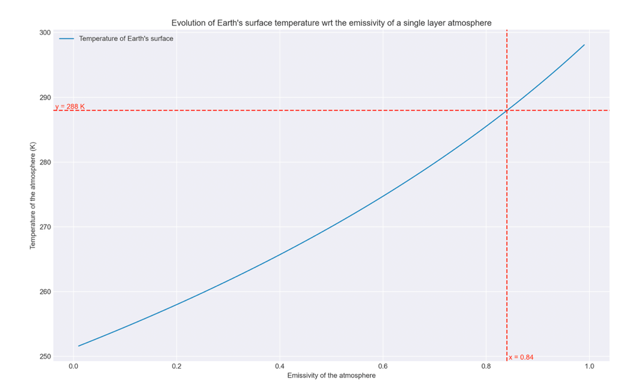

* As we can see on the figure, the Earth’s surface temperature increases with the emissivity of the atmosphere, from 252K without atmosphere (emissivity of 0.01) and 298K with an opaque layer (opaque to longwave radiation).

This behaviour was expected, indeed, because we made the hypothesis that emissivity=absorptivity, when we increase the emissivity of the layer, we increase its absorptivity. Thus, more Earth’s surface longwave radiation is being absorbed, and the greenhouse effect is more important. Another interesting point is that the curve is non-linear.

* We can also read that to match Earth’s surface temperature (288 K), the emissivity of the single layer should be equal to 0.84. This emissivity (=absorptivity) is high, it means that 84% of the radiation emitted from earth would be absorbed by the layer, which seems unrealistic. Therefore, a single layer cannot model properly earth’s atmosphere, we should take into consideration multiple layers.

**Influence of the number of layers:**

We want to see the influence of the number of layers on the Earth’s surface temperature.

To do so, I set the:

* Emissivity: 0.255 (this value is suggested by studies to be the effective emissivity of Earth’s atmosphere.
* Solar constant: S0=1350W/m2
* Earth albedo to 0.33, this was the value used in our previous examples.

Then, I calculated Earth’s surface temperature for a number of layers from 1 to 10.

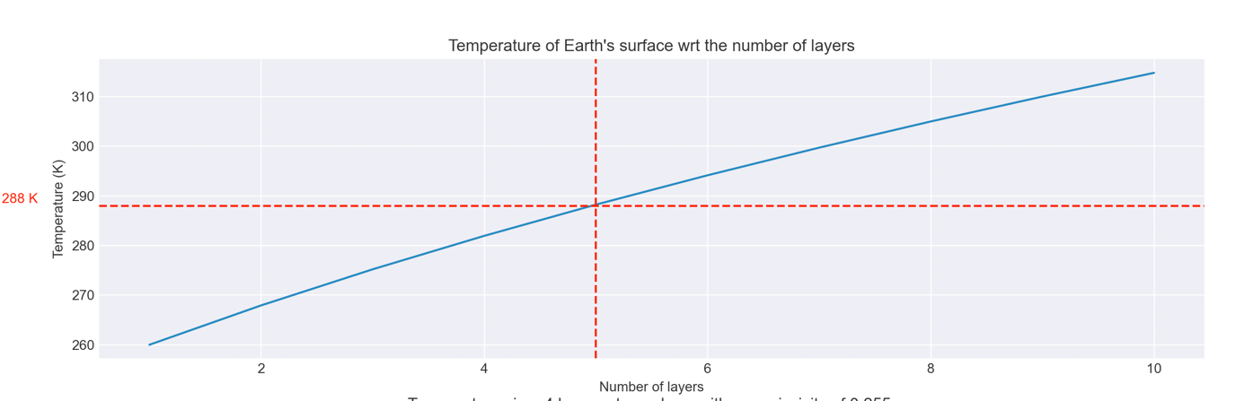

* In the figure we can see that the temperature increases almost linearly with the number of layers (at least between 0 and 10 layers), Earth’s surface temperature increases from 260 K with 1 layer to 315 K with 10 layers. This behaviour was expected, indeed by adding a new layer, it makes it more difficult for Earth radiation to escape the atmosphere, thus the temperatures need to be warmer to emits more radiation.
* We can also read, that 5 layers are necessary to match Earth’s surface temperature. Let’s see what the temperature profile in this specific atmosphere would be.

To plot the temperature with ratio to altitude, I used two simplifications:

* I considered that the layers are evenly distributed within the atmosphere
* I considered that the atmosphere height is 100km

With these two hypotheses, we can plot the Temperature of the atmosphere with ratio to the altitude.

* On this graph we can see that the slope is much lower for the first 25km. This slope corresponds to the variation between the layer 0–Earth’s surface–and the first layer of atmosphere. We can explain the slope difference by the fact that we considered Earth as emitting with an emissivity of 1 whereas all the layer of atmosphere will have an emissivity of 0.255.

This last graph is very limited by the way that we only have 5 temperature points. A good idea would be to increase the number of layers to get more temperature data. In fact, this won’t work, because as we saw previously, increasing the number of layers modifies the temperature profile. This points out a big issue of our model; the model doesn’t converge to a steady value when we increase its accuracy (the number of layer). This can be explained by the very restrictive hypothesis that we made. I will talk more about the limitation of the model in the discussion part.

Q4)

*How many atmospheric layers do we expect on the planet Venus?*

To answer this question, I used the same technique as in question 3)b). But I changed the parameters we used for earth to Venus parameters:

I set the:

* Emissivity: 1 (opaque to longwave radiation as suggested)
* Solar constant: S0=2600W/m2
* Venus’ albedo: 0.71 (this was the value I used in another class, and by doing a quick search on google, we can argue that this value is relevant).

Then, I calculated Venus’ surface temperature for a number of layers from 1 to 100.

* In the figure we can see that the temperature increases almost logarithmically with the number of layers. Venus’ surface temperature increases from 286 K with 1 layer to 759 K with 100 layers. We observe the same behaviour as explained for Earth.
* We can also read, that 71 layers are necessary to match Venus’ surface temperature. This is significantly greater than what we calculated for Earth (taking into account that the emissivity we set for Venus’ atmosphere is already much higher than for the Earth), it means that Venus has a much stronger greenhouse effect. We can also derive that conclusion from the fact that without any atmosphere Venus’ surface temperature would be less than 286K instead of 700K.

Q5)

*What would the Earth’s surface temperature be under a nuclear winter*

*scenario?*

To model this scenario, we have to modify our equations. In particular we have to change the array b, indeed, during a nuclear winter the sun light is absorbed by the last layer of atmosphere instead of Earth’s surface. Even though the last layer of atmosphere is opaque to shortwave radiation (absorption for shortwave radiation=1), I considered that it has the same emissivity for longwave radiation than the other layers. With this hypothesis, we can keep the matrix A.

Thus, I created a new function called “solve_N_layer_nuclear_winter” to compute this scenario.

To do so, I set the:

* Emissivity: 0.5
* Solar constant: S0=1350W/m2
* Earth albedo to 0.4, indeed, I considered that a part of the light is reflected by the last layer. I chose arbitrary 0.4, considering that the ashes and smoke would have a higher albedo than Earth’s surface. It doesn’t contradict the absorptivity=1, indeed there is no sun light transmitted through the layer.

I did the same hypothesis that for Q3) considering the layers altitude.

* We can see a very different temperature profile than before. Indeed, the whole atmosphere is at a very low constant temperature of 229 K, whereas the last layer is at a much higher temperature of 250 K. This result, correspond to what we would expect from a nuclear winter: a very cold temperature at the surface. We measured a drop of 58°C from current temperatures, which may be overestimated. Indeed, by a quick search on the internet, we would expect a 20-40°C drop in temperature. We could get closer to what expected by increasing the last layer’s albedo.

Conclusion:

The simplistic model of an N-layer atmosphere with a constant emissivity, is very interesting to understand the greenhouse effect. Indeed, it allows to obtain realistic Earth’s surface temperature. It allows to prove that there are two phenomena increasing the greenhouse effect: the number of layers of atmosphere, the emissivity of the layers. The higher the emissivity is, the more powerful the greenhouse effect is. The more layers of atmosphere we have, the more powerful the greenhouse effect is.

This model can also be used for computing the greenhouse effect of other planets, why the greenhouse effect is more or less important there.

Finally, it gives a quick overview of what would happen during a nuclear winter, and why the temperatures would drop significantly during such event.

Discussion:

However this model is very simple, we did many restrictive hypotheses, that prevent us from having an accurate model of temperatures within Earth’s atmosphere.

Indeed, we only took into consideration radiative exchange of heat while there are other heat exchange processes at stake. The convective heat exchange is very important, especially within the Troposphere for example. Moreover, we considered that each layer has the same emissivity, which is not true. Depending on the composition of the layer the emissivity can vary widely. We also considered the layers transparent to sun radiation, which is not exactly true, there is a small part that is being absorbed. Finally, the model uses discrete layers, whereas the real atmosphere continuous. Therefore, all these inaccuracies explain the limits of our model, however this approach is still a good way of understanding how the greenhouse effect influence the temperature of Earth.