Server side template injection

Vulnerability present in template engines such as jinja, apache velocity etc. The attacker injects a payload into a template which is then rendered by the server.

Walk-through for building payloads

Payload used in this challenge -

Preliminary testing of SSTI can be done using payloads such as {{7*7}} which if evaluated by the server gives an indication of SSTI.

Reference article - (SSTI (Server Side Template Injection) - HackTricks ) MUST READ BEFORE READING FURTHER.

<server-ip>/{{config.__class__.__base__.__subclasses__()[140].__init__.__globals__['sys'].modules['os'].popen("cat flag.txt").read()}}

Whoa!!! that’s whole lot of syntax in there.

Let’s break it down piece by piece and understand what’s in there.

For a moment let’s forget about payloads, hackers etc. and understand ‘Python’ (as the template engine used was flask framework)

Everything that is defined in python is an object.
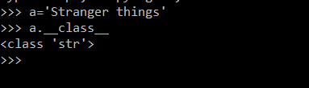

‘a’ is an object belonging to class ‘str’.

So let’s see what’s the base class for ‘a’ is:-
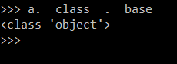

The base class is of type object. (Read this again :- Everything that is defined in python is an object.)

Now moving forward let’s see what are the sub classes that object class holds within itself.

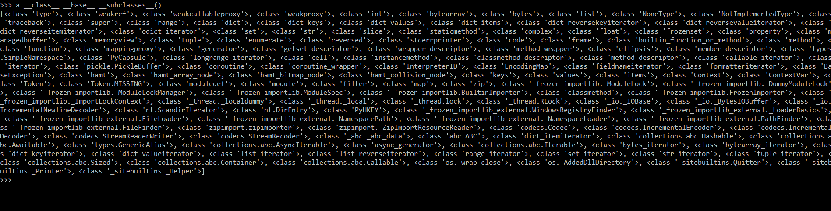
Whoaa !!!

That’s a whole lot of subclasses (Python Subclass of a class | CodesDope ) in there. So we can say object is the super class of all these classes.

Now let’s take a pause and think how is this related to SSTI . The main purpose of any attack is to gain confidential information or taking over a system / achieve the capability to execute remote code.

Now Python has several libraries like os (OS Module in Python with Examples - GeeksforGeeks ) through which we can achieve RCE.

So drilling down to the requirement of constructing an exploit we have to make use of os for performing command injections. Now the challenge is importing os directly is a little bit hasty (can be done). So I have taken a different approach for this purpose.

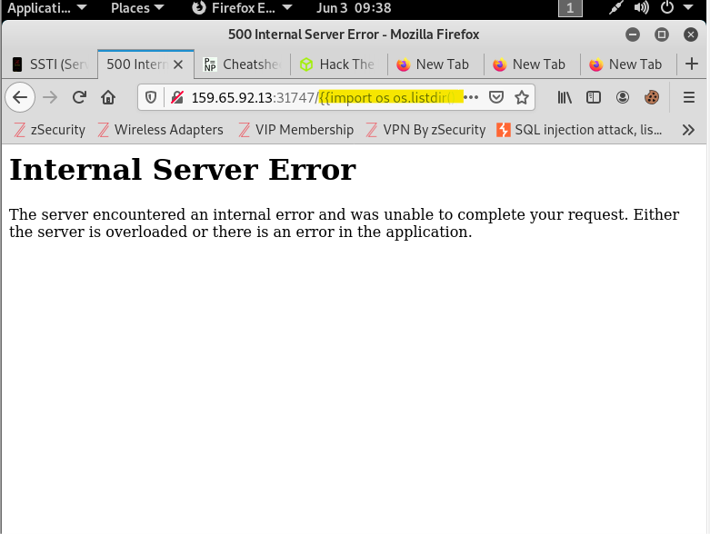

Fig:- Payload:- <server-ip>/{{import os os.listdir}}

So the approach taken here is locating sys (Python Sys Module - Javatpoint ) which in turn will give ‘os’ which might have been used in the subclass.
As you can see the subclass with index 80 has the sys module invoked in it. Now that’s very dangerous !! Cause sys has access to runtime environment of python including calling other modules like ‘os’.

Now moving on let’s get the os module. Syntax – sys.modules[‘os’].<functions that can be used with os>

As shown above module ‘os’ is present in the system.

Now let’s do a simple operation like listing all files in the directory.

As you can see the directory is listed.

Whoa!! So let’s see what we have accomplished, we listed files in a directory by making a variable in python.

In the payload mentioned the object taken is ‘config’ (Flask config | Learn How to perform config in Flask? (educba.com) ) which stores essential information in for a Flask application.

There are several other methods of doing the same thing. This is just one method explained. The main goal is deliver the concept on how the payload works behind the scene.

