[Adrián Aránegas Molina](mailto:aaramol2909@g.educaand.es)

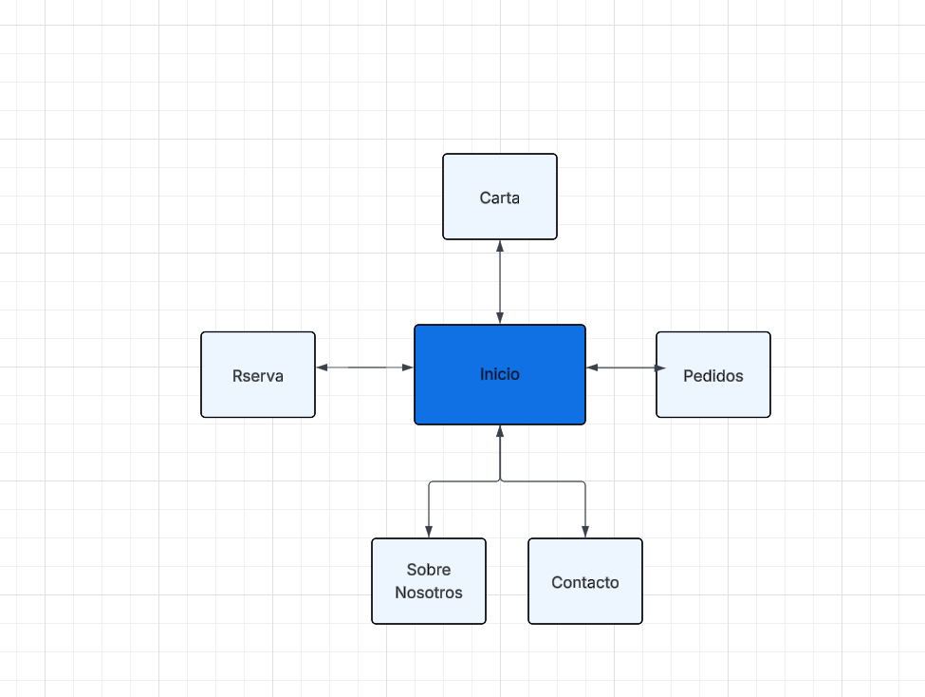

Hecho en:[AQUI](https://lucid.app/documents#/home?folder_id=recent)

**WIREFRAME**

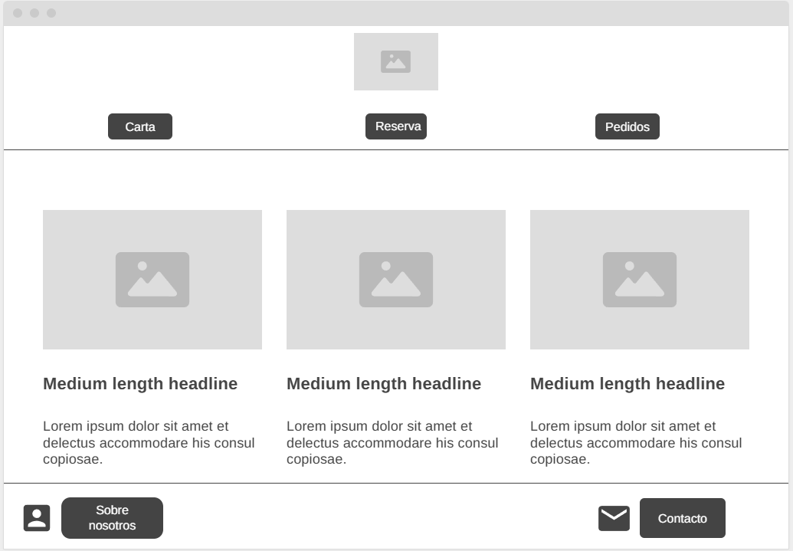

[INICIO](https://wireframe.cc/sPQSUh)

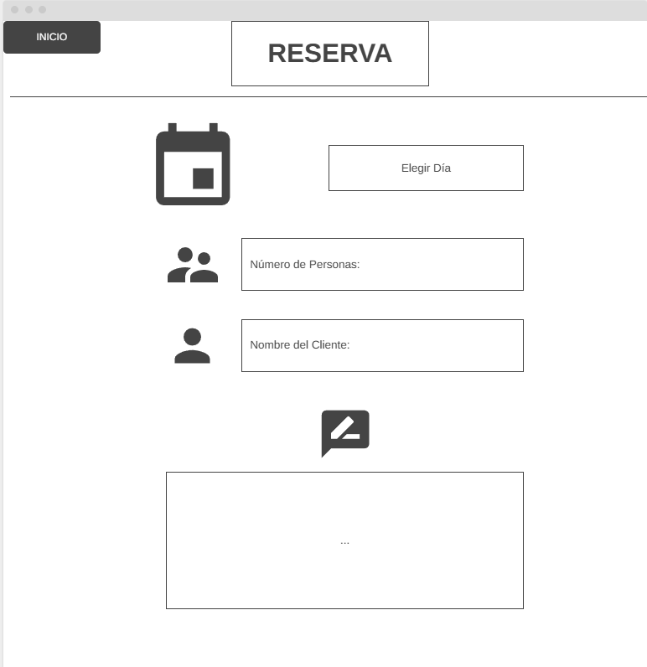

[RESERVA](https://wireframe.cc/z5gsBj)

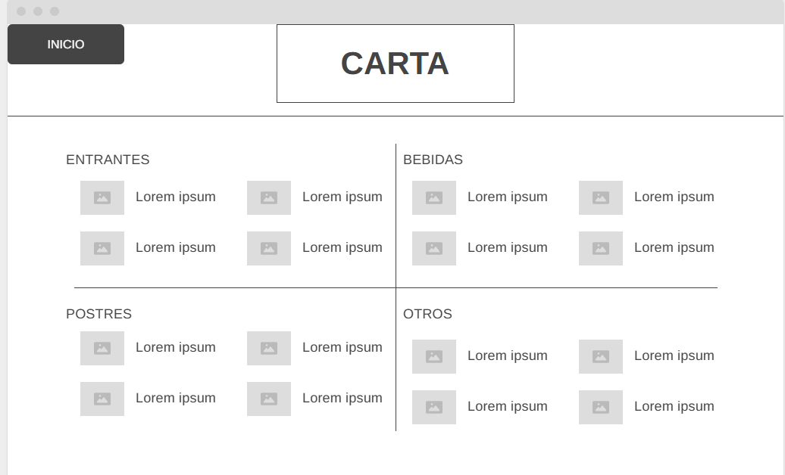

[CARTA](https://wireframe.cc/k01DN2)

**Mockup**

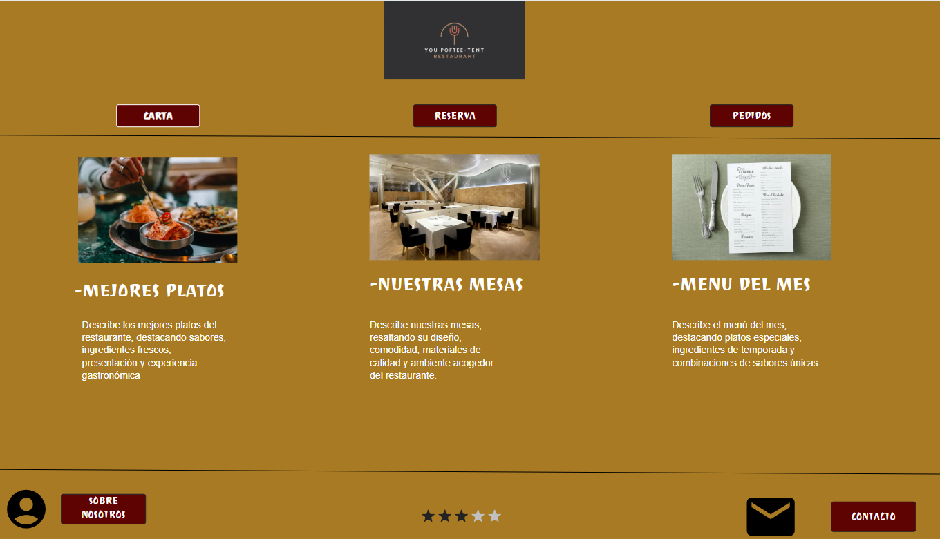

[INICIO](https://app.moqups.com/QQN8ZiUtwZbbhAMCmg15pw3qG3KDQOnJ/edit/page/ad64222d5)