STATISTICAL METHODS FOR DATA SCIENCE
MINI PROJECT #1
NAME: ADRITA DUTTA
NET-ID: axd172930
SPRING 2018

SECTION 1:

Q1.Consider a discrete random variable X that takes 4 values-1, 2, 3 and 4 with respective probabilities 1/2, 1/8, 1/8, and 1/4.

(a) Compute E(X), var(X) and P(X # 2) analytically, i.e., using their formulas.

Answer:
1) X= x₁, x₂, x₃, x₄= 1, 2, 3, 4
2) P=p₁, p₂, p₃, p₄=1/2, 1/8, 1/8, 1/4

=> E(X) = μ
= x₁p₁+x₂p₂+x₃p₃+ . . . +x_{n}p_{n}.

=
=
E(X) = 2.125

3)
x_{i} | p_{i} | (x_{i}-μ)²
1 | 1/2 | (1-2.125)²=1.265
2 | 1/8 | (2-2.125)²=0.0156
3 | 1/8 | (3-2.125)²=0.7656
4 | 1/4 | (4-2.125)²=3.5156

=> var(X) =Σ σ²p_{i} [1<= i <= 4]
=
=
=
var(X) =1.60905

=>P(X<=2)= P(1)+P(2)
= p₁+p₂
=

P(X<=2) =0.625

(b) Explain how you would simulate a draw from the distribution of X.

Answer:

Knowing discrete random variable X takes values x₁, x₂, x₃, x₄ with
probabilities p1, p2, p3, p4
pi = P {X =xi}
1)Divide the interval A=[1,4] into subintervals [A₁,A₂,A₃,A₄]
A₁=[0,p₁)
A₂=[p1, p1+p2)
A₃=[p₁+p₂, p₁+p₂+p₃)
A₄=[ p₁+p₂+p_{3,} p₁+p₂+p₃+p₄)
2)obtain standard uniform Random Variable U
3) If , let
P{X=x_{i}}= P{}=p_{i}

(c) Approximate E(X), var(X) and P(X # 2) using Monte Carlo simulation with 1,000 draws 5 times. Summarize the results in a table.

=> E(X) using Monte Carlo= E(X_bar)
= [1<= i <= 4]

=
= μ

=> Var(X) using Monte Carlo = Var(X_bar)
=
=
=

=> P(X<=2) using Monte Carlo =

Results in table:

1000 draws 5 times(Code for obtaining following results in Section 2)

Repitation | E(X) | Var(X) | P(X<=2)
1 | 2.495858 | 1.374329 | 0.4193617
2 | 2.490398 | 1.202729 | 0.4490126
3 | 2.456381 | 1.292734 | 0.4426159
4 | 2.53589 | 1.414128 | 0.4195495
5 | 2.518635 | 1.270768 | 0.3914974

(d) Repeat (c) with 5,000 and 10,000 draws.

5000 draws 5 times(Code for obtaining following results in Section 2)

Repitation | E(X) | Var(X) | P(X<=2)
1 | 2.486245 | 1.252768 | 0.4123660
2 | 2.512163 | 1.223974 | 0.4106074
3 | 2.518696 | 1.233815 | 0.4089927
4 | 2.487804 | 1.276931 | 0.4236489
5 | 2.501934 | 1.254684 | 0.4124114

10000 draws 5 times(Code for obtaining following results in Section 2)

Repitation | E(X) | Var(X) | P(X<=2)
1. | 2.509946 | 1.232619 | 0.4189146
2. | 2.489397 | 1.235854 | 0.4190509
3. | 2.104793 | 1.714490 | 0.4823175
4. | 2.147993 | 1.255690 | 0.4112808
5. | 2.485007 | 1.693625 | 0.4433729

(e) Compare you results in (a), (c) and (d). Explain, with justication, what you observe.

Answer:
According to the result of a, b and c
We can see that as the value of n increases the value of E(X), Var(X) and P(X<=2) becomes closer to the value at normal distribution.
We can see that values when n=10000 is closer to the values in a than those of n=5000 or n=1000 and with the same analogy values of n=5000 are closer to a than those of n=1000.

Thus, we can say that the CLT(Central Limit Theorem ) is applicable in this case.

Q2. Suppose X1;X2; : : : ;Xn denotes a random sample from a Bernoulli (p) population, represented by the
random variable X, and let X denote the sample mean. This sample mean also represents the propor-
tion of 1s in the sample, say, ^p. We know from Central Limit Theorem that ^p approximately follows a
normal distribution when n is large. The goal of this exercise is investigate how large n should be for
the approximation to be good. For this investigation, we will focus on p = 0:10; 0:25; 0:50; 0:75; 0:90,
and n = 10; 30; 50; 100.

(a) What is the approximate distribution of ^p when n is large?

Answer:
Approximate distribution of ^p when n is large is Normal Distribution.

(b) For a given (n; p) combination, simulate 500 values of ^p, and make a normal Q - Q plot of the values. Does the distribution look approximately normal?

Answer:
Taking values n=100, p=0.5
The distribution does look approximately normal.
Code to obtain the plot is provided in Section 2
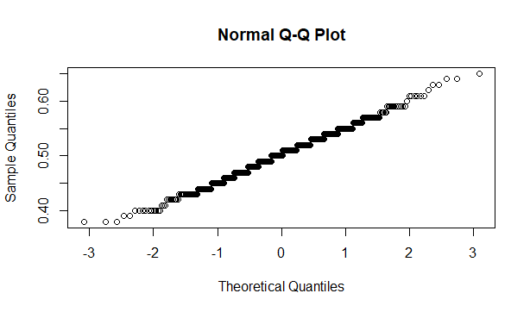

(c) Repeat (b) for the remaining combinations of (n; p) values.

1)n=10, p=0.10
2)n=10, p=0.25
3)n=10, p=0.5
4)n=10, p=0.75
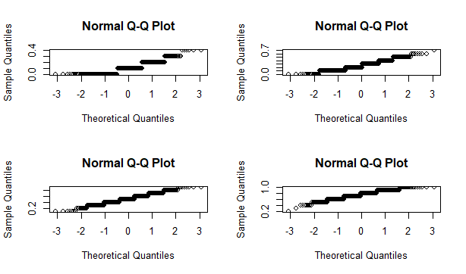
5)n=10, p=0.96)n=30, p=0.10
7)n=30, p=0.25
8)n=30, p=0.5
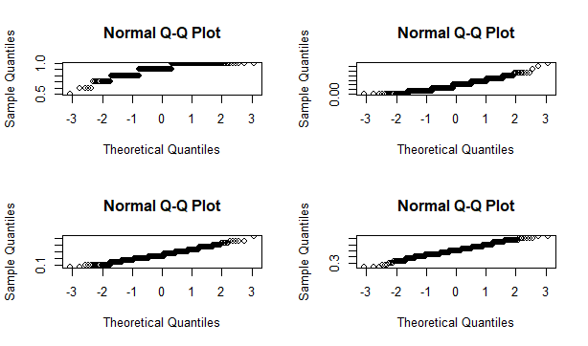

9)n=30, p=0.75
10)n=30, p=0.90
11)n=50, p=0.10
12)n=50, p=0.25
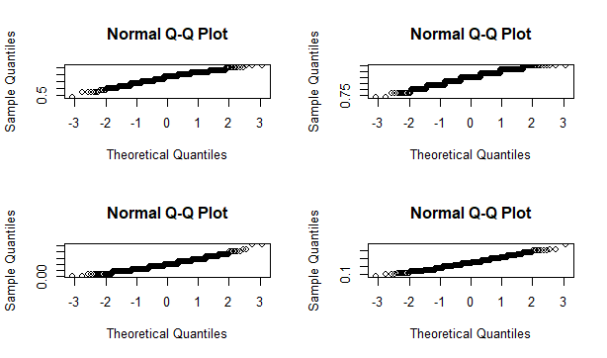
13)n=50, p=0.5
14)n=50, p=0.75
15)n=50, p=0.90
16)n=100, p=0.10
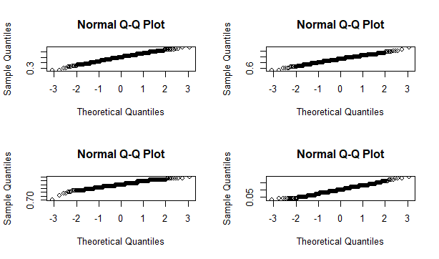

17)n=100, p=0.25
18)n=100, p=0.5
19)n=100, p=0.75
20)n=100, p=0.90
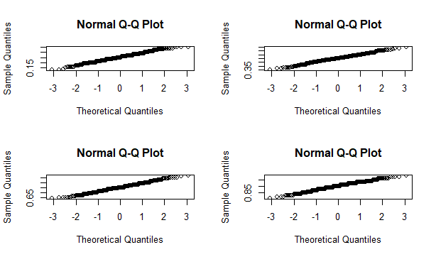

(d) What would you say about how large n should be for the approximation to be good? Does this answer depend on p? Justify your conclusions.

Answer:
According to the results from the above parts b and c we can see that for n>=30 the approximation is good approximation of normal distribution as it almost forms a straight line. In n=10 when probability value is small we get a discrete distribution.
The result does depends on p.
1.If the value of p is normal- n value does not have to be too high for good approximation
2. If the value of p is extreme(too high or too low)- n value has to be very high for good approximation

Section 2:

Q1c)MC estimation of E(X), Var(X),P(X<=2) for sample size 1000
#possible values if X
x<-1:4

#sample size n
n<-1000

#taking a sample of the given distribution
a=sample(x,n,replace=TRUE)

#calculating mean of distribution
m=mean(a)

#calculating sd of distribution
sd=sqrt(var(a))

#calculating p(x<=2) of distribution
a<-rnorm(a,m,sd)
y<-sum(a[a<=2])
prob=y/n

#replicating final result 1000 times
z=replicate(5,c(mean(a),var(a),prob))
z

1d)MC estimation of E(X), Var(X),P(X<=2) for sample size 5000
#possible values if X
x<-1:4

#sample size n
n<-5000

#taking a sample of the given distribution
a1=sample(x,n,replace=TRUE)

#calculating mean of distribution
m1=mean(a1)

#calculating sd of distribution
sd1=sqrt(var(a1))

#calculating p(x<=2) of distribution
a1<-rnorm(a1,m1,sd1)
y1<-sum(a1[a1<=2])
prob1=y1/n

#replicating final result 5000 times
p=replicate(5,c(mean(a1),var(a1),prob))
p

1d)MC estimation of E(X), Var(X),P(X<=2) for sample size 10000
#possible values if X
x<-1:4

#sample size n
n<-10000

#taking a sample of the given distribution
a2=sample(x,n,replace=TRUE)

#calculating mean of distribution
m2=mean(a2)

#calculating sd of distribution
sd2=sqrt(var(a2))

#calculating p(x<=2) of distribution
a2<-rnorm(a2,m2,sd2)
y2<-sum(a2[a2<=2])
prob=y2/n

#replicating final result 10000 times
q=replicate(5,c(mean(a2),var(a2),prob))
q

Q2b)finding qqplot of a (n,p) pair
# n=100 p=0.5

#take a random sample, take it's mean. replicate this 500 times

p1 <- replicate(500, mean(x=rbinom(100, 1, 0.5)))
qqnorm(p1)

c) The code for part c is the same as part b with different values of n and p
#to display four plots in one page
par(mfrow=c(2,2))

#n=10, p=0.1
p1 <- replicate(500, mean(rbinom(10, 1, 0.1)))
qqnorm(p1)

#n=10, p=0.25
p2 <- replicate(500, mean(rbinom(10, 1, 0.25)))
qqnorm(p2)

#n=10, p=0.5
p3 <- replicate(500, mean(rbinom(10, 1, 0.5)))
qqnorm(p3)

#n=10, p=0.75
p4 <- replicate(500, mean(rbinom(10, 1, 0.75)))
qqnorm(p4)

#n=10, p=0.9
p5 <- replicate(500, mean(rbinom(10, 1, 0.9)))
qqnorm(p5)

#n=30, p=0.1
p6 <- replicate(500, mean(rbinom(30, 1, 0.1)))
qqnorm(p6)

#n=30, p=0.25
p7 <- replicate(500, mean(rbinom(30, 1, 0.25)))
qqnorm(p7)

#n=30, p=0.5
p8 <- replicate(500, mean(rbinom(30, 1, 0.5)))
qqnorm(p8)

#n=30, p=0.75
p9 <- replicate(500, mean(rbinom(30, 1, 0.75)))
qqnorm(p9)

#n=30, p=0.9
p10 <- replicate(500, mean(rbinom(30, 1, 0.9)))
qqnorm(p10)

#n=50, p=0.1
p11 <- replicate(500, mean(rbinom(50, 1, 0.1)))
qqnorm(p11)

#n=50, p=0.25
p12 <- replicate(500, mean(rbinom(50, 1, 0.25)))
qqnorm(p12)

#n=50, p=0.5
p13 <- replicate(500, mean(rbinom(50, 1, 0.5)))
qqnorm(p13)

#n=50, p=0.75
p14 <- replicate(500, mean(rbinom(50, 1, 0.75)))
qqnorm(p14)

#n=50, p=0.9
p15 <- replicate(500, mean(rbinom(50, 1, 0.9)))
qqnorm(p15)

#n=100, p=0.1
p16 <- replicate(500, mean(rbinom(100, 1, 0.1)))
qqnorm(p16)

#n=100, p=0.25
p17 <- replicate(500, mean(rbinom(100, 1, 0.25)))
qqnorm(p17)

#n=100, p=0.5
p18 <- replicate(500, mean(rbinom(100, 1, 0.5)))
qqnorm(p18)

#n=100, p=0.75
p19 <- replicate(500, mean(rbinom(100, 1, 0.75)))
qqnorm(p19)

#n=100, p=0.9
p20 <- replicate(500, mean(rbinom(100, 1, 0.9)))
qqnorm(p20)

