STATISTICAL METHODS FOR DATA SCIENCE
MINI PROJECT #2
NAME: ADRITA DUTTA
NET-ID: axd172930
SPRING 2018

Section 1:
8.
a)read file college.csv
b)
->see the look of it

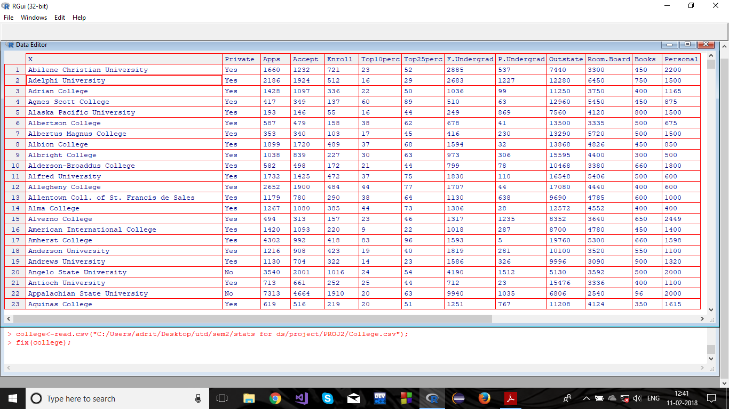
->add row names
->look of the edited table
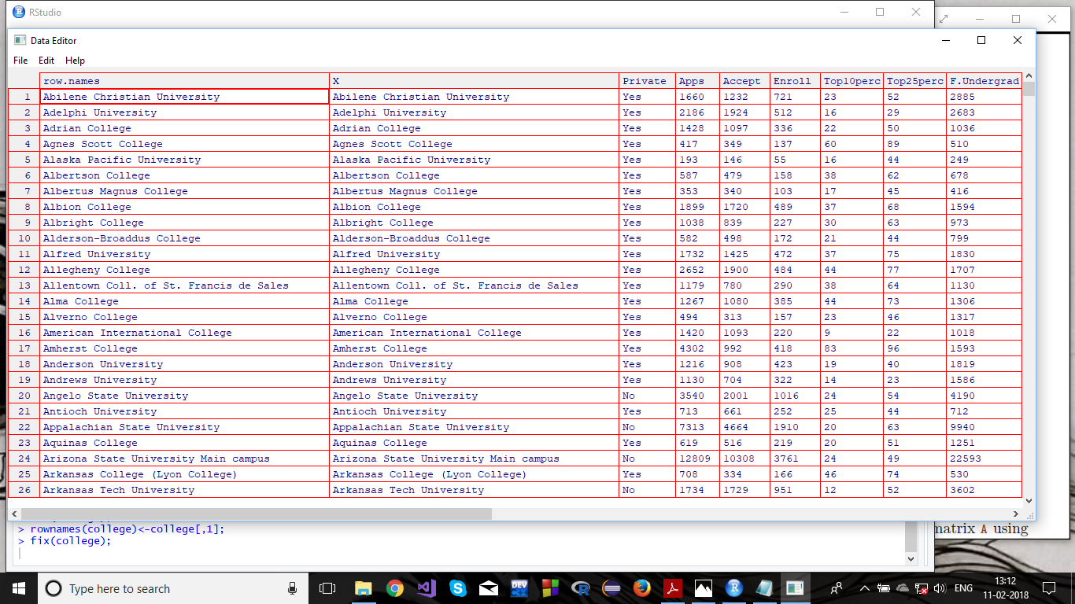

->delete college name column that can have calulations on them
->look at edited table
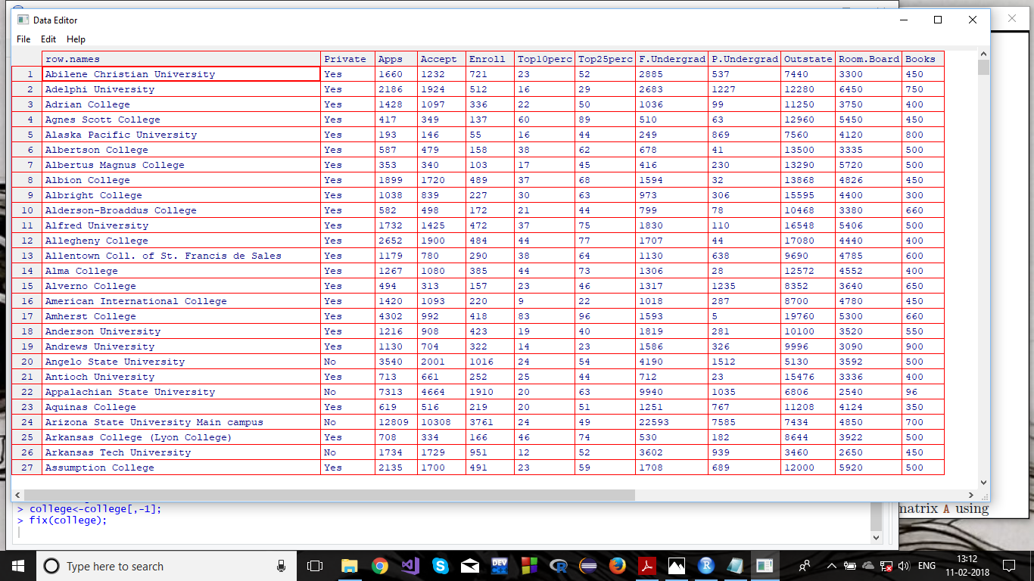

c.i)summary of all data sets
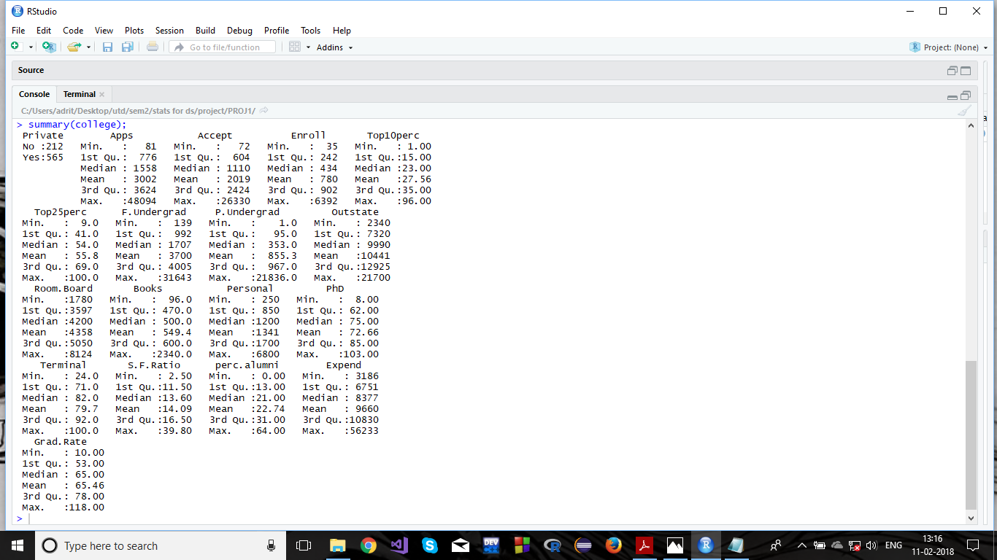

ii)scatterplot matrix of first 10 columns:
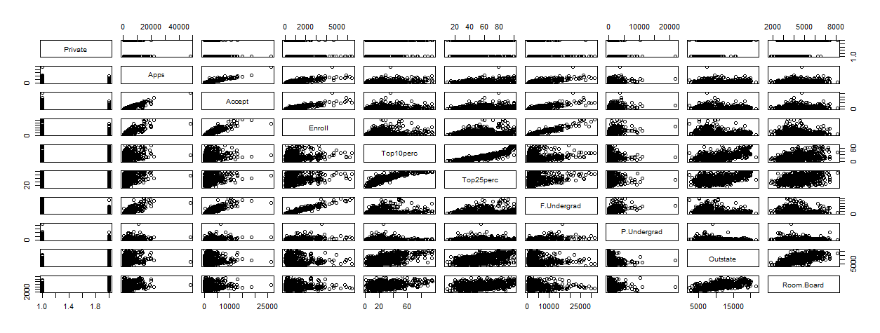

iii)side-by-side plot and boxplot of outstate vs private:
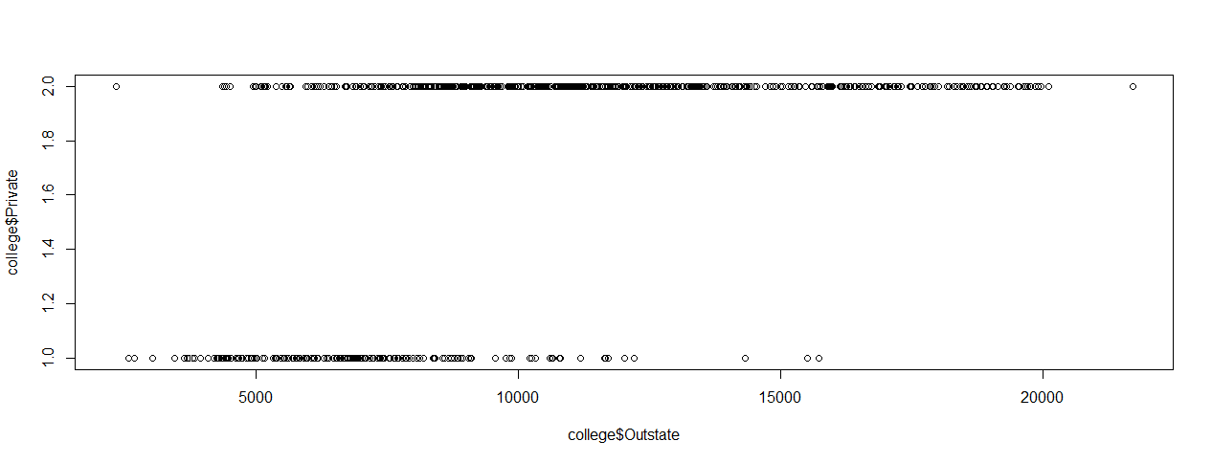
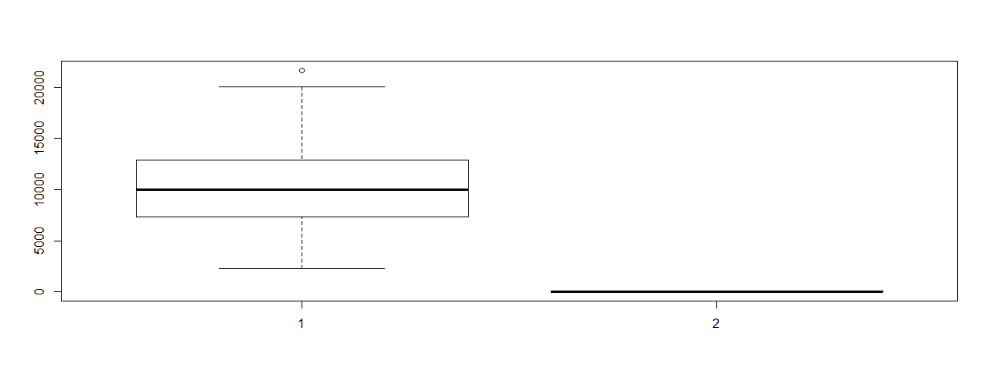
iv)create Elite, by binning the Top10perc variable
->see how many Elites using summary:

NO | YES
699 | 78

->side-by-side plot and boxplot of outstate vs Elite
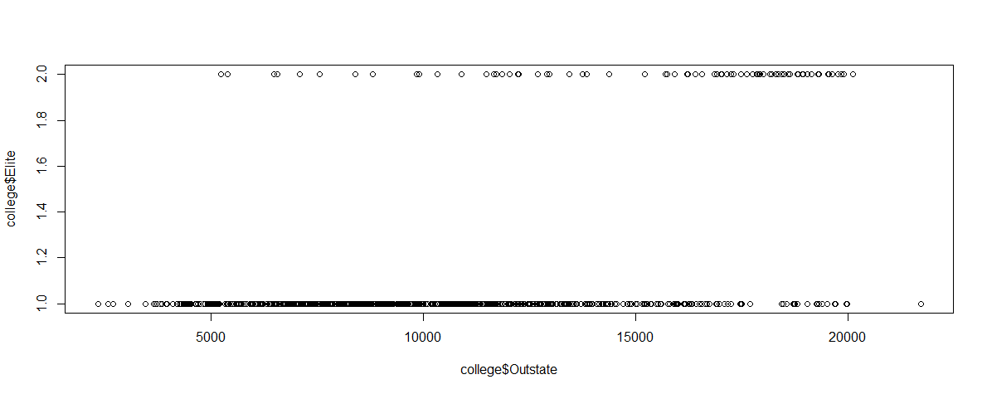
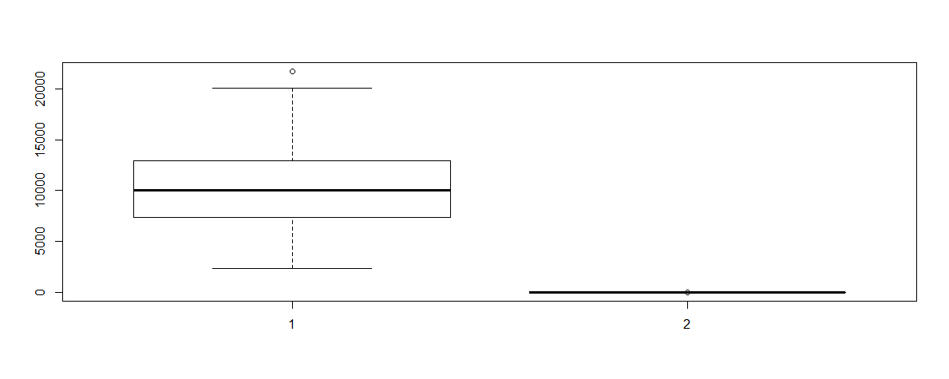

v)histograms of a few variables withdifferent bin size

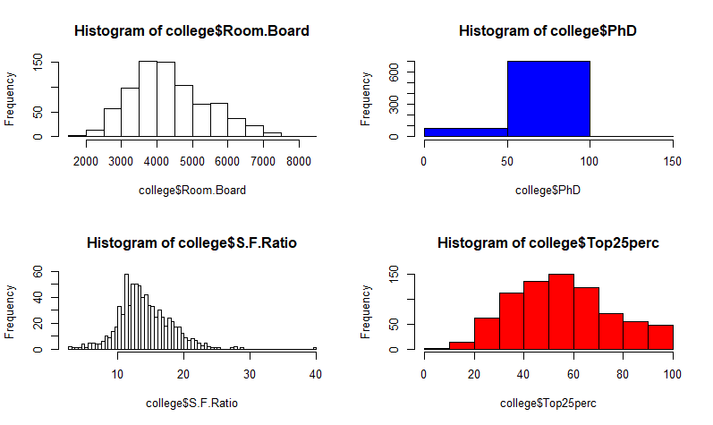

vi) On further experimenting with the given data it is observed that:
->the higher the acceptance, graduation rate has lesser variance and is thus lower in average
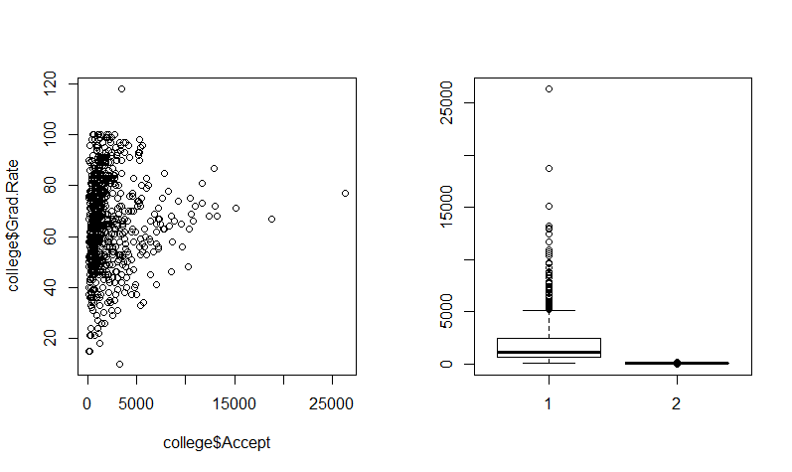
->more applicants if more number of faculty have phd
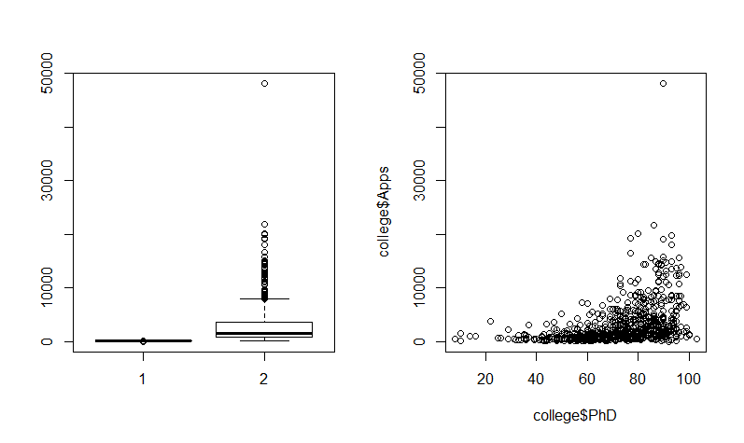
->more variance in costs of books when lesser students enrolled
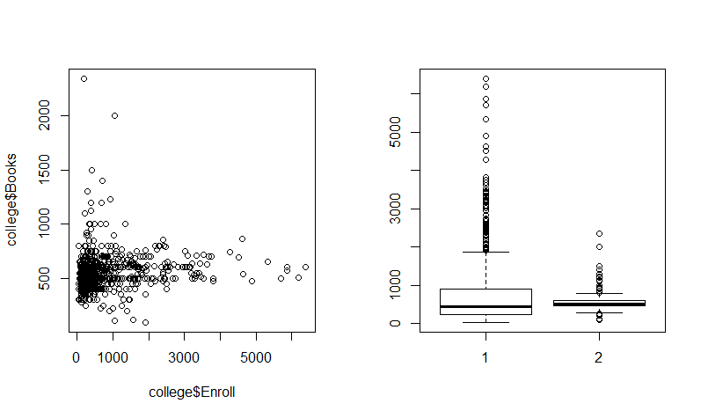
->as personal expenses increase donations have lower variance and thus lower average values
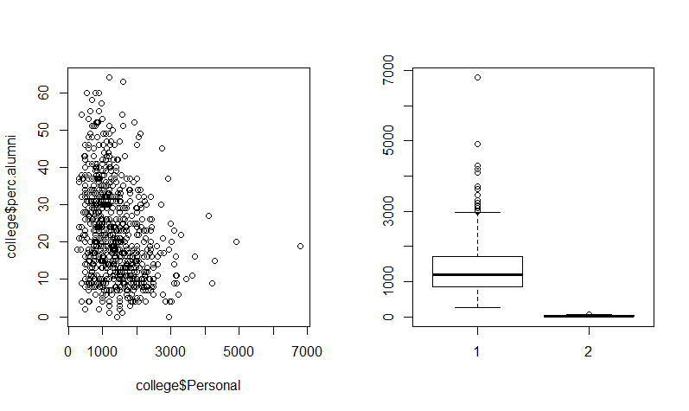

Section 2:

R-Code:

#a)read file college.csv
college<-read.csv("C:/Users/adrit/Desktop/utd/sem2/stats for ds/project/PROJ2/College.csv");

#b)
#fix file, see the look of it
fix(college);

#now we set names to each row(R will not perform any operations on row names:)
#extra column for row name added for each row
rownames(college)<-college[,1];

#see the look of the table again(this time with an extra column for names)
fix(college);

#now that we have 2 columns with uni name, delete 1
#delete the original 1 as calculations can be done on that.
college<-college[,-1];

#see table again:
fix(college);

#c)
#i)summary of data set(MIN,Q1,Q2,MEAN,Q3,MAX)
summary(college);

#ii)scatterplot matrix of first 10 columns:
pairs(college[,1:10]);

#iii)side by side boxplots of Outstate vs Private
plot(college$Outstate,college$Private)
boxplot(college$Outstate,college$Private)

#iv)creating Elite(top 10 percentile)
Elite=rep("No",nrow(college))
Elite[college$Top10perc>50]="Yes"
Elite=as.factor(Elite)
college=data.frame(college,Elite)

#summary of Elite universities
summary(college$Elite)

#boxplots of outstate vs Elite
plot(college$Outstate,college$Elite)
boxplot(college$Outstate,college$Elite)

#v)histograms of a few variables with different bin size
#dividing display page
par(mfrow=c(2,2))

#histogram of romm and board costs
hist(college$Room.Board)

#histogram of PhD students
hist(college$PhD, col=4, breaks = 2)

#histogram of student faculty ratio
hist(college$S.F.Ratio, breaks =100)

#histogram of top 25 percentile
hist(college$Top25perc, col=2)

#vi)doing other experiments on data:
#boxplot of no of acceptances and graduation rate
#we see here the higher the acceptance, graduation rate has lesser variance)
par(mfrow=c(1,2))
plot(college$Accept, college$Grad.Rate)
boxplot(college$Accept, college$Grad.Rate)

#boxplot of applicant no vs percentage of faculty with PHD
#more applicants if more number of faculty have phd
plot(college$PhD, college$Apps)
boxplot(college$PhD, college$Apps)

#boxplot of Enroll and Books
#more variance in costs of books when lesser students enrolled
plot(college$Enroll, college$Books)
boxplot(college$Enroll, college$Books)

#personal exp vs percentage of alumni who donate
#as personal expenses increase donations have lower variance and thus lower average values.
#if they spent less in college they are more likely to donate
plot(college$Personal, college$perc.alumni)

