**When you need to add a path in environment variable:**

*If a message like shown below appears on your screen then you need to add its location path in Environment Variables.*

“Application Name” is not recognised as an internal or external command, operable program or batch file.

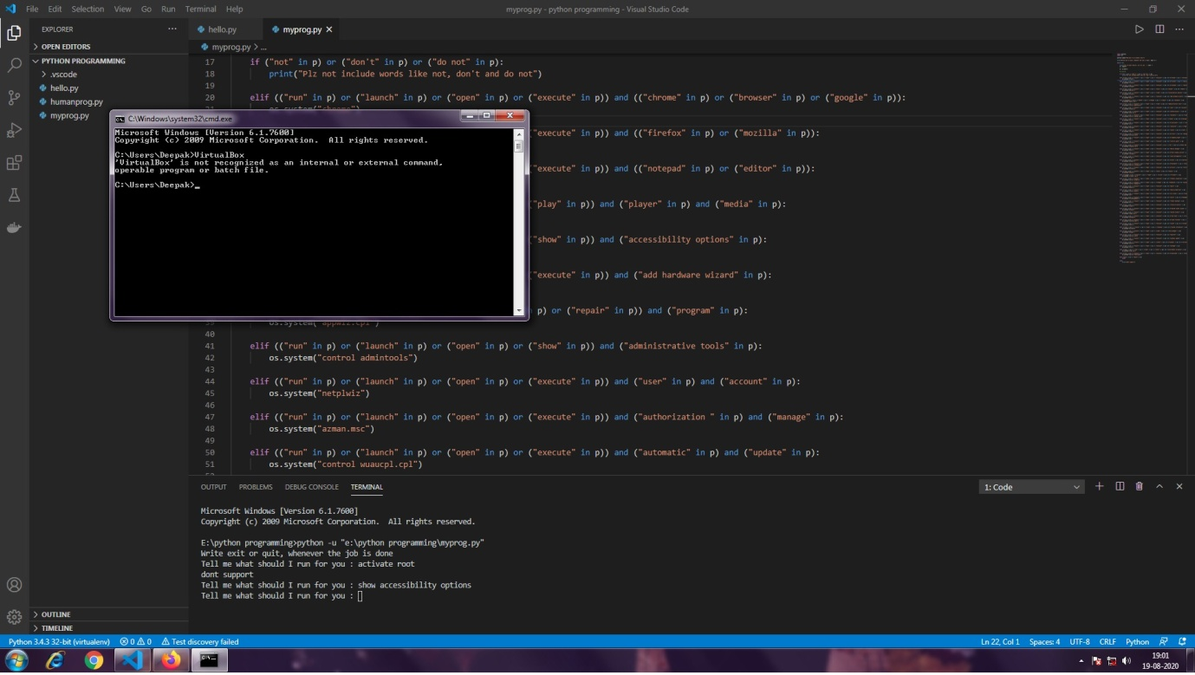

**HOW TO SET PATH IN ENVIRONMENT VARIABLE:**

1. Open that application

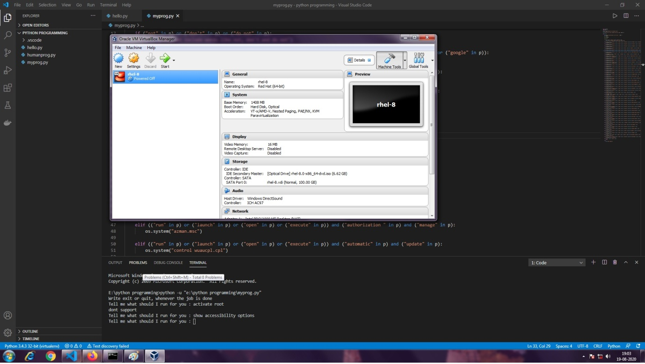

1. Run Task Manager

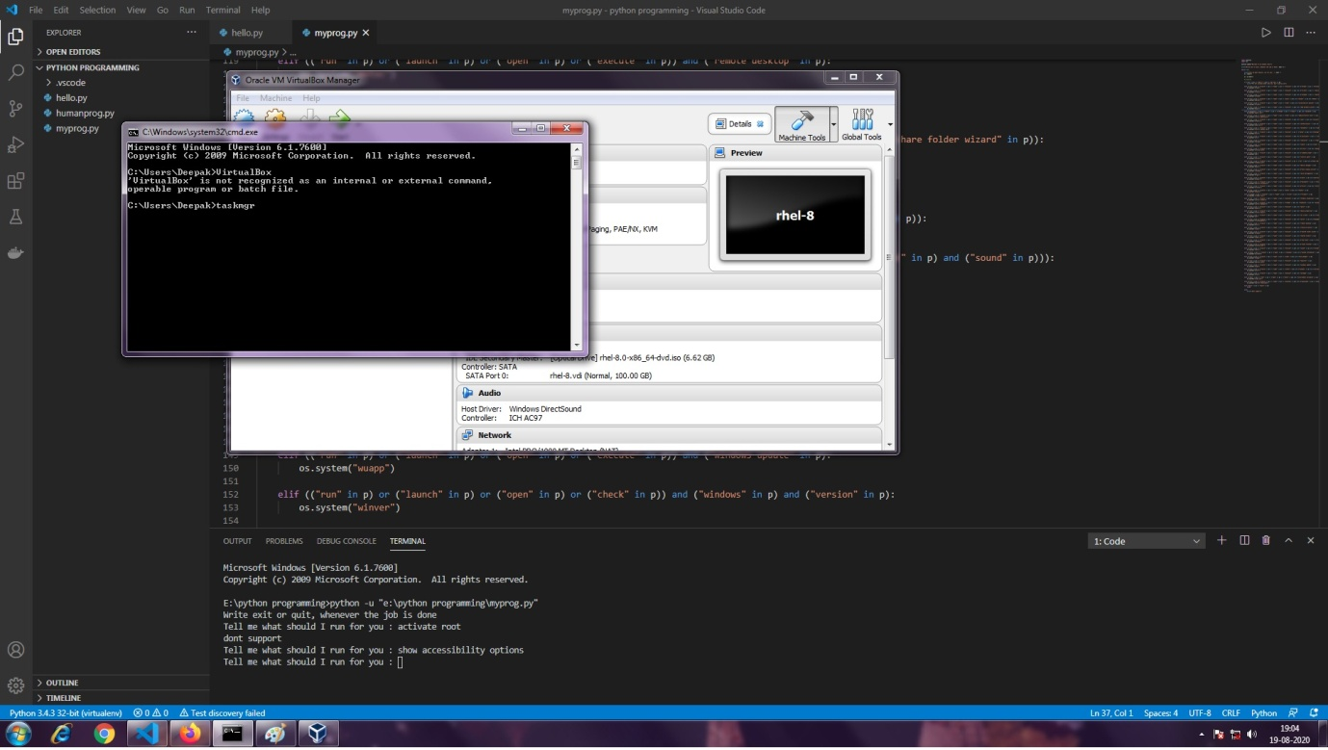

1. Find that application name in processes and open its file location as described in image:

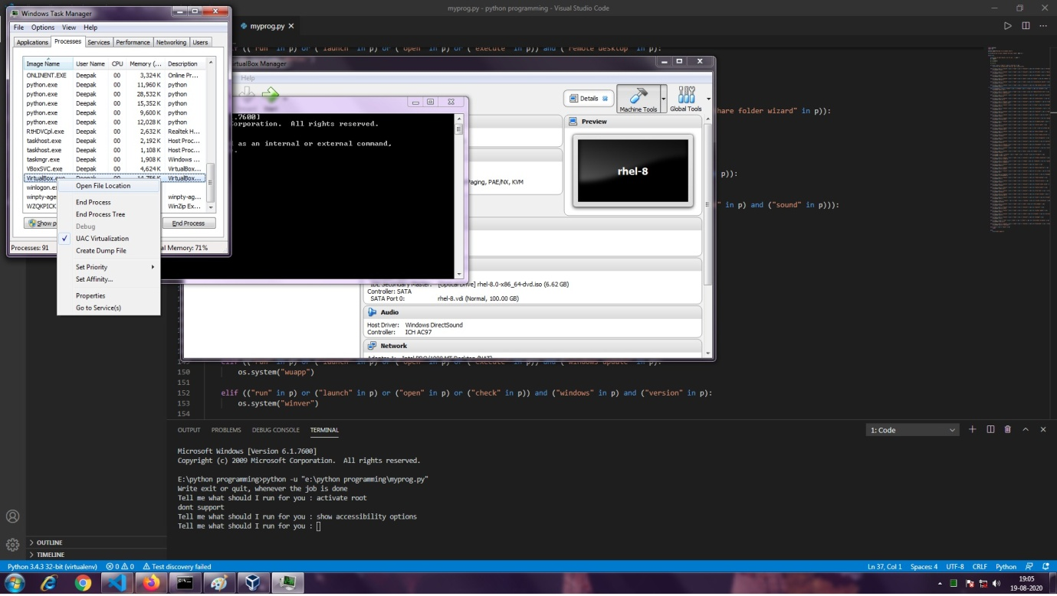

1. Copy Path as shown

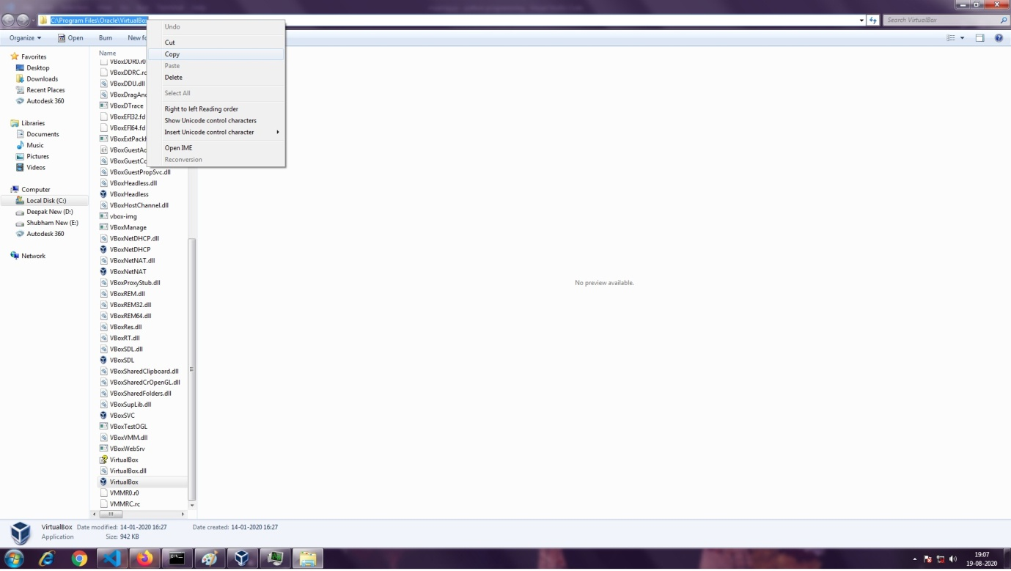

1. Open System Properties by typing sysdm.cpl in command prompt.

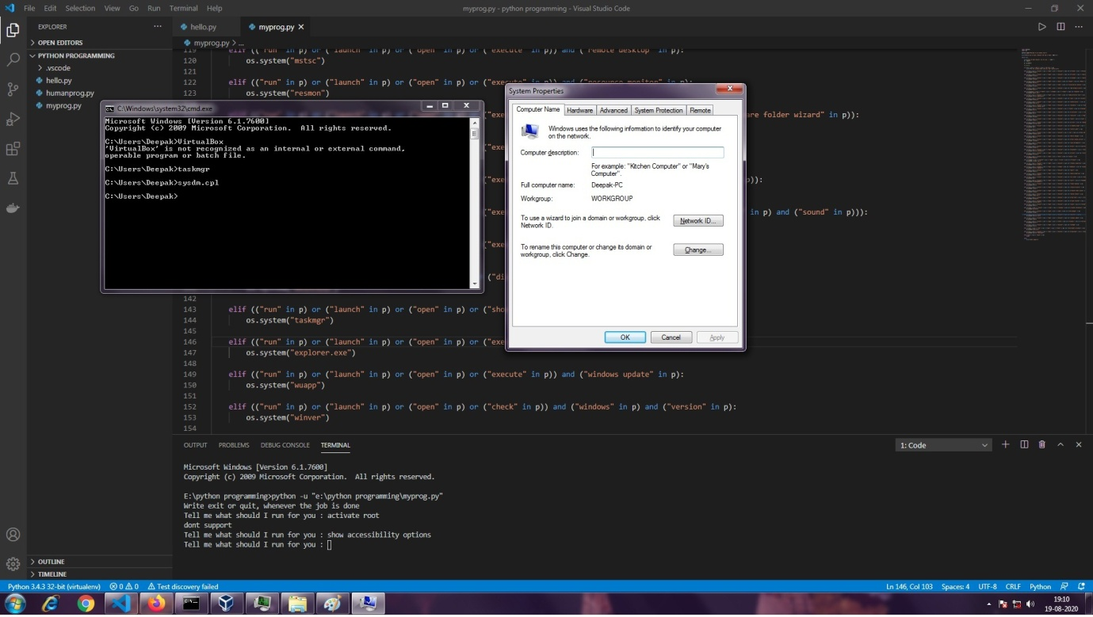

1. Go to advanced Settings and click on Environment Variables.

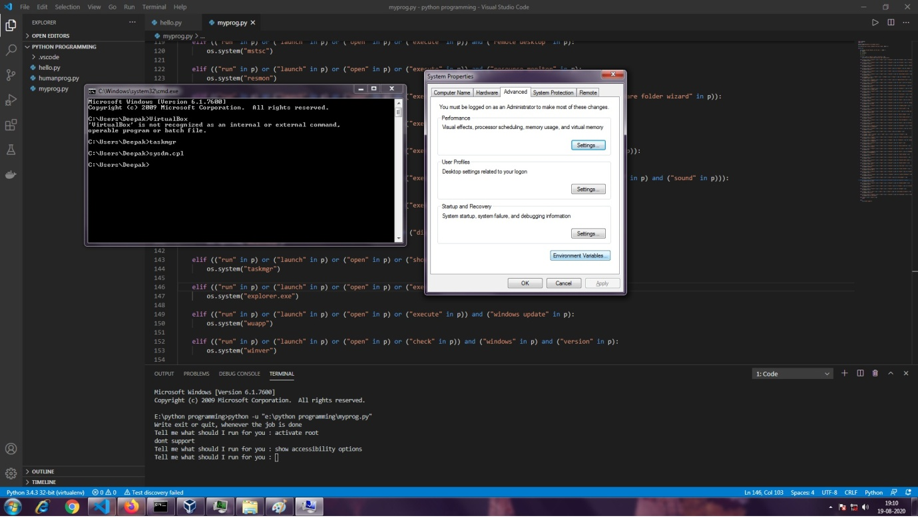

1. Select Path and click on edit

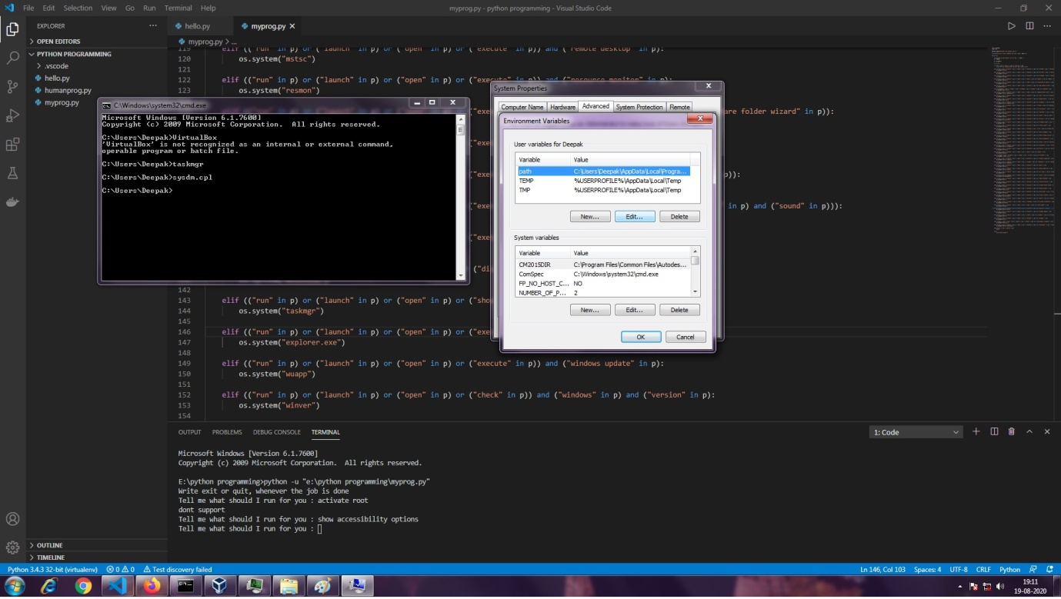

1. Write semicolon(;) at end and then paste the path following it. Finally, press OK.

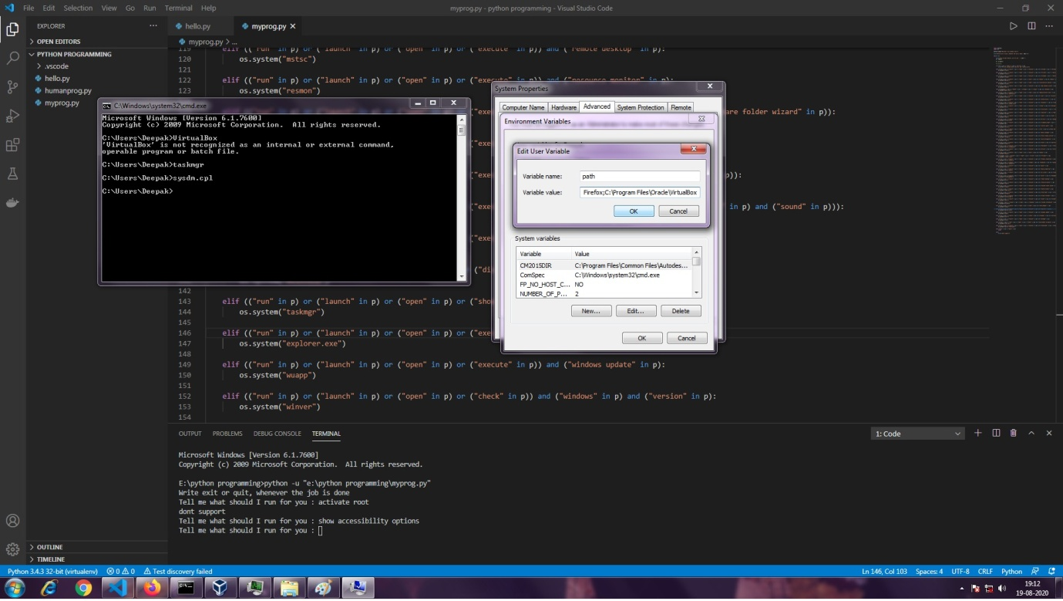

1. Click OK

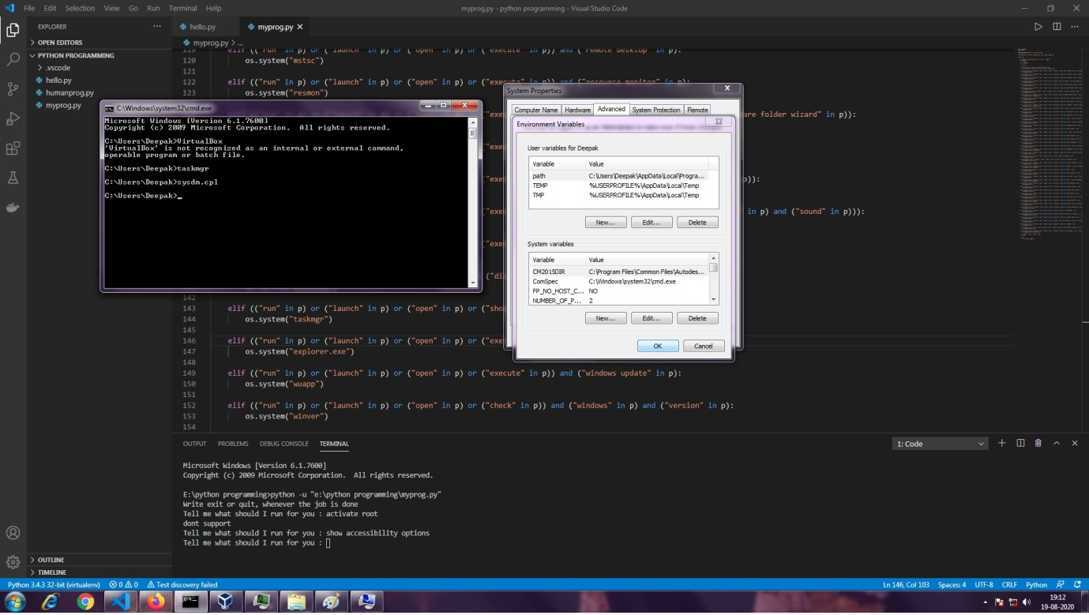

1. Again Click OK

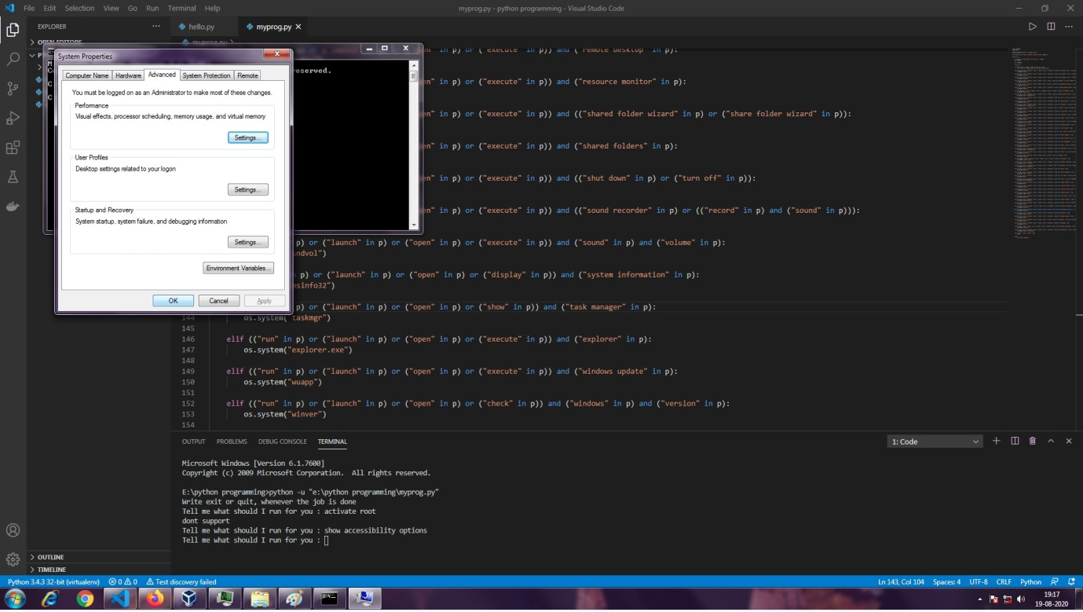

1. Close the application and run it again to make the changes.

