**Quiz Contest**

**(A Quiz )**

**A PROJECT REPORT**

**Submitted by**

Saumya Srivastava - 11902843 – A09

Adarsh Azad - 11902794 – A07

Ayush Papnoi - 11902794 – A08

# Introduction:

## Relevance:

Quiz Contest is an application that has general questions related to current affairs and computer. It has multiple choice questions with time limit and it also calculate scores of each correct answer. It is good for students of every age group it helps in increasing general knowledge about world ,Sports and computer etc. Don't need register simply give any user name and password it will saved automatically and you can login again with same user name and password don’t have to worry about the past score. The application helps the user to increase his/her knowledge..

# Basic Concepts &Tools :

## Introduction to Python

Python is an interpreted, object-oriented, high-level programming language with dynamic semantics. Its high-level built in data structures, combined with dynamic typing and dynamic binding, make it very attractive for Rapid Application Development, as well as for use as a scripting or glue language to connect existing components together. Python's simple, easy to learn syntax emphasizes readability and therefore reduces the cost of program maintenance. Python supports modules and packages, which encourages program modularity and code reuse. The Python interpreter and the extensive standard library are available in source or binary form without charge for all major platforms, and can be freely dis

# Software Requirements:

* **Platform:** Python
* **Database:** MySql

# Hardware Requirements:

* Laptop

# Diagram:

## Data Flow Diagram (DFD):

A **data flow diagram** (**DFD**) is a graphical representation of the "flow" of data through an information system, modeling

its *process* aspects. A DFD is often used as a preliminary step to create an overview of the

system. DFDs can also be used for the visualization of data processing.

A DFD shows what kind of information will be input to and output from the system, where the data will come from and go to, and where the data will be stored. It does not show information about the timing of process or information about whether processes will operate in sequence or in parallel.

* **Level 0 DFD:**

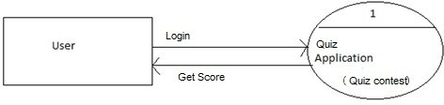

**Use Case Diagram:**

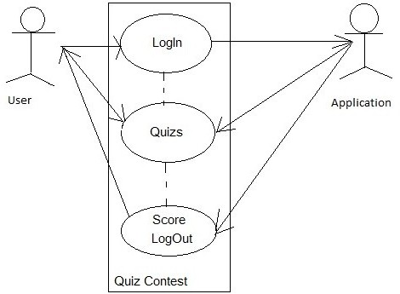

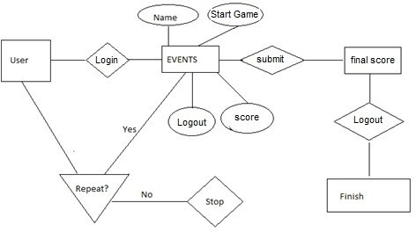

**Table Diagram:**

Design of database table which is named as Events is given below ---

|  |  |
| --- | --- |
| **Attribute Name** | **Attribute type** |
| **Id** | Int |
| **Name** | Text |
| **Info** | Text |
| **Period** | Text |
| **Period_unit** | Text |
| **Start_time** | Text |

# Form Design:

## Components---

* + Linear Layout (Vertical)
  + Linear Layout (Horizontal)
  + TextView(Medium)
  + EditText
  + Button
  + CheckBox
  + ListView
  + Spinner
  + ImageView
  + AlertDialog

# Testing:

## Objective:

The objective our test plan is to find and report as many bugs as possible to improve the integrity of our program. Although exhaustive testing is not possible, we will exercise a broad range of tests to achieve our goal. We will also test the user friendliness of our app .The application will

be used as an important tool, but we would like to ensure that it could be run on a variety of platforms with little impact on performance or usability.

## Process Overview :

The following represents the overall flow of the testing process:

* Identify the requirements to be tested. All test cases shall be derived using the current Program Specification.
* Identify which particular test(s) will be used

to test each module.

* Review the test data and test cases to ensure that the unit has been thoroughly verified and that the test data and test cases are adequate to verify proper operation of the unit.
* Identify the expected results for each test.
* Document the test case configuration, test data, and expected results.
* Perform the test(s).
* Document the test data, test cases, and test configuration used during the testing

process. This information shall be submitted via the Unit/System Test Report (STR).

* Successful unit testing is required before

the unit is eligible for component integration/system testing.

* Unsuccessful testing requires a Bug Report

Form to be generated. This document shall describe the test case, the problem encountered, it's possible cause, and the sequence of events that led to the problem. It shall be used as a basis for later technical analysis.

* Test documents and reports shall be

submitted. Any specifications to be reviewed, revised, or updated shall be handled immediately.

## Testing Process:



Project

Organize

System Test

Design

Organize Project

Design/Build Test Proc.

Design/Build

Signoff

The diagram above outlines the Test Process approach that will be followed.

* + **Organize Project** involves creating a System Test Plan, Schedule & Test Approach, and assigning responsibilities.
  + **Design/Build System Test** involves identifying Test Cycles, Test Cases, Entrance & Exit Criteria, Expected Results, etc. In general, test conditions/expected results will be identified by the Test Team in conjunction with the Development Team. The Test Team will then identify Test Cases and the Data required. The Test conditions are derived from the Program Specifications Document.
  + **Design/Build Test Procedures** includes

setting up procedures such as Error Management systems and Status reporting.

* + **Build Test Environment** includes requesting/building hardware, software and data setups.
  + **Execute System Tests** identified in the Design/Build Test Procedures will be executed. All results will be documented and Bug Report Forms filled out and given to the Development Team as necessary.
  + **Signoff** happens when all pre-defined exit criteria have been achieved.

## Testing Strategy:

The following outlines the types of testing that will be done for unit, integration, and system testing. While it includes what will be tested, the specific use cases that determine how the testing is done will be detailed in the Test Design Document. The test cases that will be used for designing use cases is shown below.

|  |  |  |  |  |
| --- | --- | --- | --- | --- |
| 1) | type the user | name | and | 1. Successful welcome user's profile come 2. Page exits |
|  | password |  |  |
| 2) | Logout |  |  |

Login Screen:

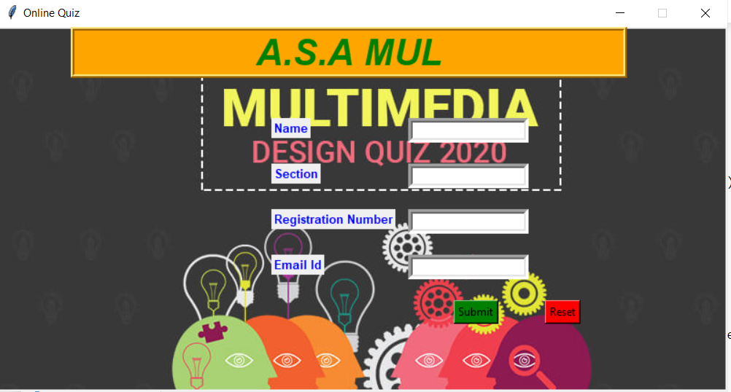

Continue page:

**Quiz page (Game Start):**

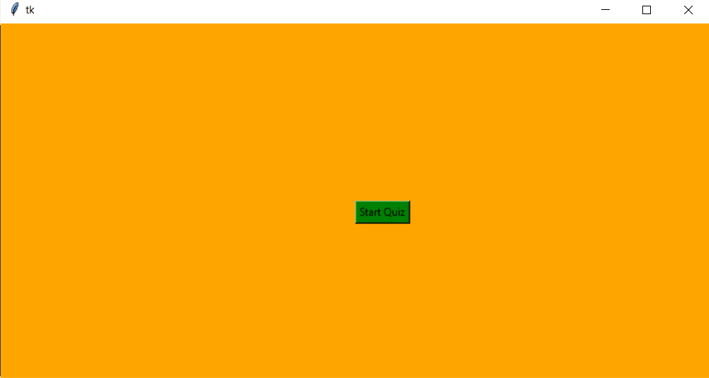

**Questions & Answers**

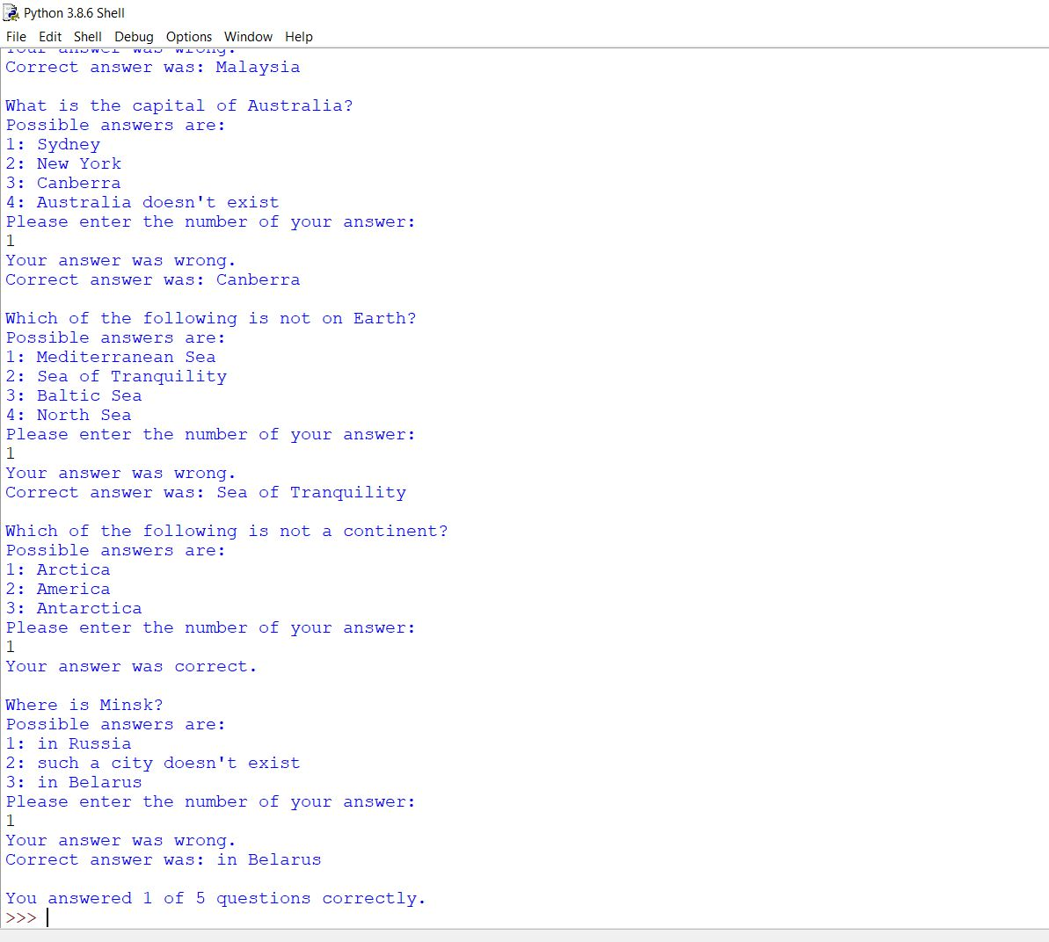

THE END