**QUESTION_01:**

**Compile:**

javac -d bin -sourcepath source source\edu\oakland\solutions\homework\newdir\Baz.java

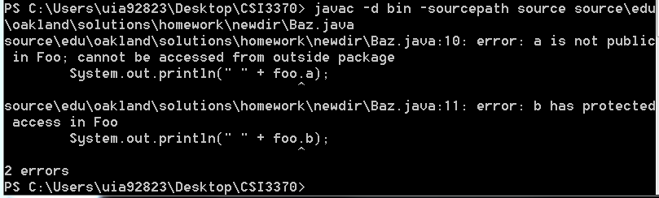

I knew that having a ‘protected’ access to the variable was going to throw and error due to having Baz outside the package. For variable ‘a’, it wasn’t explicitly told to be public. To fix these compile errors I did the following:

public class Foo

{

public int a = 5;

public int b = 6;

public int c =7;

}

**Execution:**

java -classpath bin edu.oakland.solutions.homework.newdir.Baz  
There were no execution errors.

**Final Source Code:  
Foo:**

package edu.oakland.solutions.homework;

public class Foo

{

public int a = 5;

public int b = 6;

public int c =7;

}

**Baz:**

package edu.oakland.solutions.homework.newdir;

import edu.oakland.solutions.homework.*;

public class Baz

{

public static void main(String[] args)

{

Foo foo = new Foo();

System.out.println(" " + foo.a);

System.out.println(" " + foo.b);

System.out.println(" " + foo.c);

}

}

**Final Output:**

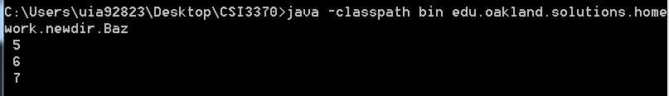

**QUESTION_02:**