**QUESTION\_01:**

**Compile:**

javac -d bin -sourcepath source source\edu\oakland\solutions\homework\newdir\Baz.java

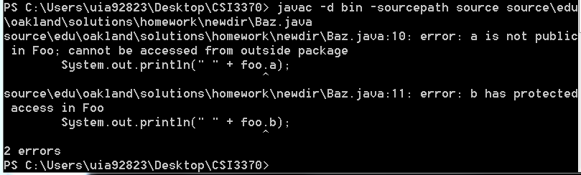

I knew that having a ‘protected’ access to the variable was going to throw and error due to having Baz outside the package. For variable ‘a’, it wasn’t explicitly told to be public. To fix these compile errors I did the following:

public class Foo

{

public int a = 5;

public int b = 6;

public int c =7;

}

**Execution:**

java -classpath bin edu.oakland.solutions.homework.newdir.Baz  
There were no execution errors.

**Final Source Code:  
Foo:**

package edu.oakland.solutions.homework;

public class Foo

{

public int a = 5;

public int b = 6;

public int c =7;

}

**Baz:**

package edu.oakland.solutions.homework.newdir;

import edu.oakland.solutions.homework.\*;

public class Baz

{

public static void main(String[] args)

{

Foo foo = new Foo();

System.out.println(" " + foo.a);

System.out.println(" " + foo.b);

System.out.println(" " + foo.c);

}

}

**Final Output:**

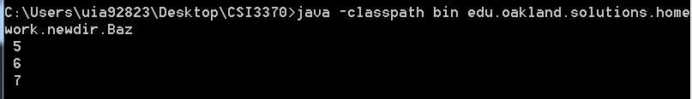

**QUESTION\_02:**

**Compile:**

javac -d bin -sourcepath source source\edu\oakland\solutions\homework\DegreesFtoC.java

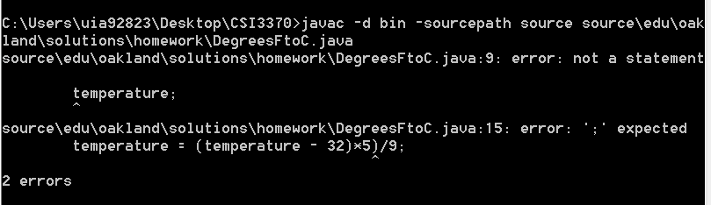

Error on initializing the variable ‘temperature’. There is also a syntactic error. Fix below:

int temperature;

Scanner in = new Scanner(System.in);

System.out.print("Enter temperature in Fahrentheit:");

temperature = in.nextInt();

temperature = ((temperature - 32)\*5)/9;

**Execution:**

java -classpath bin edu.oakland.solutions.homework.DegreesFtoC  
There were no execution errors.

**Final Source Code:  
DegressFtoC:**

package edu.oakland.solutions.homework;

import java.util.\*;

public class DegreesFtoC{

public static void main(String[] args)

{

int temperature;

Scanner in = new Scanner(System.in);

System.out.print("Enter temperature in Fahrentheit:");

temperature = in.nextInt();

temperature = ((temperature - 32)\*5)/9;

System.out.println("temperature in Celsius = " + temperature);

}

}

**Final Output:**

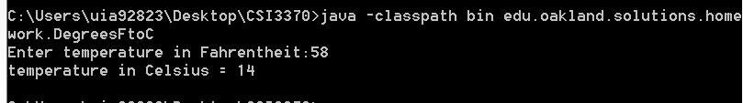

**QUESTION\_03:**

**Compile:**

javac -d bin -sourcepath source source\edu\oakland\solutions\homework\Frodo.java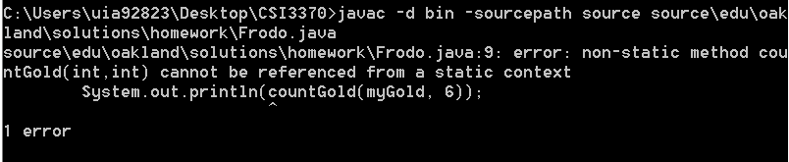

Error calling the method inside the Hobbit class. Must make the method public and static. Fix Below:

class Hobbit{

public static int countGold(int x, int y)

{

return x + y;

}

}

**Execution:**

java -classpath bin edu.oakland.solutions.homework.Frodo  
There were no execution errors.

**Final Source Code:  
Frodo:**

package edu.oakland.solutions.homework;

public class Frodo extends Hobbit

{

public static void main(String[] args)

{

Short myGold = 7;

System.out.println(countGold(myGold, 6));

}

}

class Hobbit{

public static int countGold(int x, int y)

{

return x + y;

}

}

**Final Output:**

C:\Users\uia92823\Desktop\CSI3370\source\edu\oakland\solutions\homework\01\Q3_Output.PNG

**QUESTION\_04:**

**Compile:**

javac -d bin -sourcepath source source\edu\oakland\solutions\homework\Bottom2.java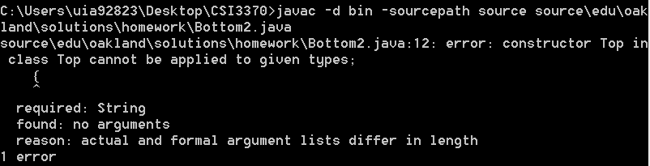

Error calling the method inside the Hobbit class. Must make the method public and static. Fix Below:

class Hobbit{

public static int countGold(int x, int y)

{

return x + y;

}

}

**Execution:**

java -classpath bin edu.oakland.solutions.homework.Frodo  
There were no execution errors.

**Final Source Code:  
Frodo:**

package edu.oakland.solutions.homework;

public class Frodo extends Hobbit

{

public static void main(String[] args)

{

Short myGold = 7;

System.out.println(countGold(myGold, 6));

}

}

class Hobbit{

public static int countGold(int x, int y)

{

return x + y;

}

}

**Final Output:**

C:\Users\uia92823\Desktop\CSI3370\source\edu\oakland\solutions\homework\01\Q3_Output.PNG