**Assignment 2**

**(Tableau)**

1. Create a set, “Top 10 Customers**”,** to calculate top 10 Customers on the basis of discount. Now Create a Calculated field by using this set to prepare a bar graph, having the following condition -

If Set is satisfied (top 10) then “High Discount” otherwise “Low discount”.

Label “High Discount” and “Low Discount” in the bar graph. (CO3)

1. Design the line bar dual axis chart to display sales and profit for states as shown in figure below. (CO2,CO3)

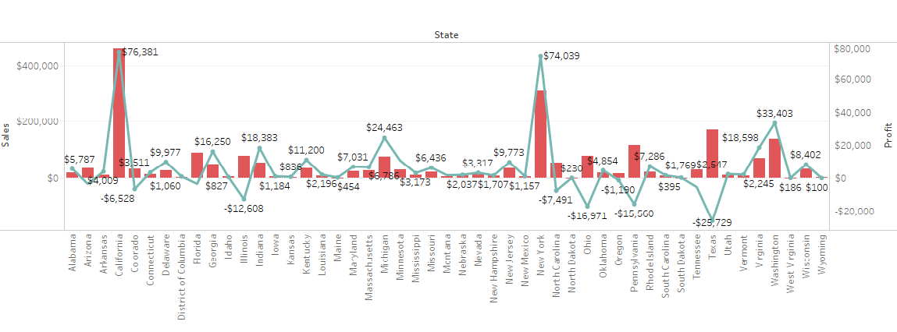

1. Design a geographical map for state wise profit for each year as shown in the figure below. Use different pages for different years in the same sheet. Use animated option to show the map year wise. (CO1,CO4)

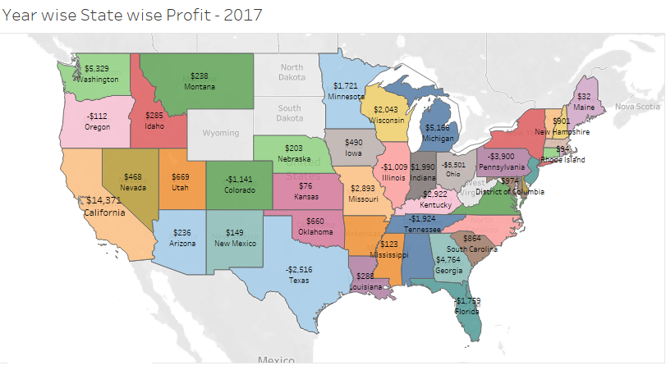

1. Create a column graph showing subcategory wise profit. subcategory has high/medium /low profit based on the rule below -

If sum of profit is more than or equal to $40000 then “HIGH”, if profit is more than or equal to $0 and < 40000 then “MEDIUM” otherwise “LOSS” (CO2, CO4)

1. Create a pie chart by using details of Region and sales. Create a hyperlink in graph in such a manner so that Wikipedia site of a particular region opens when user clicks on that region in the graph.
2. Year wise, how much discount was given to customers quarterly? Create a tabular chart showing values in ascending order with filter as year. Sample is shown below. (CO2,CO3)

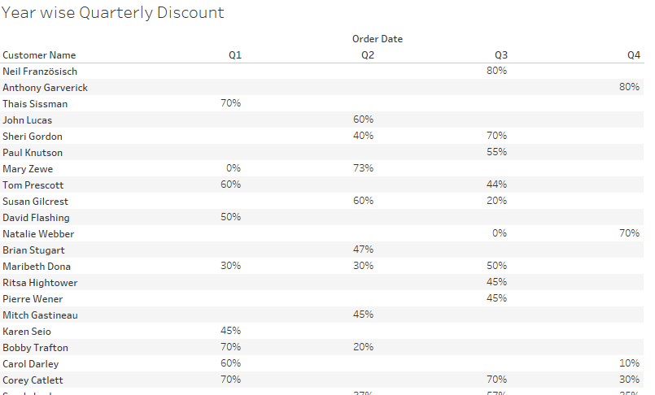

1. Display tree map to display sales subcategories for following conditions: If total sales of Manufacturer is more than or equal to 10lakh then output will be “A” else if sales of manufacturer is more than or equal to 10000000 then it will be “B” else if total sale of manufacturer is more than or equal to 6000000 then it will be otherwise “C” otherwise “D”. (CO2,CO3)
2. Design vertical bar chart to display the quantity and subcategory. Make a group “Essentials” which includes Art, Binders, Copiers, Envelops, Labels, Tables. Label Quantity. (CO3)
3. Design the Dashboard with the title “**Sales Dashboard”.** Add the Q1, Q2, Q3, Q4, Q5 with all relevant filter, set. (CO1, CO4)
4. Create the Story of your Dashboard generation from Q1 to Q9 with appropriate captions. (CO1,CO4)