PART 1 A:

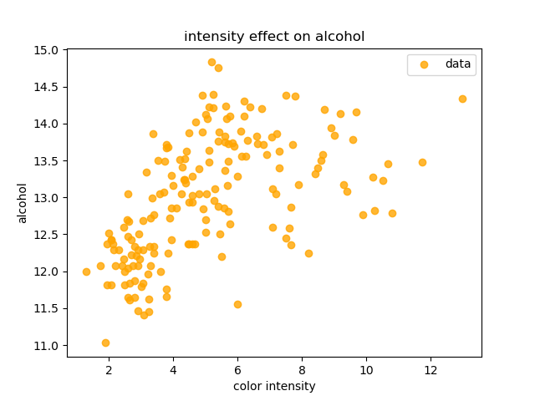

Part 1 B:

Correlation coefficient r1 is 0.09439694091041398

Correlation coefficient r2 is 0.21154459643174453

Correlation coefficient r3 is -0.31023513689108523

Correlation coefficient r4 is 0.27079822591147995

Correlation coefficient r5 is 0.28910112258745674

Correlation coefficient r6 is 0.23681492790034603

Correlation coefficient r7 is -0.15592946668732893

Correlation coefficient r8 is 0.1366979117694798

Correlation coefficient r9 is 0.5463641950837035

Correlation coefficient r10 is -0.07174719733015461

Correlation coefficient r11 is 0.07234318740052215

Correlation coefficient r12 is 0.6437200371782138

Part 1 C:

Correlation coefficient r1 is 0.09447001626963034

Correlation coefficient r2 is 0.2114698333576402

Correlation coefficient r3 is -0.31031956108507847

Correlation coefficient r4 is 0.27087191815081346

Correlation coefficient r5 is 0.2891797955885271

Correlation coefficient r6 is 0.2367312339072004

Correlation coefficient r7 is -0.15600103531377485

Correlation coefficient r8 is 0.1366164290258553

Correlation coefficient r9 is 0.5464523485959681

Correlation coefficient r10 is -0.07167506544973068

Correlation coefficient r11 is 0.07227045633454028

Correlation coefficient r12 is 0.6436400638551414

Part 1 D:

With standardization

Correlation coefficient r1 is 0.1811432407474255

Correlation coefficient r2 is 0.046585482241052946

Correlation coefficient r3 is -0.1554451257063471

Correlation coefficient r4 is 7.351778757149871e-05

Correlation coefficient r5 is 0.04015215228483619

Correlation coefficient r6 is 0.011227317165077159

Correlation coefficient r7 is -0.03185518238485736

Correlation coefficient r8 is -0.10751447699472086

Correlation coefficient r9 is 0.4655692109519123

Correlation coefficient r10 is 0.06106298349031655

Correlation coefficient r11 is 0.14062593288194877

Correlation coefficient r12 is 0.394051792558225

Y-intercept is 7.625138753543523e-15

Without standardization

Correlation coefficient r1 is 0.27043714562661786

Correlation coefficient r2 is 0.19172370973076824

Correlation coefficient r3 is 0.16846850328271612

Correlation coefficient r4 is 0.03841977525508051

Correlation coefficient r5 is 0.2559896342272888

Correlation coefficient r6 is 0.054106109292116435

Correlation coefficient r7 is 0.11700665412544228

Correlation coefficient r8 is -0.004711156419202506

Correlation coefficient r9 is 0.2127309635218259

Correlation coefficient r10 is 0.2851280927489394

Correlation coefficient r11 is 0.5151416530965677

Correlation coefficient r12 is 0.0013518207139527902

Y-intercept is 0.27520427930106656

Part 1 E:

t for b1 is 2.1594032790191453

uncorrected p-value for b1 is 0.01613150100360472

corrected p-value for b1 is 0.19357801204325664

t for b2 is 0.5553441723298066

uncorrected p-value for b2 is 0.28970570662859685

corrected p-value for b2 is 3.476468479543162

t for b3 is -1.8530568006446577

uncorrected p-value for b3 is 0.032830076923678855

corrected p-value for b3 is 0.39396092308414626

t for b4 is 0.0008764033970744976

uncorrected p-value for b4 is 0.49965089501986537

corrected p-value for b4 is 5.995810740238385

t for b5 is 0.47865263393651447

uncorrected p-value for b5 is 0.31640971268054463

corrected p-value for b5 is 3.7969165521665356

t for b6 is 0.13384051980531947

uncorrected p-value for b6 is 0.4468458954549235

corrected p-value for b6 is 5.362150745459082

t for b7 is -0.37974469823871454

uncorrected p-value for b7 is 0.3523116292575937

corrected p-value for b7 is 4.227739551091124

t for b8 is -1.2816769381317827

uncorrected p-value for b8 is 0.10087705451207243

corrected p-value for b8 is 1.2105246541448693

t for b9 is 5.550036957446916

uncorrected p-value for b9 is 5.591143137362309e-08

corrected p-value for b9 is 6.709371764834771e-07

t for b10 is 0.727930041615729

uncorrected p-value for b10 is 0.23384407058632162

corrected p-value for b10 is 2.8061288470358594

t for b11 is 1.6763976360775272

uncorrected p-value for b11 is 0.04777701187927297

corrected p-value for b11 is 0.5733241425512756

t for b12 is 4.697479902880104

uncorrected p-value for b12 is 2.7591404393456642e-06

corrected p-value for b12 is 3.310968527214797e-05

Part 2 A:

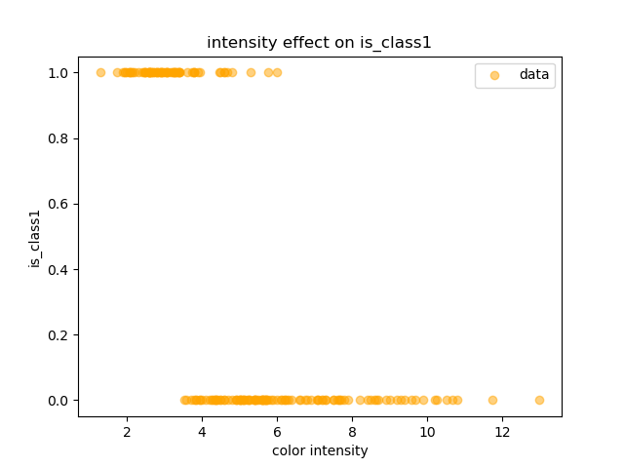

Part 2 B:

coefficient 1 is -2.8981700375737787

coefficient 2 is -0.7264803553914191

coefficient 3 is -0.885109626560152

coefficient 4 is 0.37544458289293775

coefficient 5 is -0.7517237997556138

coefficient 6 is -0.09606751988138042

coefficient 7 is 0.0849558651012219

coefficient 8 is 0.02426086141715337

coefficient 9 is 0.11482239621047362

coefficient 10 is -5.061504127077002

coefficient 11 is 0.7312015386723899

coefficient 12 is 0.3818621982448787

coefficient 13 is -2.3464527063771605

Part 2 C:

With standardization

Correlation coefficient r1 is -14.645804677066748

Correlation coefficient r2 is -9.059981898187402

Correlation coefficient r3 is -21.921320847613508

Correlation coefficient r4 is 13.41213940686719

Correlation coefficient r5 is 5.8100723783149535

Correlation coefficient r6 is 1.6751932271818653

Correlation coefficient r7 is 10.608441976032129

Correlation coefficient r8 is 11.45936509026619

Correlation coefficient r9 is 3.874762843708146

Correlation coefficient r10 is -40.69895116968685

Correlation coefficient r11 is 13.284758096433038

Correlation coefficient r12 is -0.9882384270386172

Correlation coefficient r13 is -38.455677738303905

Y-intercept is -25.22761327559601

Without standardization

b1 is -1.5764110860585461e-06

b2 is -2.092810878910463e-06

b3 is -2.512722168587509e-07

b4 is 6.941884248692457e-06

b5 is -8.928706281886373e-06

b6 is 3.9713262440211603e-07

b7 is 9.801784106608602e-07

b8 is 5.1011473264204374e-08

b9 is 6.387308934711715e-07

b10 is -1.022905053970269e-05

b11 is 7.881704841021962e-07

b12 is 1.634253766557055e-06

b13 is -0.0010028347006521632

Y-intercept is 1.7998174228483685e-07

Part 3 A:

Xs: (142, 12) (36, 12) ; ys: (142,) (36,)

Part 3 B:

without L2 regularization penalty:

Mean-squared error for penalty 0 is 0.298581

Pearson correlation coefficient for penalty 0 is 0.8325640552314094

for penalty 0.01:

Mean-squared error for penalty 0.01 is 0.298576

Pearson correlation coefficient for penalty 0.01 is 0.832566829985159

for penalty 0.1:

Mean-squared error for penalty 0.1 is 0.298482

Pearson correlation coefficient for penalty 0.1 is 0.8326206386697771

for penalty 1:

Mean-squared error for penalty 1 is 0.298116

Pearson correlation coefficient for penalty 1 is 0.8328189893321997

for penalty 10:

Mean-squared error for penalty 10 is 0.300398

Pearson correlation coefficient for penalty 10 is 0.8313187068983718

for penalty 100:

Mean-squared error for penalty 100 is 0.359150

Pearson correlation coefficient for penalty 100 is 0.8325849488088384

Part 3 C:

Xs: (142, 13) (36, 13) ; ys: (142,) (36,)

Part 3 D:

without L2 regularization penalty:

Log loss is 0.11194198941234446

precision: 1.0

recall: 1.0

f1: 1.0

specificity: 1.0

for penalty 0.01:

Log loss is 0.9781842227091427

precision: 1.0

recall: 1.0

f1: 1.0

specificity: 1.0

for penalty 0.1:

Log loss is 3.1048497719484383

precision: 1.0

recall: 1.0

f1: 1.0

specificity: 1.0

for penalty 1:

Log loss is 8.084512250109356

precision: 0.9333333333333333

recall: 1.0

f1: 0.9655172413793104

specificity: 0.9545454545454546

for penalty 10:

Log loss is 18.697479302764492

precision: 0.9333333333333333

recall: 1.0

f1: 0.9655172413793104

specificity: 0.9545454545454546

for penalty 100:

Log loss is 31.036226481488047

precision: 0.9333333333333333

recall: 1.0

f1: 0.9655172413793104

specificity: 0.9545454545454546

best penalty is 0.01

precision: 1.0

recall: 1.0

f1: 1.0

specificity: 1.0