**ASSIGNMENT 2 : JENKINS JOB CREATION: IMPLEMENTING VERSION CONTROL IN YOUR CI/CD PIPELINE.**

**STEP 1 : CREATE JOBS FOR THE PIPELINE**

* **Create Job 1 :-**

1. From the Jenkins dashboard, click on "New Item".
2. Enter the name (e.g., Job1) and select "Freestyle project".
3. Click "OK".

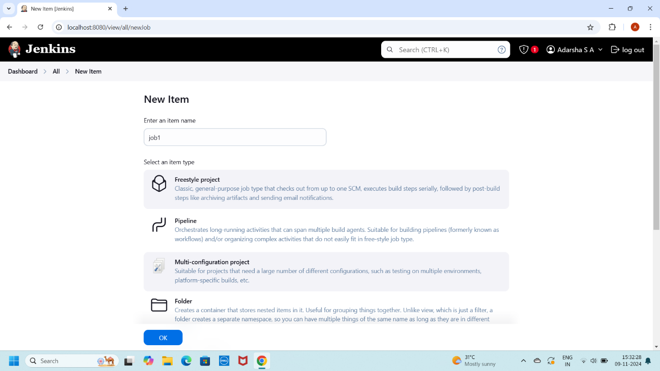

1. Under Build, choose "Windows Batch Command".
2. Enter a simple command (e.g., echo Job 1 completed)

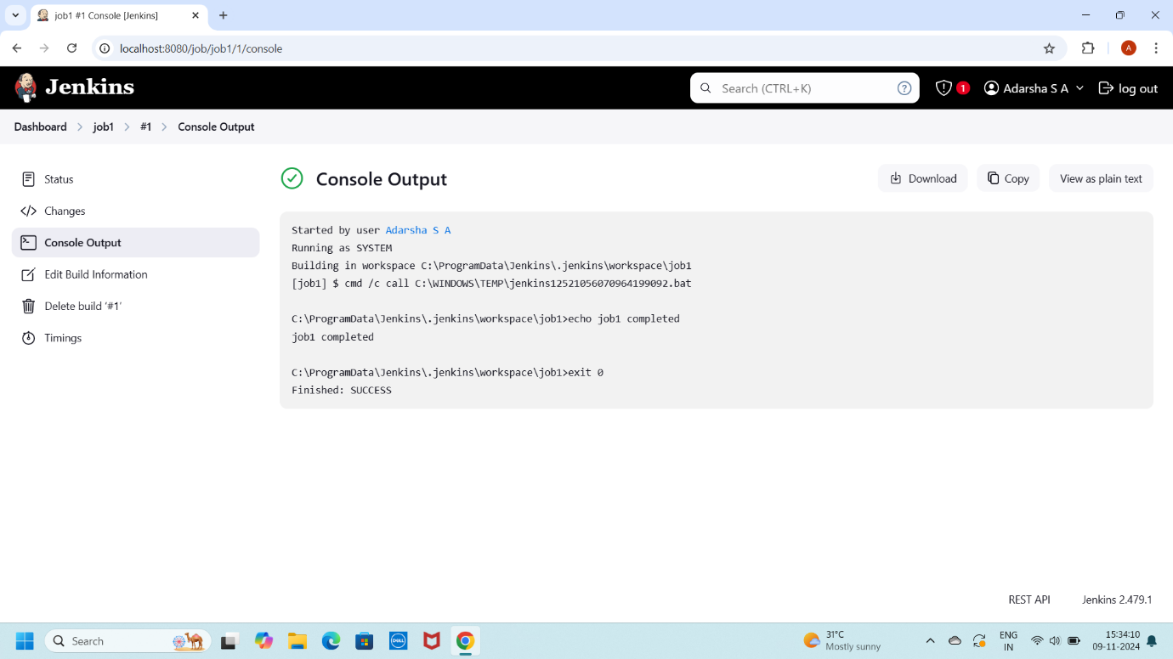

* **Create Job 2 :-**

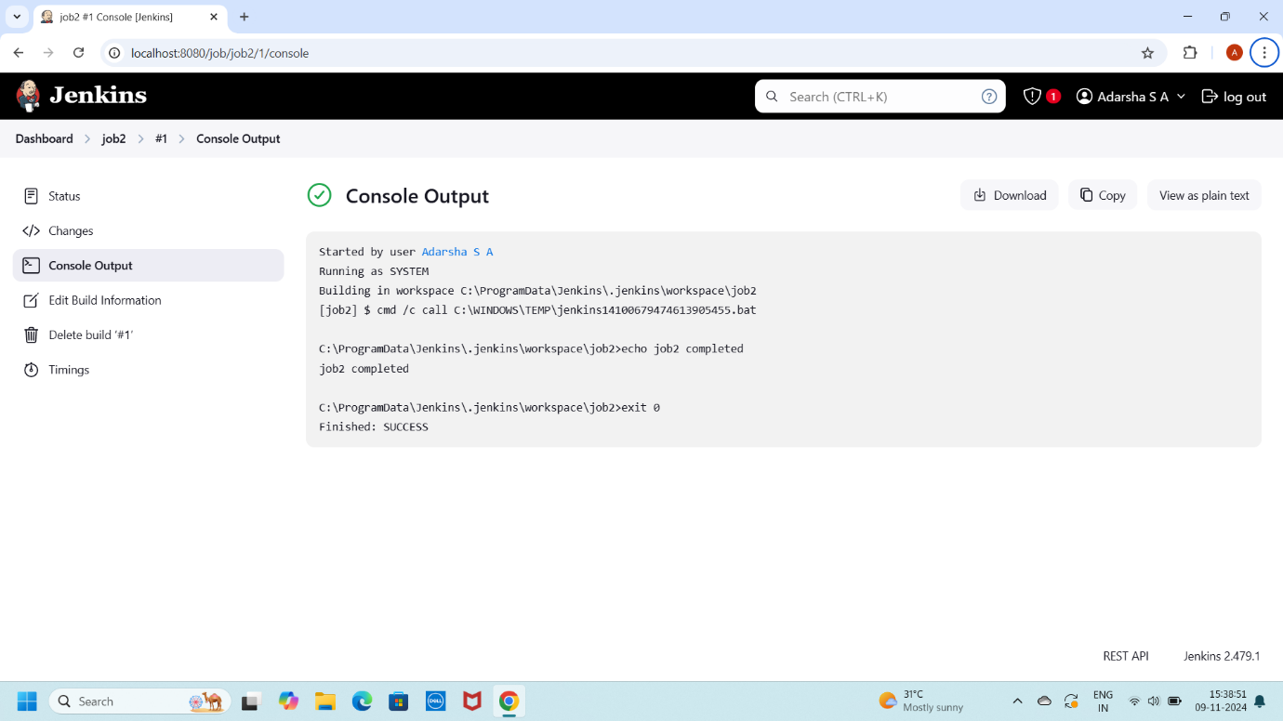

* **Create Job 3 :-**

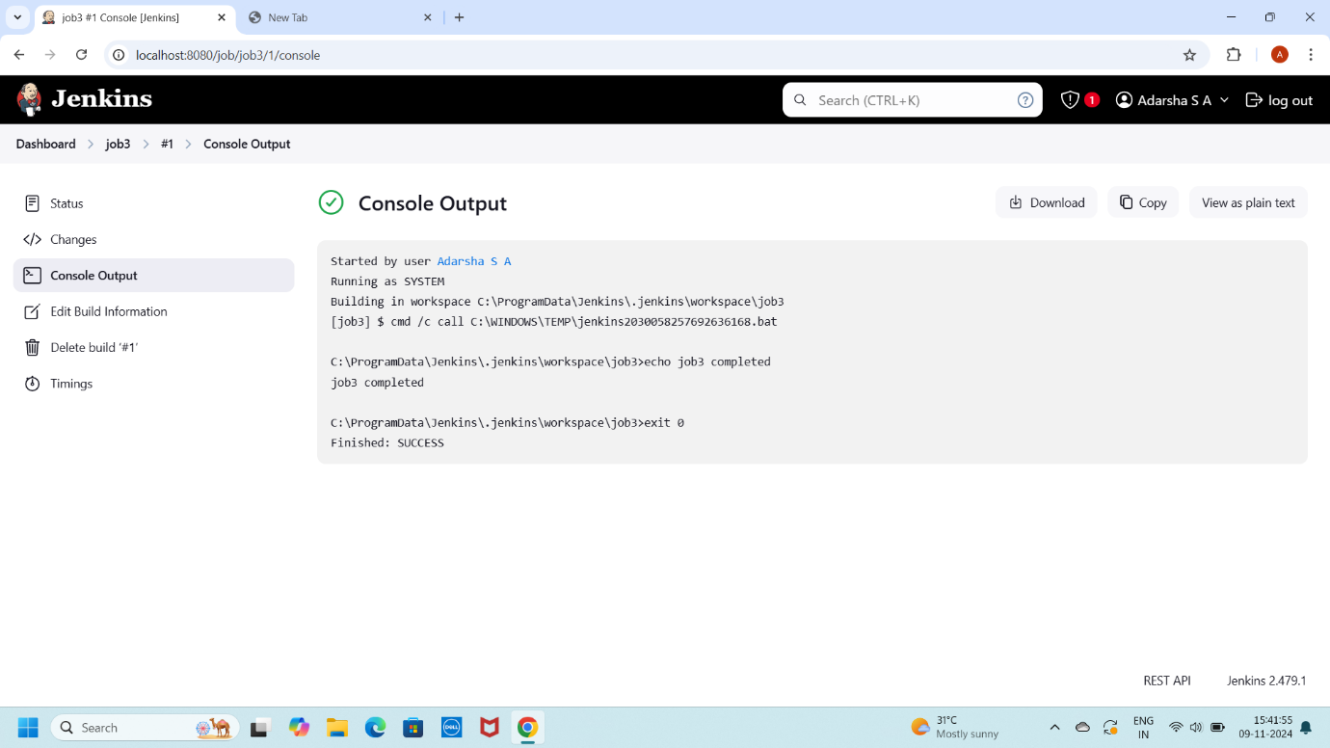

**STEP 2 : CREATE CHAIN FOR PIPELINE**

* Open each Job
* Configure -> Build Triggers -> Build after other projects is built →----
* Apply and Save
* Open the Each job in a separate window
* Run (Build Now) the First Job
* Automatically other three jobs are executed

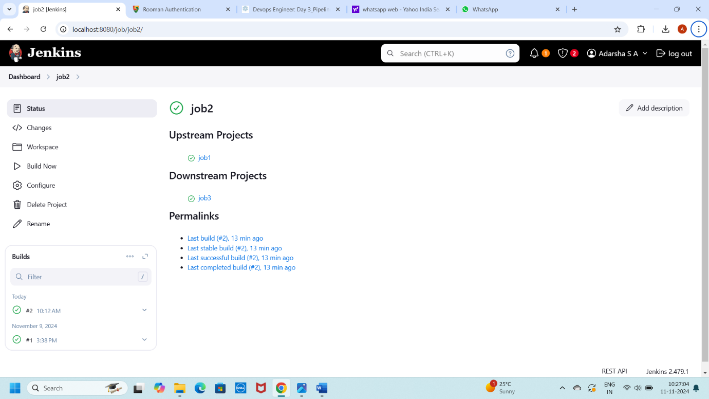

**STEP 3 : PLUGIN INSTALLATION**

* Manage Plugin ->Install Plugin ->
* Build Pipeline Plugin
* Delivery Pipeline Plugin
* Install without restart

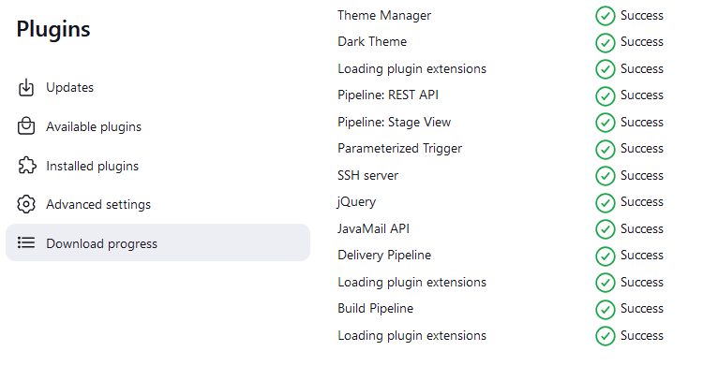

**STEP 4 : CREATE THE PIPELINE JOB**

* **Create a New Pipeline Job :-**
* Click on "New Item".
* Enter a name for your pipeline (e.g., SequentialPipeline).
* Select "Pipeline" and click "OK".

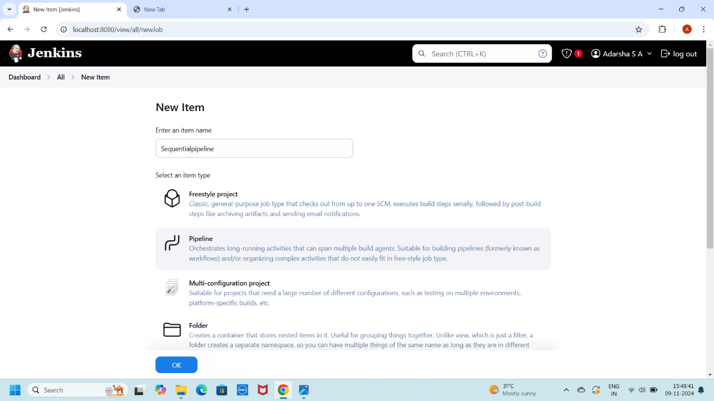

* **Configure The Pipeline :-**
* Scroll down to the Pipeline section.
* In the Definition dropdown, select "Pipeline script".

* **Write the Pipeline Script:-**

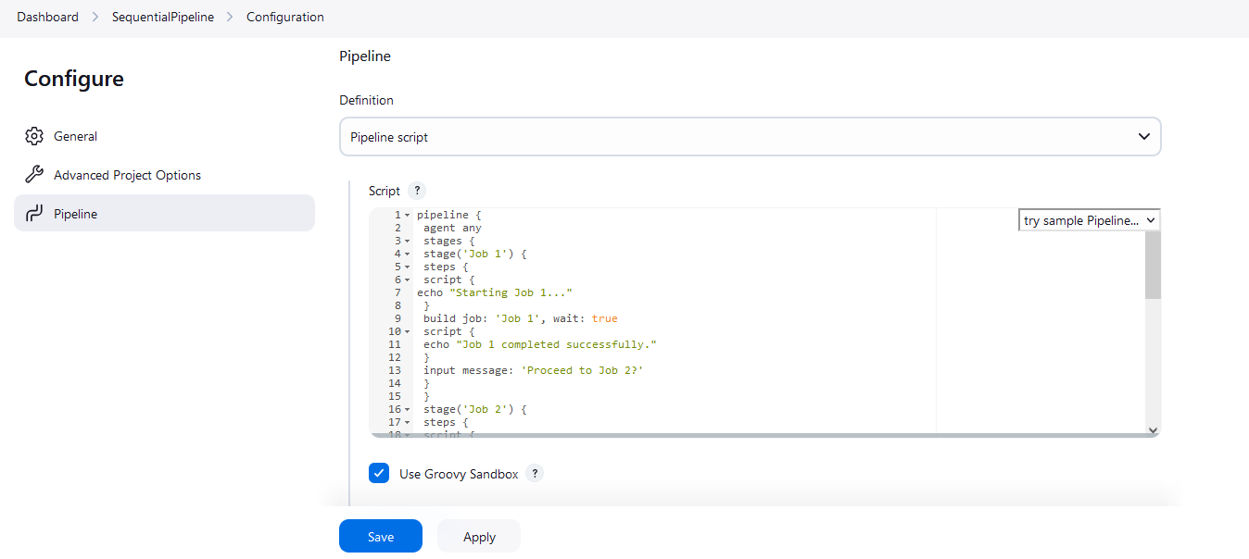

**STEP 5 : EXECUTE THE PIPELINE**

* **Run The Pipeline :-**
* From the Jenkins dashboard, click on your SequentialPipeline job.
* Click on "Build Now".
* **Monitor Execution :-**
* Click on the build number in the Build History.
* After each job completes, you will see a prompt asking for confirmation to proceed to the next job. Click "Proceed" to move to the next stage.

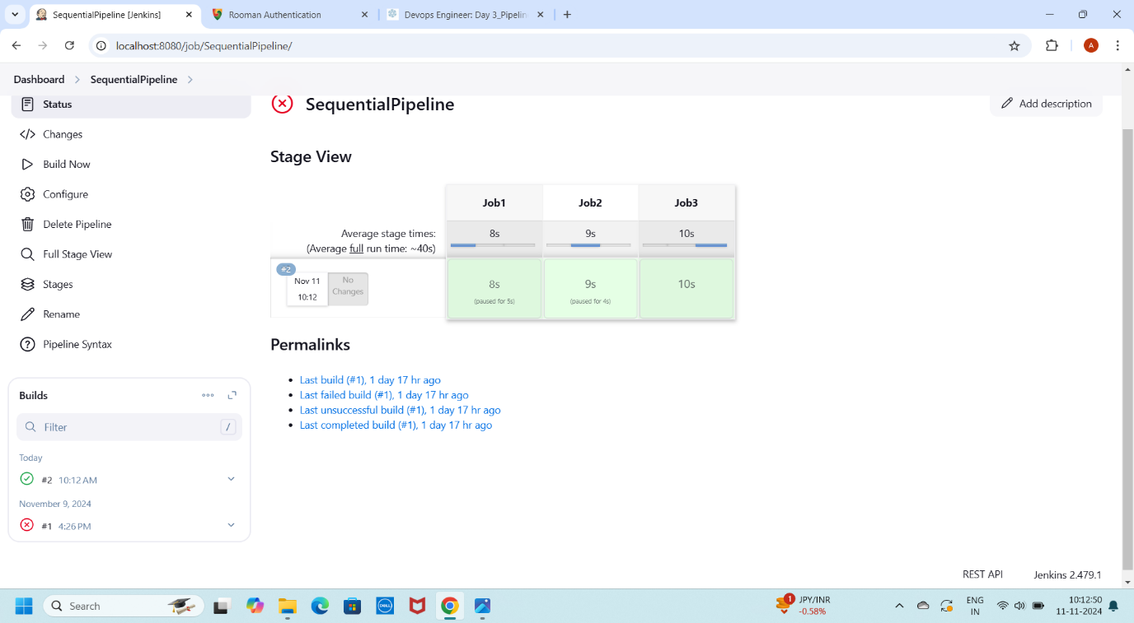

**STEP 6 : VERIFY RESULTS**

* **Check Console Output :-**
* Verify that the output confirms that each job ran sequentially, and observe the messages indicating the start and completion of each job.

