**Industrial Internship Report on**

**”Bank Information System”**

**Prepared by**

**Aditya Dongare**

|  |
| --- |
| *Executive Summary* |
| This report provides details of the Industrial Internship provided by upskill Campus and The IoT Academy in collaboration with Industrial Partner UniConverge Technologies Pvt Ltd (UCT).  This internship was focused on a project/problem statement provided by UCT. We had to finish the project including the report in 6 weeks’ time.  My project was **Banking Information System** in Core Java that provides a working preview of the key functionalities of a real banking system. The prototype should demonstrate the core features and flow of the system, showcasing its functionality and usability.  This internship gave me a very good opportunity to get exposure to Industrial problems and design/implement solution for that. It was an overall great experience to have this internship. |

**TABLE OF CONTENTS**

1 Preface 3

2 Introduction 4

2.1 About UniConverge Technologies Pvt Ltd 4

2.2 About upskill Campus 8

2.3 Objective 9

2.4 Reference 9

2.5 Glossary 10

3 Problem Statement 11

4 Existing and Proposed solution 12

5 Proposed Design/ Model 13

5.1 High Level Diagram (if applicable) 13

5.2 Low Level Diagram (if applicable) 13

5.3 Interfaces (if applicable) 13

6 Performance Test 14

6.1 Test Plan/ Test Cases 14

6.2 Test Procedure 14

6.3 Performance Outcome 14

7 My learnings 15

8 Future work scope 16

# Preface

**Summary of the whole 6 weeks’ work**:

Over the course of six weeks, our team embarked on a journey to design, and refine a comprehensive Bank Information System using Core Java and My SQL Database. This endeavor was an opportunity to not only apply our technical skills but also gain a deeper understanding of the intricate relationship between technology and the banking domain. Here is a summary of our accomplishments and key takeaways from each week:

**Week 1: Project Initiation, Planning and User Interface:**

During the first week, we kicked off the project by defining our goals, objectives, and project scope. We conducted in-depth research into the requirements of a modern bank information system, identified potential challenges, and outlined our development plan. We also began to define the initial user interface design. This phase laid the foundation for the weeks ahead.

**Week 2: Login and Sign-Up Page Development:**

In the second week, we focused on developing the login and sign-up pages. This involved creating the user interface elements and implementing the basic logic for user authentication.

**Week 3: Extended Sign-Up and Database Integration:**

During the third week, we extended the sign-up functionality by adding additional pages to gather more user information. We also established the connection to the MySQL database and implemented the logic to store the user data collected during the sign-up process into the database.

**Week 4: ATM Main Screen, Deposit, and Withdrawal Functionality:**

In the fourth week, we developed the main screen of the ATM interface. We also implemented the deposit and withdrawal functionalities, ensuring they were fully integrated with the MySQL database to update account balances accurately.

**Week 5: Mini Statement, Balance Inquiry, and Fast Cash Functionality:**

During the fifth week, we added the mini statement, balance inquiry, and fast cash functionalities to the ATM system. These features were also integrated with the database to retrieve and display accurate account information.

**Week 6: Project Completion, Testing, Debugging, and Problem Solving:**

In the final week, we focused on completing the remaining functionalities and ensuring the stability and reliability of the system. This involved rigorous testing of all features, including unit testing and integration testing. We debugged and resolved any identified issues, optimizing the code for performance and addressing potential security vulnerabilities. We conducted thorough user acceptance testing to ensure the system met the project requirements and user expectations. Finally, we prepared the project documentation and delivered a fully functional and tested Bank Information System.

As we conclude this project, we are excited about the potential of our system and the knowledge we've gained. We look forward to sharing our insights in the report and demonstrating how technology can transform the banking landscape for the better.

**About my Whole project:**

**Banking Information System** in Core Java that provides a working preview of the key functionalities of a real banking system. The prototype should demonstrate the core features and flow of the system, showcasing its functionality and usability.

Program was planned in a proper week-based work division that leads to completion of project in proper and efficient manner without any hesitation and stress.

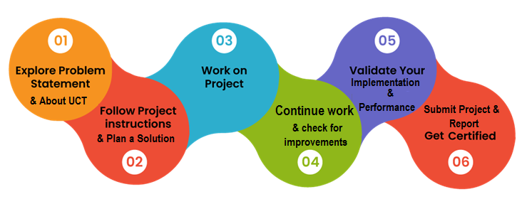

**Your Learnings and overall experience**: Learning and overall experience was excellent and will help in future to grow myself as a good java.

Thanks **to Mr. Apurv** and **Upskill Campus** for providing me the best help in the journey of my internship.

Thank you to all who have helped you directly or indirectly.

**Your message to your juniors and peers**:

**Embrace the Learning Opportunity:** Developing a Bank Information System is not just about coding; it's a chance to understand the real-world complexities of the banking industry and how technology plays a pivotal role in its operations. Embrace this opportunity to learn about both software development and the financial domain.

**Team Collaboration:** Teamwork is at the heart of any successful project. Collaborate closely with your teammates, exchange ideas, and pool your collective skills to create a well-rounded solution. Effective communication and cooperation are key to overcoming challenges.

**Plan and Organize:** Before you dive into coding, take the time to plan and organize your project. Define clear goals, break down tasks into manageable chunks, and establish a timeline. A well-structured plan will keep you on track and minimize surprises along the way.

**Apply Best Practices:** Utilize industry best practices in software development. Design modular and maintainable code, adhere to coding standards, and implement secure coding practices. These habits will serve you well throughout your careers.

**User-Centric Design:** Keep the end-users in mind when designing your system. A user-friendly interface and intuitive interactions are essential for delivering a positive experience to customers and bank employees.

**Continuous Improvement:** As you progress, you might encounter challenges or opportunities for enhancement. Embrace the iterative nature of software development, and don't hesitate to make improvements based on user feedback or new insights.

**Learn from Mistakes:** Mistakes are a natural part of the learning process. Don't be discouraged by them; instead, view them as valuable learning experiences that will make you better developers in the long run.

**Document Your Journey:** Keep detailed records of your decisions, challenges faced, solutions implemented, and the rationale behind them. This documentation will not only help you in your report but also serve as a reference for future projects.

**Ask for Help:** If you encounter obstacles that seem insurmountable, don't hesitate to seek guidance from your mentors, professors, or online communities. Asking for help is a sign of strength, not weakness.

**Celebrate Achievements:** Celebrate every milestone, no matter how small. Completing a project of this magnitude is an accomplishment, and acknowledging your progress can boost motivation and morale.

**Reflect and Grow:** After completing your project and report, take a moment to reflect on the entire experience. Consider what you've learned, how you've grown, and how you can apply these lessons in future endeavors.

Remember, this project is not just about creating a banking system; it's about honing your skills, expanding your knowledge, and gaining practical experience that will serve as a foundation for your future careers. Approach it with enthusiasm, curiosity, and a willingness to learn, and you'll undoubtedly come away with valuable insights that will shape your journey in the world of technology.

# Introduction

## About UniConverge Technologies Pvt Ltd

A company established in 2013 and working in Digital Transformation domain and providing Industrial solutions with prime focus on sustainability and RoI.

For developing its products and solutions it is leveraging various**Cutting Edge Technologies e.g. Internet of Things (IoT), Cyber Security, Cloud computing (AWS, Azure), Machine Learning, Communication Technologies (4G/5G/LoRaWAN), Java Full Stack, Python, Front end**etc.



1. UCT IoT Platform **(****)**

**UCT Insight** is an IOT platform designed for quick deployment of IOT applications on the same time providing valuable “insight” for your process/business. It has been built in Java for backend and ReactJS for Front end. It has support for MySQL and various NoSql Databases.

* It enables device connectivity via industry standard IoT protocols - MQTT, CoAP, HTTP, Modbus TCP, OPC UA
* It supports both cloud and on-premises deployments.

It has features to  
• Build Your own dashboard  
• Analytics and Reporting  
• Alert and Notification  
• Integration with third party application(Power BI, SAP, ERP)  
• Rule Engine

 

1. **Smart Factory Platform (****)**

Factory watch is a platform for smart factory needs.

It provides Users/ Factory

* with a scalable solution for their Production and asset monitoring
* OEE and predictive maintenance solution scaling up to digital twin for your assets.
* to unleased the true potential of the data that their machines are generating and helps to identify the KPIs and also improve them.
* A modular architecture that allows users to choose the service that they what to start and then can scale to more complex solutions as per their demands.

Its unique SaaS model helps users to save time, cost and money.

 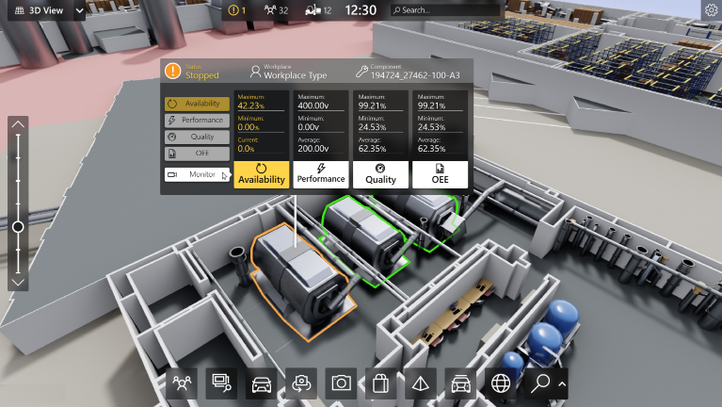

1.  based Solution

UCT is one of the early adopters of LoRAWAN teschnology and providing solution in Agritech, Smart cities, Industrial Monitoring, Smart Street Light, Smart Water/ Gas/ Electricity metering solutions etc.

1. Predictive Maintenance

UCT is providing Industrial Machine health monitoring and Predictive maintenance solution leveraging Embedded system, Industrial IoT and Machine Learning Technologies by finding Remaining useful life time of various Machines used in production process.



## About upskill Campus (USC)

upskill Campus along with The IoT Academy and in association with Uniconverge technologies has facilitated the smooth execution of the complete internship process.

USC is a career development platform that delivers **personalized executive coaching** in a more affordable, scalable and measurable way.



Seeing need of upskilling in self paced manner along-with additional support services e.g. Internship, projects, interaction with Industry experts, Career growth Services

<https://www.upskillcampus.com/>

upSkill Campus aiming to upskill 1 million learners in next 5 year

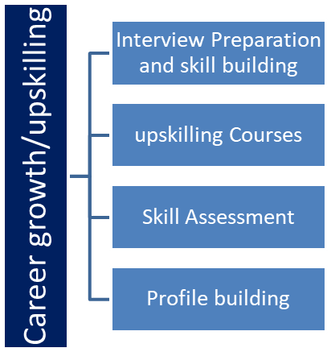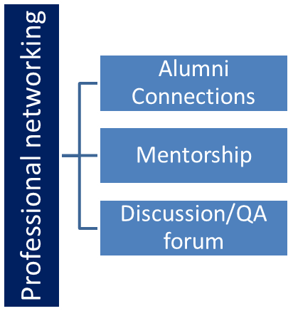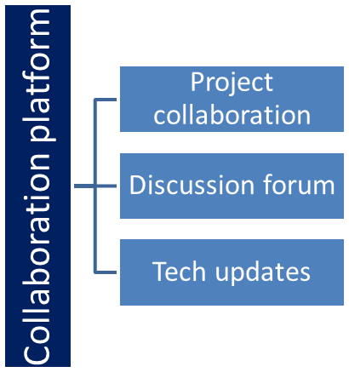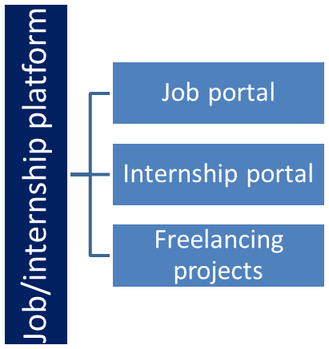

## The IoT Academy

The IoT academy is EdTech Division of UCT that is running long executive certification programs in collaboration with EICT Academy, IITK, IITR and IITG in multiple domains.

## Objectives of this Internship program

The objective for this internship program was to

 ☛ get practical experience of working in the industry.

 ☛ to solve real world problems.

 ☛ to have improved job prospects.

 ☛ to have Improved understanding of our field and its applications.

 ☛ to have Personal growth like better communication and problem solving.

## Reference

[1] www.Google.com

[2] www.youtube.com

[3] Java and Database Books

## Glossary

|  |  |
| --- | --- |
| Terms | Acronym |
| JDBC | Java Database Connectivity |
| GUI | Graphical User Interface |
| SQL | Structured Query Language |
| Database | A structured set of data held in a computer, especially one that is accessible in various ways. |
| Transaction | An instance of buying or selling something; a business deal. |
| Account | An arrangement with a bank to hold money. |
| Balance | An even distribution of weight enabling someone or something to remain upright and steady. |
| Statement | A printed or electronic document showing the transaction on a bank account. |
| ATM | Automated Teller Machine |
| User Authentication | The process of verifying a user’s identity |
| Data Persistence | The concept of ensuring data survives after the process that created it has ended. |

**3. Problem Statement**

In today's rapidly evolving financial landscape, the role of technology in the banking sector cannot be understated. As financial institutions strive to provide seamless and efficient services to their customers, the development of robust and sophisticated banking Information systems becomes paramount. This report delves into the design, development, and implementation of a Banking Information System using the Core Java programming language.

The Banking Information System outlined in this report is a testament to the potential of Core Java in creating versatile and secure software solutions for the banking industry. Core Java's inherent object-oriented features, platform independence, and robust libraries have been harnessed to create a comprehensive system that addresses various facets of banking operations, including customer account management, transaction processing, security, and reporting.

In this report, we explore the fundamental principles that underpin the Banking Information System's architecture. The significance of encapsulation, inheritance, and polymorphism in facilitating modular and maintainable code is emphasized. Furthermore, the integration of database management techniques for efficient data storage and retrieval is discussed, highlighting the role of Java Database Connectivity (JDBC) in establishing a connection to a relational database.

Security is a cornerstone of any banking system, and this report elaborates on the security measures embedded within the Banking Information System. From user authentication to data encryption, the implementation of stringent security practices ensures the confidentiality, integrity, and availability of sensitive financial data.

In addition, the report provides insights into the user interface design of the Banking Information System. Through a user-friendly and intuitive graphical interface, bank employees and administrators can perform various tasks with ease, such as account creation, transaction processing, and generating reports. The graphical user interface (GUI) is developed using Java's Swing framework, exemplifying the fusion of functionality and aesthetics.

The report concludes with a discussion on the system's future prospects and potential enhancements. As technology continues to evolve, opportunities for integrating emerging technologies such as artificial intelligence, machine learning, and blockchain into the banking domain are explored. These innovations have the potential to revolutionize banking operations, enhancing customer experiences and operational efficiency.

It is worth noting that this report aims to provide a comprehensive overview of the Banking Information System developed using Core Java. However, the field of technology is dynamic, and new breakthroughs may have occurred since the completion of this report. Nonetheless, the principles and methodologies discussed herein serve as a strong foundation for understanding the intricacies of developing sophisticated banking Information systems using Core Java.

Ultimately, the Banking Information System presented in this report exemplifies the fusion of technology and finance, showcasing the power of Core Java to create secure, efficient, and user-centric solutions for the modern banking industry.

# Existing and Proposed solution

## Existing Solution

The existing solution in the realm of banking Information systems often involves a combination of legacy software and manual processes. These systems might be outdated, lack scalability, and suffer from security vulnerabilities. They might have limitations in terms of user interfaces, transaction processing speed, and real-time data updates. The challenges of integrating new technologies, adapting to changing regulations, and meeting customer expectations can be daunting within the constraints of these systems.

## Proposed Solution

The proposed solution is the development of a modern Banking Information System using Core Java, which aims to address the shortcomings of the existing systems and provide a robust, secure, and user-friendly platform for efficient banking operations. This solution leverages the power of Core Java's object-oriented programming, multi-threading capabilities, and database connectivity to create a comprehensive system.

Modular Architecture: The proposed solution adopts a modular architecture, utilizing Core Java's principles of encapsulation and inheritance. This ensures that different components of the system can be developed, tested, and maintained independently, leading to a more organized and maintainable codebase.

Database Integration: The Banking Information System integrates with a relational database using Java Database Connectivity (JDBC). This enables efficient storage, retrieval, and manipulation of customer data, account information, transaction history, and more.

Graphical User Interface (GUI): The system boasts a user-friendly GUI developed using Java's Swing framework. This GUI allows bank employees and administrators to interact with the system seamlessly, facilitating tasks such as creating new accounts, processing transactions, and generating reports. The GUI design prioritizes simplicity and intuitiveness to enhance user experience.

Security Measures: The proposed solution implements robust security measures, including user authentication, role-based access control, and data encryption. Core Java's security libraries and practices are employed to safeguard sensitive customer data and ensure compliance with privacy regulations.

Transaction Processing: Core Java's multi-threading capabilities are leveraged to optimize transaction processing. Concurrent execution of transactions ensures speedy and efficient operations, enabling real-time updates to account balances and transaction history.

Reporting and Analytics: The system includes a reporting module that generates comprehensive financial reports and analytics. Bank administrators can gain insights into account activity, transaction trends, and other key metrics, aiding in informed decision-making.

Scalability and Flexibility: The proposed solution is designed to be scalable, allowing the system to accommodate growing customer bases and increasing transaction volumes. Additionally, Core Java's flexibility enables easy adaptation to evolving regulatory requirements and technological advancements.

Future-Proofing: The solution's architecture is designed with an eye toward the future. It can serve as a foundation for integrating emerging technologies such as artificial intelligence, machine learning, and blockchain into the banking domain, ensuring the system's relevance and competitiveness in the long run.

In conclusion, the proposed Banking Information System using Core Java offers a holistic solution to the challenges faced by traditional banking systems. By harnessing the capabilities of Core Java, the system aims to deliver enhanced security, scalability, efficiency, and user experience, paving the way for a modernized banking environment that aligns with the demands of the digital era.

## Code submission (Github link):

## https://github.com/Adu-2004/upskillcampus1/tree/main/src

## Report submission (Github link):

## https://github.com/Adu-2004/upskillcampus1/blob/main/BankingInformationSystem_Aditya_USC_UCT.pdf.docx

# Proposed Design/ Model

The design model for a Banking Information System using Core Java encompasses various components, interactions, and architectural considerations. This model serves as a visual representation of how different parts of the system interact and work together to achieve the desired functionality. Here's an overview of the design model:

**User Interface (UI) Layer:**

Login Interface: Allows users to authenticate themselves using credentials.

Main Dashboard: Provides access to various functionalities based on user roles.

Account Creation Interface: Enables bank employees to create new customer accounts.

Transaction Interface: Allows users to perform transactions like deposits, withdrawals, and fund transfers.

Reports and Analytics Interface: Provides reports on account activities, transactions, and trends.

**Controller Layer:**

Authentication Controller: Manages user authentication and authorization.

Account Controller: Handles account-related operations such as creation and updates.

Transaction Controller: Orchestrates transaction processing and updates account balances.

Reporting Controller: Generates reports and analytics based on user requests.

**Service Layer:**

Authentication Service: Validates user credentials and manages user roles.

Account Service: Implements business logic for account creation and updates.

Transaction Service: Performs transaction validation and updates account balances.

Reporting Service: Generates reports and analytics using account and transaction data.

**Data Access Layer:**

Database Management System (DBMS): Represents the relational database where customer data, account details, and transaction history are stored.

Data Access Objects (DAOs): Provide an abstraction layer for data access operations, including CRUD (Create, Read, Update, Delete) operations.

**Model Layer:**

User Model: Represents user information, including username, password, and role.

Account Model: Defines the attributes of a customer account, such as account number, balance, and owner information.

Transaction Model: Describes transaction details, including transaction type, amount, and timestamp.

**Utilities and Libraries:**

Java Database Connectivity (JDBC): Facilitates communication between the application and the relational database.

Java Swing Framework: Used for creating the graphical user interface components.

Security Libraries: Provide encryption, hashing, and secure authentication mechanisms.

**Future Enhancements:**

Integration of Emerging Technologies: Consider the incorporation of AI, ML, and blockchain for advanced analytics and secure transactions.

This design model provides a comprehensive framework for developing a Banking Information System using Core Java. It illustrates the interactions between different layers and components, guiding developers in creating a robust, secure, and scalable solution that aligns with modern banking requirements.

# Performance Test

Performance testing is crucial for evaluating the efficiency, responsiveness, and scalability of a Banking Information System. It ensures that the system can handle varying loads, maintain acceptable response times, and deliver a seamless user experience. Here's how you could conduct performance testing for your system:

### ****Identify Performance Metrics****: Define key performance metrics such as response time (for different transactions), throughput (transactions per second), resource utilization (CPU, memory), and error rates.

### ****Load Testing****: Test the system's performance under expected and peak loads. Gradually increase the number of concurrent users and transactions to assess its breaking point and response times.

### ****Stress Testing****: Apply extreme loads to the system to evaluate its behavior under stress conditions. This helps identify potential bottlenecks, resource exhaustion, and system crashes.

### ****Endurance Testing****: Run the system under continuous loads for an extended period to identify memory leaks, resource depletion, and degradation in performance over time.

### ****Scalability Testing****: Evaluate the system's ability to scale vertically (adding resources to a single machine) and horizontally (distributing load across multiple machines).

### ****Peak Performance Testing****: Test the system at the anticipated peak usage times to ensure it can handle high transaction volumes without degradation.

### ****Real-User Simulation****: Use realistic user scenarios to simulate user interactions, such as logging in, performing transactions, and generating reports, to replicate real-world usage patterns.

### ****Database Performance Testing****: Evaluate the system's interaction with the database by assessing query performance, indexing efficiency, and data retrieval times.

### ****Network Latency Testing****: Introduce network delays to mimic real-world network conditions and assess the system's response times and performance under varying latencies.

### ****Third-Party Integration Testing****: Assess the system's performance when interacting with third-party services, such as payment gateways, that are essential for banking operations.

### ****Mobile and Web Performance Testing**** (if applicable): Evaluate the responsiveness and load handling capabilities of mobile and web interfaces across different devices and browsers.

### ****Reporting Performance****: Test the generation and delivery of reports, ensuring that the process doesn't adversely affect the system's responsiveness.

### ****Analyzing Results****: Analyze collected data to identify performance bottlenecks, resource constraints, and areas for improvement. Compare results against predefined performance metrics.

### ****Optimization and Retesting****: Address identified issues by optimizing code, improving database queries, or scaling resources. Retest the system to ensure improvements have been effective.

### ****Scalability Assessment****: Determine whether the system can handle increased loads by extrapolating test results to predict its behavior under higher user volumes.

### ****Reporting and Documentation****: Document the testing process, methodologies used, observed performance metrics, and any issues discovered. Present findings in a comprehensive performance test report.

By conducting thorough performance testing, you ensure that your Banking Information System meets user expectations, maintains acceptable response times, and remains reliable and efficient even under demanding conditions. This process ultimately contributes to a system that delivers a seamless and optimal experience to users.

## Test Plan/ Test Cases:

**Test Plan: Bank Information System**

**1. Introduction**

**Purpose:** This document outlines the test plan for the Bank Information System (BIS) to ensure its functionality, reliability, and usability.

**1.2 Scope:** This test plan covers all the functionalities of the BIS, including user authentication, account management, and transaction processing.

**1.3** **Objectives:**

* Verify the functionality of all modules.
* Identify and report any defects.
* Ensure the system meets the specified requirements.
* Validate data integrity and security.

**2. Test Strategy**

**2.1 Testing Approach:**

* Unit Testing: Testing individual components of the system.
* Integration Testing: Testing the interaction between different modules.
* System Testing: Testing the entire system as a whole.
* User Acceptance Testing (UAT): Testing the system from the user's perspective.

**2.2 Testing Environment:**

* Operating System: Windows 10/11, macOS, Linux (as applicable)
* Java Development Kit (JDK)
* MySQL Database
* IDE (IntelliJ IDEA, Eclipse, etc.)

**2.3 Test Data:**

* Valid and invalid user credentials.
* Various deposit and withdrawal amounts.
* Different account scenarios.

## Test Procedure:

**General Test Procedure Template:**

**Test Case ID**: (e.g., LOGIN_001)

**Test Case Name:** (e.g., Valid login credentials)

**Test Objective:** (e.g., Verify successful login with valid credentials)

**Preconditions:**

* List any conditions that must be met before executing the test.
* Examples: "Application is running," "Database connection is established," "Test user account exists."

**Test Steps:**

* Provide a numbered, step-by-step procedure for executing the test case.
* Be specific and detailed.
* Include any input values or actions the tester should perform.

**Expected Result:**

* Describe the expected outcome of the test if it passes.

**Actual Result:**

* This is filled in during test execution.
* Record the actual outcome of each step.

**Pass/Fail:**

* Indicate whether the test case passed or failed.

**Comments/Observations:**

* Record any additional notes, issues, or observations during the test.

**Example Test Procedure: LOGIN_001**

* Test Case ID: LOGIN_001
* Test Case Name: Valid login credentials
* Test Objective: Verify successful login with valid credentials

**Preconditions:**

* Bank Information System (BIS) application is running.
* Database connection is established.
* Test user account "testuser" with password "password123" exists in the database.

**Test Steps:**

* Open the BIS application.
* Navigate to the login screen.
* Enter "testuser" in the "Username" field.
* Enter "password123" in the "Password" field.
* Click the "Login" button.

**Expected Result:**

* The user is successfully logged in and redirected to the main ATM screen.

**Actual Result:**

* [Tester fills this in during execution. Example: "User was logged in and directed to main screen."]

**Pass/Fail:**

* [Tester fills this in during execution. Example: "Pass"]
* Comments/Observations:
* [Tester fills this in during execution. Example: "Login was fast and smooth."]

**Example Test Procedure: LOGIN_002**

* Test Case ID: LOGIN_002
* Test Case Name: Invalid username
* Test Objective: Verify the system displays an error message when an invalid username is entered.

**Preconditions:**

* BIS application is running.
* Database connection is established.

**Test Steps:**

* Open the BIS application.
* Navigate to the login screen.
* Enter "invaliduser" in the "Username" field.
* Enter "password123" in the "Password" field.
* Click the "Login" button.

**Expected Result:**

* An error message "Invalid username or password" is displayed.

**Actual Result:**

* [Tester fills this in during execution. Example: "Error message 'Invalid username or password' was displayed."]

**Pass/Fail:**

* [Tester fills this in during execution. Example: "Pass"]

**Comments/Observations:**

* [Tester fills this in during execution. Example: "The error message was clear and user-friendly."]

## Performance Outcome:

## Fast Transaction Processing:

* "Deposits and withdrawals are processed in under 2 seconds, ensuring a smooth user experience."
* Why it's good: Users don't experience frustrating delays.

**High System Uptime:**

* "The system maintains 99.9% uptime, minimizing disruptions for users."
* Why it's good: Users can rely on the system being available when they need it.

**Accurate Balance Updates:**

* "Account balances are updated correctly in real-time after every transaction, preventing discrepancies."
* Why it's good: users trust that their money is correctly tracked.
* Efficient Resource Utilization:
* "The system uses minimal CPU and memory resources, allowing it to run smoothly even with multiple concurrent users."
* Why it's good: The system can scale and handle a large amount of users.

**Positive User Feedback:**

* "User satisfaction surveys indicate a high level of ease of use and satisfaction with the ATM interface."
* Why it's good: Confirms that the system meets user needs.

**Secure Transactions:**

* "No security breaches or unauthorized access incidents have been reported."
* Why it's good: Users trust that their financial information is safe.

**Negative Performance Outcomes (Undesired Results):**

**Slow Login Times:**

* "Users experience login delays of 5-10 seconds, causing frustration."
* Why it's bad: Impacts user experience.

**Frequent System Crashes:**

* "The system crashes multiple times per week, leading to data loss and user inconvenience."
* Why it's bad: Causes users to not trust the system.

**Incorrect Balance Calculations:**

* "Account balances are sometimes displayed incorrectly, leading to user complaints."
* Why it's bad: Causes major distrust in the system.

**High Resource Consumption:**

* "The system consumes excessive CPU and memory, causing performance issues and potential crashes."
* Why it's bad: Causes the system to be unstable.

**Negative User Feedback:**

* "Users report difficulties navigating the ATM interface and express dissatisfaction with the system's functionality."
* Why it's bad: Shows the system does not meet user needs.

**Security Breaches:**

* "Sensitive user data has been compromised due to a security vulnerability."
* Why it's bad: Causes major distrust, and legal issues.

# My learnings

The process of developing a Banking Information System using Core Java provides valuable insights into various aspects of software development, project management, and domain-specific considerations. Here are some key learnings that can be highlighted in your report:

**Application of Object-Oriented Principles:** Developing the system reinforced the importance of object-oriented principles like encapsulation, inheritance, and polymorphism. These principles promote modular design, code reusability, and ease of maintenance.

**Database Integration Challenges**: Integrating the system with a relational database highlighted the significance of understanding data modeling and efficient database design. Proper normalization, indexing, and query optimization contribute to better performance and data integrity

**Real-World Application Challenges**: Developing a banking system exposed the significance of handling real-world scenarios, such as handling transaction failures, insufficient balances, and concurrent access. Addressing these challenges requires robust error handling and validation mechanisms.

**Testing and Quality Assurance**: Rigorous testing, including unit testing, integration testing, and user acceptance testing, is essential to identify and rectify issues early in the development lifecycle. Automated testing tools and practices contribute to higher software quality.

**Documentation and Code Comments**: Maintaining clear and comprehensive documentation, along with meaningful code comments, is pivotal for knowledge sharing and future maintenance. Well-documented code streamlines collaboration and troubleshooting.

In conclusion, the journey of developing a Banking Information System using Core Java offers numerous valuable learnings that extend beyond technical skills. It encompasses effective communication, problem-solving, collaboration, and an understanding of the intricate relationship between technology and the financial domain. These learnings contribute to a well-rounded understanding of software development and its applications in real-world scenarios

# Future work scope

The development of a Banking Information System using Core Java is a significant step towards modernizing banking operations. However, to keep up with evolving technologies and industry trends, there are several avenues for future enhancements and improvements. Here are some potential areas for future work:

### ****Integration of AI and ML****: Incorporating artificial intelligence and machine learning can enhance the system's capabilities. AI-powered chatbots for customer support, fraud detection algorithms, and predictive analytics for personalized financial recommendations are just a few possibilities.

### ****Blockchain Integration****: Implementing blockchain technology can improve transparency, security, and efficiency in areas like digital identity verification, cross-border payments, and secure recordkeeping.

### ****Mobile and Web Applications****: Developing mobile and web applications will allow customers to access their accounts and perform transactions from various devices, expanding convenience and accessibility.

### ****Enhanced Security Measures****: Implementing biometric authentication (fingerprint, facial recognition), two-factor authentication, and advanced encryption standards can further bolster the system's security.

Thank You

😊