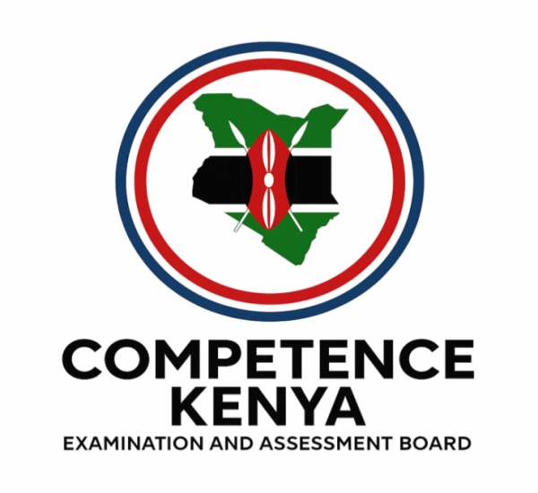

KENYA CERTIFICATE OF BASIC EDUCATION (K.C.B.E)

GRADE 10 – AVIATION TECHNOLOGY (THEORY)
April 2026
Time: 2 Hours
Code: CKEAB 004
LEARNER’S DETAILS
Name: _______________________________________School: ___________________________________________
Assessment Number: ____________________School Code: ______________ Date: ________Signature: _________
INSTRUCTIONS TO LEARNERS
- Attempt all questions.
- Write clearly and number your responses correctly.
- Diagrams must be well-labelled.
- Calculators are not allowed.

SECTION A: STRUCTURED QUESTIONS
- Define an injury caused by electrical current and give two ways to prevent it.

Definition
Injury

Ways of preventing electrical injuries
i. _____________________________________________________________________________________________.
ii. ____________________________________________________________________________________________.
iii. ____________________________________________________________________________________________.

- Name the part of an airport where aircraft are parked and maintained.
______________________________________________________

- Explain why helicopters can hover in the air while planes cannot. ______________________________________________________________________________________________________________________________________________________________________________________________________________________________________________________________________________
- Outline three common types of safety signs used in workplaces or public areas.
  - _______________________________________________________________________________.
  - _______________________________________________________________________________.
  - _______________________________________________________________________________.
- List two pioneers of early aviation and state the contribution of each.
  - _______________________________________________________________________________.
  - _______________________________________________________________________________.
  - _______________________________________________________________________________.
- State what the following safety sign represents.



______________________________________________________________________________.

- Match the following aviation terms with their correct definitions:
Term | Definition
a) Runway | i) Aircraft take-off and landing strip
b) Apron | ii) Area for servicing and parking aircraft
c) Terminal | iii) Building where passengers check in and board
d) Hangar | iv) Shelter for storing aircraft

- Give two advantages of helicopter flight over fixed-wing aircraft in emergency rescue operations.
  - __________________________________________________________________________________________.
  - __________________________________________________________________________________________.
  - __________________________________________________________________________________________.
- State the major differences between lighter-than-air and heavier-than-air aircraft.
Lighter than air aircraft | Heavier than air aircraft

- The following are descriptions of aircraft components. Name them:
a) Rotating part that generates lift in a helicopter.__________________________________________.
b) Fixed surface used for lift in airplanes.________________________________________________.
c) Engine that provides thrust in a jet plane._______________________________________________.
- Mention three types of injuries that can occur in an aviation environment.
  - __________________________________________________________________________________________.
  - __________________________________________________________________________________________.
  - __________________________________________________________________________________________.
- Outline the steps a pilot takes before take-off at an airport.
  - __________________________________________________________________________________________.
  - __________________________________________________________________________________________.
  - __________________________________________________________________________________________.
  - __________________________________________________________________________________________.
  - __________________________________________________________________________________________.
  - __________________________________________________________________________________________.
- Describe the function of an airport terminal.
  - __________________________________________________________________________________________.
  - __________________________________________________________________________________________.
  - __________________________________________________________________________________________.

- Match the following aircraft types with their uses:
Aircraft Type | Use
a) Glider | i) Military reconnaissance or sports
b) Cargo plane | ii) Transporting goods over long distances
c) Passenger plane | iii) Carrying people on scheduled flights
d) Helicopter | iv) Rescue and emergency operations
- Give one difference between thermal injury and mechanical injury.

Thermal injury | Mechanical injury

- Below is a simplified sketch of an airplane.
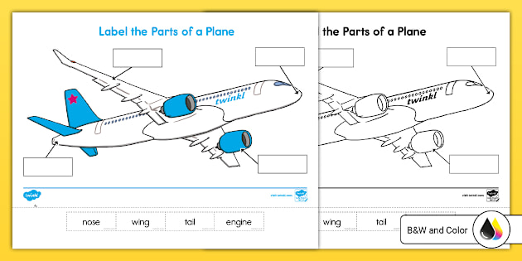
a b

c d
a) Label FOUR main parts of the aircraft. (4 marks)

  - __________________________________________________________________________________________.
  - __________________________________________________________________________________________.
  - __________________________________________________________________________________________.

b) State ONE function of the tail section. (1 mark)

_____________________________________________________________________________________________

- Indicate whether the statement is TRUE or FALSE and give a brief reason.
a) All aircraft require engines to fly.
Answer: __________
Reason: _________________________________________________________________________________________
b) A runway is used for aircraft maintenance.
Answer: __________
Reason: ________________________________________________________________________________________
c) Personal protective equipment reduces workplace accidents.
Answer: __________
Reason: ______________________________
d) Balloons demonstrate lighter-than-air flight.
Answer: __________ _____________________________________________________________________________
Reason: ______________________________
e) Aviation safety rules apply only to pilots.
Answer: __________
Reason: _______________________________________________________________________________________

- Match Column A with Column B.
Column A | Column B
(i) Hangar | A. Aircraft guidance
(ii) Control tower | B. Aircraft storage
(iii) Runway | C. Fire emergency response
(iv) First aid kit | D. Take-off and landing
(v) Fire extinguisher | E. Emergency treatment

SECTION B: (25 MARKS)
- a) Differentiate between fixed-wing and rotary-wing aircraft. (4 marks)
Fixed wing aircraft | Rotary wing aircraft
b) Give TWO examples of each category. (4 marks)

Fixed wing aircraft | Rotary wing aircraft

- A student working in an aviation workshop fails to wear safety gloves and sustains a minor cut.
a) Classify the injury according to severity. (2 marks)
____________________________________________________________________________

b) Outline FOUR steps of first aid for the injury. (4 marks)
  - __________________________________________________________________________________________.
  - __________________________________________________________________________________________.
  - __________________________________________________________________________________________.
  - __________________________________________________________________________________________.
c) State THREE workshop safety rules that were ignored. (3 marks)
  - __________________________________________________________________________________________.
  - __________________________________________________________________________________________.
  - __________________________________________________________________________________________.

- a) Identify FOUR aviation-related careers. (4 marks)
  - __________________________________________________________________________________________.
  - __________________________________________________________________________________________.
  - __________________________________________________________________________________________.
  - __________________________________________________________________________________________.
b) Explain TWO responsibilities of an air traffic controller. (4 marks)
  - __________________________________________________________________________________________.
  - __________________________________________________________________________________________.
SECTION C: (25 MARKS)
- History and Development of Aviation (10 marks)
a) Describe THREE major milestones in aviation development. (6 marks)
  - __________________________________________________________________________________________.
  - __________________________________________________________________________________________.
  - __________________________________________________________________________________________.
b) Analyse how modern aircraft differ from early flying machines. (4 marks)
  - __________________________________________________________________________________________.
  - __________________________________________________________________________________________.
  - __________________________________________________________________________________________.
  - __________________________________________________________________________________________.
- During a school visit to a major airport, learners observed strict security checks and restricted movement zones.
a) Describe THREE operational areas of an airport. (9 marks)
  - __________________________________________________________________________________________.
  - __________________________________________________________________________________________.
  - __________________________________________________________________________________________.
  - __________________________________________________________________________________________.
b) Explain THREE safety rules that visitors must observe in airport restricted areas. (6 marks)
  - __________________________________________________________________________________________.
  - __________________________________________________________________________________________.
  - __________________________________________________________________________________________.
  - __________________________________________________________________________________________.

