

KENYA CERTIFICATE OF BASIC EDUCATION (K.C.B.E)
GRADE 10 – BIOLOGY (THEORY)

April 2026
Time: 2 Hours
Code: CKEAB 004
LEARNER’S DETAILS
Name: _______________________________________School: ___________________________________________
Assessment Number: ____________________School Code: ______________ Date: ________Signature: _________
INSTRUCTIONS TO LEARNERS
- Answer all questions in the spaces provided.
- All responses must be structured and clearly explained.
- Use diagrams where required and label them correctly.
- Write brief answers in Section A and detailed explanations in Section B.
- The total mark for this paper is 70.
SECTION A: (30 MARKS)
1. A rural community is facing increased cases of malaria, poor crop productivity, and contamination of drinking water.
a) Define the term Biology. (2 marks)
________________________________________________________________________________________________
________________________________________________________________________________________________
b) Explain THREE practical ways knowledge of Biology can help solve the problems faced by the community. (6 marks)
  - __________________________________________________________________________________________.
  - __________________________________________________________________________________________.
  - __________________________________________________________________________________________.
  - __________________________________________________________________________________________.

2. a) Describe FOUR branches of Biology and state what each studies. (4 marks)
  - __________________________________________________________________________________________.
  - __________________________________________________________________________________________.
  - __________________________________________________________________________________________.
  - __________________________________________________________________________________________.
b) For each branch identified above, suggest one related career. (4 marks)
BRANCH
CAREER

3. a) Outline THREE qualities of a good Biology researcher. (3 marks)
  - __________________________________________________________________________________________.
  - __________________________________________________________________________________________.
  - __________________________________________________________________________________________.
b) Explain THREE ethical considerations that must be observed when conducting biological investigations involving living organisms. (3 marks)
  - __________________________________________________________________________________________.
  - __________________________________________________________________________________________.
  - __________________________________________________________________________________________.
4. a) Describe FOUR general laboratory safety rules observed during Biology practical lessons. (4 marks)
  - __________________________________________________________________________________________.
  - __________________________________________________________________________________________.
  - __________________________________________________________________________________________.
  - __________________________________________________________________________________________.
b) Explain TWO reasons why proper storage of biological specimens is important. (4 marks)
  - __________________________________________________________________________________________.
  - __________________________________________________________________________________________.
SECTION B: (20 MARKS)
5. a) Draw and label a simple light microscope. (4 marks)

b) Describe the procedure for preparing a temporary slide of an onion epidermis. (4 marks)
  - __________________________________________________________________________________________.
  - __________________________________________________________________________________________.
  - __________________________________________________________________________________________.
  - __________________________________________________________________________________________.
c) Explain TWO differences between magnification and resolution. (2 marks)
________________________________________________________________________________________________________________________________________________________________________________________________________________________________________________________________________________________________________________________________________________________________________________________________.

6. a) Describe the process of wet preservation of an animal specimen. (4 marks)
  - __________________________________________________________________________________________.
  - __________________________________________________________________________________________.
  - __________________________________________________________________________________________.
  - __________________________________________________________________________________________.
b) State FOUR details that must appear on a properly prepared specimen label. (4 marks)
  - __________________________________________________________________________________________.
  - __________________________________________________________________________________________.
  - __________________________________________________________________________________________.
  - __________________________________________________________________________________________.
c) Explain TWO precautions observed during field collection of plant specimens. (2 marks)
  - __________________________________________________________________________________________.
  - __________________________________________________________________________________________.
SECTION C: 20 MARKS)
7. a) Identify FOUR specialized plant cells and describe their functions. (4 marks)
  - __________________________________________________________________________________________.
  - __________________________________________________________________________________________.
  - __________________________________________________________________________________________.
  - __________________________________________________________________________________________.
b) Identify FOUR specialized animal cells and describe their functions. (4 marks)
  - __________________________________________________________________________________________.
  - __________________________________________________________________________________________.
  - __________________________________________________________________________________________.
  - __________________________________________________________________________________________.

c) Explain how structure relates to function in any ONE specialized cell. (2 marks)
Specialized cell ________________

Structural adaptations
  - __________________________________________________________________________________________.
  - __________________________________________________________________________________________.
8. a) Arrange the following in correct order from smallest to largest level of organization:
Organ, Tissue, Cell, Organ system, Organelle. (2 marks)
________________________________________________________________________________________________________________________________________________________________________________________________
b) Give an example of each
Level of organization | Example
Organ
Tissue
Organ system
Organelle
Cell

c) Explain the role of each of the following in a multicellular organism: (2 marks)
i) Tissue
__________________________________________________________________________________________.
__________________________________________________________________________________________.
ii) Organ
__________________________________________________________________________________________.
__________________________________________________________________________________________.
d) Describe how different organ systems work together to maintain life in humans. (2 marks)

  - __________________________________________________________________________________________.
  - __________________________________________________________________________________________.

- Name the parts of a cell labelled. (4 marks)

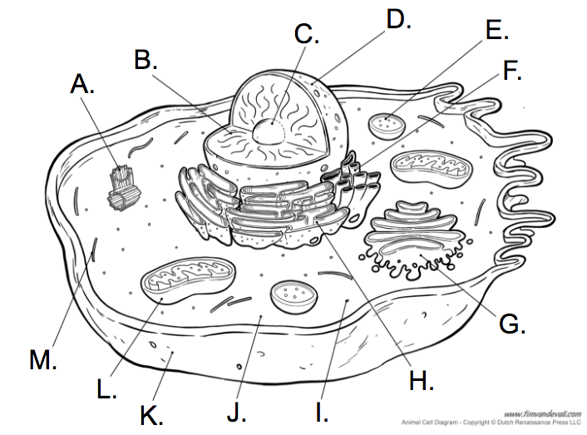

Part | Name
C
D
E
F
G
H
J
K
L

