

KENYA CERTIFICATE OF BASIC EDUCATION (K.C.B.E)

GRADE 10 –CORE MATHEMATICS
April 2026
Time: 2 Hours
Code: CKEAB 004
LEARNER’S DETAILS
Name: _______________________________________School: ___________________________________________
Assessment Number: ____________________School Code: ______________ Date: ________Signature: _________
INSTRUCTIONS TO LEARNERS
- Answer all questions.
- Show all working clearly.
- Use mathematical tables or a calculator where necessary.

CORE MATHEMATICS (100 MARKS)
- Solve for $x$: (3 marks)
$$4^{x+1}×2^{2x-3}=512$$

- Use logarithms to evaluate: (3 marks)
$$\frac{2.735×0.0846}{0.693}$$

- Solve without using tables: (3 marks)
$$log\left(2x+5\right)+log3=log\left(x+11\right)$$

- The length of a rectangular hall is $\left(x+4\right)$ m and the width is $\left(x-3\right)$ m.
If its area is 77 m², find its dimensions. (3 marks)

- A sphere, a cone and a cylinder have equal radii. Their curved surface areas are equal.
If the volume of the sphere is 1437 cm³:
a) Find the radius of the sphere. (3 marks)
b) Find the volume of the cylinder. (4 marks)
c) Find the volume of the cone. (3 marks)
(Give answers to 4 significant figures)

- The table shows marks scored by students:
Marks | 0–10 | 11–20 | 21–30 | 31–40 | 41–50
Frequency | 5 | 18 | 32 | 25 | 10
a) Calculate the mean mark. (4 marks)

b) The table below shows time in minutes that a group of 45 students took to complete a mathematics test.

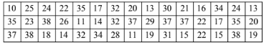

(i) From the given data, complete the frequency distribution table below. (2 marks)

(ii) Using the frequency distribution table in (a) above, draw a histogram to represent the data. (3 marks)

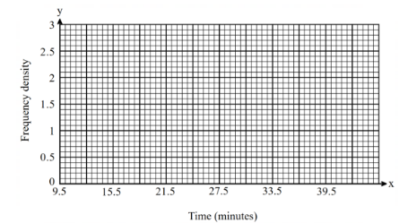

(c) From the histogram, estimate the:

(i) Median time in minutes. (3 marks)

(ii) Number of students that spent from 21.5 minutes to 36.5 minutes. (2 marks)

- Solve the following simultaneous equations using graphical method. (4 mks)

3x – 2y = 7

2x – y = 7

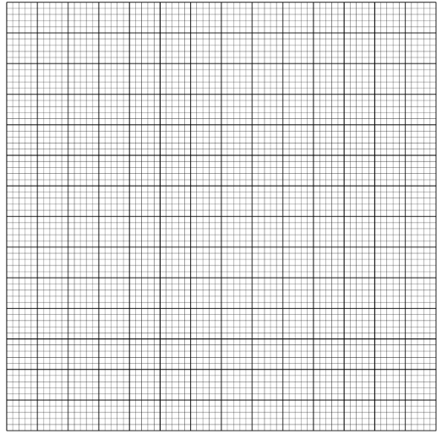
- Find the area of a triangle with sides 8 cm, 10 cm and 12 cm.
(Use Heron’s formula) (3 marks)

- A trader spent $\frac{2}{5}$ of his money on stock and $\frac{3}{4}$ of the remainder on transport.
He remained with Ksh 9,000.
Find the amount spent on transport. (3 marks)

- Solve: (3 marks)
$$5^{x+2}={125}^{x-1}$$

- Two similar cones have volumes 864 cm³ and 256 cm³.(4 marks)
If the curved surface area of the smaller cone is 200 cm², find that of the larger cone.

- A piece of wire leaves a remainder of 5 cm when divided into pieces of 18 cm, 24 cm or 30 cm.
Find the length of the wire. (3 marks)

- Using a ruler and a pair of compasses only.

(i) Construct line AB = 6cm. (1 mark)

(ii) Construct triangle DAB where angle DAB = 75° and AB = BD. (2 marks)

(iii) Complete the parallelogram ABCD. (1 mark)

(iv) Drop a perpendicular from A to BD and hence find the area of the parallelogram. (3 marks)

(v) Construct a circle to touch line BC, AB produced and DC produced. Measure its radius. (3 marks)

- Two towns are 60 km apart. James leaves Town A at 8.00 a.m. travelling at 20 km/h. Peter leaves Town B at 9.00 a.m. travelling at 30 km/h towards James.
a) How long after 8.00 a.m. do they meet? (2 marks)

b) At what time do they meet? (1 mark)

- Simplify completely: (3 marks)
$$\frac{{\left(a+3b\right)}^{2}-{\left(a-3b\right)}^{2}}{6ab}$$

- Use logarithms to evaluate: (3 marks)
$$\frac{58.72×406}{0.845}$$

- Mwangi mixed the following materials as follows:
Cement : Sand = 2 : 5
Sand : Ballast = 3 : 7
a) Find the ratio Cement : Ballast. (2 marks)

b) If 35 bags of sand are used, how many bags of cement are required? (2 marks)

c) A bag of cement costs Ksh 720, sand Ksh 150 and ballast Ksh 110. Find cost of the mixture. (3 marks)

d) A lorry carries 4 tonnes per trip and charges Ksh 9,500 per trip. How much will it cost to transport 28 tonnes? (3 marks)

- a) Calculate the gradient of the line passing through the points: A(2, 3) and B(6, 11). (2 marks)

b) Find the gradient of the line joining the points P(–4, 5) and Q(2, –7). (2 marks)

- a) Find the equation of the straight line passing through the points (1, 4) and (5, 12).
Give your answer in the form y = mx + c. (2 marks)

b) Determine the equation of the line that passes through the point (3, –2) and is parallel to the line
y = 4x + 1. (2 marks)

c) Find the equation of the line that passes through the point (2, 5) and is perpendicular to the line
y = 3x – 4. (2 marks)

- a) Round 48.376 to:
i) 1 decimal place

ii) 2 significant figures (1 mark)

b) A length is measured as 25 cm correct to the nearest cm. State the maximum possible error. (1 mark)

- The actual length of a rod is 50 cm. It was measured as 48 cm. Calculate the percentage error. (2 marks)

- Two aeroplanes S and R leave an airport at the same time. S flies on the bearing of 240º at 750Km/h while R flies due East at 600Km/hr.

    - Calculate the distance of each aeroplane after 30minutes

    - Using a scale of 1cm to represent 50km make an accurate scale drawing to show the positions of the aeroplanes after 30minutes

    - Use the scale drawing to find the distance between the two aeroplanes after 30minutes

    - If each aeroplane landed after 30minutes and S received a signal to join R in 45minutes. Find its speed.

  - Determine the bearing of:
    - S from R:________________________________________
    - R from S:________________________________________

- The table below gives a field book showing the results of a survey of a section of a piece of land between A and E. All measurements are in metres.
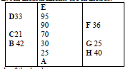
  - Draw a sketch of the land.

  - Calculate the area of this piece of land.

