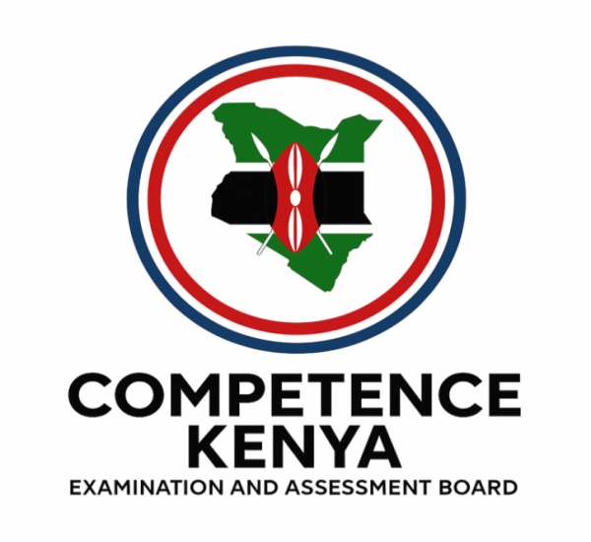
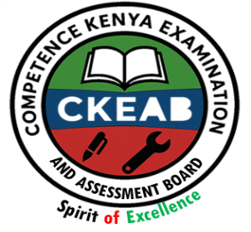
KENYA CERTIFICATE OF BASIC EDUCATION (K.C.B.E)
GRADE 10 – CRE (THEORY)

April 2026
Time: 2 Hours
Code: CKEAB 004
LEARNER’S DETAILS
Name: _______________________________________School: ___________________________________________
Assessment Number: ____________________School Code: ______________ Date: ________Signature: _________
INSTRUCTIONS TO LEARNERS
- Answer all questions in the spaces provided.
- All answers must be structured, with explanations and examples where necessary.
- Use relevant Biblical references where necessary.
- Ensure your answers are clear, neat, and well-organized.
- Marks for each question are indicated at the end.
SECTION A: (80 MARKS)
1. a) Define the Bible and explain its significance to Christians. (3 marks)
________________________________________________________________________________________________________________________________________________________________________________________________
b) Explain FIVE reasons why the Bible is considered the inspired Word of God. (5 marks)
i. _____________________________________________________________________________________________.
ii. ____________________________________________________________________________________________.
iii. ____________________________________________________________________________________________.
iv. ____________________________________________________________________________________________.
v. _____________________________________________________________________________________________.
c) State TWO ways Christians should handle and respect the Holy Bible. (2 marks)
i. _____________________________________________________________________________________________.
ii. ____________________________________________________________________________________________.
2. a) Explain how God inspired human authors to write the Bible. (4 marks)
i. _____________________________________________________________________________________________.
ii. ____________________________________________________________________________________________.
iii. ____________________________________________________________________________________________.
iv. ____________________________________________________________________________________________.

b) Name THREE Old Testament authors and the books they wrote. (3 marks)
i. _____________________________________________________________________________________________.
ii. ____________________________________________________________________________________________.
iii. ____________________________________________________________________________________________.
c) State THREE qualities God required of those who wrote Scripture. (3 marks)
i. _____________________________________________________________________________________________.
ii. ____________________________________________________________________________________________.
iii. ____________________________________________________________________________________________.
3. a) Identify the FIVE categories of the Old Testament books. (5 marks)
i. _____________________________________________________________________________________________.
ii. ____________________________________________________________________________________________.
iii. ____________________________________________________________________________________________.
iv. ____________________________________________________________________________________________.
v. _____________________________________________________________________________________________.
b) Give ONE example of a book from each category. (5 marks)
i. _____________________________________________________________________________________________.
ii. ____________________________________________________________________________________________.
iii. ____________________________________________________________________________________________.
iv. ____________________________________________________________________________________________.
v. _____________________________________________________________________________________________.
c) State TWO benefits of grouping the Bible books into categories. (2 marks)
i. _____________________________________________________________________________________________.
ii. ____________________________________________________________________________________________.
4. a) List FIVE literary forms used in the Bible. (5 marks)
i. _____________________________________________________________________________________________.
ii. ____________________________________________________________________________________________.
iii. ____________________________________________________________________________________________.
iv. ____________________________________________________________________________________________.
v. _____________________________________________________________________________________________.
b) Identify the literary form of the book of Proverbs. (1 mark)
i. _____________________________________________________________________________________________.
c) Explain TWO reasons why understanding literary forms is important in studying the Bible. (2 marks)
i. _____________________________________________________________________________________________.
ii. ____________________________________________________________________________________________.

5. a) Name FIVE methods used to study the Bible. (5 marks)
i. _____________________________________________________________________________________________.
ii. ____________________________________________________________________________________________.
iii. ____________________________________________________________________________________________.
iv. ____________________________________________________________________________________________.
v._____________________________________________________________________________________________.
b) Explain TWO benefits of regular Bible study. (2 marks)
i. _____________________________________________________________________________________________.
ii. ____________________________________________________________________________________________.
c) State ONE career related to the study of C.R.E. (1 mark)
i. _____________________________________________________________________________________________.
ii. ____________________________________________________________________________________________.
6. a) Define the term sin. (2 marks)
. _______________________________________________________________________________________________.
. _______________________________________________________________________________________________.
b) State THREE consequences of sin after the Fall. (3 marks)
i. _____________________________________________________________________________________________.
ii. ____________________________________________________________________________________________.
iii. ____________________________________________________________________________________________.
iv. ____________________________________________________________________________________________.
c) Outline TWO privileges humans enjoyed before sin. (2 marks)
i. _____________________________________________________________________________________________.
ii. ____________________________________________________________________________________________.
d) Name ONE way God demonstrated His love after the Fall. (1 mark)
i. _____________________________________________________________________________________________.
7. a) Define redemption. (2 marks) ________________________________________________________________________________________________________________________________________________________________________________________________
b) Explain THREE steps in God’s redemptive plan. (6 marks)
i. _____________________________________________________________________________________________.
ii. ____________________________________________________________________________________________.
iii. ____________________________________________________________________________________________.
c) Mention TWO ways Christians respond to God’s plan of salvation. (2 marks)
i. _____________________________________________________________________________________________.
ii. ____________________________________________________________________________________________.
8. a) Define stewardship. (2 marks)
________________________________________________________________________________________________________________________________________________________________________________________________
b) State FOUR qualities of a good steward. (4 marks)
i. _____________________________________________________________________________________________.
ii. ____________________________________________________________________________________________.
iii. ____________________________________________________________________________________________.
iv. ____________________________________________________________________________________________.
c) Describe TWO ways students can practice good stewardship in school or at home. (2 marks)
i. _____________________________________________________________________________________________.
ii. ____________________________________________________________________________________________.
9. a) Describe THREE ways God provided for the Israelites during the Exodus. (6 marks)
i. _____________________________________________________________________________________________.
ii. ____________________________________________________________________________________________.
iii. ____________________________________________________________________________________________.
b) State TWO lessons Christians can learn from the Exodus. (4 marks)
i. _____________________________________________________________________________________________.
ii. ____________________________________________________________________________________________.
10. a) Define a covenant. (2 marks)
i. _____________________________________________________________________________________________.
ii. ____________________________________________________________________________________________.
b) State FOUR responsibilities of the Israelites under the Sinai covenant. (4 marks)
i. _____________________________________________________________________________________________.
ii. ____________________________________________________________________________________________.
iii. ____________________________________________________________________________________________.
iv. ____________________________________________________________________________________________.
c) Describe FOUR ways Christians today apply the Ten Commandments in daily life. (4 marks)
i. _____________________________________________________________________________________________.
ii. ____________________________________________________________________________________________.
iii. ____________________________________________________________________________________________.
iv. ____________________________________________________________________________________________.

