

KENYA CERTIFICATE OF BASIC EDUCATION (K.C.B.E)
GRADE 10 –ESSENTIAL MATHEMATICS

April 2026
Time: 2 Hours
Code: CKEAB 004
LEARNER’S DETAILS
Name: _______________________________________School: ___________________________________________
Assessment Number: ____________________School Code: ______________ Date: ________Signature: _________
INSTRUCTIONS TO LEARNERS
i. Answer all questions.
ii. Show all working.
iii. Non-programmable calculators allowed.
iv. Take π = 3.14 unless stated otherwise.

SECTION A (35 MARKS)

1. (6 Marks)
a) Simplify:
$$\frac{3^{4}×3^{-2}}{3^{3}}$$

b) Express 0.00032 in standard form.

c) Rationalize and simplify:
$$\frac{5}{\sqrt{3}}$$

d) Evaluate:
$$\sqrt{50}+3\sqrt{8}$$

2. (7 Marks)
a) Expand and simplify:
$$\left(2x-3\right)\left(x+5\right)-{\left(x-4\right)}^{2}$$

b) Factorise completely:
$$3x^{2}-11x-4$$

c) Solve:
$$4x^{2}-9=0$$

3. (6 Marks)
Solve:
$$3x+2y=17$$
$$2x-y=4$$

4. (8 Marks)
A projectile is modeled by:
$$h=-2t^{2}+12t+5$$

a) Find the maximum height.

b) Determine the time when the projectile hits the ground.

c) Find the average rate of change between t = 1 and t = 3.

5. (8 Marks)
a) Solve:
$$\log_{10}x+\log_{10}4=2$$

b) Solve:
$$\log_{3}81=x$$

c) Evaluate using logarithm laws:
$$\frac{log500-log5}{log10}$$

SECTION B (35 MARKS)

6. (8 Marks)
Points A(2,3), B(8,7)
a) Find the distance AB.

b) Find the midpoint of AB.

c) Find the equation of the line AB.

7. (7 Marks)
Two similar cones have radii 3 cm and 9 cm.
a) Find the scale factor.

b) If the smaller cone has volume 40 cm³, find the volume of the larger cone.

c) If the slant height of the smaller cone is 5 cm, find that of the larger cone.

8. (8 Marks)
A cylindrical water tank has radius 7 m and height 10 m.
a) Find its volume.

b) Find its total surface area.

c) If water costs KSh 50 per cubic meter, find the cost to fill the tank.

9. (6 Marks)

Draw he following lines on the same Cartesian plane and determine if they are perpendicular to each other

$$Y=\frac{x}{4}+5$$

$$Y=-4x-2$$
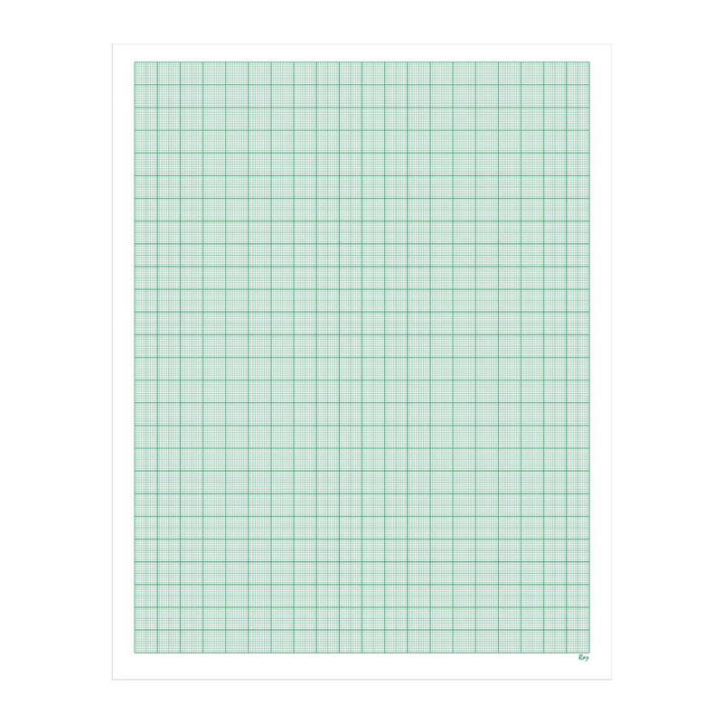

10. (6 Marks)
In triangle XYZ:
Angle X = 35°
Side opposite X = 8 cm
Angle Y = 65°

Y
65°

8cm

X 35°

Z
a) Find angle Z.

b) Find side YZ using sine rule.

c) Find the area of the triangle.

SECTION C (30 MARKS)

11. (10 Marks)
A ship sails 120 km on a bearing of 030°.
It then sails 80 km on a bearing of 120°.
a) Represent the journey on a scale diagram (1 cm = 20 km).

b) Find the final displacement from the starting point.

c) Find the bearing of the final position from the starting point.

12. (10 Marks)
a) Solve the following graphically:
a)
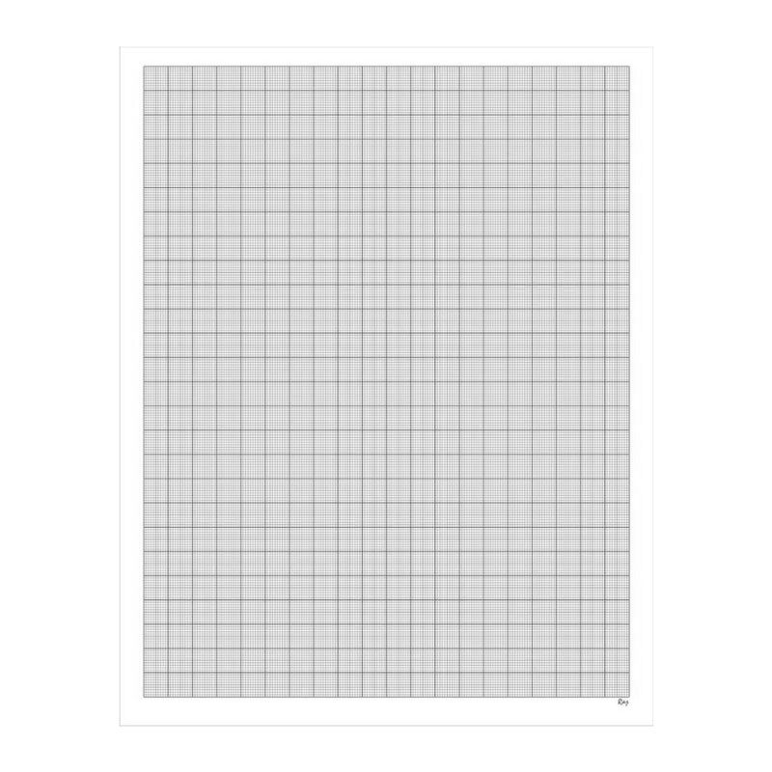
$y=x and$ $x+y=4$

b) Add the following matrices
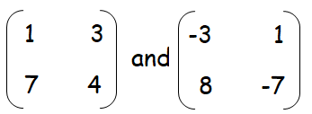

13. A rectangular garden measures (x + 4) m by (2x - 3) m.
a) Form an expression for the area.

b) If the area is 70 m², find x.

c) A path of width 1 m is built inside the garden. Find the new area remaining.

