
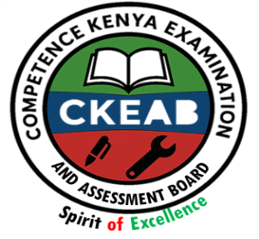
KENYA CERTIFICATE OF BASIC EDUCATION (K.C.B.E)

GRADE 10 –FINE ARTS
April 2026
Time: 2 Hours
Code: CKEAB 004
LEARNER’S DETAILS
Name: _______________________________________School: ___________________________________________
Assessment Number: ____________________School Code: ______________ Date: ________Signature: _________
INSTRUCTIONS TO LEARNERS
- Write your name, school, assessment number, signature, and date on all answer sheets.
- This paper consists of Section A (35 marks) and Section B (65 marks).
- Answer all questions in Section A.
- In Section B, answer Question 6 and any other two questions.
- Write all answers clearly in the spaces provided.
- Do not write in the margins.
- Check your work before submission.
SECTION A: (35 Marks)
1. Study the figure below showing a mural painted on a classroom wall.
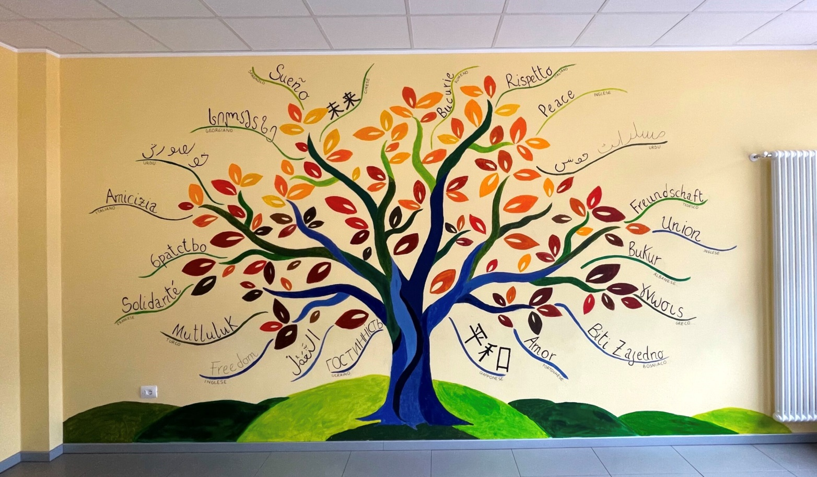
a) Identify three principles of design that make the mural visually effective. (3 marks)
i. ___________________________ ii. ____________________________iii. _______________________________
b) Mention two techniques used to create textures in wall paintings. (2 marks)
i. ___________________________________________
ii. ___________________________________________
c) Explain how contrast is applied to attract attention in mural art. (2 marks)
i. _______________________________________________________________________________________________
ii. ______________________________________________________________________________________________
d) Identify two tools or materials required for creating mural art. (2 marks)
i. ______________________________________________________________________________
ii. ______________________________________________________________________________
2. a) Define typography in visual communication. (1 mark)
________________________________________________________________________________________________________________________________________________________________________________________________
b) Identify two types of calligraphy nibs or pens suitable for artistic writing. (2 marks)
i. ______________________________________________________________________________
ii. ______________________________________________________________________________
c) State three rules for designing readable and attractive text. (3 marks)
i. ______________________________________________________________________________
ii. ______________________________________________________________________________
iii. ______________________________________________________________________________
d) Explain two ways line and color enhance logos or trademarks. (2 marks)
i. ______________________________________________________________________________
ii. ______________________________________________________________________________
e) Mention two features of an effective poster that communicates its message clearly. (2 marks)
i. ______________________________________________________________________________
ii. ______________________________________________________________________________
3. a) Define stencil art. (1 mark)
________________________________________________________________________________________________________________________________________________________________________________________________
b) List three materials used to produce stencil artworks. (3 marks)
i. ______________________________________________________________________________
ii. ______________________________________________________________________________
iii. ______________________________________________________________________________

c) Explain two ways repetition or pattern in spray art adds rhythm to the artwork. (2 marks)
i. ______________________________________________________________________________
ii. ______________________________________________________________________________

d) State one reason for trimming and mounting finished stencil artworks. (1 mark)
________________________________________________________________________________________________________________________________________________________________________________________________4. A learner wants to paint a hill, river, and trees using watercolors.
a) Explain how foreground, middle ground, and background are distinguished using color values. (2 marks)
________________________________________________________________________________________________________________________________________________________________________________________________
b) Outline four steps for applying a graded wash in a landscape painting. (4 marks)
i. ______________________________________________________________________________
ii. ______________________________________________________________________________
iii. ______________________________________________________________________________
iv. ______________________________________________________________________________
c) Identify two types of wash commonly used in water-colour painting. (2 marks)
i. ______________________________________________________________________________
ii. ______________________________________________________________________________
d) Mention three purposes of using a viewfinder while planning the painting. (3 marks)
i. ______________________________________________________________________________
ii. ______________________________________________________________________________
iii. ______________________________________________________________________________
5. Study the figure below



a) Define collage. (1 mark)
________________________________________________________________________________________________________________________________________________________________________________________________
b) Differentiate single-media and mixed-media collage. (2 marks)
i. ______________________________________________________________________________
ii. ______________________________________________________________________________
c) Mention two ways texture improves collage composition. (2 marks)
i. ______________________________________________________________________________
ii. ______________________________________________________________________________
d) State two skills developed when giving feedback on a peer’s artwork. (2 marks)
i. _____________________________________________________________________________________
ii. _____________________________________________________________________________________
6. A learner sets up a bottle, fruit, and a cup on a table for drawing.
a) Name two preparatory steps before starting the drawing. (2 marks)
i. _____________________________________________________________________________________
ii. _____________________________________________________________________________________
b) Explain two ways shading makes objects appear three-dimensional. (2 marks)
i. _____________________________________________________________________________________
ii. _____________________________________________________________________________________
c) State two methods to indicate the source of light in a still life drawing. (2 marks)
i. _____________________________________________________________________________________
ii. _____________________________________________________________________________________
7. The figure bellows shows a portrait.

a) Identify four elements of art present in the portrait. (4 marks)
i. _____________________________________________________________________________________
ii. _____________________________________________________________________________________
iii. _____________________________________________________________________________________
iv. _____________________________________________________________________________________
b) State three principles of design applied in the portrait. (3 marks)
i. _____________________________________________________________________________________
ii. _____________________________________________________________________________________
iii. _____________________________________________________________________________________
c) Name two types of texture that enhance realism in portrait drawings. (2 marks)
i. ___________________________________________________________________________________________
ii. ___________________________________________________________________________________________
d) Define form as used in portrait drawing. (2 marks)
________________________________________________________________________________________________________________________________________________________________________________________________
e) Mention three purposes of keeping a sketchbook. (3 marks)
i. ___________________________________________________________________________________________
ii. ___________________________________________________________________________________________
iii. ___________________________________________________________________________________________

