

KENYA CERTIFICATE OF BASIC EDUCATION (K.C.B.E)
GRADE 10 –GENERAL SCIENCE

April 2026
Time: 2 Hours
Code: CKEAB 004
LEARNER’S DETAILS
Name: _______________________________________School: ___________________________________________
Assessment Number: ____________________School Code: ______________ Date: ________Signature: _________
INSTRUCTIONS TO LEARNERS
- Write your name, school, assessment number, date and signature on all answer sheets.
- Answer all questions in the spaces provided.
- Read each question carefully before writing your answer.
- Write your answers neatly and in an organized manner.
- Marks are indicated at the end of each question.
- Use relevant Biblical references where necessary.
- Do not write in the margins.
- Check your work before submission.
- Manage your time to complete all questions.
Answer all questions.
1: A student mixes sugar, water, and yeast in a flask. After 30 minutes, bubbles appear and a balloon tied to the flask inflates.
a) Identify the process occurring in the experiment. (1 mark)
_______________________________________________________________________________________________
b) Name the gas produced during this process. (1 mark)
_______________________________________________________________________________________________
c) State one method to test for the gas produced. (2 marks)
_______________________________________________________________________________________________
_______________________________________________________________________________________________
d) State one conclusion the student can make from the experiment. (1 mark)
_______________________________________________________________________________________________
e) Give one practical use of this process in industry. (2 marks)
i. _____________________________________________________________________________________________
ii. ____________________________________________________________________________________________

2: a) Define seed dormancy. (1 mark)
_______________________________________________________________________________________________
_______________________________________________________________________________________________
b) Identify two conditions necessary for seed germination. (2 marks)
i. _____________________________________________________________________________________________
ii. _____________________________________________________________________________________________
c) Differentiate between growth and development in plants. (1 mark)
_______________________________________________________________________________________________
_______________________________________________________________________________________________
_______________________________________________________________________________________________
_______________________________________________________________________________________________
3: a) Define respiration in living organisms. (1 mark)
_______________________________________________________________________________________________
_______________________________________________________________________________________________
b) List two substrates used in cellular respiration. (2 marks)
i. _____________________________________________________________________________________________
ii. ____________________________________________________________________________________________
c) Give two differences between aerobic and anaerobic respiration. (4 marks)
AEROBIC RESPIRATION | ANAEROBIC RESPIRATION
d) State two uses of anaerobic respiration in daily life or industry. (2 marks)
i. _______________________________________________________________________________
ii. _______________________________________________________________________________
e) Mention one energy-related importance of respiration to living organisms. (2 marks)
_______________________________________________________________________________________________
_______________________________________________________________________________________________
_______________________________________________________________________________________________
4: A group sets up an experiment with a leafy plant, cobalt chloride paper, and a bell jar.
a) Name the process being investigated. (1 mark)
________________________________________________________________________________________

b) Name the tissue responsible for water transport. (1 mark)
_________________________________________________________________________
c) List three factors affecting transpiration. (3 marks)
i. _______________________________________________________________________________________________
ii. ______________________________________________________________________________________________
iii. ______________________________________________________________________________________________
d) State three importance of transpiration in plants. (3 marks)
i. ______________________________________________________________________________________________
ii. ______________________________________________________________________________________________
iii. _____________________________________________________________________________________________
5: A student eats a meal of rice, meat, and vegetables.
a) Name two regions where digestion occurs. (2 marks)
i. _______________________________________________________________________________
ii. _______________________________________________________________________________
b) Identify two enzymes involved in digestion. (2 marks)
i. _______________________________________________________________________________
ii. _______________________________________________________________________________
c) Give one food type digested by each enzyme named above. (2 marks)
i. _______________________________________________________________________________
ii. _______________________________________________________________________________
d) State two adaptations of the small intestine that make absorption efficient. (2 marks)
i. _______________________________________________________________________________
ii. _______________________________________________________________________________
e) Name two parts of the digestive system labelled A and C in the diagram. (2 marks)
A: ___________________________
C: ___________________________
f) Explain the role of enzymes in digestion. (5 marks)
_______________________________________________________________________________________________
_______________________________________________________________________________________________
_______________________________________________________________________________________________
_______________________________________________________________________________________________
_______________________________________________________________________________________________
6: Name the following specialized animal cells:
Q: Cell that transports oxygen ________________________________________________________
R: Cell that transmits electrical impulses ________________________________________________

7: Arrange the following from smallest to largest: tissues, organism, organs, cells, organ systems.
________________________________________________________________________________________________________________________________________________________________________________________________ 8: A student observes a plant cell under a microscope.
a) Name two types of microscopes that can be used to study cells. (2 marks)
i. _______________________________________________________________________________
ii. _______________________________________________________________________________
b) State one difference between a light microscope and an electron microscope. (1 mark)
_______________________________________________________________________________________________
_______________________________________________________________________________________________
_______________________________________________________________________________________________
c) Identify the parts A, B, C of a plant cell. (3 marks)
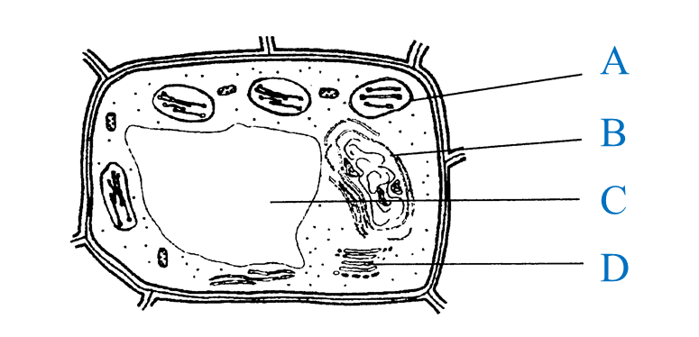
A: ______________________________ B: _____________________________ C: ___________________________
d) State one function of each part named above. (4 marks)
A: _______________________________________________________________________________
B: _______________________________________________________________________________
C: _______________________________________________________________________________
9: During a practical, students notice plants near sunlight grow taller than those in shade.
a) Give two skills acquired when studying General Science. (2 marks)
i. _______________________________________________________________________________
ii. _______________________________________________________________________________
b) State two methods scientists can use to collect evidence. (2 marks)
i. _______________________________________________________________________________
ii. _______________________________________________________________________________
c) Give two reasons why evidence collection is important. (2 marks)
i. _______________________________________________________________________________
ii. _______________________________________________________________________________
d) State two ways General Science helps in environmental conservation. (2 marks)
i. _______________________________________________________________________________
ii. _______________________________________________________________________________
e) Give two examples of modern technology influenced by scientific knowledge. (2 marks)
i. _______________________________________________________________________________
ii. _______________________________________________________________________________
10: Match the branch of General Science with its focus:
Branch | Focus
Biology
Chemistry
Physics
11: a) Define General Science. (2 marks)
________________________________________________________________________________________________________________________________________________________________________________________________
b) State two importance of studying General Science in daily life. (4 marks)
i. _______________________________________________________________________________
ii. _______________________________________________________________________________
c) Mention two careers linked to General Science. (4 marks)
i. _______________________________________________________________________________
ii. _______________________________________________________________________________
d) State two skills learners develop through studying General Science. (5 marks)
i. _______________________________________________________________________________
ii. _______________________________________________________________________________
iii. _______________________________________________________________________________
iv. _______________________________________________________________________________
v. _______________________________________________________________________________
12: a) Name two plant growth hormones. (2 marks)
i. _______________________________________________________________________________
ii. _______________________________________________________________________________
b) Explain the role of plant hormones in growth. (5 marks)
________________________________________________________________________________________________________________________________________________________________________________________________________________________________________________________________________________________________________________________________________________________________________________________________________________________________________________________________________________________________

