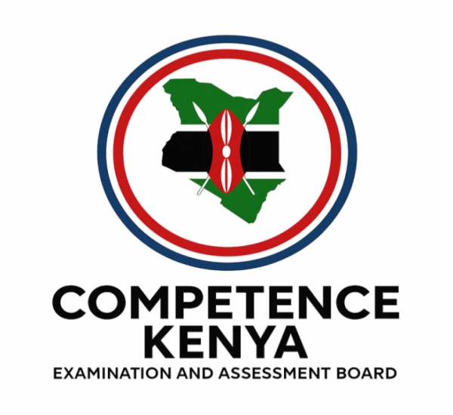
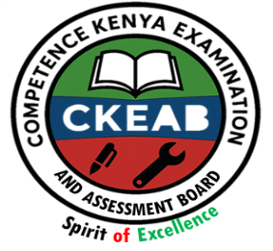
KENYA CERTIFICATE OF BASIC EDUCATION (K.C.B.E)
GRADE 10 –HISTORY AND CITIZENSHIP

April 2026
Time: 2 Hours
Code: CKEAB 004
LEARNER’S DETAILS
Name: _______________________________________School: ___________________________________________
Assessment Number: ____________________School Code: ______________ Date: ________Signature: _________
INSTRUCTIONS TO LEARNERS
- Write your name, school, assessment number, signature and date on all answer sheets.
- Answer all questions in the spaces provided.
- Read each question carefully before answering.
- Use neat, clear, and well-organized writing.
- Do not write in the margin.
- Check your work before submission.
- Manage your time carefully to complete the exam.

SECTION A: HISTORY (35 MARKS)

1. a) Differentiate between the following terms nationalism and socialism . (2 marks)
________________________________________________________________________________________________________________________________________________________________________________________________________________________________________________________________________________________________
b) State four factors that led to the rise of African nationalism in Africa. (4 marks)
i. _______________________________________________________________________________________________
ii. ______________________________________________________________________________________________ iii. ______________________________________________________________________________________________
iv. ______________________________________________________________________________________________

c) State the achievement of the following African nationalist:
- Kwame Nkrumah
______________________________________________________________________________________________________________________________________________________________________________________________________________________________________________________________________________
- Jomo Kenyatta (2 marks)
______________________________________________________________________________________________________________________________________________________________________________________________________________________________________________________________________________

2. a) Give three reasons for the convening of the Berlin Conference. (3 marks)
i. _______________________________________________________________________________________________
ii. ______________________________________________________________________________________________ iii. ______________________________________________________________________________________________
b) State three agreements reached during the conference. (3 marks)
i. _______________________________________________________________________________________________
ii. ______________________________________________________________________________________________ iii. ______________________________________________________________________________________________
3. a) Outline four reasons for the colonisation of Africa by European powers. (4 marks)
i. _______________________________________________________________________________________________
ii. ______________________________________________________________________________________________ iii. ______________________________________________________________________________________________
iv. ______________________________________________________________________________________________
b) Match the following African countries with their colonial masters: (2 marks)
Country | Colonial Master
Ghana
Kenya
Mozambique
Senegal

4. a) Identify the supreme ruler of the Buganda Kingdom. (1 mark)
__________________________________________________________
b) State two functions of each of the following officials: (4 marks)
i) Katikiro
i. _______________________________________________________________________________________________
ii. ______________________________________________________________________________________________ iii. ______________________________________________________________________________________________
iv. ______________________________________________________________________________________________
ii) Omulamuzi
i. _______________________________________________________________________________________________
ii. ______________________________________________________________________________________________ iii. ______________________________________________________________________________________________
iv. ______________________________________________________________________________________________
c) Define the following titles in the Buganda administration: (2 marks)
- Omwanika
i. _______________________________________________________________________________________________
ii. ______________________________________________________________________________________________
- Bataka
i. _______________________________________________________________________________________________
ii. ______________________________________________________________________________________________

5. a) State three similarities and two differences between the Nyamwezi Chiefdom and the Wanga Kingdom. (5 marks)
Similarities
i. _______________________________________________________________________________________________
ii. ______________________________________________________________________________________________ iii. ______________________________________________________________________________________________
iv. ______________________________________________________________________________________________

Differences
Nyamwezi chiefdom | Wanga kingdom
b) Explain three characteristics of the Neolithic Period. (3 marks)
i. _______________________________________________________________________________________________
ii. ______________________________________________________________________________________________ iii. ______________________________________________________________________________________________
SECTION B: CITIZENSHIP (35 MARKS)

6. a) Define the term general election. (2 marks)
________________________________________________________________________________________________________________________________________________________________________________________________
b) Outline four principles of Kenya’s electoral system. (4 marks)
i. _______________________________________________________________________________________________
ii. ______________________________________________________________________________________________ iii. ______________________________________________________________________________________________
iv. ______________________________________________________________________________________________
c) State four functions of the Independent Electoral and Boundaries Commission (IEBC). (4 marks)

i. _______________________________________________________________________________________________
ii. ______________________________________________________________________________________________ iii. ______________________________________________________________________________________________
iv. ______________________________________________________________________________________________

7. a) Name four elective positions contested during general elections in Kenya. (4 marks)
i. _______________________________________________________________________________________________
ii. ______________________________________________________________________________________________ iii. ______________________________________________________________________________________________
iv. ______________________________________________________________________________________________
b) State two stages in the electoral process. (2 marks)
i. _______________________________________________________________________________________________
ii. ______________________________________________________________________________________________

8. a) Define public resources. (2 marks)
________________________________________________________________________________________________________________________________________________________________________________________________
b) Name three types of public resources. (3 marks)
i. _______________________________________________________________________________________________
ii. ______________________________________________________________________________________________ iii. ______________________________________________________________________________________________
c) State one consequence of misuse of public resources. (1 mark)
________________________________________________________________________________________________________________________________________________________________________________________________

9. a) Name three major language groups in Kenya. (3 marks)
i. _______________________________________________________________________________________________
ii. ______________________________________________________________________________________________ iii. ______________________________________________________________________________________________
iv. ______________________________________________________________________________________________
b) State four reasons for the migration of communities in Kenya. (4 marks)
i. _______________________________________________________________________________________________
ii. ______________________________________________________________________________________________ iii. ______________________________________________________________________________________________
iv. _________________________________________________________________________________

10. a) Define pastoralism. (2 marks)
i. _______________________________________________________________________________________________
ii. ______________________________________________________________________________________________ iii. ______________________________________________________________________________________________
iv. ______________________________________________________________________________________________
b) Identify two pastoralist communities in East Africa. (2 marks)
i. _______________________________________________________________________________________________
ii. ______________________________________________________________________________________________ c) State two challenges faced by pastoralist communities. (2 marks)
i. _______________________________________________________________________________________________
ii. ______________________________________________________________________________________________

