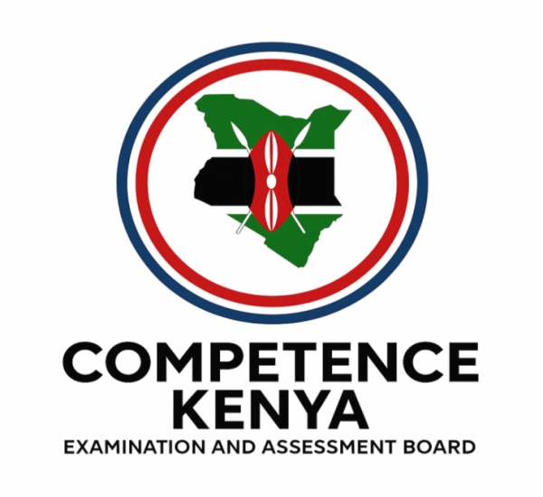
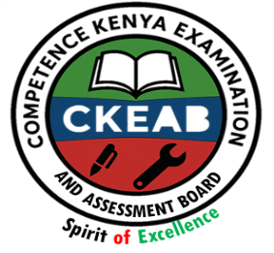
KENYA CERTIFICATE OF BASIC EDUCATION (K.C.B.E)
GRADE 10 –HOMESCIENCE

April 2026
Time: 2 Hours
Code: CKEAB 004
LEARNER’S DETAILS
Name: _______________________________________School: ___________________________________________
Assessment Number: ____________________School Code: ______________ Date: ________Signature: _________
INSTRUCTIONS TO LEARNERS
- Answer ALL questions.
- A county government is planning affordable housing for young families.
a) Explain four factors that should be considered when selecting a suitable house for a family. (4 marks)
i.______________________________________________________________________________________________.
ii.______________________________________________________________________________________________.
iii.______________________________________________________________________________________________.
iv.______________________________________________________________________________________________.
b) Describe two social benefits of living in a well-planned residential area. (2 marks)
i.______________________________________________________________________________________________.
ii.______________________________________________________________________________________________.
c) State two responsibilities of a family in maintaining their house. (2 marks)
i.______________________________________________________________________________________________.
ii.______________________________________________________________________________________________.
- During a practical lesson, a learner suffered a minor burn in the kitchen.
a) Outline the correct procedure for giving first aid to a person with a minor burn. (4 marks)
i.______________________________________________________________________________________________.
ii.______________________________________________________________________________________________.
iii.______________________________________________________________________________________________.
iv.______________________________________________________________________________________________.

b) Identify three possible causes of burns at home. (3 marks)
i.______________________________________________________________________________________________.
ii.______________________________________________________________________________________________.
iii.______________________________________________________________________________________________.
c) Explain three measures that can reduce accidents in the kitchen. (3 marks)
i.______________________________________________________________________________________________.
ii.______________________________________________________________________________________________.
iii.______________________________________________________________________________________________.
- A health officer was invited to talk to learners about adolescence.
a) Differentiate between physical and emotional changes during adolescence. (4 marks)
________________________________________________________________________________________________________________________________________________________________________________________________________________________________________________________________________________________________________________________________________________________________________________________________
b) Discuss two challenges adolescents may face during puberty. (2 marks)
i.______________________________________________________________________________________________.
ii.______________________________________________________________________________________________.
c) Suggest two ways adolescents can maintain good reproductive health. (2 marks)
i.______________________________________________________________________________________________.
ii.______________________________________________________________________________________________.
- A nutritionist visited your school to educate learners about healthy eating.
a) Classify nutrients into body-building, energy-giving and protective foods, giving two examples in each case. (6 marks)
Body building food | Energy giving food | Protective food

b) Explain two consequences of protein deficiency in the body. (2 marks)
i.______________________________________________________________________________________________.
ii.______________________________________________________________________________________________.
c) Describe two advantages of enriching staple foods through fortification. (2 marks)
i.______________________________________________________________________________________________.
ii.______________________________________________________________________________________________.
- A learner prepared a meal using different cooking methods.
a) Compare moist heat and dry heat methods of cooking, giving two examples for each. (4 marks)
.______________________________________________________________________________________________.
.______________________________________________________________________________________________.
.______________________________________________________________________________________________.
.______________________________________________________________________________________________.
b) Explain three effects of cooking on food nutrients. (3 marks)
i.______________________________________________________________________________________________.
ii.______________________________________________________________________________________________.
iii.______________________________________________________________________________________________.
c) Describe three rules of personal hygiene to observe during food preparation. (3 marks)
i.______________________________________________________________________________________________.
ii.______________________________________________________________________________________________.
iii.______________________________________________________________________________________________.
d) Outline two methods of cleaning wooden kitchen equipment. (2 marks)
i.______________________________________________________________________________________________.
ii.______________________________________________________________________________________________.
e) Explain how proper storage of sharp tools improves kitchen safety. (2 marks)
i.______________________________________________________________________________________________.
ii.______________________________________________________________________________________________.

- A family is constructing a modern kitchen.
a) Describe the work triangle principle in kitchen design. (3 marks)
i.______________________________________________________________________________________________.
ii.______________________________________________________________________________________________.
iii.______________________________________________________________________________________________.
b) Explain three advantages of an L-shaped kitchen layout. (3 marks)
i.______________________________________________________________________________________________.
ii.______________________________________________________________________________________________.
iii.______________________________________________________________________________________________.
c) Identify four major kitchen equipment found in a modern kitchen. (4 marks)
i.______________________________________________________________________________________________.
ii.______________________________________________________________________________________________.
iii.______________________________________________________________________________________________.
iv.______________________________________________________________________________________________.
d) State two safety precautions when using electrical kitchen appliances. (2 marks)
i.______________________________________________________________________________________________.
ii.______________________________________________________________________________________________.
- Food from a school event caused stomach upset among some learners.
a) Explain the difference between food contamination and food poisoning. (2 marks)
________________________________________________________________________________________________________________________________________________________________________________________________________________________________________________________________________________________________
b)mention two symptoms of food poisoning
i.______________________________________________________________________________________________.
ii.______________________________________________________________________________________________.

c) State three causes of food contamination. (3 marks)
i.______________________________________________________________________________________________.
ii.______________________________________________________________________________________________.
iii.______________________________________________________________________________________________.
d) Suggest three methods of preserving food at home. (3 marks)
i.______________________________________________________________________________________________.
ii.______________________________________________________________________________________________.
iii.______________________________________________________________________________________________.
iv.______________________________________________________________________________________________.
- A learner is interested in pursuing a career in Foods and Nutrition.
a) Discuss four skills required for success in food-related careers. (4 marks)
i.______________________________________________________________________________________________.
ii.______________________________________________________________________________________________.
iii.______________________________________________________________________________________________.
iv.______________________________________________________________________________________________.
b) Explain four career opportunities available in the field of Home Science. (4 marks)
i.______________________________________________________________________________________________.
ii.______________________________________________________________________________________________.
iii.______________________________________________________________________________________________.
iv.______________________________________________________________________________________________.

