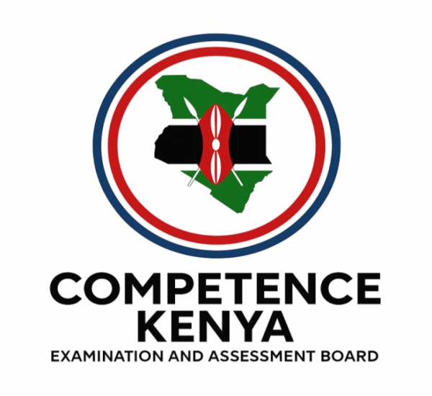
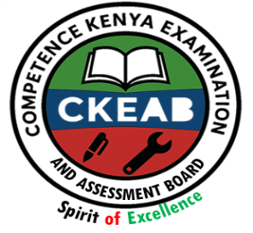
KENYA CERTIFICATE OF BASIC EDUCATION (K.C.B.E)
GRADE 10 –MANDARIN

April 2026
Time: 2 Hours
Code: CKEAB 004
LEARNER’S DETAILS
Name: _______________________________________School: ___________________________________________
Assessment Number: ____________________School Code: ______________ Date: ________Signature: _________
INSTRUCTIONS TO LEARNERS
Answer all questions in mandarin

SECTION A: WRITTEN (70 Marks)

PART A: READING (20 Marks)

Yuèdú duǎnwén:
Wǒ jiào Wáng Jié, jīnnián shíliù suì. Wǒ zhù zài Nèiluóbì. Wǒ jiā yǒu sì kǒu rén: bàba, māma, mèimei hé wǒ. Wǒ de bàba shì yīshēng, tā zài yīyuàn gōngzuò. Wǒ de māma shì lǎoshī, tā hěn xǐhuān huàhuà. Wǒ de mèimei shí suì, tā shì xuéshēng. Wǒ xǐhuān tī zúqiú hé kànshū, dànshì wǒ bù xǐhuān qǐ zǎo.

A. Huídá wèntí (8 marks)
- Tā jiào shénme míngzi?
- Tā jǐ suì?
- Tā zhù zài nǎlǐ?
- Shéi xǐhuān huàhuà?

B. Cóng kèwén zhǎo cí (4 marks)
- Doctor → __________
- Teacher → __________
- Hospital → __________
- Like → __________

C. Wánchéng biǎogé (4 marks)
Bàba → __________________________
Māma → __________________________
Mèimei → _________________________
Wáng Jié → _______________________

D. Zhǔtí (4 marks)
Zhè piān wénzhāng de zhǔyào yìsi shì shénme?
Guānjiàn cí: jiātíng, àihào, shēnghuó, zìwǒ jièshào

PART B: LANGUAGE USE (25 Marks)

A. Tián rù dàicí (5 marks)
- ___ shì Lǐ Míng.
- ___ shì wǒ de péngyou.
- ___ zhù zài Shànghǎi.
- ___ xǐhuān yóuyǒng.
- ___ shì lǎoshī.

B. Tián rù dòngcí (7 marks)
(shì, yǒu, gōngzuò, xǐhuān, zhù, xuéxí)
- Wǒ ___ xuéshēng.
- Wǒ jiā ___ wǔ kǒu rén.
- Bàba zài yīyuàn ___.
- Jiějie ___ chànggē.
- Wǒ ___ zài chéngshì.
- Māma ___ lǎoshī.
- Wǒmen ___ Hànyǔ.

C. Yòng “de” jiégòu (6 marks)
- Zhè shì wǒ ___ shūbāo.
- Tā shì tā ___ gēge.
- Wǒmen qù wǒmen ___ xuéxiào.
- Nà shì tāmen ___ fángzi.
- Tā xǐhuān tā ___ jiā.
- Zhè shì wǒ ___ gǒu.

D. Xiě wèntí (7 marks)
- Nǐ xǐhuān Hànyǔ ma?
- Tā zhù zài nǎlǐ?
- Nǐ yǒu chǒngwù ma?
- Tā jǐ suì?
- Nǐ bàba zuò shénme gōngzuò?
- Tāmen xǐhuān yùndòng ma?
- Xuéxiào zài nǎlǐ?

PART C: WRITING (25 Marks)
Xiě yī piān 80–100 zì de duǎnwén jièshào nǐ hé nǐ de jiārén.
Yāoqiú:
- Míngzi, niánlíng
- Zhù zài nǎlǐ
- Jiārén
- Xǐhuān hé bù xǐhuān
- Yòng: shì, yǒu, zhù, xǐhuān hé “de”
- Zhìshǎo sān gè xíngróngcí

SECTION B: ORALS (30 Marks)

PART A: LISTENING (15 Marks)

Fāyīn hé shēngdiào (5 marks)
Jiātíng
Xuéxiào
Yīshēng
Xǐhuān
Chéngshì
Zhùyì: shēngmǔ, yùnmǔ, shēngdiào, liúlì

Tīnglì lǐjiě (10 marks)
Huídá wèntí:
- Zhǔyào nèiróng shì shénme?
- Tí dào le shéi?
- Shéi xǐhuān shénme?
- Tāmen zhù zài nǎlǐ?
- Zhè duàn huà de zhǔtí shì shénme?

PART B: SPEAKING (15 Marks)

Kǒutóu jièshào (8 marks)
- Míngzi
- Niánlíng
- Zhùzài dì
- Jiārén
- Àihào

Rìcháng duìhuà (7 marks)
- Nǐ zhù zài nǎlǐ?
- Nǐ jiā yǒu jǐ kǒu rén?
- Nǐ xǐhuān shénme yùndòng?
- Nǐ yǒu chǒngwù ma?
- Nǐ bàba zuò shénme gōngzuò?
- Jiàoshì lǐ yǒu shénme?
- Nǐ xǐhuān Hànyǔ ma? Wèishénme?

