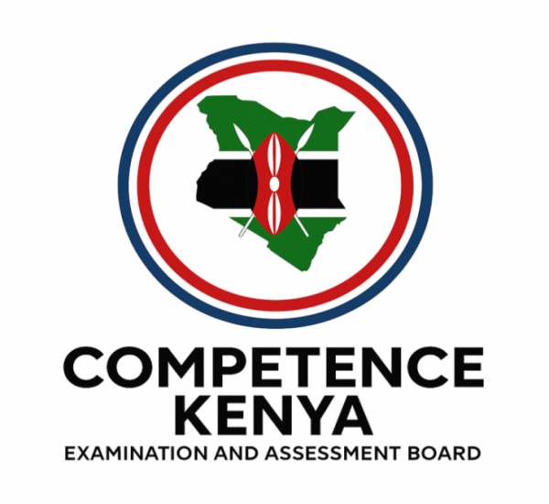
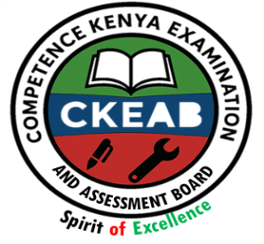
KENYA CERTIFICATE OF BASIC EDUCATION (K.C.B.E)
GRADE 10 –PHYSICAL EDUCATION

April 2026
Time: 2 Hours
Code: CKEAB 004
LEARNER’S DETAILS
Name: _______________________________________School: ___________________________________________
Assessment Number: ____________________School Code: ______________ Date: ________Signature: _________
INSTRUCTIONS TO LEARNERS
Answer all questions
SECTION A: THEORY (80 Marks)
QUESTION 1: RUGBY (6 MARKS)
a) Name three types of passes commonly used in rugby. (3 marks)
i. _________________________________________________________________________________________
ii. _________________________________________________________________________________________
iii. _________________________________________________________________________________________
b) Explain two safety rules observed when performing a tackle. (2 marks)
i. _________________________________________________________________________________________
ii. _________________________________________________________________________________________
c) State one benefit of mastering the side step in rugby. (1 mark)
________________________________________________________________________________________________________________________________________________________________________________________________
QUESTION 2: VOLLEYBALL (8 MARKS)
a) Identify three facilities found in a volleyball court. (3 marks)
i. _________________________________________________________________________________________
ii. _________________________________________________________________________________________
iii. _________________________________________________________________________________________
b) Describe the correct body position when performing a spike. (3 marks)
i. _________________________________________________________________________________________
ii. _________________________________________________________________________________________
iii. _________________________________________________________________________________________
c) List two pieces of equipment used in volleyball. (2 marks)
i. _________________________________________________________________________________________
ii. _________________________________________________________________________________________

QUESTION 3: BASKETBALL (10 MARKS)
a) Identify three zones of a basketball court. (3 marks)
i. _________________________________________________________________________________________
ii. _________________________________________________________________________________________
iii. _________________________________________________________________________________________
b) Outline three defensive techniques used to mark an opponent. (3 marks)
i. _________________________________________________________________________________________
ii. _________________________________________________________________________________________
iii. _________________________________________________________________________________________
c) State two pieces of equipment used in a basketball game. (2 marks)
i. _________________________________________________________________________________________
ii. _________________________________________________________________________________________
d) Explain two advantages of effective marking during a basketball game. (2 marks)
i. _________________________________________________________________________________________
ii. _________________________________________________________________________________________
QUESTION 4: HANDBALL (7 MARKS)
a) Draw and label a handball court, showing goal area and centre line. (3 marks)
b) Describe two key stances used when passing the ball. (2 marks)
i. _________________________________________________________________________________________
ii. _________________________________________________________________________________________
c) State two advantages of accurate passing in handball. (2 marks)
i. _________________________________________________________________________________________
ii. _________________________________________________________________________________________
QUESTION 5: FOOTBALL (10 MARKS)
a) Identify three qualities of a good goalkeeper. (3 marks)
i. _________________________________________________________________________________________
ii. _________________________________________________________________________________________
iii. _________________________________________________________________________________________
b) Describe the correct stance before executing a lofted pass. (2 marks)
________________________________________________________________________________________________________________________________________________________________________________________________
c) Explain two roles of follow-through when kicking the ball. (2 marks)
i. _________________________________________________________________________________________
ii. _________________________________________________________________________________________

d) State three goalkeeping skills observed during play. (3 marks)
i. _________________________________________________________________________________________
ii. _________________________________________________________________________________________
iii. _________________________________________________________________________________________
QUESTION 6: NETBALL (9 MARKS)
a) Name three facilities used in a netball game. (3 marks)
i. _________________________________________________________________________________________
ii. _________________________________________________________________________________________
iii. _________________________________________________________________________________________
b) Identify three types of passes commonly used in netball. (3 marks)
i. _________________________________________________________________________________________
ii. _________________________________________________________________________________________
iii. _________________________________________________________________________________________
c) Explain two safety precautions observed during a netball game. (3 marks)
i. _________________________________________________________________________________________
ii. _________________________________________________________________________________________
iii. _________________________________________________________________________________________
QUESTION 7: GENERAL FITNESS AND MOVEMENT SKILLS (7 MARKS)
a) Define the term “follow-through” in ball games. (2 marks)
________________________________________________________________________________________________________________________________________________________________________________________________
b) Explain two benefits of proper dodging techniques in sports. (2 marks)
i. _________________________________________________________________________________________
ii. _________________________________________________________________________________________
c) Identify three qualities of an effective marker in any ball game. (3 marks)
i. _________________________________________________________________________________________
ii. _________________________________________________________________________________________
iii. _________________________________________________________________________________________
QUESTION 8: VOLLEYBALL SERVE AND SETTING (6 MARKS)
a) Identify the types of volleyball serves. (3 marks)
i. _________________________________________________________________________________________
ii. _________________________________________________________________________________________
iii. _________________________________________________________________________________________

b) Describe correct hand placement when performing a set. (2 marks)
i. _________________________________________________________________________________________
ii. _________________________________________________________________________________________
c) State one safety precaution when serving in volleyball. (1 mark)
________________________________________________________________________________________________________________________________________________________________________________________________
QUESTION 9: SPORTS EQUIPMENT IDENTIFICATION (6 MARKS)
  - Draw four equipment used in a game of football

b) Name two pieces of protective equipment used in rugby. (2 marks)
i. _________________________________________________________________________________________
ii. _________________________________________________________________________________________
QUESTION 10: SAFETY IN SPORTS (11 MARKS)
a) State three general safety rules observed in team ball games. (3 marks)
i. _________________________________________________________________________________________
ii. _________________________________________________________________________________________
iii. _________________________________________________________________________________________
b) Explain two ways warm-up exercises prevent injuries. (2 marks)
i. _________________________________________________________________________________________
ii. _________________________________________________________________________________________
c) Describe two safety precautions for goalkeepers in football. (2 marks)
i. _________________________________________________________________________________________
ii. _________________________________________________________________________________________
d) Outline two safety rules for handball. (2 marks)
i. _________________________________________________________________________________________
ii. _________________________________________________________________________________________
e) State two safety measures in rugby. (2 marks)
i. _________________________________________________________________________________________
ii. _________________________________________________________________________________________

