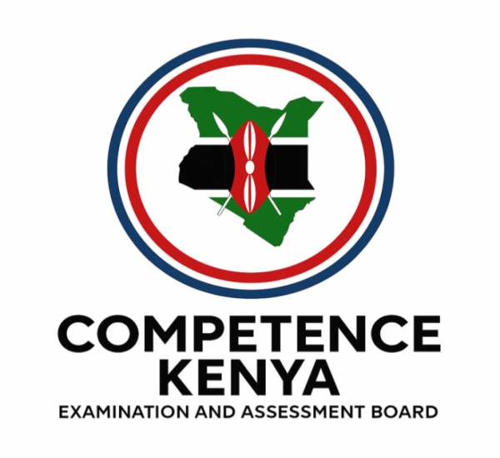
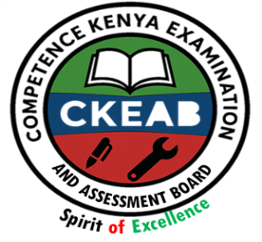
KENYA CERTIFICATE OF BASIC EDUCATION (K.C.B.E)
GRADE 10 –POWER MECHANICS

April 2026
Time: 2 Hours
Code: CKEAB 004
LEARNER’S DETAILS
Name: _______________________________________School: ___________________________________________
Assessment Number: ____________________School Code: ______________ Date: ________Signature: _________
INSTRUCTIONS TO LEARNERS
- Answer all questions.
- Show all working in calculation questions.

SECTION A (60 MARKS)

1. a) Define the term Power Mechanics. (2 marks)
________________________________________________________________________________________________________________________________________________________________________________________________
b) Explain two major objectives of studying Power Mechanics in Senior secondary school. (4 marks)
i. ______________________________________________________________________________________________.
ii. ______________________________________________________________________________________________.
2. a) Identify three career opportunities in the field of Power Mechanics. (3 marks)
i. ______________________________________________________________________________________________.
ii. ______________________________________________________________________________________________.
iii. _____________________________________________________________________________________________.
b) Describe three ethical qualities expected of a professional motor vehicle technician. (3 marks)
i. ______________________________________________________________________________________________.
ii. ______________________________________________________________________________________________.
iii. _____________________________________________________________________________________________.

3. a) Name the inventor of the first practical gasoline-powered automobile and state the year of invention. (2 marks)
Name: ________________________________ year: _____________________________________

b) Explain two limitations of early motor vehicles. (2 marks)
i. ______________________________________________________________________________________________.
ii. ______________________________________________________________________________________________.
c) Discuss two ways mass production transformed the automobile industry. (4 marks)
i. ______________________________________________________________________________________________.
ii. ______________________________________________________________________________________________.
4. a) Differentiate between a two-stroke and a four-stroke engine. (4 marks)
Two stroke engine | Four stroke engine
b) Explain two advantages of modern hybrid engines over conventional petrol engines. (4 marks)
i. ______________________________________________________________________________________________.
ii. ______________________________________________________________________________________________.
5. a) Identify four essential sections found in a well-organized power mechanics workshop. (4 marks)
i. ______________________________________________________________________________________________.
ii. ______________________________________________________________________________________________.
iii. _____________________________________________________________________________________________. v._____________________________________________________________________________________________.
b) Explain two reasons why proper workshop layout improves efficiency and safety. (4 marks)
i. ______________________________________________________________________________________________.
ii. ______________________________________________________________________________________________.
6. a) State four general safety rules in a power mechanics workshop. (4 marks)
i. ______________________________________________________________________________________________.
ii. ______________________________________________________________________________________________.
iii. _____________________________________________________________________________________________. v._____________________________________________________________________________________________.

b) Explain two consequences of ignoring safety procedures in a workshop. (4 marks)
i. ______________________________________________________________________________________________.
ii. ______________________________________________________________________________________________.
7. a) Describe the function of the following tools: (6 marks)
i) Vernier caliper
__________________________________________________________________________________________.
__________________________________________________________________________________________.
ii) Micrometer screw gauge
__________________________________________________________________________________________.
__________________________________________________________________________________________.
iii) Torque wrench
__________________________________________________________________________________________.
__________________________________________________________________________________________.
b) Explain why precision measuring tools are important in engine assembly. (2 marks)
  - __________________________________________________________________________________________.
  - __________________________________________________________________________________________.

8. a) Classify the following as ferrous or non-ferrous metals: steel, aluminium, copper, cast iron. (4 marks)

Ferrous metals | Nonferrous metals
b) Explain two properties that make aluminium suitable for engine components. (4 marks)
  - __________________________________________________________________________________________.
  - __________________________________________________________________________________________.

SECTION B (40 MARKS)
Answer all questions.

9. a) Define orthographic projection. (2 marks)
__________________________________________________________________________________________.
__________________________________________________________________________________________.
b) Explain the importance of accuracy in technical drawing. (3 marks)
  - __________________________________________________________________________________________.
  - __________________________________________________________________________________________.
  - __________________________________________________________________________________________.
c) Describe two instruments used in mechanical drawing and their uses. (3 marks)
  - __________________________________________________________________________________________.
  - __________________________________________________________________________________________.
  - __________________________________________________________________________________________.

10. A school plans to establish a new Power Mechanics training workshop.
a) Outline four factors to consider when selecting the workshop site. (4 marks)
  - __________________________________________________________________________________________.
  - __________________________________________________________________________________________.
  - __________________________________________________________________________________________.
  - __________________________________________________________________________________________.
b) Explain two ways the workshop can promote environmental sustainability. (4 marks)
  - __________________________________________________________________________________________.
  - __________________________________________________________________________________________.

11. a) Explain the function of the following vehicle systems: (4 marks)
i) Cooling system
__________________________________________________________________________________________.
__________________________________________________________________________________________.

ii) Lubrication system
__________________________________________________________________________________________.
__________________________________________________________________________________________.
b) Describe two signs that indicate a faulty braking system. (4 marks)
  - __________________________________________________________________________________________.
  - __________________________________________________________________________________________.

12. a) Explain two reasons why many countries are encouraging the use of electric vehicles. (4 marks)
  - __________________________________________________________________________________________.
  - __________________________________________________________________________________________.
b) Discuss two challenges facing electric vehicle adoption in developing countries. (4 marks)
  - __________________________________________________________________________________________.
  - __________________________________________________________________________________________.

13. A mechanic discovers that an engine overheats frequently.
a) Identify two possible causes of engine overheating. (4 marks)
  - __________________________________________________________________________________________.
  - __________________________________________________________________________________________.
b) Suggest two preventive maintenance practices to avoid engine overheating. (4 marks)
  - __________________________________________________________________________________________.
  - __________________________________________________________________________________________.

