AGRICULTURE GRADE 10
MID-TERM 2 EXAM 2026
TIME: 2 HOURS 30 MINUTES
NAME……………………………………………………...ADM NO………………………………………………
DATE………………………………………………………………………...SIGN…………………………………….
INSTRUCTIONS TO CANDIDATES
- Answer ALL questions in the spaces provided
- Show all your working for calculation questions
- Write your name and class on the answer sheet

SECTION A: (45 MARKS)
1. Define the term agricultural land. (2 marks)
_______________________________________________________________________________________________
_______________________________________________________________________________________________
_______________________________________________________________________________________________

2. State four ways of accessing agricultural land for farming. (4 marks)
i) ________________________________________________________________________________
_______________________________________________________________________________________________
ii) ________________________________________________________________________________
_______________________________________________________________________________________________
iii) ________________________________________________________________________________
_______________________________________________________________________________________________
iv) ________________________________________________________________________________
_______________________________________________________________________________________________

3. Study the diagram below showing different land types and answer the questions that follow. (5 marks)
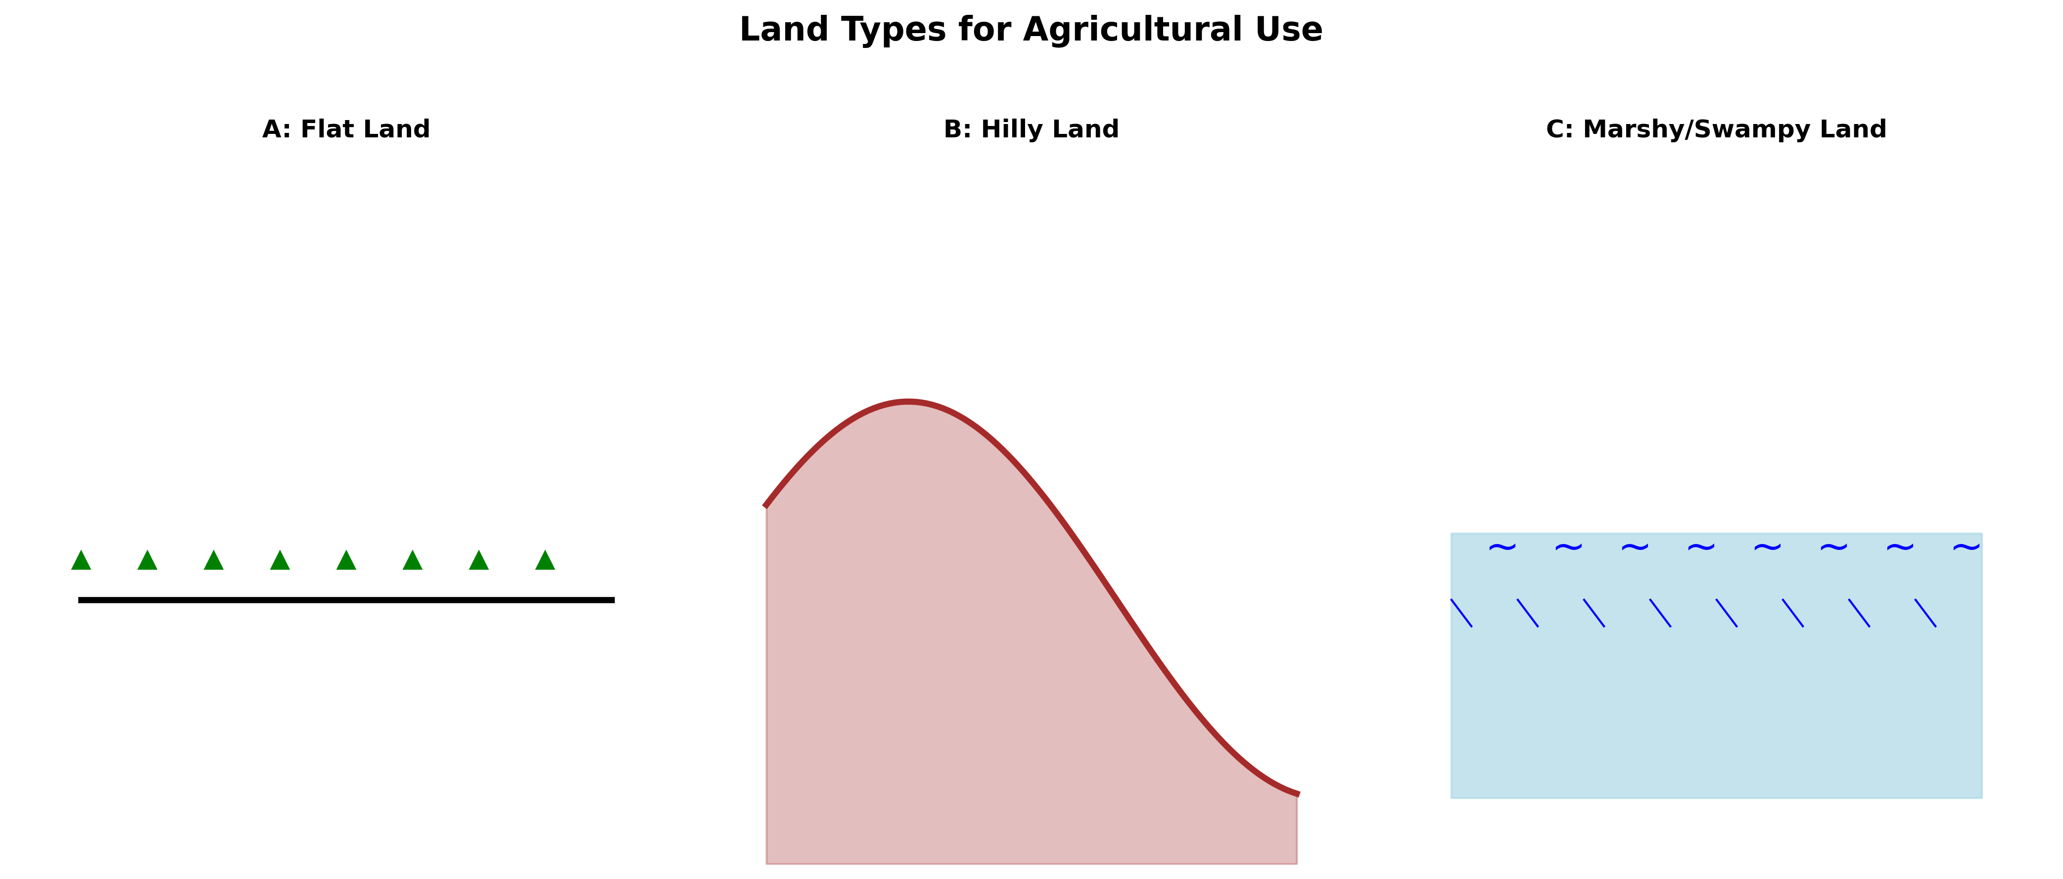

a) Identify land type B and state its agricultural significance. (2 marks)
_______________________________________________________________________________________________
_______________________________________________________________________________________________
_______________________________________________________________________________________________
b) State two challenges of using land type C for farming. (2 marks)
i) ________________________________________________________________________________
_______________________________________________________________________________________________
ii) ________________________________________________________________________________
_______________________________________________________________________________________________
c) Suggest one method to improve land type C for crop production. (1 mark)
_______________________________________________________________________________________________
_______________________________________________________________________________________________

4. Explain how each of the following factors affects land productivity: (6 marks)
a) Altitude:
_______________________________________________________________________________________________
_______________________________________________________________________________________________
_______________________________________________________________________________________________
b) Climate:
_______________________________________________________________________________________________
_______________________________________________________________________________________________
_______________________________________________________________________________________________
c) Biotic factors:
_______________________________________________________________________________________________
_______________________________________________________________________________________________
_______________________________________________________________________________________________

5. Name four soil properties that affect crop growth. (4 marks)
i) ________________________________________________________________________________
ii) ________________________________________________________________________________
iii) ________________________________________________________________________________
iv) ________________________________________________________________________________

6. Explain three ways a farmer can improve soil productivity. (6 marks)
i) ________________________________________________________________________________
_______________________________________________________________________________________________
_______________________________________________________________________________________________
ii) ________________________________________________________________________________
_______________________________________________________________________________________________
_______________________________________________________________________________________________
iii) ________________________________________________________________________________
_______________________________________________________________________________________________
_______________________________________________________________________________________________

7. State three objectives of land preparation before planting. (3 marks)
i) ________________________________________________________________________________
_______________________________________________________________________________________________
ii) ________________________________________________________________________________
_______________________________________________________________________________________________
iii) ________________________________________________________________________________
_______________________________________________________________________________________________

8. Study the crop rotation cycle diagram and answer the questions. (5 marks)
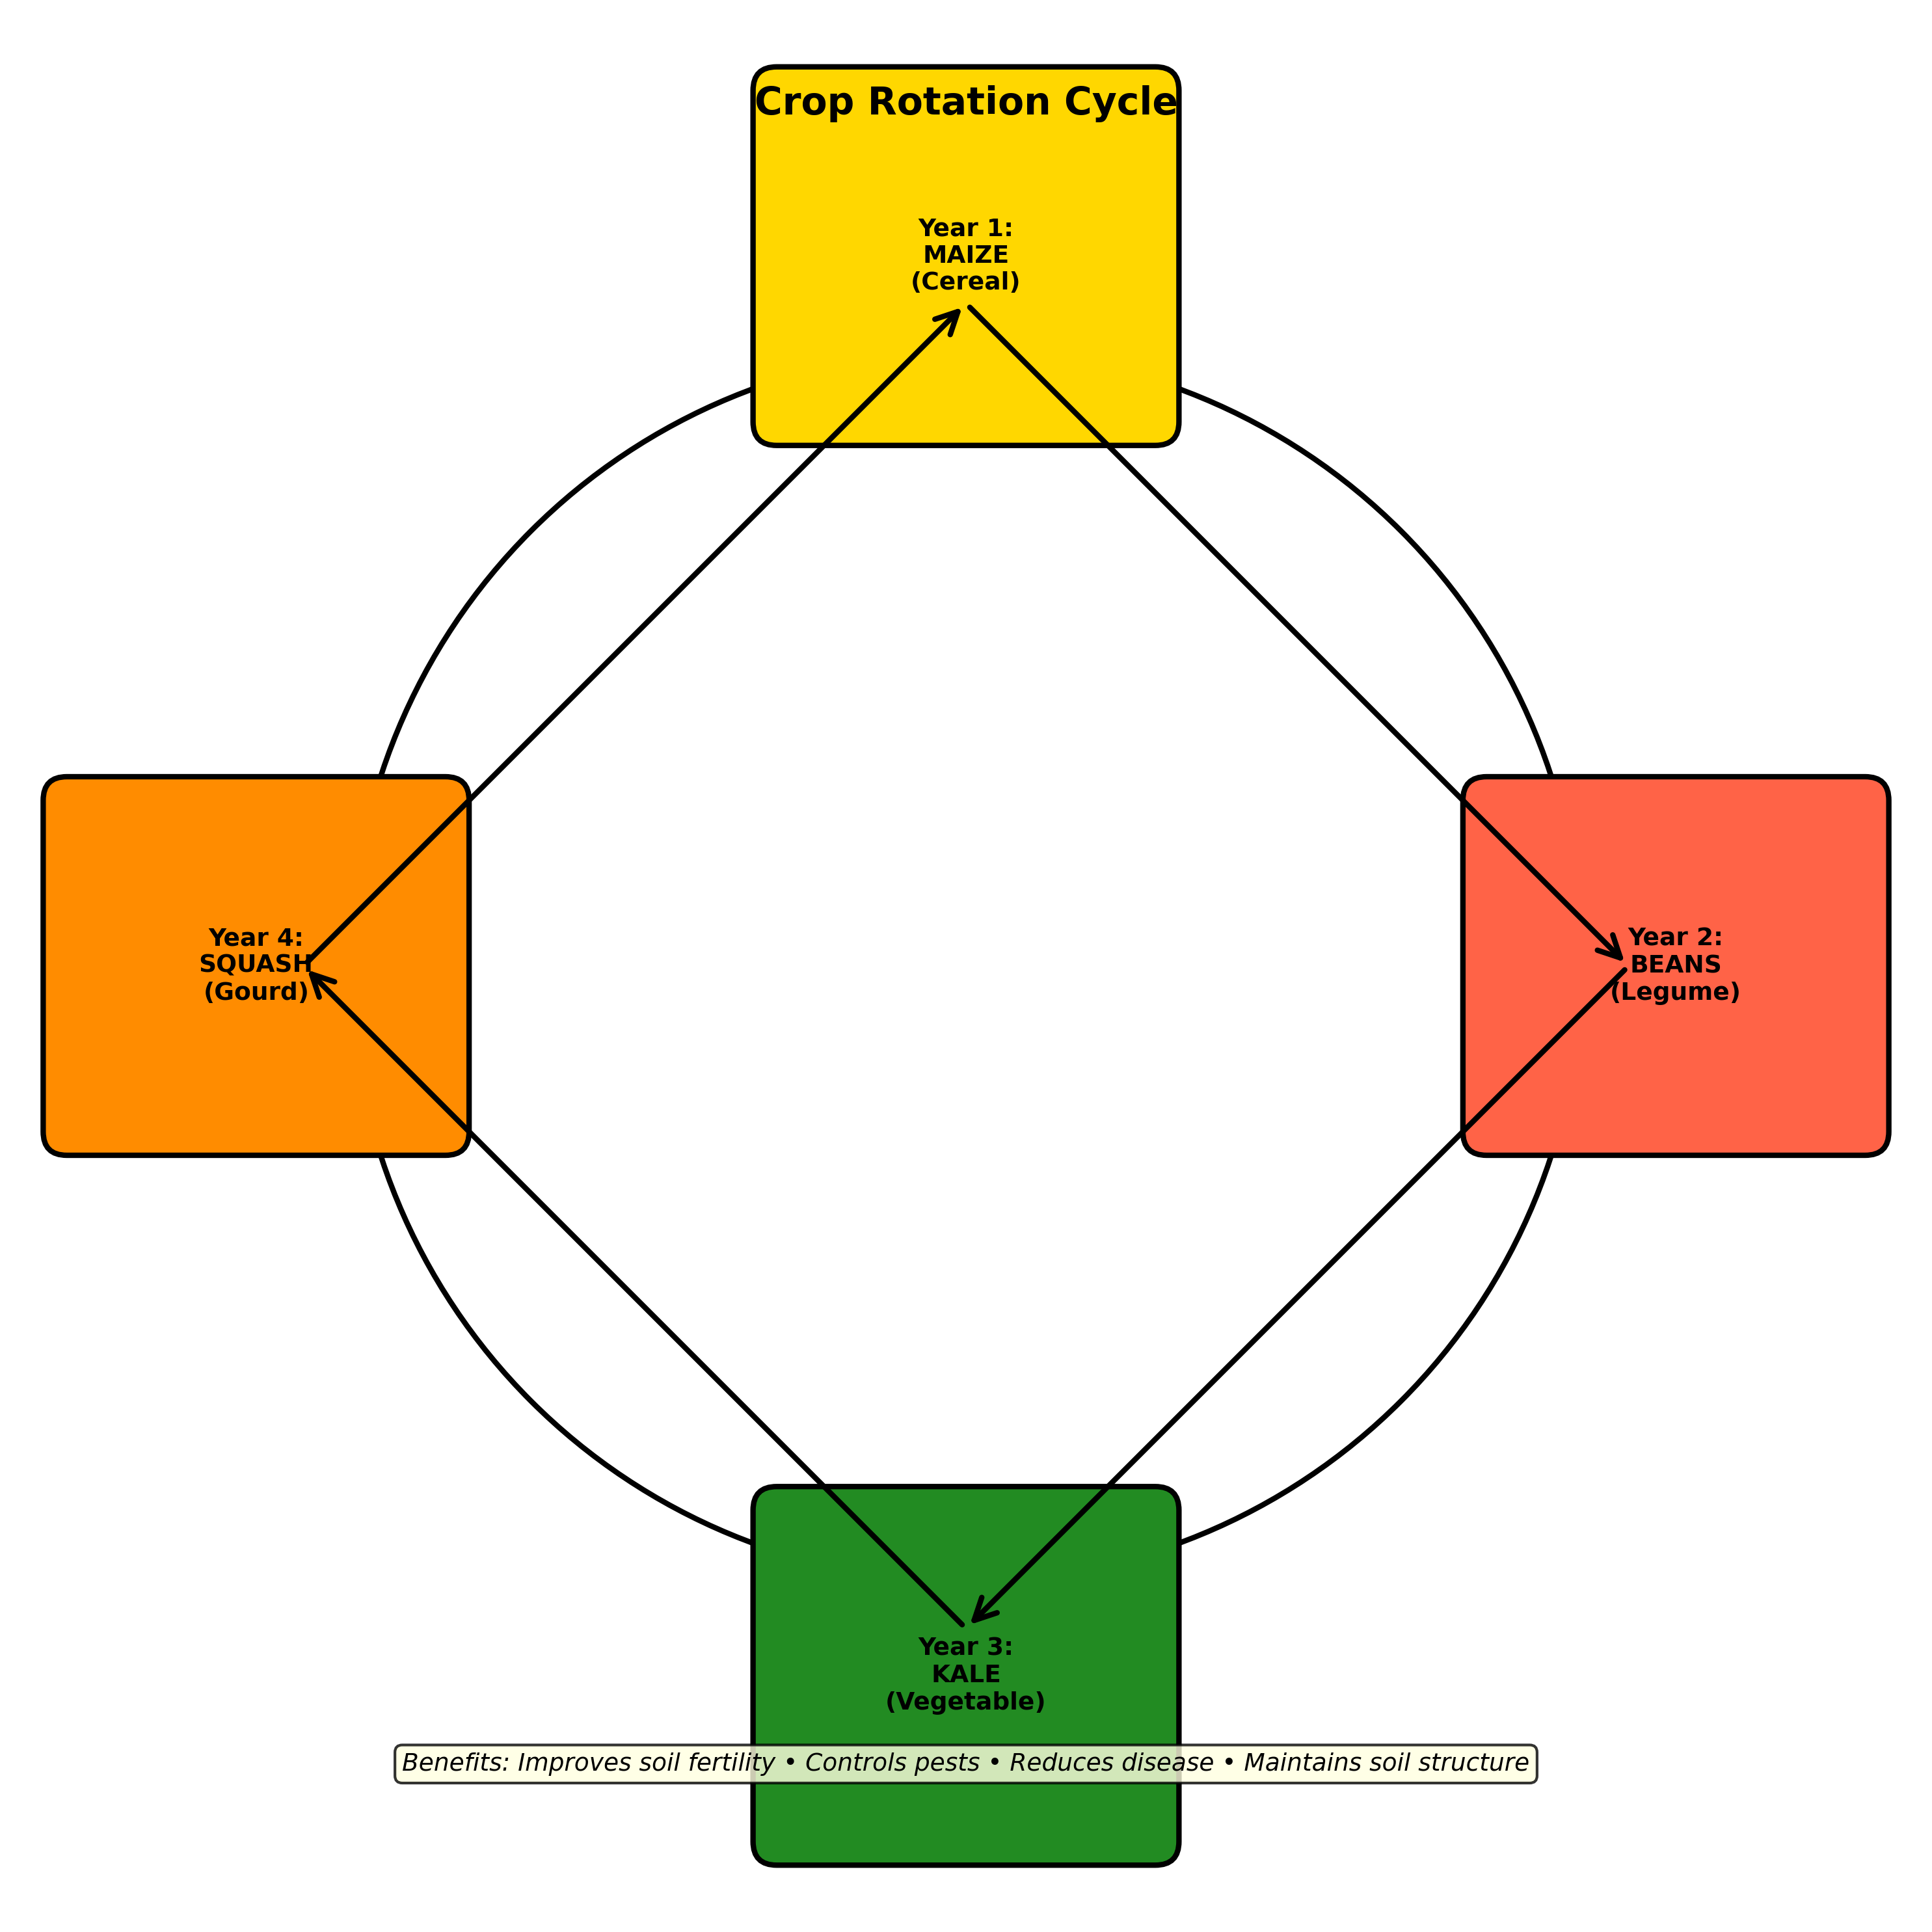

a) What is crop rotation? (1 mark)
_______________________________________________________________________________________________
_______________________________________________________________________________________________
b) State two benefits of crop rotation. (2 marks)
i) ________________________________________________________________________________
_______________________________________________________________________________________________
ii) ________________________________________________________________________________
_______________________________________________________________________________________________
c) Name two crops that can be rotated with maize. (2 marks)
i) ________________________________________________________________________________
ii) ________________________________________________________________________________

9. Study the weed control methods diagram and answer the questions. (4 marks)
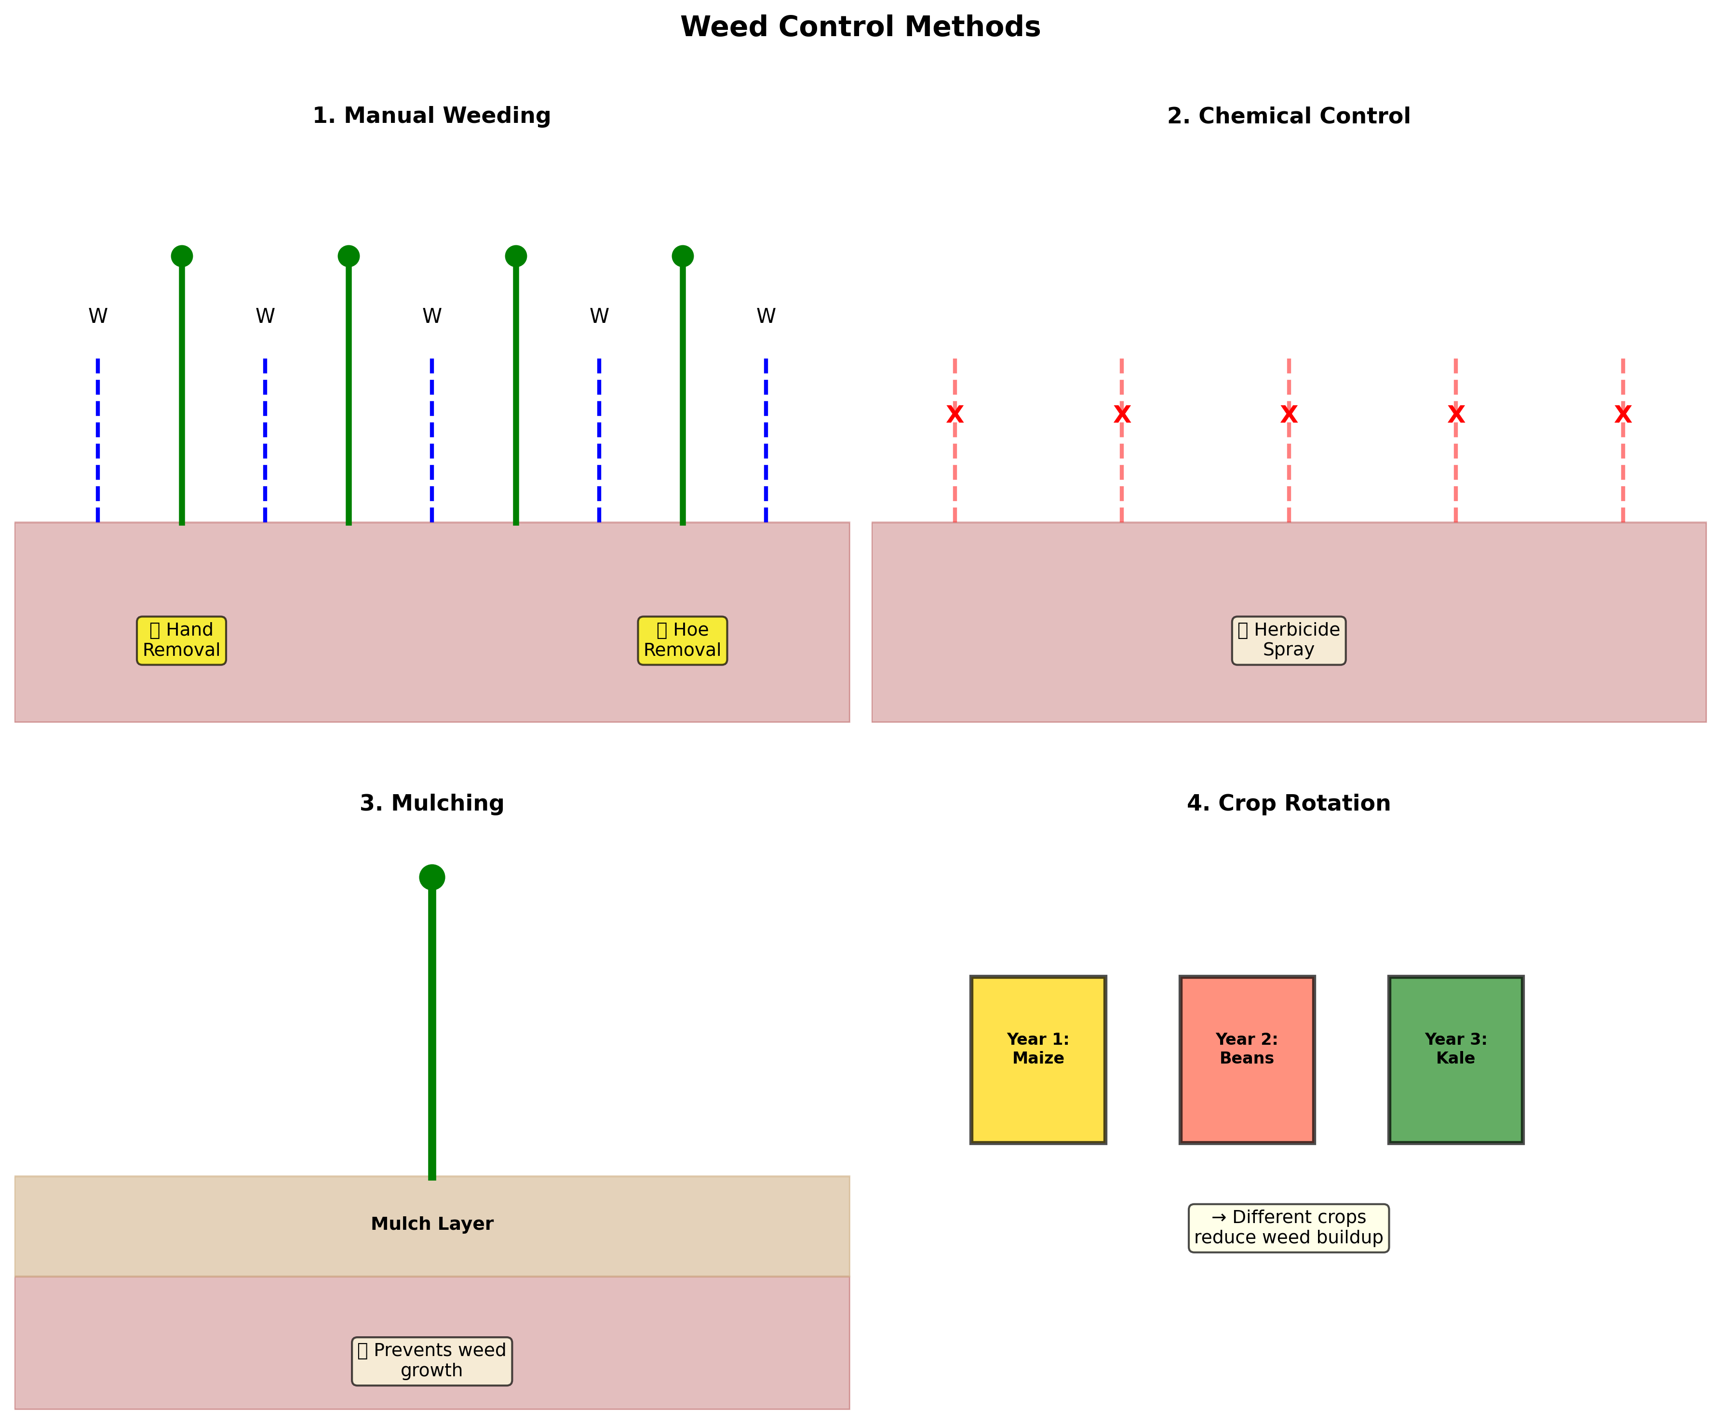

a) Name two methods of weed control shown in the diagram. (2 marks)
i) ________________________________________________________________________________
ii) ________________________________________________________________________________
b) Describe how mulching helps in weed control. (2 marks)
_______________________________________________________________________________________________
_______________________________________________________________________________________________
_______________________________________________________________________________________________

10. Explain three reasons why field management practices are important. (3 marks)
i) ________________________________________________________________________________
_______________________________________________________________________________________________
ii) ________________________________________________________________________________
_______________________________________________________________________________________________
iii) ________________________________________________________________________________

SECTION B:(30 MARKS)
11. Define the following terms: (3 marks)
a) Livestock breed:
_______________________________________________________________________________________________
_______________________________________________________________________________________________
b) Animal production:
_______________________________________________________________________________________________
_______________________________________________________________________________________________

12. Study the livestock breeds diagram and answer the questions. (4 marks)
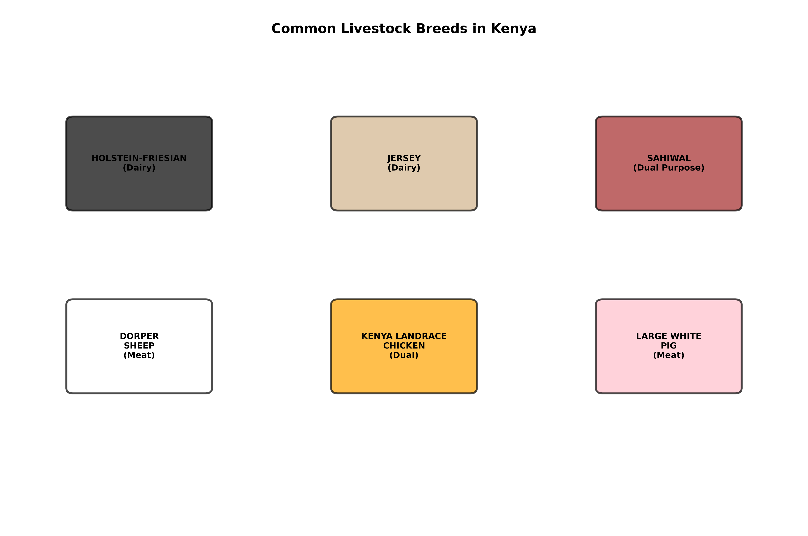

a) Name one dairy cattle breed and one characteristic. (1 mark)
_______________________________________________________________________________________________
_______________________________________________________________________________________________
b) State one advantage of raising indigenous breeds in Kenya. (1 mark)
_______________________________________________________________________________________________
_______________________________________________________________________________________________
c) Name one poultry breed suitable for egg production. (1 mark)
_______________________________________________________________________________________________
_______________________________________________________________________________________________
d) Explain one reason for keeping different livestock breeds. (1 mark)
_______________________________________________________________________________________________
_______________________________________________________________________________________________

13. State five safety measures to observe when handling livestock. (5 marks)
a) ___________________________________________________________________________
_______________________________________________________________________________________________
b) ___________________________________________________________________________
_______________________________________________________________________________________________
c) ___________________________________________________________________________
_______________________________________________________________________________________________
d) ___________________________________________________________________________
_______________________________________________________________________________________________
e) ___________________________________________________________________________
_______________________________________________________________________________________________

14. Explain four signs of disease in livestock. (4 marks)
i) ________________________________________________________________________________
_______________________________________________________________________________________________
ii) ________________________________________________________________________________
_______________________________________________________________________________________________
iii) ________________________________________________________________________________
_______________________________________________________________________________________________
iv) ________________________________________________________________________________
_______________________________________________________________________________________________

15. Differentiate between vaccination and drenching in livestock health management. (3 marks)
Vaccination:
_______________________________________________________________________________________________
_______________________________________________________________________________________________
Drenching:
_______________________________________________________________________________________________
_______________________________________________________________________________________________

16. Explain three advantages of beekeeping as an agricultural enterprise. (3 marks)
i) ________________________________________________________________________________
_______________________________________________________________________________________________
_______________________________________________________________________________________________
ii) ________________________________________________________________________________
_______________________________________________________________________________________________
_______________________________________________________________________________________________
iii) ________________________________________________________________________________
_______________________________________________________________________________________________
_______________________________________________________________________________________________

17. Name four essential conditions for successful animal rearing. (4 marks)
i) ________________________________________________________________________________
ii) ________________________________________________________________________________
iii) ________________________________________________________________________________
iv) ________________________________________________________________________________

SECTION C: (25 MARKS)
18. Define the following agricultural tools: (4 marks)
a) Hoe:
_______________________________________________________________________________________________
_______________________________________________________________________________________________
b) Panga:
_______________________________________________________________________________________________
_______________________________________________________________________________________________
c) Rake:
_______________________________________________________________________________________________
_______________________________________________________________________________________________
d) Mattock:
_______________________________________________________________________________________________
_______________________________________________________________________________________________

19. Explain three advantages of using improved agricultural equipment in farming. (3 marks)
i) ________________________________________________________________________________
_______________________________________________________________________________________________
_______________________________________________________________________________________________
ii) _____________________________________________________________________________
_______________________________________________________________________________________________
_______________________________________________________________________________________________
iii) ________________________________________________________________________________
_______________________________________________________________________________________________
_______________________________________________________________________________________________

20. Define value addition and give two examples of value-added agricultural products. (3 marks)

_______________________________________________________________________________________________
_______________________________________________________________________________________________
Example 1: ______________________________________________________________________
Example 2: ______________________________________________________________________

21. Explain three requirements for establishing a successful agricultural enterprise. (6 marks)
i) ________________________________________________________________________________
_______________________________________________________________________________________________
_______________________________________________________________________________________________
ii) ________________________________________________________________________________
_______________________________________________________________________________________________
_______________________________________________________________________________________________
iii) ________________________________________________________________________________
_______________________________________________________________________________________________
_______________________________________________________________________________________________

22. Name four marketing channels for agricultural produce. (4 marks)
i) ________________________________________________________________________________
ii) ________________________________________________________________________________
iii) ________________________________________________________________________________
iv) ________________________________________________________________________________

23. Explain two advantages of composting in farming. (2 marks)
i) ________________________________________________________________________________
_______________________________________________________________________________________________
ii) ________________________________________________________________________________
_______________________________________________________________________________________________

24. A farmer has 2 hectares of land and wants to plant maize. If the recommended plant spacing is 75 cm between rows and 30 cm between plants within a row, calculate the number of maize plants that can be planted.
_______________________________________________________________________________________________
_______________________________________________________________________________________________
_______________________________________________________________________________________________
_______________________________________________________________________________________________
_______________________________________________________________________________________________
_______________________________________________________________________________________________
_______________________________________________________________________________________________
_______________________________________________________________________________________________

25. Draw and label a soil profile diagram showing the five soil horizons (O, A, B, C, and R) with their names and contents.

