BIOLOGY GRADE 10
MID-TERM 2 EXAM 2026
TIME: 2 HOURS 30 MINUTES

NAME…………………………………….ADM NO………………………………….
DATE……………………………………………SIGN……………………………….

INSTRUCTIONS TO CANDIDATES

1. Write your name, admission number and date in the spaces provided.
2. Answer ALL questions in the spaces provided.
3. This paper has two sections: Section A and B.

SECTION A (40 MARKS)
Answer all questions in this section.
1. (a) Describe the structure of a mitochondrion and explain how its structure is adapted to its function. (5 marks)

(b) Draw and label a complete diagram of a mitochondrion. (3 marks)

2. (a) A plant was placed in a photosynthesis apparatus. The rate of photosynthesis was measured at different light intensities. The results are shown in the table below:

Light Intensity (×1000 lux) | Rate of Photosynthesis (cm³/min)
0 | -0.5
2 | 2.0
4 | 4.0
6 | 4.5
8 | 4.8

i) What is the light compensation point? (2 marks)

ii) Calculate the percentage increase in the rate of photosynthesis when light intensity increases from 4×1000 lux to 8×1000 lux. Show your working. (2 marks)

(b) Name the process by which plants lose water from their leaves. (1 mark)

3. (a) Describe the process of anaerobic respiration in plants. (4 marks)

(b) State two differences between aerobic and anaerobic respiration. (2 marks)

4. (a) Draw and label the transverse section of a dicot leaf showing the different tissues. (5 marks)

(b) Explain why the palisade mesophyll is located on the upper surface of the leaf. (3 marks)

5. (a) Define osmosis. (1 mark)

(b) A cell is placed in a hypertonic solution. Describe what happens to the cell and explain why. (4 marks)

SECTION B (40 MARKS)
Answer any FOUR questions from this section.
6. (a) Draw and label a diagram of the human heart showing all four chambers and the major blood vessels. (6 marks)

(b) Explain the pathway of blood through the heart during one complete heartbeat. (4 marks)

7. A student carried out an experiment to investigate the effect of temperature on enzyme activity. The enzyme used was catalase and the substrate was hydrogen peroxide. The graph below shows the results.
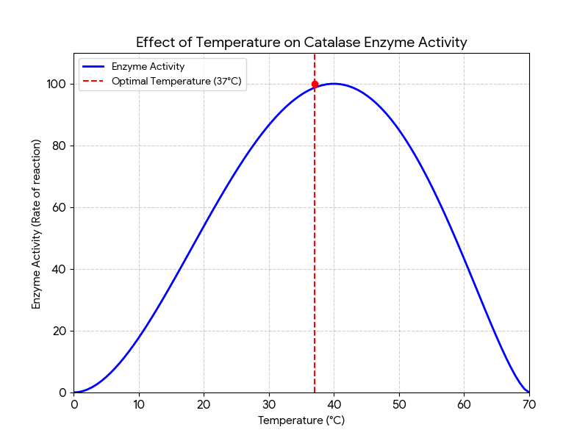
(a) Draw the curve showing the relationship between temperature (0-70°C) and enzyme activity. Mark the optimal temperature. (3 marks)

(b) Explain why enzyme activity increases with temperature up to the optimal temperature. (2 marks)

(c) What happens to the enzyme at temperatures above 60°C and why? (2 marks)

(d) Name the part of the enzyme that is responsible for substrate binding. (1 mark)

8. (a) Define each of the following terms: (3 marks)
i) Reflex

ii) Synapse

iii) Hormone

(b) Draw and label the reflex arc showing the pathway from a sensory receptor to an effector. (4 marks)

(c) Explain why reflex actions are faster than conscious responses. (3 marks)

9. (a) Describe the menstrual cycle in the human female and name the hormones involved. (6 marks)

(b) State two methods of contraception and explain how each method works. (4 marks)

10. (a) What is meant by the term 'carrying capacity' of an environment? (2 marks)

(b) A population of bacteria doubles every hour. If 100 bacteria are present initially, how many will be present after 4 hours? Show your working. (2 marks)

(c) Name four biotic factors that can limit population growth. (2 marks)

(d) State the difference between a food chain and a food web. (2 marks)

11. (a) What is meant by the term mutation? (1 mark)

(b) Name two environmental factors that can cause mutations. (1 mark)

(c) Explain how natural selection leads to evolution. (4 marks)

(d) Give two pieces of evidence for evolution. (2 marks)

