CHEMISTRY GRADE 10
MIDTERM 2 EXAM 2026
TIME: 2 HOURS

NAME……………………………………….ADM NO…………………………
DATE………………………………………SIGN……………………………….

INSTRUCTIONS
- Answer ALL questions
- This paper consists of TWO sections: Section A, Section B.
- Section A carries 40 marks, Section B carries 40 marks.
- Show all your working where necessary

SECTION A (40 MARKS)
Answer ALL questions in this section.
1.The diagram below shows part of an atom. (5 marks)
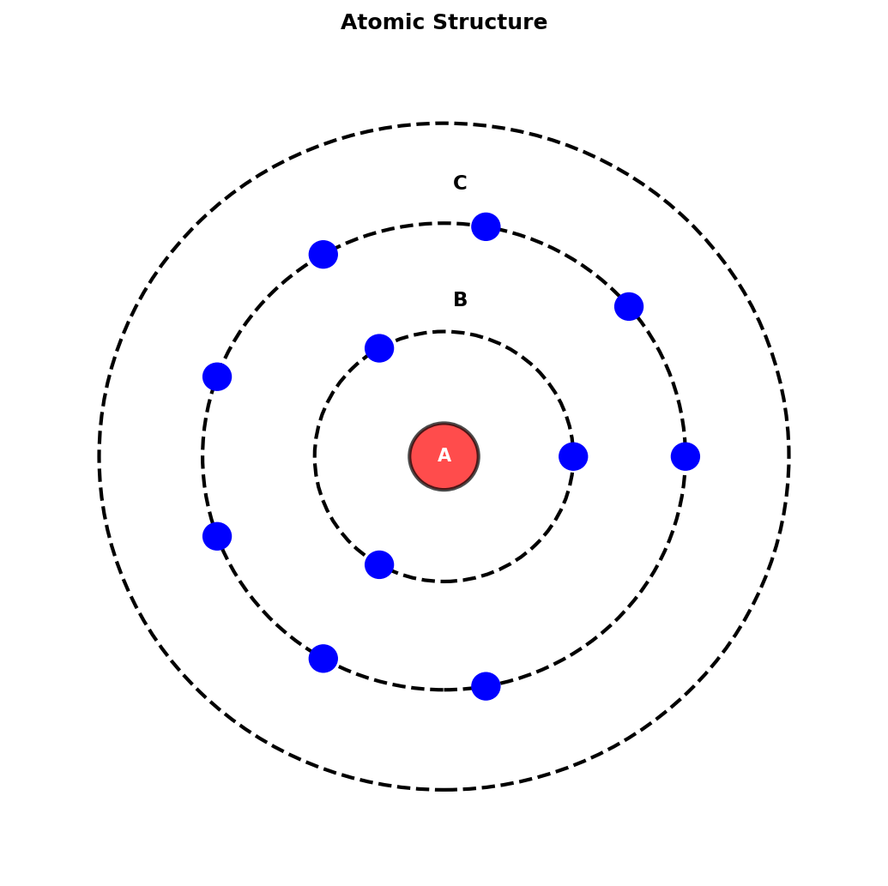
(a) Identify the parts labeled A, B and C in the diagram above. (3 marks)

(b) State the relative mass of a proton. (1 mark)

(c) Define isotopes. (1 mark)

2.The diagram shows a laboratory apparatus used in chemistry. (6 marks)
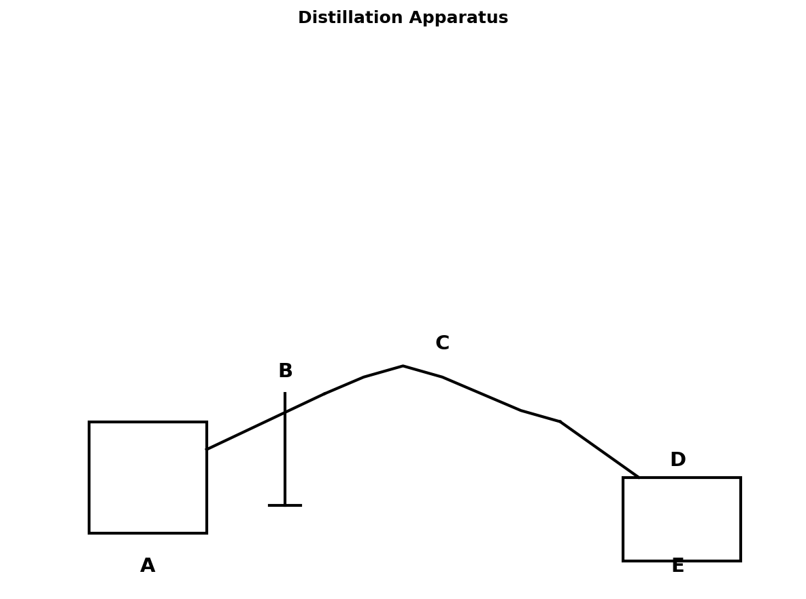
(a) Name the apparatus labeled A, B, C, D and E. (5 marks)

(b) What is the purpose of apparatus C? (1 mark)

3.Study the diagram below and answer the questions that follow. (7 marks)
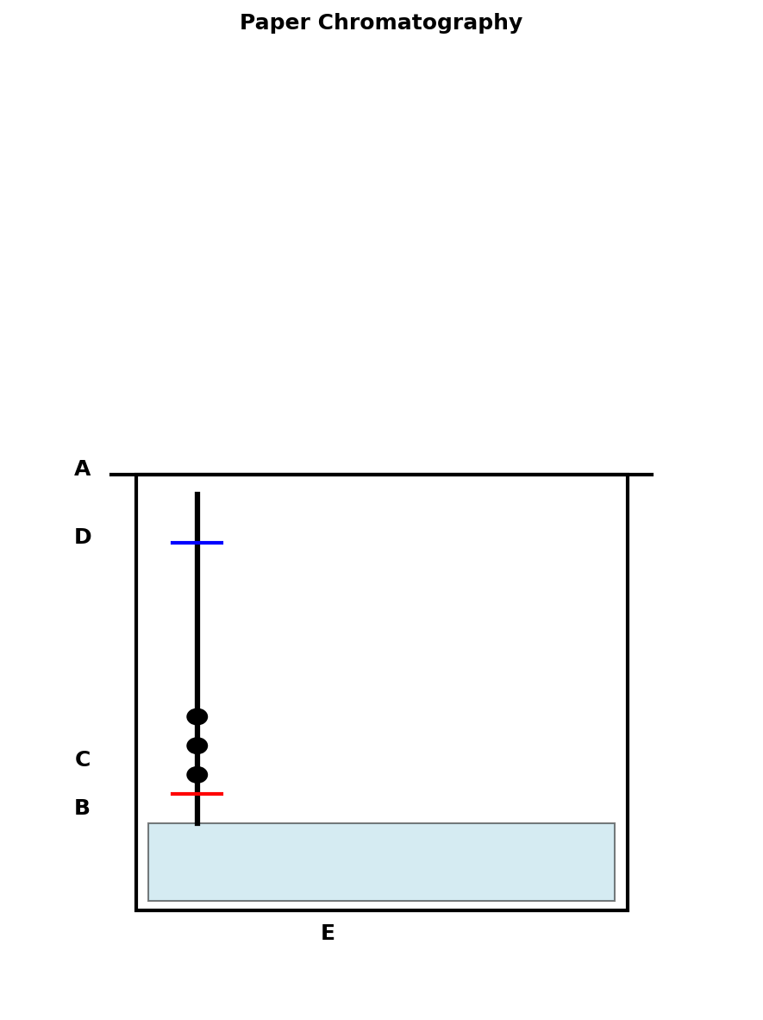
(a) Name the apparatus labeled A and D. (2 marks)

(b) What do B and C represent? (2 marks)

(c) State one use of paper chromatography. (1 mark)

(d) Calculate the Rf value of the spot if distance from origin to spot is 3 cm and distance to solvent front is 5 cm. (2 marks)

4.The diagram below shows an experimental setup for heating. (8 marks)
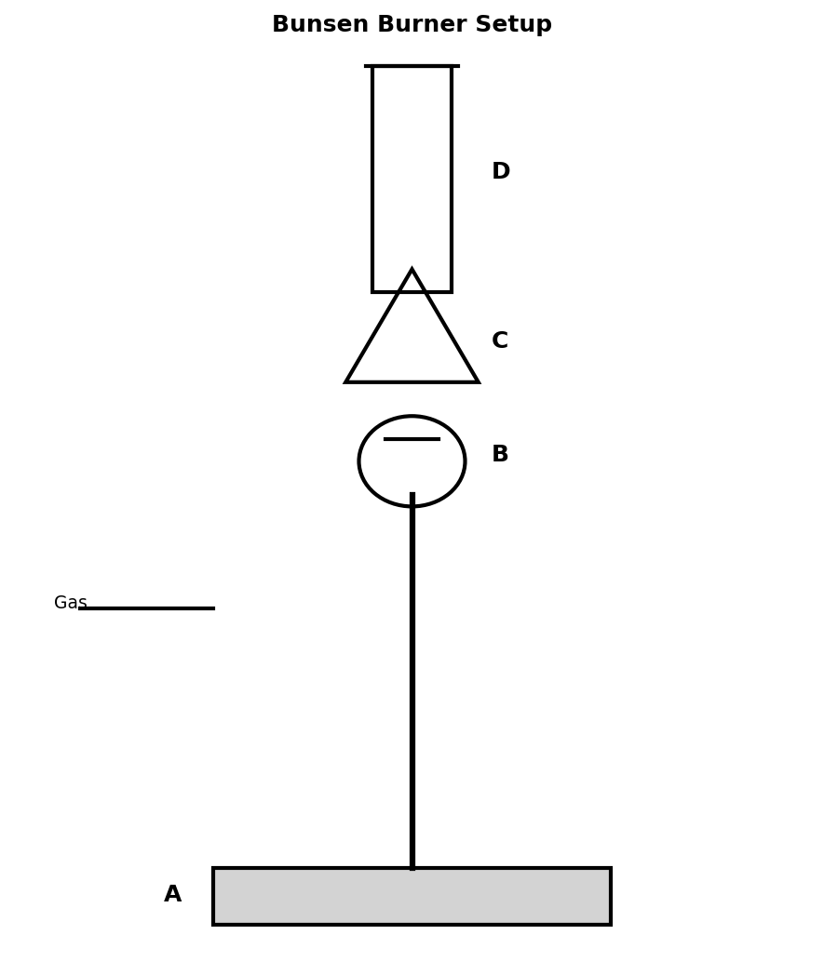
(a) Identify the apparatus labeled A, B, C and D. (4 marks)

(b) Explain the function of apparatus C. (2 marks)

(c) State two safety precautions when using this apparatus. (2 marks)

5.The diagram below shows an electrolysis cell. (8 marks)
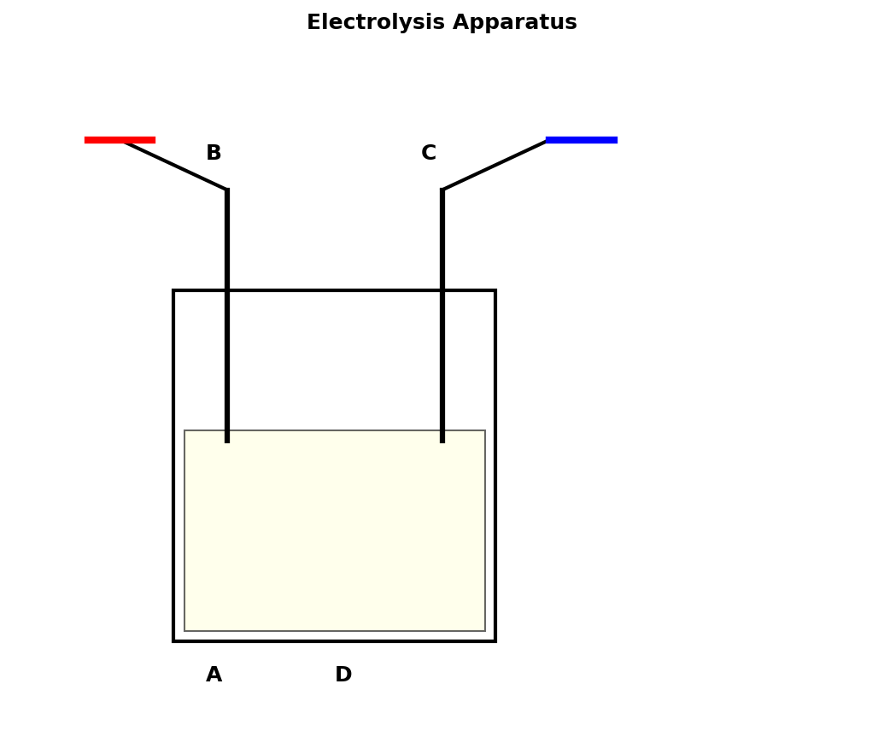
(a) Identify the parts labeled A, B and C. (3 marks)

(b) Explain what happens at the cathode during electrolysis. (2 marks)

(c) Write an equation for the electrolysis of molten sodium chloride. (3 marks)

SECTION B (40 MARKS)
Answer ALL questions in this section.
6.Calculate the molar mass of: (a) Calcium carbonate, (b) Sodium hydroxide, (c) Sulphuric acid. (6 marks)

7.A sample of magnesium oxide has molar mass 40 g/mol. Calculate the number of moles in 8 g. (3 marks)

8.What volume of hydrogen gas would be produced when 1.2 g magnesium reacts with dilute hydrochloric acid at RTP? (5 marks)

9.Calculate the percentage composition by mass of calcium in calcium carbonate. (6 marks)
[Atomic masses: Ca = 40, C = 12, O = 16]

10.Differentiate between evaporation and distillation. (4 marks)

11.Describe the method of preparing a pure solid by crystallization. (6 marks)

12.(a) Define oxidation in terms of oxygen. (2 marks)

(b) State two sources of oxygen in the laboratory. (2 marks)

(c) Describe how you would test for oxygen gas in the laboratory. (2 marks)

13.(a) Define a chemical reaction. (2 marks)

(b) Give three types of chemical reactions with examples. (6 marks)

