CORE MATHEMATICS GRADE 10
MID TERM 2 EXAM 2026
TIME: 2 HOURS 30 MINUTES

NAME………………………………………………….ADM NO…………………………………….

DATE…………………………………………………SIGN……………………………………………

INSTRUCTIONS TO CANDIDATES
- This paper consists of two sections: Section A and Section B.
- Answer all questions in Section A.
- Answer any five questions from Section B.
- All questions carry equal marks as indicated.
- Show all workings clearly.

SECTION A: 40 MARKS

1. Simplify: (2x²y)(3xy³)

[4 marks]

2. Solve the equation: 3(2x − 5) = 4x + 7

[4 marks]

3. A number is increased by 20% to give 96. Find the original number.

[4 marks]
4. Evaluate: 2³ × 2⁵ ÷ 2⁴

[4 marks]

5. Factorize completely: x² − 9x + 20

[4 marks]

6. A triangle has sides 6 cm, 8 cm and 10 cm. Determine whether it is right-angled. Give a reason.

[4 marks]

7. Simplify the ratio 24:36:60

[4 marks]

8. A machine gives a 15% loss. If the cost price is Sh 2,000, find the selling price.

[4 marks]

9. The average of 6, 8, 10, x and 14 is 10. Find x.

[4 marks],

10. A class has 12 boys and 18 girls. Find the probability of selecting a boy at random.

[4 marks]

SECTION B: 60 MARKS
Answer any five questions from this section
11. Solve the simultaneous equations and find 3x − 2y
(a) Solve: 2x + y = 11 and x − y = 1

[4 marks]

(b) Hence find the value of 3x − 2y

[2 marks]

12. The coordinates of triangle PQR are P(1, 2), Q(5, 2) and R(5, 6).
(a) Plot the triangle on a Cartesian plane

[2 marks]
(b) Find the area of triangle PQR

[4 marks]

13. A rectangular field is 60 m long and 35 m wide.
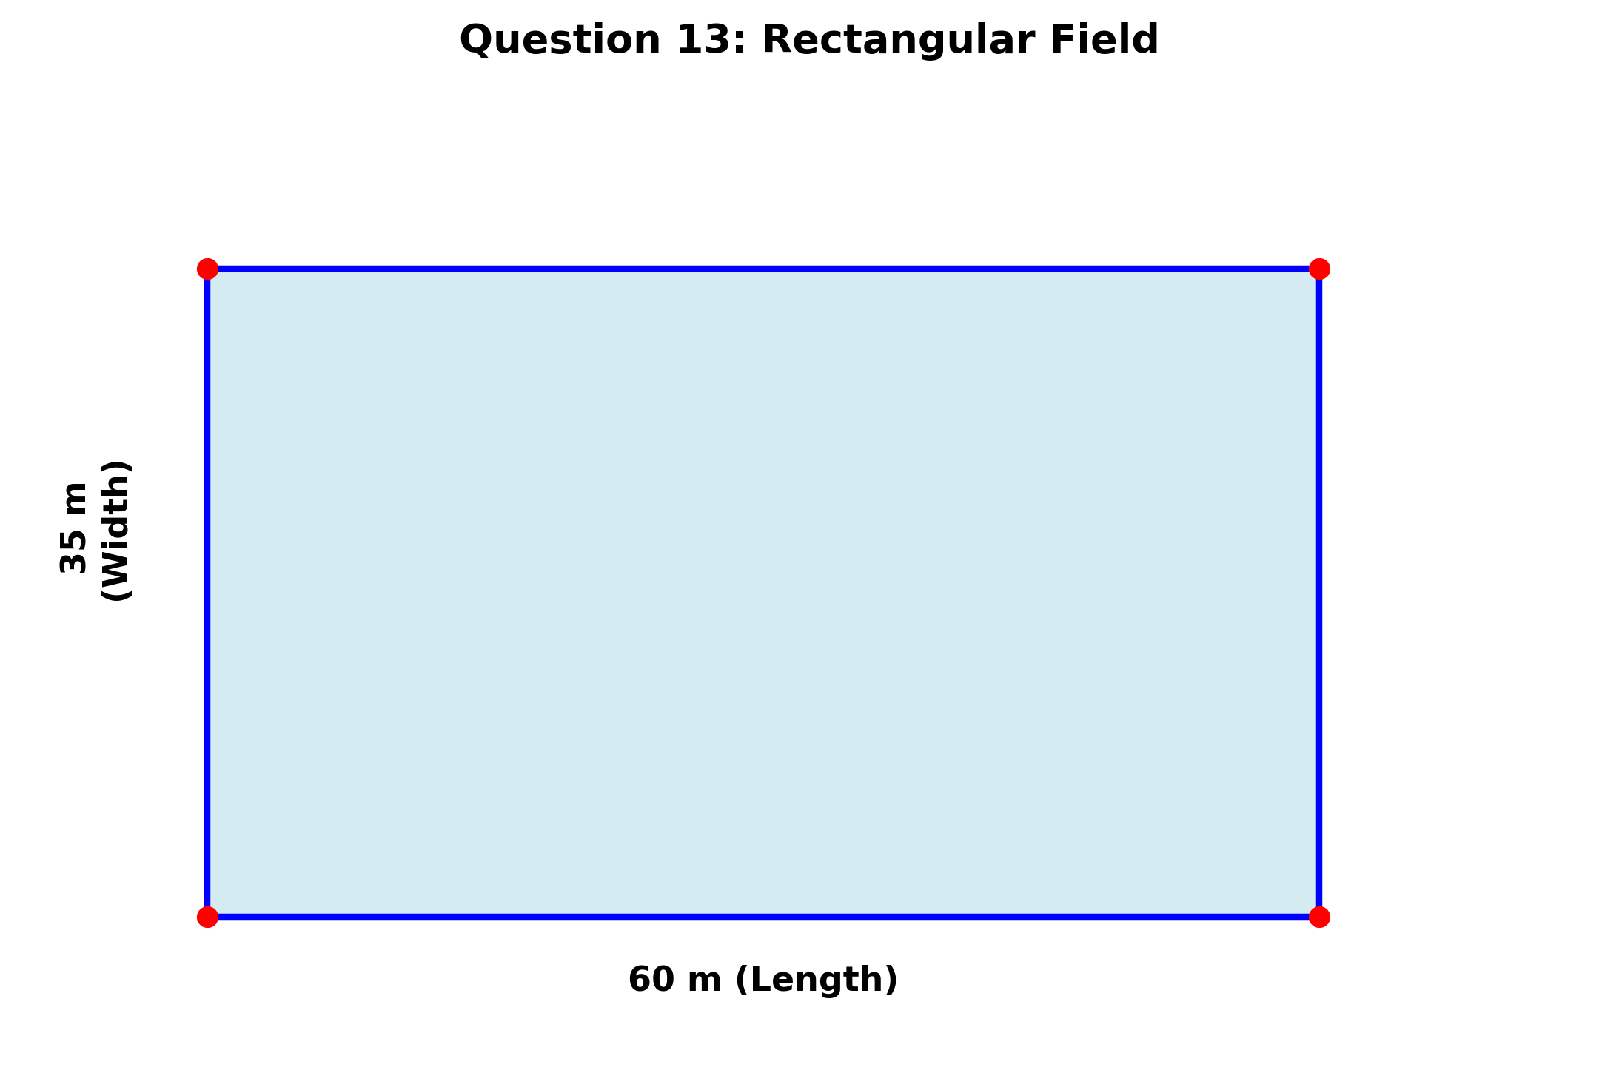
(a) Find its perimeter.

[2 marks]

(b) Find its area in m² and hectares.

[4 marks]

14. A right-angled triangle has base 12 cm and height 5 cm.
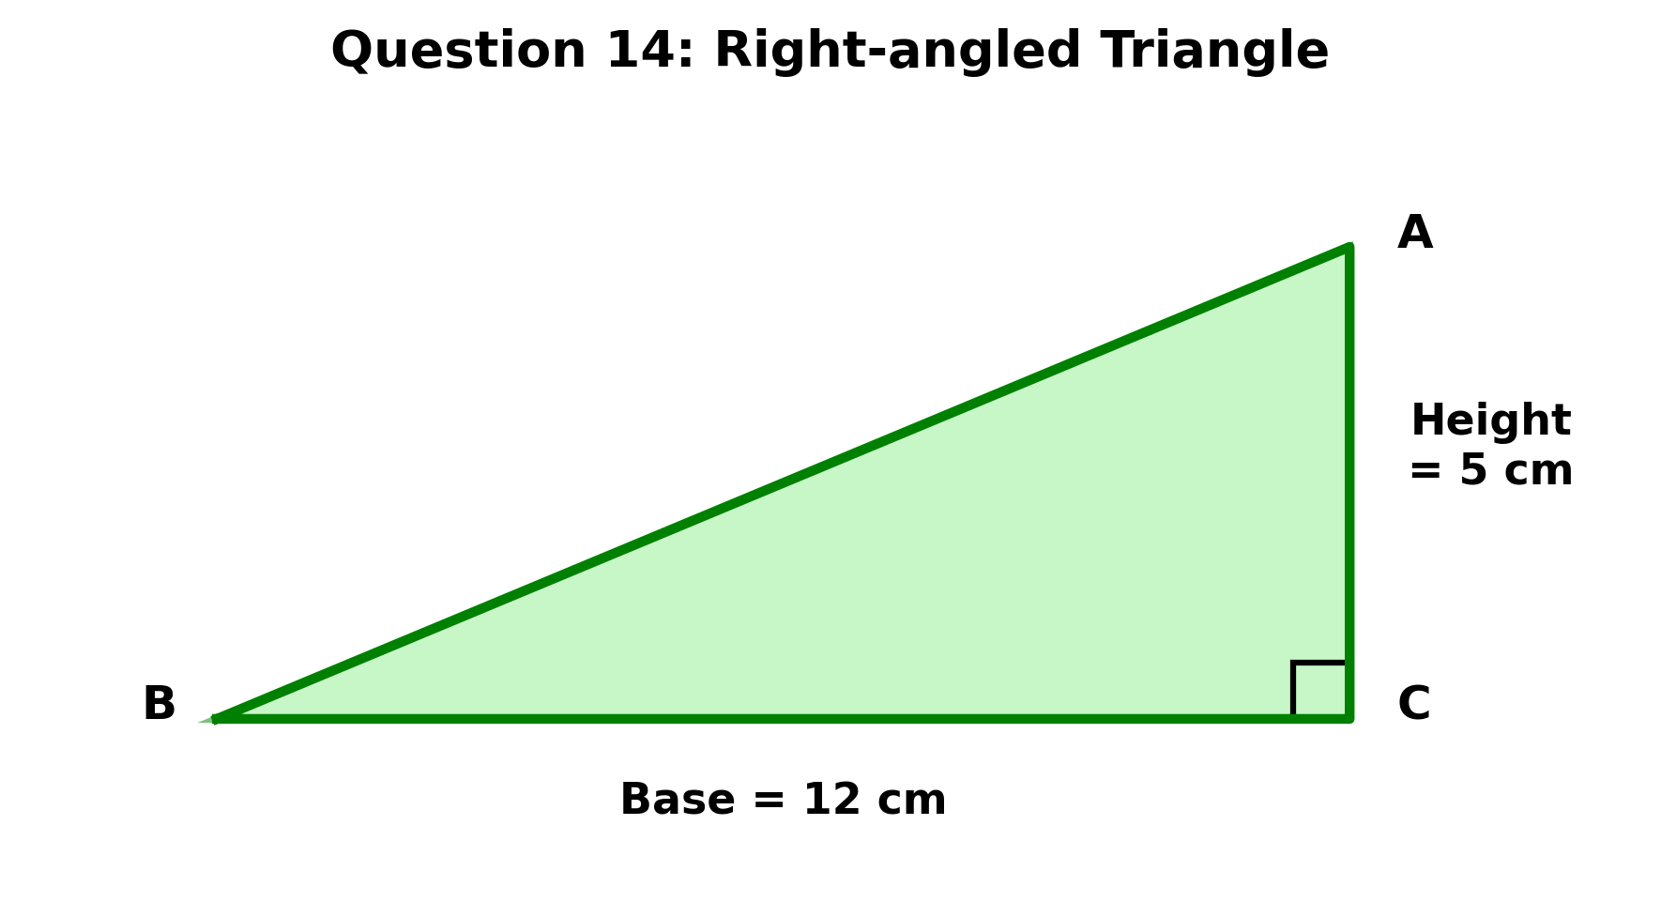
(a) Find its area.

[2 marks]

(b) Find the length of the hypotenuse.

[4 marks]

15. A circular garden has radius 7 m.
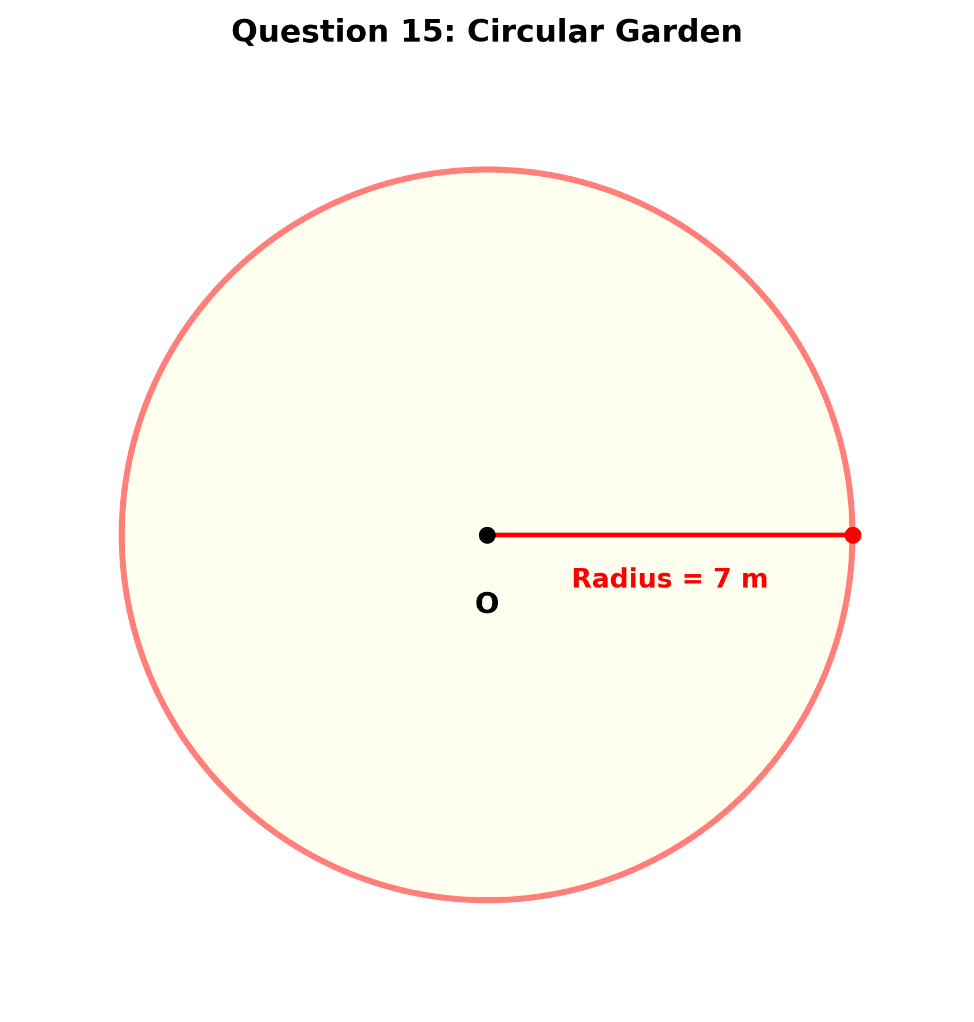
(a) Find its circumference.

[2 marks]

(b) Find its area. (Use π = 22/7)

[4 marks]

16. On a map, 1 cm represents 5 km. Two towns are 8.4 cm apart on the map.
(a) Find the actual distance between the towns.

[3 marks]

(b) If a lorry travels at 60 km/h, find the time taken to travel the distance.

[3 marks]

17. A bag contains 5 red, 3 blue and 2 green balls.
(a) Find the probability of picking a blue ball.

[2 marks]

(b) Find the probability of picking a red or green ball.

[4 marks]

18. The following data shows the number of books read by students:
2, 3, 4, 4, 5, 6, 6, 6, 7

(a) Find the mode.

[1 mark]

(b) Find the median.

[2 marks]

(c) Find the mean.

[3 marks]

