GRADE 10 GEOGRAPHY
MID-TERM 2 EXAM 2026
TIME: 2 HOURS

NAME……………………………………………ADM NO…………………………

DATE……………………………………………...SIGN……………………………….

INSTRUCTIONS TO CANDIDATES:
- Write your name admission number in the spaces provided.
- Answer ALL questions.
- Write your answers in the spaces provided.

1.(a) Define Geography. (2 marks)

(b) Name two branches of Geography and give one example of a topic studied in each. (2 marks)

(a) What is a contour line on a topographic map? (1 mark)

(b) State two map symbols commonly used to show human features. (2 marks)

2.(a) Define population density. (1 mark)

(b) Give two physical factors that influence population distribution. (2 marks)

3.(a) What is an earthquake focus? (1 mark)

(b) Give two human activities that increase vulnerability to floods. (2 marks)

4.(a) Define the term “scale” as used in maps. (1 mark)

(b) Convert the scale 1:50,000 into a statement scale. (2 marks)

5. Use the map below to answer questions that follow.
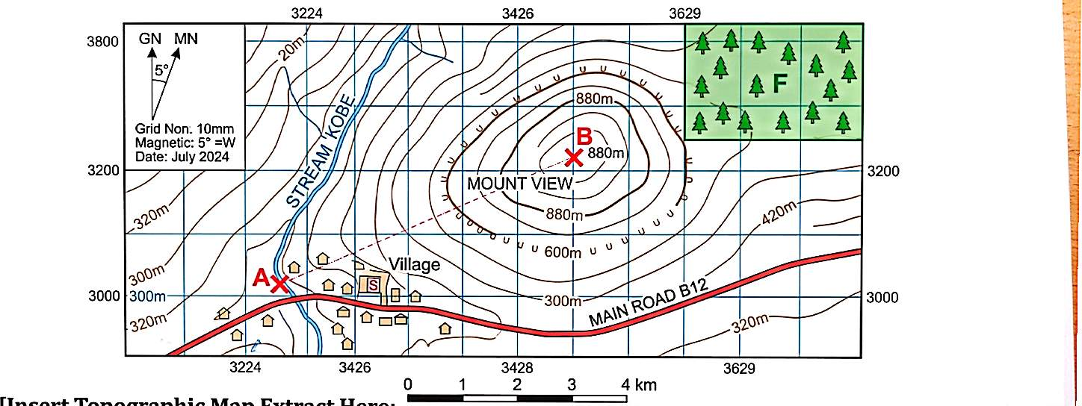

(a) Calculate ground distance between A and B. Show steps. (4 marks)

(b) Calculate the average gradient between A and B. Show working. (4 marks)

(c) Calculate the actual area of forest F in square kilometres. Show working. (3 marks)

(d) Draw a vertical cross-section along the line AB. (5 marks)

6.(a) Give the grid reference (four-figure) of the settlement centre marked S. (2 marks)

(b) Find the magnetic bearing from point A to B. (2 marks)

7. (a) Describe the internal structure of the Earth with a labeled diagram. (6 marks)

(b) Explain three causes of earthquakes. (6 marks)

8. (a) Describe five effects of volcanic eruptions. (10 marks)

(b) Give three conditions necessary for the formation of volcanoes. (2 marks)

9. (a) With an aid of well labelled diagrams, describe how anticlines and synclines are formed. (6 marks)

10. (a) Explain three social factors that influence population distribution in Kenya. (6 marks)

(b) Calculate the mean and range for household sizes: 12, 15, 18, 20, 22, 25, 30. (4 marks)

11. (a) Explain four characteristics of planned settlements. (4 marks)

(b) Describe three factors that influence the location of industries in Kenya. (6 marks)

12. Explain four methods used to conserve soil in agricultural areas. (8 marks)

13. (a) State four functions of GIS in natural resource management. (4 marks)

(b) Convert the coordinate 1°30′45″ S into decimal degrees. (2 marks)

(c) Calculate the area of a 0.8 km by 0.6 km field in hectares. (3 marks)

(d) Explain one advantage and one limitation of using satellite imagery. (3 marks)

