PHYSICS GRADE 10
MID TERM 2 2026
TIME: 2 HOURS

NAME………………………...ADM NO…………………………………
DATE……………………...SIGN………………………………………….

1. A car accelerates uniformly from rest to a velocity of 25 m/s in 8 seconds. Calculate:
(a) The acceleration of the car

(b) The distance covered during this acceleration

(4 marks)

2. Study the diagram below showing forces acting on an object on an inclined plane:
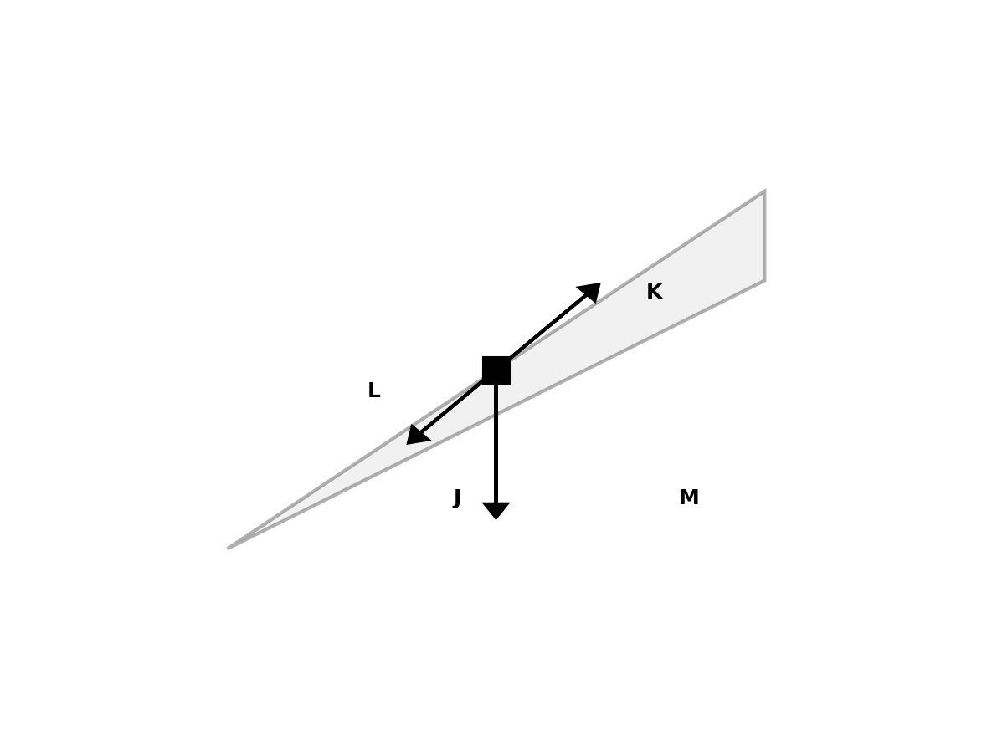

(a) Identify the forces labeled J, K, and L

(b) What is represented by angle M?

(c) If the mass of the object is 5 kg and the angle is 30°, calculate the component of weight parallel to the plane.

(6 marks)

3. A 2 kg object falls freely from a height of 10 meters.
(a) Calculate its potential energy at the initial height.

(b) Calculate its kinetic energy just before hitting the ground.

(c) What principle does this demonstrate?

(5 marks)

4. Distinguish between elastic and inelastic collisions.

(3 marks)

5. The diagram below shows a transverse wave:
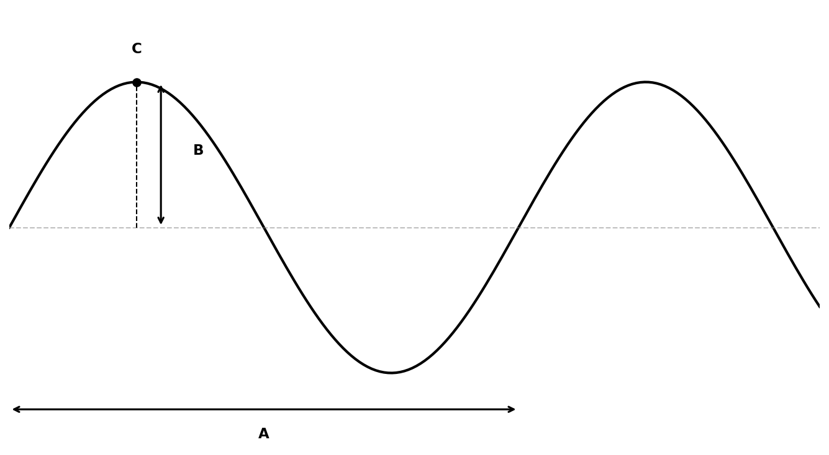

(a) Label the parts identified as A, B, and C on the diagram.

(b) If the frequency of the wave is 2 Hz and wavelength is 6.28 m, calculate the wave speed.

(c) State the difference between a longitudinal and transverse wave.

(6 marks)

6. Study the circuit diagram below:
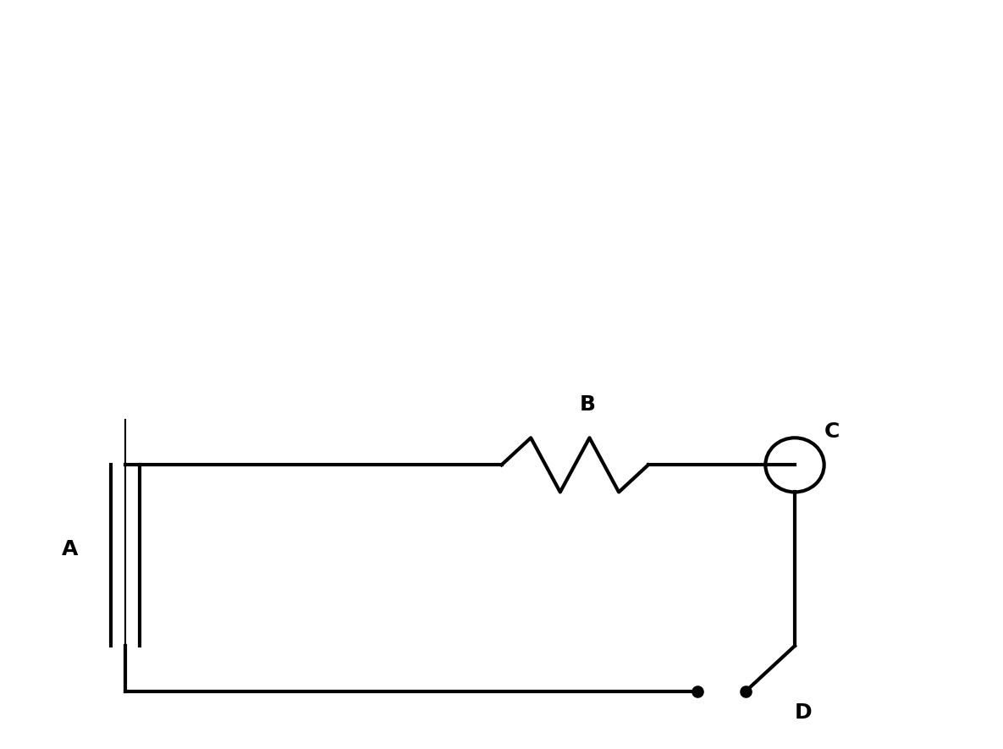

(a) Name the components labeled A, B, C, and D in the circuit.

(b) State the function of component D.

(c) If the EMF of the battery is 12 V and the total resistance is 4 Ω, calculate the current in the circuit using Ohm's law.

(7 marks)

7. (a) State Kirchhoff's current law.

(b) Two resistors of 3 Ω and 6 Ω are connected in parallel across a 12 V supply. Calculate the total resistance.

(c) Calculate the total current supplied by the battery.

(7 marks)

8. The diagram below shows an electromagnet setup:
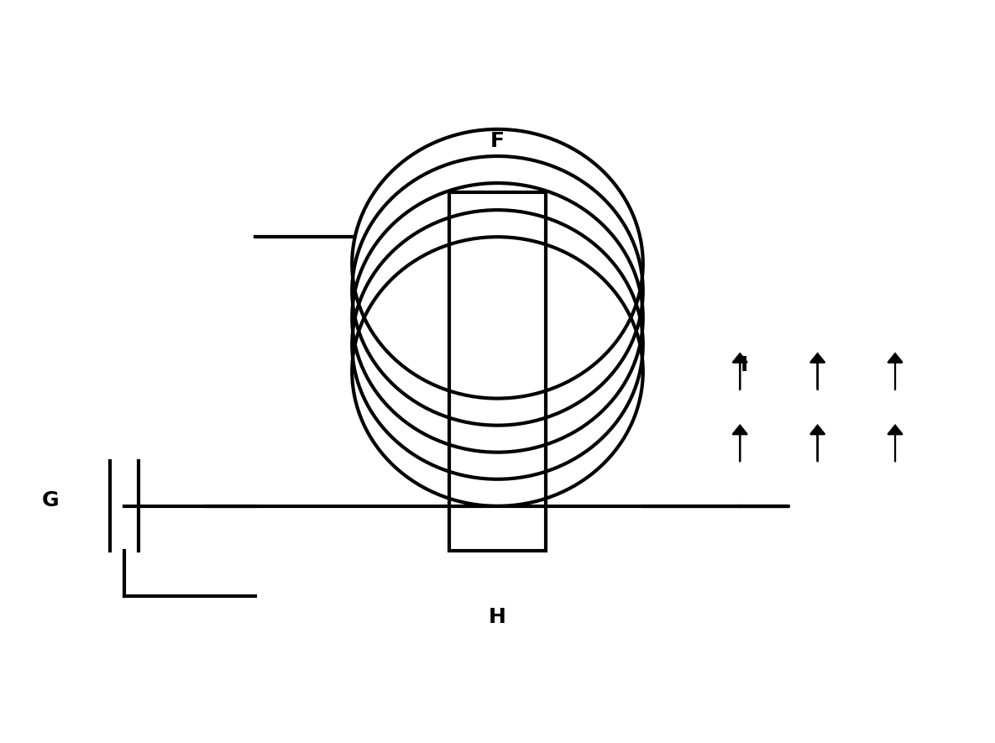

(a) Identify the components labeled F, G, H, and I.

(b) What is the function of component H in the electromagnet?

(c) How would increasing the number of turns in the coil affect the strength of the electromagnet?

(6 marks)

9. (a) State Fleming's left-hand rule.

(b) A current-carrying conductor of length 0.5 m is placed in a magnetic field of 0.8 T. If the current is 2 A, calculate the force on the conductor.

(5 marks)

10. The diagram below shows light refraction at an interface between two media:
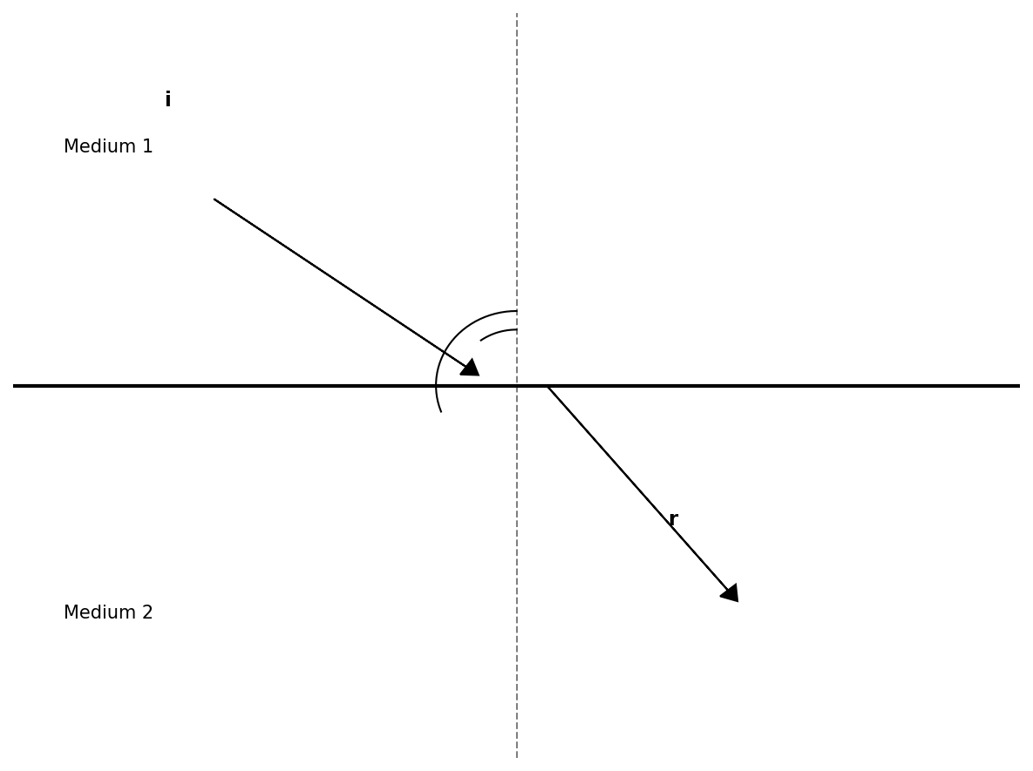

(a) Identify the angles labeled i and r on the diagram.

(b) State Snell's law of refraction.

(c) If the angle of incidence is 30° and the refractive index of medium 2 is 1.5, and medium 1 is air (n=1), calculate the angle of refraction.

(7 marks)

11. The diagram below shows a convex lens with an object placed in front of it:
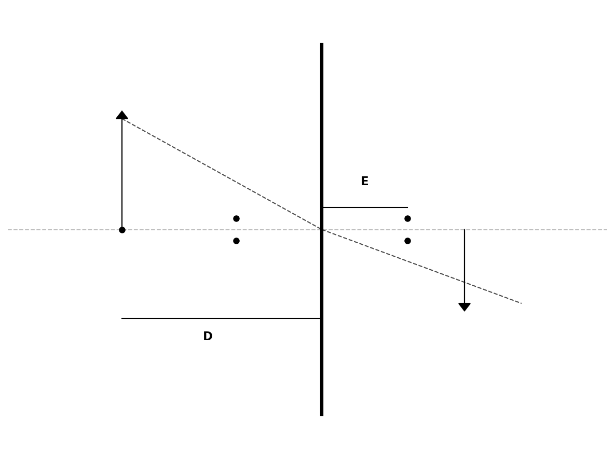

(a) Identify the points and distances labeled D and E on the diagram.

(b) Using the lens formula 1/f = 1/u + 1/v, where u = 30 cm and f = 10 cm, calculate the image distance (v).

(c) Calculate the magnification of the image. (8marks)

