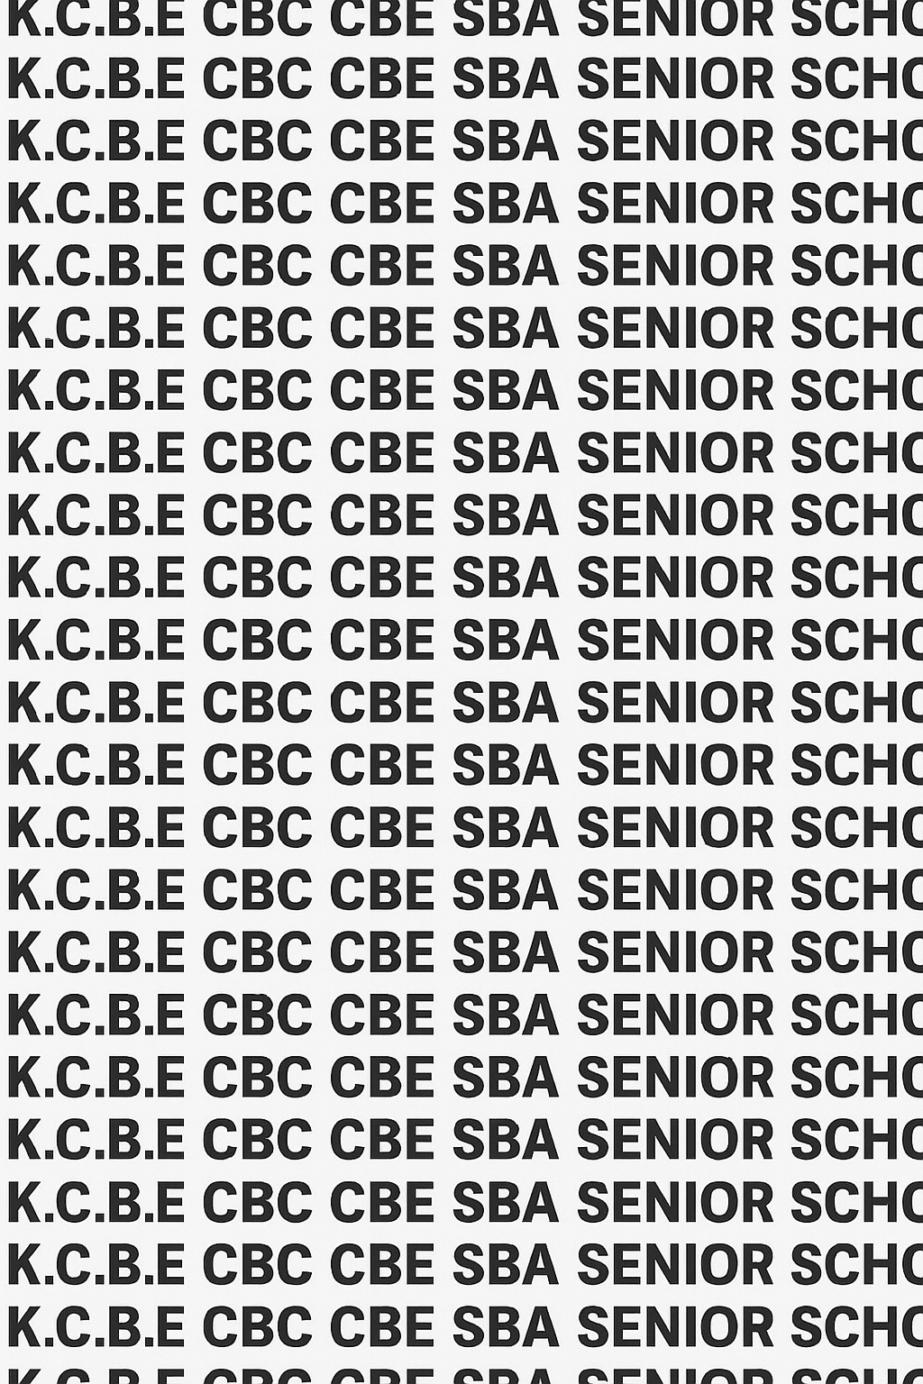
KENYA CERTIFICATE OF BASIC EDUCATION (K.C.B.E)


GRADE 10 APPLIED AGRICULTURE (Theory) TERM 1 JANUARY 2026
Time: 2 Hours
COMPETENCE BASED EDUCATION CKEAB 001

LEARNER’S DETAILS
Name: _______________________________________________________________________________________.
School: ______________________________________________________________________________________.
Assessment Number: ________________________________. Date: __________________________________.
School Code: _______________________________. Signature: ________________________________.

INSTRUCTIONS TO LEARNERS
- Write your name, assessment number, class and date on all the answer sheets provided.
- Answer all the questions in the spaces provided.
- Use a blue or black pen for writing. Pencils should be used only for drawings and diagrams.

Performance Levels Grid

SCORE GRID
-AGRICULTURE- -001- -Senior School-
Section A | Q1a | Q1b | Q1c | Q1d | Q2 | Q3a | Q3b | Q3c | Q4 | Q5 | Q6a | Q6b | Q7a | Q7b | Section Total
Max Marks | 2 | 2 | 2 | 1 | 6 | 3 | 6 | 4 | 6 | 6 | 4 | 8 | 3 | 4 | 60
Learner Score

Section B | Q8a | Q8b | Q8c | Q9 | Q10 | Q11a | Q11b | Q11c | Q11d | Q11e | Section Total
Max Marks | 4 | 8 | 4 | 8 | 6 | 1 | 3 | 2 | 2 | 2 | 40
Learner Score
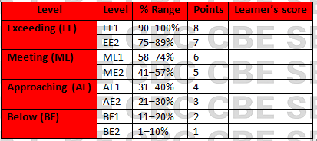
Section | Max Marks | Learner Score
A | 60
B | 40
TOTAL | 100

This paper has 8 printed pages. Please check out to ensure all pages are printed
Turn over
SECTION A: (60 Marks)
Answer all questions in this section.
- A farmer wants to start a maize farm but does not own land. Answer the following questions:
(a) Identify one legal way a farmer can access land for agricultural use. (2 marks) ________________________________________________________________________________________________________________________________________________________________________________________
(b) State one advantage of using this method. (2 marks) ________________________________________________________________________________________________________________________________________________________________________________________
(c) State one disadvantage of using this method. (2 marks) ________________________________________________________________________________________________________________________________________________________________________________________ (d) Give a relevant example where this method can be applied. (1 mark) ________________________________________________________________________________________________________________________________________________________________________________________
- Susan has bought a land for a certain agricultural activity. Identify three uses of land for agricultural production and explain why each is important. (6 marks)
 | Use | Importance
i
ii
iii
- Timothy is a farmer in Nyandarua, he plans to plant some trees in his farm
(a) Name three natural factors that can affect his land productivity. (3 marks)
- ______________________________________________________________________________________
- ______________________________________________________________________________________
- ______________________________________________________________________________________
(b) Explain three benefits of planting trees in the farm. (6 marks)
- ______________________________________________________________________________________
- ______________________________________________________________________________________
- ______________________________________________________________________________________
(c) Suggest suitable crops for high altitude and low altitude regions. (4 marks)
High altitude crops | Low altitude crops
- A group of students visited a farm and observed the farmer preparing the land. Explain three reasons why land is important in agricultural production. (6 marks)
- ______________________________________________________________________________________
- ______________________________________________________________________________________
- ______________________________________________________________________________________
- A farmer wants to grow vegetables. Explain the following properties of soil and their importance to crop production: (6 marks)
(a) Physical properties ________________________________________________________________________________________________________________________________________________________________________________________
(b) Chemical properties ________________________________________________________________________________________________________________________________________________________________________________________ (c) Biological properties ________________________________________________________________________________________________________________________________________________________________________________________
- Mwangi set up of apparatus for finding the percentage of humus contents in a soil by ignition.
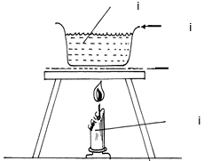
i
ii
iii

iv

a. Label the apparatus. (4 marks)
i) ____________________________________________________________________________________
ii) ___________________________________________________________________________________
iii) ___________________________________________________________________________________
iv) ___________________________________________________________________________________
b. Outline the steps followed in carrying out the illustrated experiment. (8 marks)
i) ____________________________________________________________________________________
ii) ___________________________________________________________________________________
iii) ___________________________________________________________________________________
iv) ___________________________________________________________________________________
- (a) Tamara was asked by her teacher to name the three types of soils. Which one are they? (3 marks)
i) ____________________________________________________________________________________
ii) ___________________________________________________________________________________
iii) ___________________________________________________________________________________
(b) Name two ways of determining soil texture (4 marks)
i) ____________________________________________________________________________________
ii) ___________________________________________________________________________________

SECTION B: (40 Marks)
Answer all questions in this section.
- The diagram below shows soil profile.
(a) Label the horizons. (4 marks)

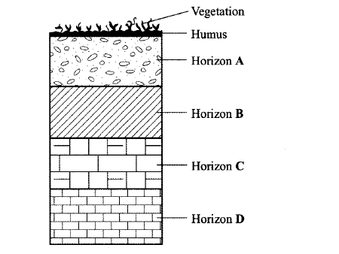

A: _____________________________________. B: _____________________________________.
C: _____________________________________. D: _____________________________________.

(b) Describe the characteristics of each horizon. (8 marks)

Horizon | Characteristic
A
B
C
D
(c) Explain how the soil profile affects crop production. (4 marks)
i) ____________________________________________________________________________________
ii) ___________________________________________________________________________________

- Explain how the following soil properties affect crop growth: (8 marks)
(a) Soil texture
________________________________________________________________________________________________________________________________________________________________________________________
(b) Soil structure
________________________________________________________________________________________________________________________________________________________________________________________
(c) Soil fertility
________________________________________________________________________________________________________________________________________________________________________________________
(d) Soil porosity
________________________________________________________________________________________________________________________________________________________________________________________
- A farmer inherited a 5-acre land in a semi-arid region. He wants to practice mixed farming. Using your knowledge of land and soil properties: (6 marks)
(a) Suggest suitable crops and livestock for the region.
________________________________________________________________________________________________________________________________________________________________________________________
(b) Explain how soil and climate factors will influence his choice.
________________________________________________________________________________________________________________________________________________________________________________________
(c) Suggest ways to improve soil fertility and water retention.
________________________________________________________________________________________________________________________________________________________________________________________
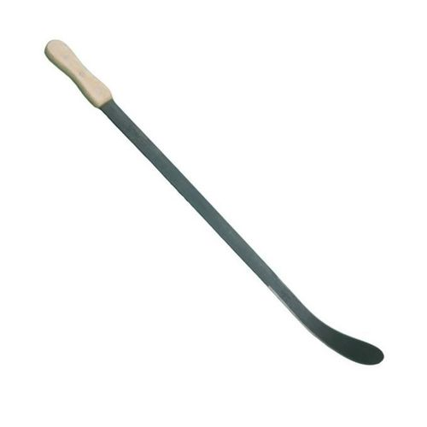
- a) Grade 10 learners used the farm tool below for farm clearance activity

Name the farm tool. (1 mark)
_______________________________________

b) Give one use of each of the following tools: (3 marks)
i. Wheelbarrow
__________________________________________________________________________________________
__________________________________________________________________________________________
ii. Rake
__________________________________________________________________________________________
__________________________________________________________________________________________
iii. Tape measure
__________________________________________________________________________________________
__________________________________________________________________________________________
c) State two maintenance practices for a wheelbarrow. (2 marks)
__________________________________________________________________________________________
__________________________________________________________________________________________
d) List two dangers of using farm tools incorrectly. (2 marks)
__________________________________________________________________________________________
__________________________________________________________________________________________
e) Explain two benefits of maintaining farm tools in good condition. (2 marks)
- ______________________________________________________________________________________
- ______________________________________________________________________________________

©2026
All rights reserved
©COMPETENCE KENYA EXAMINATION AND ASSESSMENT BOARD
THIS IS THE LAST PRINTED PAGE

