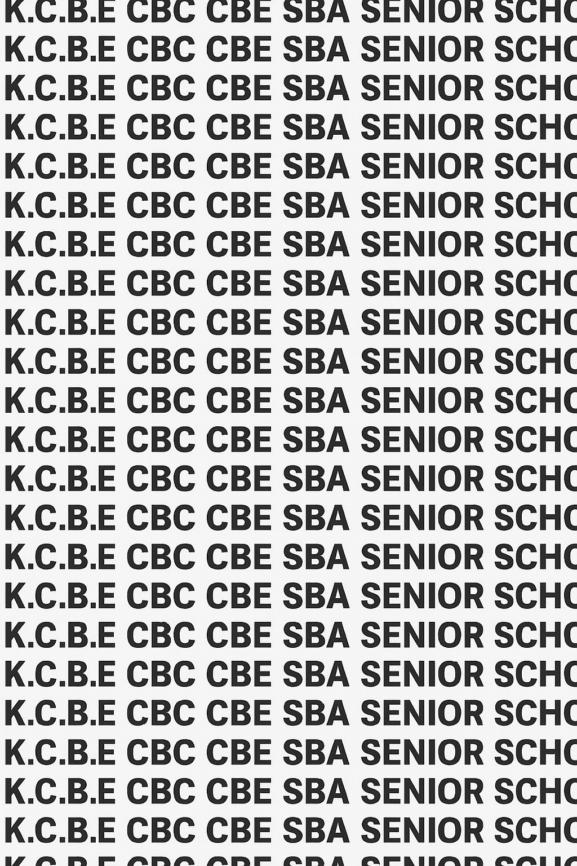
KENYA CERTIFICATE OF BASIC EDUCATION (K.C.B.E)
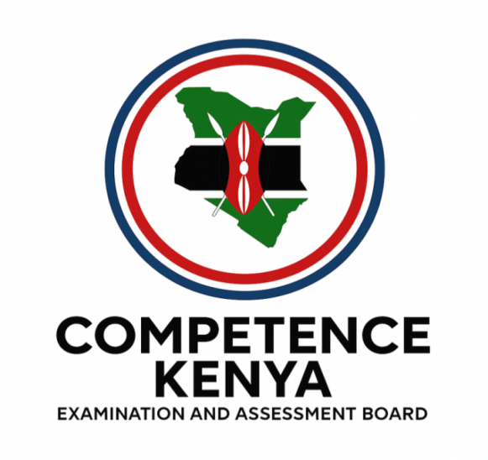
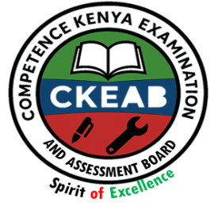


GRADE 10 AVIATION TECHNOLOGY (Theory) TERM 1 JANUARY 2026
Time: 1 Hour 30 Minutes
COMPETENCE ASSESSMENT EXAMINATION CKEAB 001

LEARNER’S DETAILS
Name: _______________________________________________________________________________________.
School: ______________________________________________________________________________________.
Assessment Number: ________________________________. Date: __________________________________.
School Code: _______________________________. Signature: ________________________________.

INSTRUCTIONS TO LEARNERS
- Write your name, assessment number, class and date on all the answer sheets provided.
- Answer all the questions in the spaces provided.
- Use a blue or black pen for writing. Pencils should be used only for drawings and diagrams.

SCORE GRID Performance Levels
-AVIATION- -001- -Senior School-
Question Number | Maximum Marks | Learner Score
1 | 4 marks | 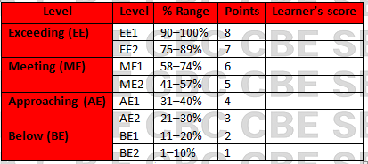
2 | 4 marks
3 | 2 marks
4 | 3 marks
5 | 2 marks
6 | 2 marks
7 | 2 marks
8 | 2 marks
9 | 2 marks
10 | 2 marks
11 | 2 marks
12 | 2 marks
13 | 2 marks
14 | 2 marks
SECTION A SUBTOTAL | 40 marks
15 | 12 marks
16 | 12 marks
17 | 10 marks
18 | 14 marks
19 | 12 marks
SECTION B SUBTOTAL | 60 marks
GRAND TOTAL | 100 MARKS
This paper has 8 printed pages. Please check out to ensure all pages are printed
Turn over
SECTION A: (60 Marks)
Answer all questions in this section.

1. The school Aviation Club watched a documentary on the evolution of flight.
(a) Name two pioneers in the field of aviation (2 marks)
i._________________________________________________________
ii. ________________________________________________________

(b) Identify the following. (2 marks)
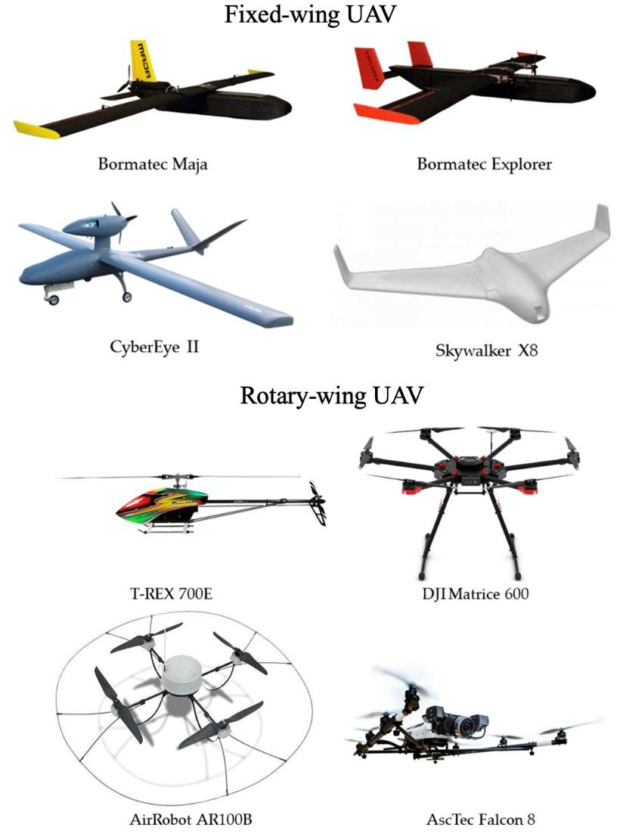

A B

A._________________________________________________________
B. ________________________________________________________

2. A learner launched a simple hot air balloon model using a candle and a plastic bag.
Explain two principles that allowed the balloon to rise. (4 marks)
i.______________________________________________________________________________________________
ii. _____________________________________________________________________________________________

3. The Aviation Club teacher brought a hand glider model to class.
State two characteristics of gliders that help them stay airborne without engines. (2 marks)
i.______________________________________________________________________________________________
ii. _____________________________________________________________________________________________

4. During a lesson about aircraft categories, you observed pictures of an airplane, a helicopter, and a hot air balloon.
Match each to its correct type: (3 marks)
(a) Fixed-wing aircraft Helicopter
(b) Rotary-wing aircraft Hot air balloon
(c) Lighter-than-air aircraft Aeroplane

5. A pilot was required to choose an aircraft for search and rescue operations in mountainous areas.
Give two reasons why a helicopter is suitable for this task. (2 marks)
i.______________________________________________________________________________________________
ii. _____________________________________________________________________________________________

6. State two functions of cargo aircraft in air transport. (2 marks)
i.______________________________________________________________________________________________
ii. _____________________________________________________________________________________________

7. Give two contributions of the Wright Brothers to modern aviation. (2 marks)
i.______________________________________________________________________________________________
ii. _____________________________________________________________________________________________

8. Identify two roles of aerodromes in the aviation industry. (2 marks)
i.______________________________________________________________________________________________
ii. _____________________________________________________________________________________________

9. List two safety gears commonly used by aviation technicians while working on aircraft. (2 marks)
i.______________________________________________________________________________________________
ii. _____________________________________________________________________________________________

10. Give two common causes of electrical shocks in an aviation workshop. (2 marks)
i.______________________________________________________________________________________________
ii. _____________________________________________________________________________________________

11. State two reasons why first aid is important in an aviation workplace. (2 marks)
i.______________________________________________________________________________________________
ii. _____________________________________________________________________________________________

12. A student tripped over a toolbox and suffered a cut on the hand.
State two first aid steps the responder should take. (2 marks)
i.______________________________________________________________________________________________
ii. _____________________________________________________________________________________________

13. Identify two hazards associated with personal safety in an aircraft hangar. (2 marks)
i.______________________________________________________________________________________________
ii. _____________________________________________________________________________________________

14. State two signs that show a person may require CPR. (2 marks)
i.______________________________________________________________________________________________
ii. _____________________________________________________________________________________________

SECTION B (60 MARKS)

Answer ALL questions

15. Learners at Sunrise Secondary School visited an aviation museum that showcased early flight inventions.

(a) Describe how the Montgolfier Brothers’ hot air balloon (1783) contributed to the understanding of lighter-than-air flight. (3 marks)
i.______________________________________________________________________________________________
ii. _____________________________________________________________________________________________
iii.______________________________________________________________________________________________
iv. _____________________________________________________________________________________________

(b) Explain two key ideas introduced by Sir George Cayley that shaped modern aircraft design. (4 marks)
i.______________________________________________________________________________________________
ii. _____________________________________________________________________________________________

(c) The museum guide demonstrated the difference between heavier-than-air and lighter-than-air aircraft.
Explain two differences between them. (4 marks)
 | Heavier than air aircraft | Lighter than air aircraft

i

ii

(d) State one reason why early gliders were important in aviation evolution. (1 mark)
i.______________________________________________________________________________________________
ii. _____________________________________________________________________________________________

16. During an aviation exhibition, different aircraft were displayed for learners.

(a) A military jet, a passenger airliner, and a crop-spraying aircraft were exhibited.
State one function of each. (3 marks)
Aircraft | Function

Military jet

Passenger airliner

Crop spraying aircraft

(b) Using a labelled sketch, differentiate between fixed-wing and rotary-wing aircraft. (4 marks)

(c) Explain three advantages of fixed-wing aircraft over rotary-wing aircraft in commercial aviation. (3 marks)
i.______________________________________________________________________________________________
ii. _____________________________________________________________________________________________
iii.______________________________________________________________________________________________

(d) Identify two reasons why lighter-than-air aircraft are rarely used for passenger transport today. (2 marks)
i.______________________________________________________________________________________________
ii. _____________________________________________________________________________________________

17. The county government plans to build a new airstrip to improve economic activities.

(a) Explain three ways the airstrip will contribute to economic development in the region. (6 marks)
i.______________________________________________________________________________________________
ii. _____________________________________________________________________________________________

b) State two reasons why aviation is important in emergency response. (2 marks)
i.______________________________________________________________________________________________
ii. _____________________________________________________________________________________________

(c) List two disadvantages of air transport. (2 marks)
i.______________________________________________________________________________________________
ii. _____________________________________________________________________________________________

18. In an aviation workshop simulation, students practiced identifying hazards and following safety procedures.

(a) State four general rules related to personal safety in the aviation workplace. (4 marks)
i.______________________________________________________________________________________________
ii. _____________________________________________________________________________________________
iii.______________________________________________________________________________________________
iv. _____________________________________________________________________________________________

(b) Explain three hazards that may lead to accidents when working around aircraft. (3 marks)
i.______________________________________________________________________________________________
ii. _____________________________________________________________________________________________
iii.______________________________________________________________________________________________

(c) A student accidentally touched a live electrical wire and received an electric shock.
Describe three first aid steps that should be taken. (3 marks)
i.______________________________________________________________________________________________
ii. _____________________________________________________________________________________________
i.______________________________________________________________________________________________

(d) Outline two safety measures for preventing burns in an aviation environment. (2 marks)
i.______________________________________________________________________________________________
ii. _____________________________________________________________________________________________

(e) Explain two reasons why proper housekeeping is important in an aircraft hangar. (2 marks)
i.______________________________________________________________________________________________
ii. _____________________________________________________________________________________________

19. Aviation learners were conducting practical work when different accidents happened.

(a) A student dropped a metal bar on the leg of a classmate causing a fracture.
State three signs of a fracture. (3 marks)
i.______________________________________________________________________________________________
ii. _____________________________________________________________________________________________
iii.______________________________________________________________________________________________

(b) Explain three steps for administering first aid to a person with a suspected fracture. (3 marks)
i.______________________________________________________________________________________________
ii. _____________________________________________________________________________________________
iii.______________________________________________________________________________________________

(c) During a wiring exercise, a learner sustained a burn on the arm.
Describe three first aid steps the class should take to treat the burn. (3 marks)
i.______________________________________________________________________________________________
ii. _____________________________________________________________________________________________
iii.______________________________________________________________________________________________

(d) A student collapsed and stopped breathing during the lesson.
State three steps of performing CPR. (3 marks)
i.______________________________________________________________________________________________
ii. _____________________________________________________________________________________________
iii.______________________________________________________________________________________________

©2026
All rights reserved
©COMPETENCE KENYA EXAMINATION AND ASSESSMENT BOARD
THIS IS THE LAST PRINTED PAGE

