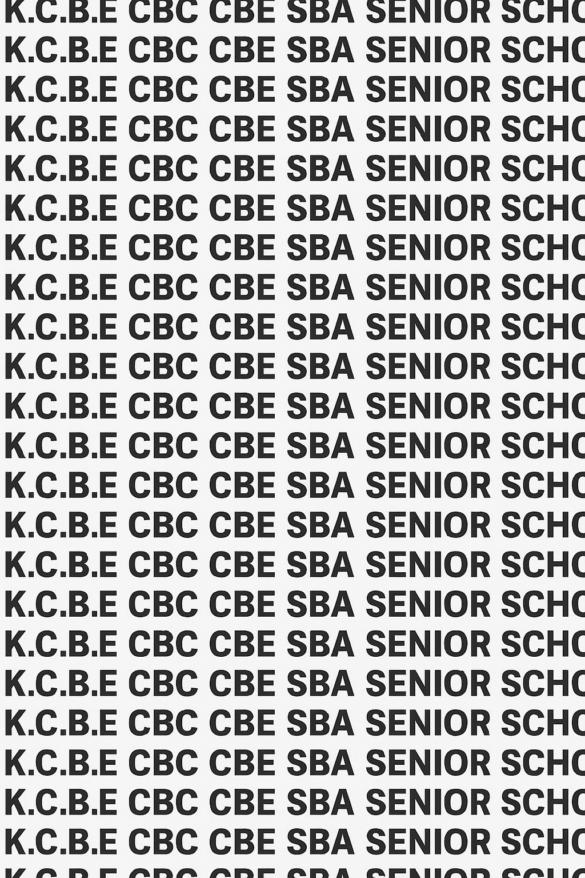
KENYA CERTIFICATE OF BASIC EDUCATION (K.C.B.E)




GRADE 10 BUILDING CONSTRUCTION (Theory) TERM 1 JANUARY 2026
Time: 1 Hour 50 Minutes
COMPETENCE ASSESSMENT EXAMINATION CKEAB 001

LEARNER’S DETAILS
Name: _______________________________________________________________________________________.
School: ______________________________________________________________________________________.
Assessment Number: ________________________________. Date: __________________________________.
School Code: _______________________________. Signature: ________________________________.

INSTRUCTIONS TO LEARNERS
- Write your name, assessment number, class and date on all the answer sheets provided.
- Answer all the questions in the spaces provided.
- Use a blue or black pen for writing. Pencils should be used only for drawings and diagrams.

SCORE GRID Performance Levels Grid
Question Number | Maximum Marks | Learner’s Score  -BUILDING TECHNOLOGY- -001- -Senior School- | Examiner’s Initials
1 | 6
2 | 4
3 | 4
4 | 4 |  | 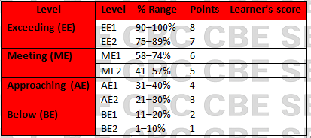
5 | 4
6 | 4
7 | 4
8 | 4
SECTION A TOTAL | 40
9 | 10
10 | 9
11 | 16
12 | 14
13 | 10
14 | 10
SECTION B TOTAL | 60
GRAND TOTAL | 100

This paper has 9 printed pages. Please check out to ensure all pages are printed
Turn over
SECTION A: (60 Marks)
Answer all questions in this section.

1. A family living in rural Kericho plans to move to town and build a permanent house.
(a) Define the term building as used in construction. (2 marks)
__________________________________________________________________________________________________
__________________________________________________________________________________________________
(b) State two functions of a building to a family. (2 marks)
- ____________________________________________________________________________________________
- ____________________________________________________________________________________________
(c) Give two reasons why the family prefers a permanent house over a temporary one. (2 marks)
- ____________________________________________________________________________________________
- ____________________________________________________________________________________________

2. During a history lesson, learners observed pictures of early human building.
(a) Name the earliest type of human shelter. (1 mark)
_______________________________________________________________
(b) Explain one reason early humans used this shelter. (1 mark)
__________________________________________________________________________________________________
__________________________________________________________________________________________________
(c) Describe two ways buildings have changed from early shelters to modern structures. (2 marks)
- ____________________________________________________________________________________________
- ____________________________________________________________________________________________

3. The sketch below represents a simple building structure.
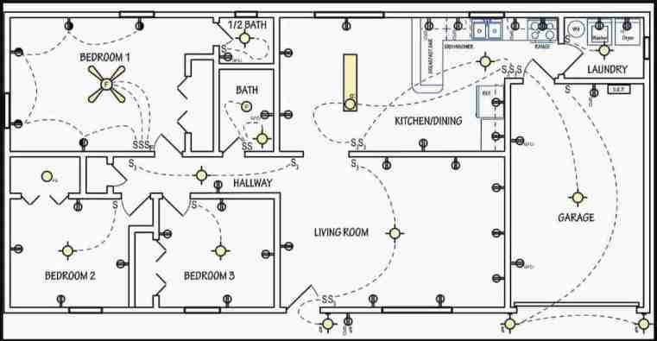
Identify any four components shown in the sketch. (4 marks)
- ____________________________________________________________________________________________
- ____________________________________________________________________________________________
- ____________________________________________________________________________________________
- ____________________________________________________________________________________________

4. A school is planning to build a new library.
(a) Identify the category of building a library falls under. (1 mark)
_______________________________________________________________________
(b) State two reasons why this category is important in the community. (2 marks)
- ____________________________________________________________________________________________
- ____________________________________________________________________________________________
(c) Give one example of another building in the same category. (1 mark)
____________________________________________________________________________________________
____________________________________________________________________________________________

5. A contractor wants to select a site for a new residential house.
(a) State two factors to consider when selecting a site. (2 marks)
- ____________________________________________________________________________________________
- ____________________________________________________________________________________________
(b) Name two natural features that should be avoided during site selection. (2 marks)
- ____________________________________________________________________________________________
- ____________________________________________________________________________________________

6. A group of learners visited a construction site and noticed workers wearing safety gear.
(a) State two safety measures that should be observed during site preparation. (2 marks)
- ____________________________________________________________________________________________
- ____________________________________________________________________________________________
(b) Identify two safety gears appropriate for this stage. (2 marks)
- ____________________________________________________________________________________________
- ____________________________________________________________________________________________

7. A class project requires learners to clear and level a small portion of land.
(a) List four hand tools suitable for site clearing. (2 marks)
- ____________________________________________________________________________________________
- ____________________________________________________________________________________________
- ___________________________________________________________________________________________
- ____________________________________________________________________________________________
(b) Name two methods used to level a construction site. (2 marks)
- ____________________________________________________________________________________________
- ____________________________________________________________________________________________

8. During site preparation, workers removed the top layer of soil.
(a) Name this process. (1 mark)
_________________________________________________________________________________________
(b) State one reason why this process is important. (1 mark)
____________________________________________________________________________________________
____________________________________________________________________________________________
(c) Mention two tools used in the process. (2 marks)
- ____________________________________________________________________________________________
- ____________________________________________________________________________________________

SECTION B: (60 marks)

Answer all questions in the spaces provided below

9. A company plans to set up a new commercial building in Nakuru town.
(a) Define a commercial building. (2 marks)
_________________________________________________________________________________________________
_________________________________________________________________________________________________
(b) State two examples of commercial buildings. (2 marks)
- ____________________________________________________________________________________________
- ____________________________________________________________________________________________
(c) Explain three reasons why commercial buildings are important in urban areas. (6 marks)
- ____________________________________________________________________________________________
- ____________________________________________________________________________________________
- ____________________________________________________________________________________________

10. A group of Grade 10 learners designed a simple drawing showing a floor, walls, roof, door and window.
(a) Sketch a simple building showing floor, wall, roof, door and window. (Teacher to award for correct components) (4 marks)

(b) State the function of each of the following parts:
(i) Roof (1 mark)
_________________________________________________________________________________________________
_________________________________________________________________________________________________
(ii) Wall (1 mark)
_________________________________________________________________________________________________
_________________________________________________________________________________________________
(iii) Floor (1 mark)
_________________________________________________________________________________________________
_________________________________________________________________________________________________
(iv) Window (1 mark)
_________________________________________________________________________________________________
_________________________________________________________________________________________________
(v) Door (1 mark)
_________________________________________________________________________________________________
_________________________________________________________________________________________________

11. Musa wants to construct a small rental house on his piece of land.
(a) Explain three reasons why proper site preparation is important. (6 marks)
- ____________________________________________________________________________________________
- ____________________________________________________________________________________________
- ____________________________________________________________________________________________
(b) Discuss three factors he must consider when choosing the site. (6 marks)
- ____________________________________________________________________________________________
- ____________________________________________________________________________________________
- ____________________________________________________________________________________________
(c) Describe two dangers that may occur if site preparation is not done well. (4 marks)
- ____________________________________________________________________________________________
- ____________________________________________________________________________________________

12. A building contractor has instructed workers to clear bushes, remove stones, and level the land before construction.
(a) Name four tools suitable for clearing bushes and stones. (4 marks)
- ____________________________________________________________________________________________
- ____________________________________________________________________________________________
- ___________________________________________________________________________________________
- ____________________________________________________________________________________________
(b) Describe the cut method of site levelling. (3 marks)
____________________________________________________________________________________________
____________________________________________________________________________________________
____________________________________________________________________________________________
(c) Describe the fill method of site levelling. (3 marks)
____________________________________________________________________________________________
____________________________________________________________________________________________
____________________________________________________________________________________________
(d) Explain the cut and fill method and give one advantage of using it. (4 marks)
____________________________________________________________________________________________
____________________________________________________________________________________________
____________________________________________________________________________________________
____________________________________________________________________________________________
____________________________________________________________________________________________
____________________________________________________________________________________________

13. Your school plans to build a new social hall.
(a) Identify the type of building a social hall is. (1 mark)
____________________________________________________________________________________________
____________________________________________________________________________________________
(b) Explain three functions of social buildings in a community. (6 marks)
- ____________________________________________________________________________________________
- ____________________________________________________________________________________________
- ____________________________________________________________________________________________
(c) State three safety precautions to observe during site preparation for the hall. (3 marks)
- ____________________________________________________________________________________________
- ____________________________________________________________________________________________
- ____________________________________________________________________________________________

14. A community group wants to construct recreation facilities in a village.
(a) Name four types of recreational buildings. (4 marks)
- ____________________________________________________________________________________________
- ____________________________________________________________________________________________
- ____________________________________________________________________________________________
- ____________________________________________________________________________________________
(b) Explain three ways recreational buildings benefit the society. (6 marks)
- ____________________________________________________________________________________________
- ____________________________________________________________________________________________
- ____________________________________________________________________________________________

©2026
All rights reserved
©COMPETENCE KENYA EXAMINATION AND ASSESSMENT BOARD
THIS IS THE LAST PRINTED PAGE

