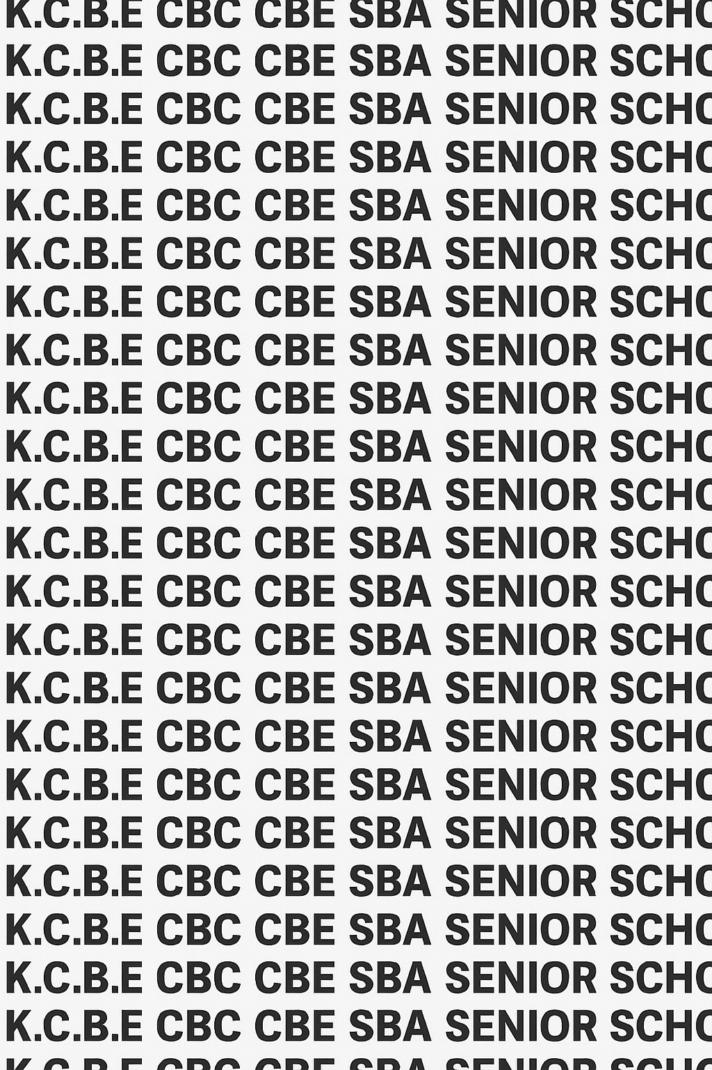
KENYA CERTIFICATE OF BASIC EDUCATION (K.C.B.E)




GRADE 10 BUSINESS STUDIES (Theory) TERM 1 JANUARY 2026
Time: 1 Hour 30 Minutes
COMPETENCY BASED EDUCATION CKEAB 001

LEARNER’S DETAILS
Name: _______________________________________________________________________________________.
School: ______________________________________________________________________________________.
Assessment Number: ________________________________. Date: __________________________________.
School Code: _______________________________. Signature: ________________________________.

INSTRUCTIONS TO LEARNERS
- Write your name, assessment number, class and date on all the answer sheets provided.
- Answer all the questions in the spaces provided.
- Use a blue or black pen for writing. Pencils should be used only for drawings and diagrams.

SCORE GRID
-BUSINESS STUDIES- -001- -Senior School-
Section A | Q1 | Q2 | Q3 | Q4 | Q5 | Q6 | Q7 | Q8a | Q8b | Q9 | Q10 | Q11 | Q12 | Q13 | Q14 | Q15 | Q16 | Q17 | Q18 | Q19 | Q20 | SECTION A TOTAL
Max Marks | 2 | 2 | 2 | 2 | 2 | 2 | 1 | 2 | 1 | 2 | 2 | 2 | 2 | 2 | 2 | 2 | 2 | 2 | 2 | 2 | 2 | 60
Learner Score

Section B | Q21a |  | Q21b | Q21c | Q21d |  | Q22a | Q22b | Q22c | Q22d | Q23a | Q23b | Q23c | Q23d | Q23e | Q24a | Q24b | Q24c | Q24d | Q25a | Q25b | Q25c | Q25d | SECTION B TOTAL
Max Marks | 2 |  | 2 | 2 | 2 |  | 2 | 2 | 2 | 2 | 2 | 2 | 2 | 2 | 2 | 2 | 2 | 2 | 2 | 2 | 2 | 2 | 2 | 40
Learner Score
Section |  | Max Marks |  |  |  | 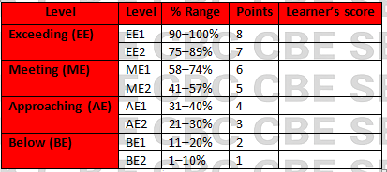  Learner Score
A |  | 60
B |  | 40
TOTAL |  | 100

Performance Levels Grid

This paper has 8 printed pages. Please check out to ensure all pages are printed
Turn over
SECTION A: (60 Marks)
Answer all questions in this section.

1. A supermarket cashier receives a KSh 200 note from a customer. State two functions of money shown in this transaction. (2 marks)

i. _______________________________________________________________________________________________

ii. _______________________________________________________________________________________________.

2. A learner found a new 1000 currency note on her way to school.

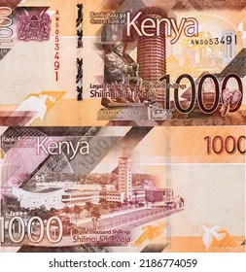

State two security features modern Kenyan currency must have. (2 marks)

i. _______________________________________________________________________________________________

ii. _______________________________________________________________________________________________.

3. State two ethical practices a mobile-money agent should observe when handling customers’ cash. (2 marks)

i. _______________________________________________________________________________________________

ii. _______________________________________________________________________________________________.

4. A businessman prefers storing his wealth in form of land rather than cash. State two reasons people demand money even when they have assets. (2 marks)

i. _______________________________________________________________________________________________

ii. _______________________________________________________________________________________________.

5. Give two roles of money in a modern economy. (2 marks)

i. _______________________________________________________________________________________________

ii. _______________________________________________________________________________________________.

6. Identify two factors that determine the supply of money in an economy. (2 marks)

i. _______________________________________________________________________________________________

ii. _______________________________________________________________________________________________.

7. State one reason why a business should set goals. (1 mark)

_______________________________________________________________________________________________

_______________________________________________________________________________________________.

8. Abel plans to buy a smartphone worth Ksh.18,000 in four months. He has targeted to save at least Ksh 5,000 per month to raise the amount required.

Use the information above to formulate Abel’s financial goals by filling in the following table. (2 marks)
Goal | Time frame | Amount required | Action plan

Outline one benefit that Abel will get from setting his financial goal. (1 mark)

_______________________________________________________________________________________________

_______________________________________________________________________________________________.

9. Give two examples of short-term goals for a small retail shop. (2 marks)

i. _______________________________________________________________________________________________

ii. _______________________________________________________________________________________________.

10. State two forms of unethical behaviour related to the use of money. (2 marks)

i. _______________________________________________________________________________________________

ii. _______________________________________________________________________________________________.

11. A trader wants to set financial goals for the next term. State two steps he should follow. (2 marks)

i. _______________________________________________________________________________________________

ii. _______________________________________________________________________________________________.

12. Identity two functions of money used when a parent pays school fees. (2 marks)

i. _______________________________________________________________________________________________

ii. _______________________________________________________________________________________________.

13. State two reasons why counterfeit money is dangerous to the economy. (2 marks)

i. _______________________________________________________________________________________________

ii. _______________________________________________________________________________________________.

14. Give two factors considered when setting business goals. (2 marks)

i. _______________________________________________________________________________________________

ii. _______________________________________________________________________________________________.

15. State two reasons why long-term goals are important to a business. (2 marks)

i. _______________________________________________________________________________________________

ii. _______________________________________________________________________________________________.

16. A shopkeeper deposits her daily sales through mobile banking. State two reasons why people prefer electronic money.
(2 marks)

i. _______________________________________________________________________________________________

ii. _______________________________________________________________________________________________.

17. List two ways money facilitates economic development. (2 marks)

i. _______________________________________________________________________________________________

ii. _______________________________________________________________________________________________.

18. State two indicators of proper use of money in a business. (2 marks)

i. _______________________________________________________________________________________________

ii. _______________________________________________________________________________________________.

19. Give two examples of long-term goals for a school canteen business. (2 marks)

i. _______________________________________________________________________________________________

ii. _______________________________________________________________________________________________.

20. Identify two reasons that may increase demand for money in Kenya today. (2 marks)

i. _______________________________________________________________________________________________

ii. _______________________________________________________________________________________________.

SECTION B (40 MARKS)
Answer ALL questions

21. Kimani operates a small electronics shop in Eldoret town. Most of his customers pay through cash or mobile money.
(a) Explain three functions of money demonstrated in Kimani’s daily business transactions. (2 marks)

i. _______________________________________________________________________________________________

ii. _______________________________________________________________________________________________.

iii. ______________________________________________________________________________________________
(b) Describe two reasons why customers demand money before making purchases. (2 marks)

i. _______________________________________________________________________________________________

ii. _______________________________________________________________________________________________.
(c) State two ethical practices Kimani must observe when handling customers’ money. (2 marks)

i. _______________________________________________________________________________________________

ii. _______________________________________________________________________________________________.
(d) Explain three negative effects of using counterfeit money in businesses like Kimani’s. (2 marks)

i. _______________________________________________________________________________________________

ii. _______________________________________________________________________________________________.

iii. ______________________________________________________________________________________________

22. The Central Bank of Kenya is conducting a campaign to educate the public on detecting fake currency.
(a) State two reasons why security features are important. (2 marks)

i. _______________________________________________________________________________________________

ii. _______________________________________________________________________________________________.

iii. ______________________________________________________________________________________________
(b) Describe four security features found on Kenyan banknotes that help prevent counterfeiting. (2 marks)

i. _______________________________________________________________________________________________.

ii. _______________________________________________________________________________________________.

iii. ______________________________________________________________________________________________.

iv. ______________________________________________________________________________________________.
(c) Explain two dangers of failing to recognize fake currency in business. (2 marks)

i. _______________________________________________________________________________________________

ii. _______________________________________________________________________________________________.
(d) State two ways the public can ensure they use genuine currency. (2 marks)

i. _______________________________________________________________________________________________

ii. _______________________________________________________________________________________________.

23. Kenya's economic growth depends on how the Central Bank controls money supply.
(a) Define the term money supply. (2 marks)

_______________________________________________________________________________________________

_______________________________________________________________________________________________.

______________________________________________________________________________________________
(b) Explain three factors that determine the amount of money supplied in an economy.(2 marks)

i. _______________________________________________________________________________________________.

ii. _______________________________________________________________________________________________.

iii. ______________________________________________________________________________________________.
(c) Describe three ways money supply affects business operations.(2 marks)

i. _______________________________________________________________________________________________.

ii. _______________________________________________________________________________________________.

iii. ______________________________________________________________________________________________.
(d) State two reasons why governments regulate money supply.(2 marks)

i. _______________________________________________________________________________________________.

ii. _______________________________________________________________________________________________.

e) Identify the following curves as either demand or supply. (2 marks)

Price

Price

Quantity Quantity

A B

A: ____________________________________.

B: ____________________________________.

24. Mary has opened a small tailoring shop and wants it to grow into a well-established boutique.
(a) Explain four reasons why setting goals is important for Mary's business. (2marks)

i. _______________________________________________________________________________________________.

ii. _______________________________________________________________________________________________.

iii. ______________________________________________________________________________________________.

iv. ______________________________________________________________________________________________.
(b) Describe four factors Mary should consider when setting her business goals. (2 marks)

i. _______________________________________________________________________________________________.

ii. _______________________________________________________________________________________________.

iii. ______________________________________________________________________________________________.

iv. ______________________________________________________________________________________________.
(c) Using the SMART approach, outline three features Mary should apply when setting her income goal for the next six months. (3 marks)

i. _______________________________________________________________________________________________.

ii. _______________________________________________________________________________________________.

iii. ______________________________________________________________________________________________.
(d) Give three examples of long-term goals Mary can set for her business. (2 marks)

i. _______________________________________________________________________________________________.

ii. _______________________________________________________________________________________________.

iii. ______________________________________________________________________________________________.

25. A youth group in Nakuru wants to start a poultry project but needs to plan financially.
(a) State four steps the group should follow when setting financial goals. (2 marks)

i. _______________________________________________________________________________________________.

ii. _______________________________________________________________________________________________.

iii. ______________________________________________________________________________________________.

iv. ______________________________________________________________________________________________.

(b) Explain three reasons why demand for money may rise when such a project begins. (2 marks)

i. _______________________________________________________________________________________________.

ii. _______________________________________________________________________________________________.

iii. ______________________________________________________________________________________________.
(c) Describe three roles of money that will help the group successfully run their business. (2 marks)

i. _______________________________________________________________________________________________.

ii. _______________________________________________________________________________________________.

iii. ______________________________________________________________________________________________.
(d) Give four examples of short-term financial goals suitable for the youth group. (2 marks)

i. _______________________________________________________________________________________________.

ii. _______________________________________________________________________________________________.

iii. ______________________________________________________________________________________________.

iv. ______________________________________________________________________________________________.
©2026
All rights reserved
©COMPETENCE KENYA EXAMINATION AND ASSESSMENT BOARD
THIS IS THE LAST PRINTED PAGE

