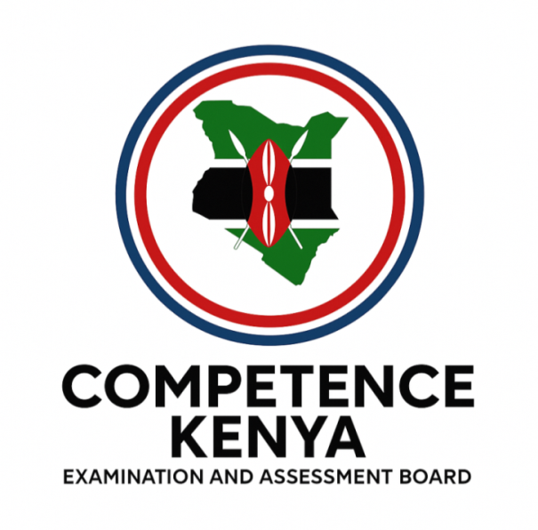
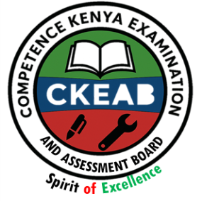
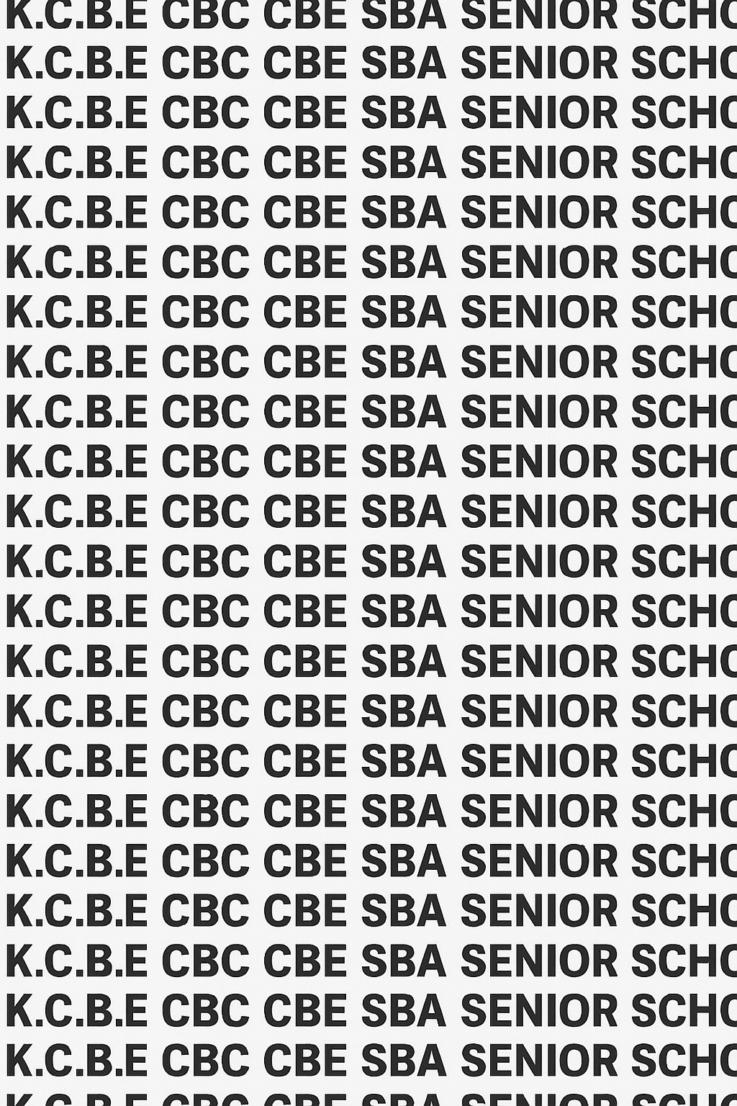
KENYA CERTIFICATE OF BASIC EDUCATION (K.C.B.E)


GRADE 10 CHEMISTRY (Theory) TERM 1 JANUARY 2026
Time: 2 HOURS
COMPETENCY BASED EDUCATION CKEAB 001

LEARNER’S DETAILS
Name: _______________________________________________________________________________________.
School: ______________________________________________________________________________________.
Assessment Number: ________________________________. Date: __________________________________.
School Code: _______________________________. Signature: ________________________________.

INSTRUCTIONS TO LEARNERS
- Write your name, assessment number, class and date on all the answer sheets provided.
- Answer all the questions in the spaces provided.
- Use a blue or black pen for writing. Pencils should be used only for drawings and diagrams.

SCORE GRID
-CHEMISTRY- -001- -Senior School-
Section A | Q1a | Q1b | Q1c | Q2a | Q2b | Q2c | Q2d | Q3a | Q3b | Q4 | Q5a | Q5b | Q5c | Q6 | Q7 | Q8a | Q8b | Q8c | Q9 | Q10a | Q10b | Q10c | TOTAL (40)
Marks | 1 | 1 | 1 | 1 | 1 | 1 | 1 | 1 | 1 | 3 | 1 | 1 | 1 | 2 | 3 | 1 | 2 | 1 | 3 | 1 | 1 | 1 | 40
Learner

Section B | 11a(i) | 11a(ii) | 11a(iii) | 11b | 11c | 12a | 12bi | 12bii | 12biii | 12c | 13a | 13b | 13c | 13di | 13dii | 13e | 14a | 14b | 14c | 14d | 14ei | 14eii | 15a | 15b(i) | 15b(ii) | 15b(iii) | 15b(iv) | 15c | TOTAL (60)
Marks | 2 | 2 | 2 | 2 | 2 | 4 | 2 | 2 | 2 | 2 | 2 | 3 | 2 | 1 | 1 | 1 | 3 | 3 | 3 | 2 | 2 | 1 | 4 | 1 | 1 | 1 | 1 | 6 | 60
Learner

Performance Levels Grid
Section | Max Marks |  | Learner Score
A | 40
B | 60
TOTAL | 100
Level | Level | % Range |  | Points | Learner’s score
Exceeding (EE) | EE1 | 90–100% |  | 8
 | EE2 | 75–89% |  | 7
Meeting (ME) | ME1 | 58–74% |  | 6
 | ME2 | 41–57% |  | 5
Approaching (AE) | AE1 | 31–40% |  | 4
 | AE2 | 21–30% |  | 3
Below (BE) | BE1 | 11–20% |  | 2
 | BE2 | 1–10% |  | 1
This paper has 10 printed pages. Please check out to ensure all pages are printed
Turn over
SECTION A: (40 Marks)
Answer all questions in this section.

1. A mother is seen reading labels on detergent containers before buying.
(a) Define Chemistry. (1mk)
_________________________________________________________________________________________________
_________________________________________________________________________________________________
(b) Identify one branch of chemistry. (1mk)
_________________________________________________________________________________________________
_________________________________________________________________________________________________
(c) State one career related to the branch you named in (b). (1mk)
_________________________________________________________________________________________________
_________________________________________________________________________________________________

2. A clinic issues medicine to patients in clearly labelled packets.
(a) Define the term drug. (1mk)
_________________________________________________________________________________________________
_________________________________________________________________________________________________
(b) What is a prescription? (1mk)
_________________________________________________________________________________________________
_________________________________________________________________________________________________
(c) State the meaning of dosage. (1mk)
_________________________________________________________________________________________________
_________________________________________________________________________________________________
(d) Identify one consumer right when receiving prescribed drugs. (1mk)
_________________________________________________________________________________________________
_________________________________________________________________________________________________

3. Name two effects of abusing the following drugs:
(a) Cigarettes (1mk)
_________________________________________________________________________________________________
_________________________________________________________________________________________________
(b) Khat (miraa) (1mk)
_________________________________________________________________________________________________
_________________________________________________________________________________________________

4. State three roles of chemistry in modern agriculture. (3mks)
- ____________________________________________________________________________________________
- ____________________________________________________________________________________________
- ____________________________________________________________________________________________

5. A student was asked to name the first 20 elements in order.
Write the names of elements with atomic numbers:
(a) 1 (1mk)
_________________________________________________________________________________________________
(b) 8 (1mk)
_________________________________________________________________________________________________
(c) 12 (1mk)
_________________________________________________________________________________________________

6. State two differences between atomic number and mass number. (2mks)
_________________________________________________________________________________________________
_________________________________________________________________________________________________
_________________________________________________________________________________________________
_________________________________________________________________________________________________

7. Give three responsibilities of learners in maintaining a safe learning environment. (3mks)
- ____________________________________________________________________________________________
- ____________________________________________________________________________________________
- ____________________________________________________________________________________________

8. A medicine advert states:

“This drug may cause side effects such as dizziness.”

(a) What is a substance? (1mk)
_________________________________________________________________________________________________
_________________________________________________________________________________________________
(b) Give two common routes of drug intake. (2mks)
_________________________________________________________________________________________________
_________________________________________________________________________________________________
(c) State one side effect of heroin abuse. (1mk)
_________________________________________________________________________________________________
_________________________________________________________________________________________________

9. State three contributions of chemistry in the entertainment industry. (3mks)
_________________________________________________________________________________________________
_________________________________________________________________________________________________
_________________________________________________________________________________________________

10. Write the electronic configuration using s and p notation for:
(a) Nitrogen (Atomic number = 7) (1mk)

(b) Magnesium (Atomic number = 12) (1mk)

(c) Argon (Atomic number = 18) (1mk)

SECTION B (60 MARKS)
Answer ALL questions.

11. A community hospital receives complaints that some herbal drinks sold around the market are causing dizziness and stomach upsets.
(a) Explain three roles of chemistry in ensuring safety of such herbal products. (6mks)
- ____________________________________________________________________________________________
- ____________________________________________________________________________________________
- ____________________________________________________________________________________________
(b) Describe two responsibilities of consumers when buying herbal substances. (2mks)
_________________________________________________________________________________________________
_________________________________________________________________________________________________
(c) State two qualities of a safe learning/working environment in a chemistry lab. (2mks)
_________________________________________________________________________________________________
_________________________________________________________________________________________________

12. A youth centre conducts research on drugs abused by teenagers in the area.
(a) Explain two reasons why young people abuse drugs such as glue/cobbler’s blue. (4mks)
_________________________________________________________________________________________________
_________________________________________________________________________________________________
(b) For each of the drugs below, describe one mode of intake and one health effect:
(i) Cocaine (2mks)
_________________________________________________________________________________________________
_________________________________________________________________________________________________
(ii) Illicit brew (chang’aa) (2mks)
_________________________________________________________________________________________________
_________________________________________________________________________________________________
(iii) Cannabis (bhang) (2mks)
_________________________________________________________________________________________________
_________________________________________________________________________________________________

(c) State two long-term effects of mandrax on the human body. (2mks)
_________________________________________________________________________________________________
_________________________________________________________________________________________________

13. A teacher uses models to explain how scientists discovered the structure of the atom.
(a) State two postulates of Dalton’s atomic theory. (2mks)
_________________________________________________________________________________________________
_________________________________________________________________________________________________
(b) With reference to the representative model of the gold foil experiment, answer the following question
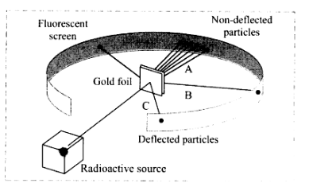

What evidence regarding an atom do lines A, B and C provide? (3mks)
_________________________________________________________________________________________________
_________________________________________________________________________________________________
_________________________________________________________________________________________________
(c) Give two conclusions made from the experiment. (2mks)
_________________________________________________________________________________________________
_________________________________________________________________________________________________
(d) Define the following terms:
(i) Isotope (1mk)
_________________________________________________________________________________________________
_________________________________________________________________________________________________
(ii) Orbital (1mk)
_________________________________________________________________________________________________
_________________________________________________________________________________________________
(e) Identify the subatomic particle present in different numbers in isotopes of the same element. (1mk)
_________________________________________________________________________________________________
_________________________________________________________________________________________________

14. A chemist is analysing an element, X, whose isotopes have masses 20 and 22, in the ratio 3:1.
(a) Calculate the relative atomic mass of element X. (3mks)

(b) Draw a labelled diagram showing the first three energy levels in an atom. (3mks)

(c) Explain the relationship between energy levels and orbitals. (3mks)
_________________________________________________________________________________________________
_________________________________________________________________________________________________
_________________________________________________________________________________________________
_________________________________________________________________________________________________
(d) State the order of filling of electrons into the first four orbitals. (2mks)
_________________________________________________________________________________________________
_________________________________________________________________________________________________

(e) Write the electron configuration using s and p notation for:
(i) Phosphorus (Z = 15) (2mks)

(ii) Neon (Z = 10) (1mk)

15. A career guidance teacher organizes a talk on chemistry-related professions.
(a) List four branches of chemistry. (4mks)
_________________________________________________________________________________________________
_________________________________________________________________________________________________
_________________________________________________________________________________________________
_________________________________________________________________________________________________
(b) Write a career to the correct branch of chemistry: (4mks)
(i) Pharmacist: _________________________________________
(ii) Petroleum engineer: _________________________________________
(iii) Food technologist: _________________________________________
(iv) Forensic scientist: _________________________________________
(c) Explain three ways chemistry is applied in the manufacturing industry. (6mks)
_________________________________________________________________________________________________
_________________________________________________________________________________________________
_________________________________________________________________________________________________

©2026
All rights reserved
©COMPETENCE KENYA EXAMINATION AND ASSESSMENT BOARD
THIS IS THE LAST PRINTED PAGE

