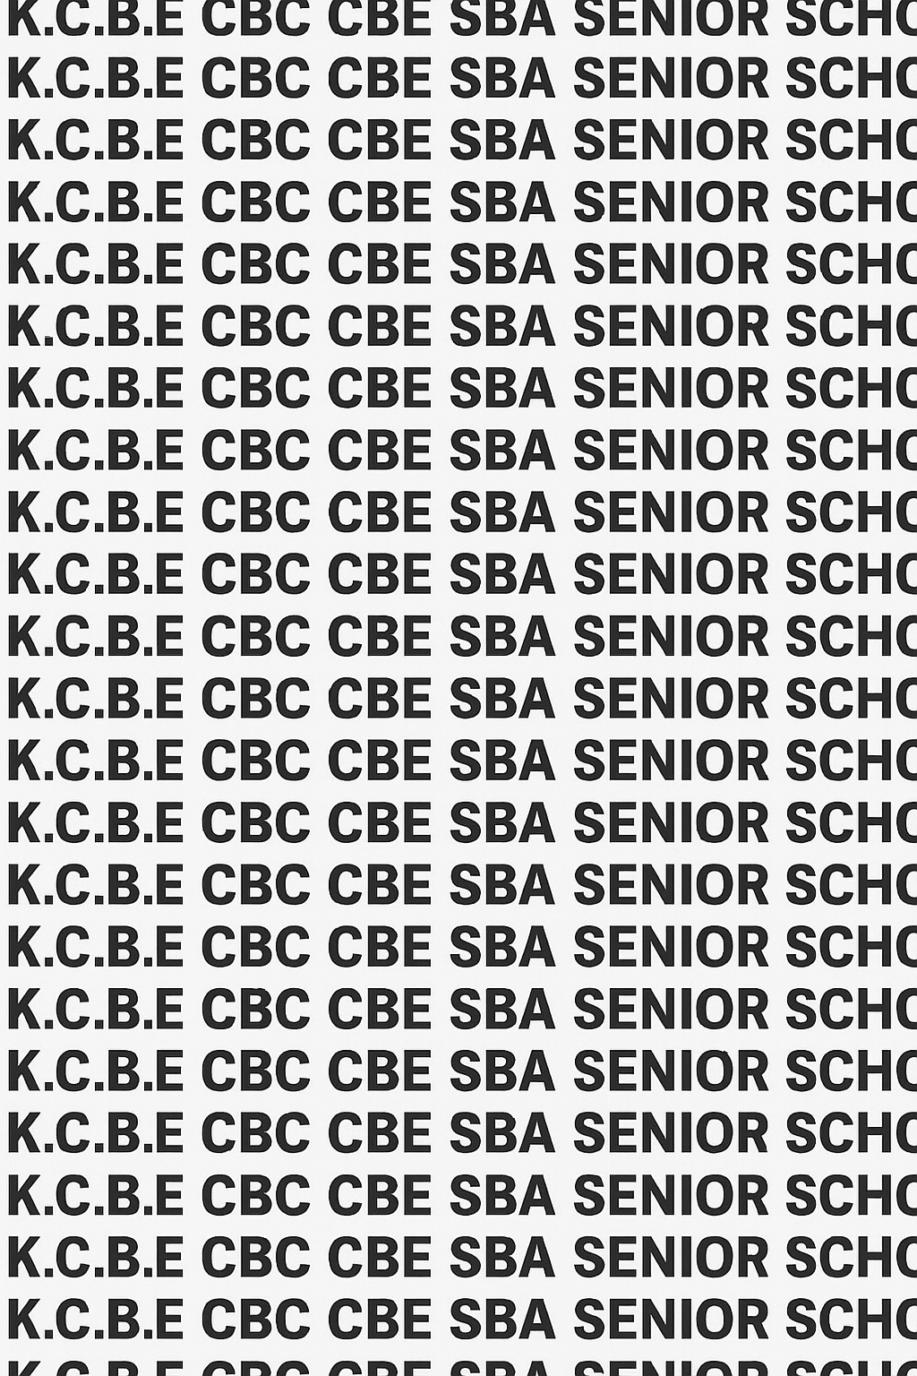
KENYA CERTIFICATE OF BASIC EDUCATION (K.C.B.E)
GRADE 10 COMPUTER STUDIES (Theory) TERM 1 JANUARY 2026
Time: 1 Hour 30 Minutes
COMPETENCE ASSESSMENT EXAMINATION CKEAB 001

LEARNER’S DETAILS
Name: _______________________________________________________________________________________.
School: ______________________________________________________________________________________.
Assessment Number: ________________________________. Date: __________________________________.
School Code: _______________________________. Signature: ________________________________.

INSTRUCTIONS TO LEARNERS
- Write your name, assessment number, class and date on all the answer sheets provided.
- Answer all the questions in the spaces provided.
- Use a blue or black pen for writing. Pencils should be used only for drawings and diagrams.



SCORE GRID
No. | 1 | 2 | 3 | 4 | 5 | 6 | 7 | 8 | 9 | 10 | 11 | 12 | 13 | Total
Marks | 4 | 6 | 4 | 4 | 4 | 6  -COMPUTER STUDIES- -001- -Senior School- | 6 | 10 | 12 | 10 | 10 | 8 | 10 | 100
Learner Score

Section | Max Marks | 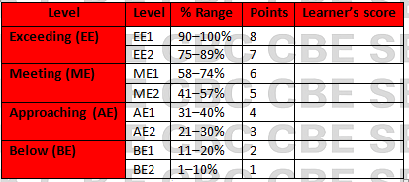  Learner Score
A | 40
B | 60
TOTAL | 100

Performance Levels Grid

This paper has 7 printed pages. Please check out to ensure all pages are printed
Turn over

SECTION A: (40 Marks)
Answer all questions in this section.

1. (a) Define a computer. (2 marks)
__________________________________________________________________________________________________

__________________________________________________________________________________________________

(b) Give two reasons why modern society depends heavily on computers. (2 marks)

__________________________________________________________________________________________________

__________________________________________________________________________________________________

2. A Grade 10 learner visits a museum and sees several early computing devices.
(a) State the main purpose of the Abacus. (1 mark)
__________________________________________________________________________________________________

__________________________________________________________________________________________________

(b) Explain how Napier’s Bones worked. (2 marks)
__________________________________________________________________________________________________

__________________________________________________________________________________________________

(c) State one limitation of the Pascaline. (1 mark)
__________________________________________________________________________________________________

__________________________________________________________________________________________________

(d) Give two uses of the Jacquard Loom in the development of modern computing. (2 marks)

__________________________________________________________________________________________________

__________________________________________________________________________________________________

3. Write the technology with its generation of computers:
(a) Vacuum tubes ______________________________________________ (1 mark)
(b) Transistors ______________________________________________ (1 mark)
(c) Integrated circuits ______________________________________________ (1 mark)
(d) Very Large Scale Integration (VLSI) ______________________________________________ (1 mark)

4. State the function of each type of bus:
(a) Data bus (1 mark)
__________________________________________________________________________________________________

__________________________________________________________________________________________________

(b) Address bus (1 mark)
__________________________________________________________________________________________________

__________________________________________________________________________________________________

(c) Control bus (1 mark)
__________________________________________________________________________________________________

__________________________________________________________________________________________________

(d) System bus (1 mark)

__________________________________________________________________________________________________

__________________________________________________________________________________________________

5. List four main functional units of a digital computer. (4 marks)

6. Convert the following:
(a) 18₁₀ to binary (2 marks)

(b) 62₁₀ to octal (2 marks)

(c) 255₁₀ to hexadecimal (2 marks)

7. Give the function of each:
(a) ALU (2 marks)
__________________________________________________________________________________________________

__________________________________________________________________________________________________

(b) Control Unit (2 marks)
__________________________________________________________________________________________________

__________________________________________________________________________________________________

(c) Registers (2 marks)

__________________________________________________________________________________________________

__________________________________________________________________________________________________

SECTION B: (60 Marks)
Answer all questions

8. A school is upgrading from old desktop computers to modern laptops to improve digital learning.
(a) Describe ONE key technology used in each of the following generations:
i. First Generation ______________________________________________________ (1 mark)
ii. Second Generation ______________________________________________________ (1 mark)
iii. Third Generation ______________________________________________________ (1 mark)
iv. Fourth Generation ______________________________________________________ (1 mark)
v. Fifth Generation ______________________________________________________ (1 mark)

(b) Explain TWO advantages of fourth-generation computers for a school environment. (2 marks)
__________________________________________________________________________________________________

__________________________________________________________________________________________________

(c) State TWO disadvantages of first-generation computers that made them unsuitable for modern schools. (2 marks)
__________________________________________________________________________________________________

__________________________________________________________________________________________________
(d) Suggest ONE reason why the school prefers laptops over desktops. (1 mark)

__________________________________________________________________________________________________

__________________________________________________________________________________________________

9. A technician is repairing a computer that keeps restarting. They suspect problems with the Von Neumann architecture components.

(a) State the three key elements of a Von Neumann computer. (3 marks)
__________________________________________________________________________________________________

__________________________________________________________________________________________________

__________________________________________________________________________________________________

(b) Explain the role of each element in the fetch–execute cycle. (3 marks)
__________________________________________________________________________________________________

__________________________________________________________________________________________________

__________________________________________________________________________________________________

(c) Describe the relationship among these elements during program execution. (3 marks)
__________________________________________________________________________________________________

__________________________________________________________________________________________________

__________________________________________________________________________________________________

(d) Give three reasons why understanding architecture is important for computer technicians. (3 marks)

__________________________________________________________________________________________________

__________________________________________________________________________________________________

__________________________________________________________________________________________________

10. A company wants to buy processors and is comparing RISC and CISC.

(a) State TWO differences between RISC and CISC architectures. (4 marks)
__________________________________________________________________________________________________

__________________________________________________________________________________________________

(b) Give TWO advantages of RISC processors in battery-powered devices like smartphones. (2 marks)
__________________________________________________________________________________________________

__________________________________________________________________________________________________
(c) Explain TWO reasons why some computers still use CISC processors. (2 marks)

__________________________________________________________________________________________________

__________________________________________________________________________________________________

(d) State TWO examples of devices where RISC architecture is widely used. (2 marks)

__________________________________________________________________________________________________

__________________________________________________________________________________________________

11. A programmer is designing a program that stores colors using numbers.
(a) Convert 101011₂ to decimal. (2 marks)

(b) Convert 3A₁₆ to decimal. (2 marks)

(c) Convert 72₁₀ to hexadecimal. (2 marks)

(d) Convert 1100₂ to octal. (2 marks)

(e) Explain ONE advantage of using hexadecimal in programming rather than binary. (2 marks)

__________________________________________________________________________________________________

__________________________________________________________________________________________________

12. During a practical lesson, students observe how data flows inside a computer.
(a) Draw and label the simple functional organization of a computer. (4 marks)

(b) Explain the role of control signals in computer operation. (2 marks)

__________________________________________________________________________________________________

__________________________________________________________________________________________________
(c) State TWO differences between primary and secondary storage. (2 marks)

__________________________________________________________________________________________________

__________________________________________________________________________________________________

13. A student wants to connect a printer, keyboard, and external storage device to a computer.
(a) Define the term interface in computers. (2 marks)

__________________________________________________________________________________________________

__________________________________________________________________________________________________
(b) State TWO types of ports used to connect external devices. (2 marks)

__________________________________________________________________________________________________

__________________________________________________________________________________________________

(c) Give the function of each of the following ports:
i. USB (2 marks)
__________________________________________________________________________________________________

ii. HDMI (2 marks)
__________________________________________________________________________________________________
(d) Explain ONE advantage of USB over older serial ports. (2 marks)

__________________________________________________________________________________________________

__________________________________________________________________________________________________

©2026
All rights reserved
©COMPETENCE KENYA EXAMINATION AND ASSESSMENT BOARD
THIS IS THE LAST PRINTED PAGE

