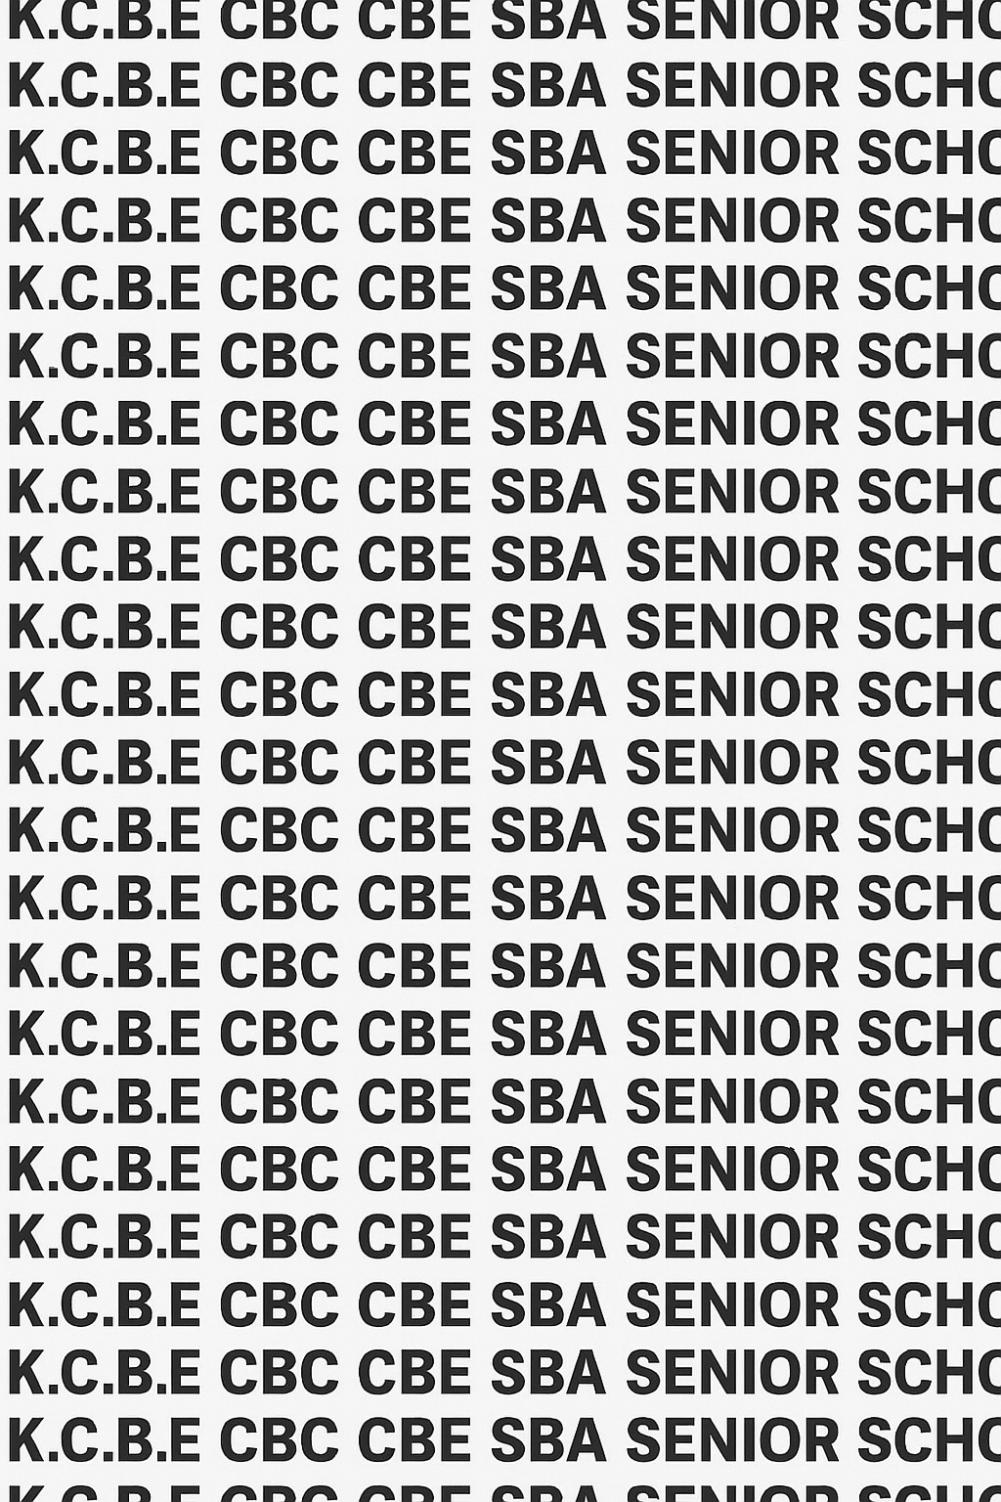
KENYA CERTIFICATE OF BASIC EDUCATION (K.C.B.E)


GRADE 10 CORE MATHEMATICS TERM 1 JANUARY 2026
Time: 2 Hours
COMPETENCY BASED EDUCATION CKEAB 001

LEARNER’S DETAILS
Name: _______________________________________________________________________________________.
School: ______________________________________________________________________________________.
Assessment Number: ________________________________. Date: __________________________________.
School Code: _______________________________. Signature: ________________________________.

INSTRUCTIONS TO LEARNERS
- Write your name, school, assessment number, date, school code and then sign.
- Answer all questions in Section A.
- Answer any five questions in Section B.
- Show all your working.
- Use mathematical tables or a calculator where necessary .
-CORE MATHEMATICS- -001- -Senior School-
SCORE GRID Section | Q1 | Q2 | Q3a | Q3b | Q4 | Q5 | Q6 | Q7 | Q8 | Q9 | Q10 | Section Total (40)
Marks (Max) | 4 | 2 | 1 | 1 | 4 | 1 | 2 | 4 | 4 | 4 | 5 | 40
Learner Score

Section | Q11a | Q11b | Q11c | Q12a | Q12b | Q12c | Q13a | Q13b | Q13c | Q14a | Q14b | Q14c | Q15a | Q15b | Q15c | Q16a | Q16b | Q16c | Q17a | Q17b | Q17c | Section Total (60)
Marks (Max) | 3 | 3 | 6 | 4 | 4 | 4 | 4 | 4 | 4 | 3 | 3 | 6 | 3 | 3 | 6 | 4 | 4 | 4 | 4 | 4 | 4 | 60
Learner Score
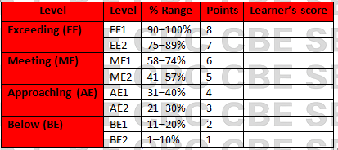
Section | Max Marks | Learner Score
A | 40
B | 60
TOTAL | 100

This paper has 6 printed pages. Please check out to ensure all pages are printed
Turn over
SECTION A: (40 Marks)
Answer all questions in this section.
1. A shopkeeper sold 15 boxes of sugar. If the number of boxes sold yesterday was 15, classify the number as even, odd, prime, or composite. Explain your answer.

2. A machine produces 8 units per hour. Find the reciprocal of the production rate.

3. Determine whether the following numbers are rational or irrational:
(a) $\sqrt{49}$

(b) $\sqrt{2}$

4. Using a calculator, find the reciprocal of $0.25$ and show your working in fraction form.

5.Express $5^{3}×5^{4}$ as a single power of 5.

6. Simplify $\frac{2^{5}×2^{3}}{2^{4}}$.

7. Using logarithm tables, find $log250$ to 4 decimal places.

8. Simplify $log100+log0.1$ using the laws of logarithms.

9. Evaluate ${\left(27\right)}^{\frac{2}{3}}$.

10. Expand and simplify $\left(x+3\right)\left(x-5\right)$.

SECTION B: 60 MARKS
Answer any five questions.
11. A trader invests Ksh 5000 in a business. The growth of the investment is modeled by the expression $A=5000×2^{n}$, where $n$ is the number of months.
a) Evaluate $A$ after 3 months. (3 marks)

b) Express $2^{3}×2^{4}$ as a single power and verify your answer. (3 marks)

c) Using logarithms, find the number of months $n$ required for the investment to reach Ksh 80,000. (6 marks)

12. A group of students is designing a rectangular garden. The area $A$ in square meters is given by $A=x^{2}+5x-24$.
a) Factorize the quadratic expression. (4 marks)

b) Determine the possible values of $x$ if $A=0$. (4 marks)

c) Verify your solutions by substitution. (4 marks)

13. An engineer is analyzing load on a bridge. The load is modeled by $P={10}^{x}$.
a) If $P=1000$, find $x$ using logarithms to base 10. (4 marks)

b) Simplify $\frac{{10}^{6}×{10}^{2}}{{10}^{3}}$ using the laws of indices. (4 marks)

c) Evaluate ${\left(100\right)}^{3/2}$. (4 marks)

14. A student measures the side lengths of a cube as $x$ cm. The volume $V$ is $V=x^{3}$.
a) Express $V$ in terms of powers if $x=2y$. (3 marks)

b) Simplify ${\left(3^{2}\right)}^{4}$ using the laws of indices. (3 marks)

c) If $V=512$, find $x$. (6 marks)

15. A store reduces the price of a TV from Ksh 45,000 to Ksh 36,000.
a) Calculate the fraction representing the discount. (3 marks)

b) Express $45,000-36,000$ as a factorized quadratic if necessary. (3 marks)

c) If the discount is repeated every year, express the price after 3 years using powers. (6 marks)

16. The population of a town grows according to $P=5000{\left(1.1\right)}^{t}$, where $t$ is in years.
a) Find the population after 5 years. (4 marks)

b) Determine $t$ if the population reaches 10,000 using logarithms. (4 marks)

c) Simplify ${\left(1.1\right)}^{3}×{\left(1.1\right)}^{2}$ using the laws of indices. (4 marks)

17. A rectangle has length $x+2$ and width $x-3$. The area is $2x^{2}-5x-12$.
a) Form a quadratic equation from the area expression. (4 marks)

b) Solve the quadratic equation by factorization. (4 marks)

c) Interpret the solutions in the context of the rectangle’s dimensions. (4 marks)

©2026
All rights reserved
©COMPETENCE KENYA EXAMINATION AND ASSESSMENT BOARD
THIS IS THE LAST PRINTED PAGE

