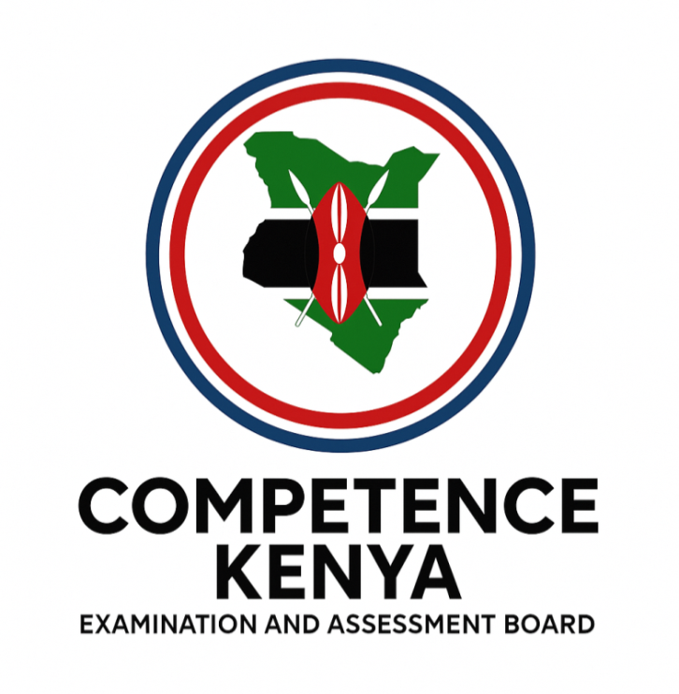
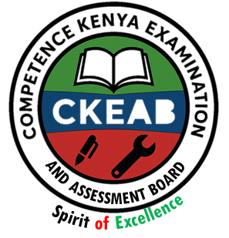
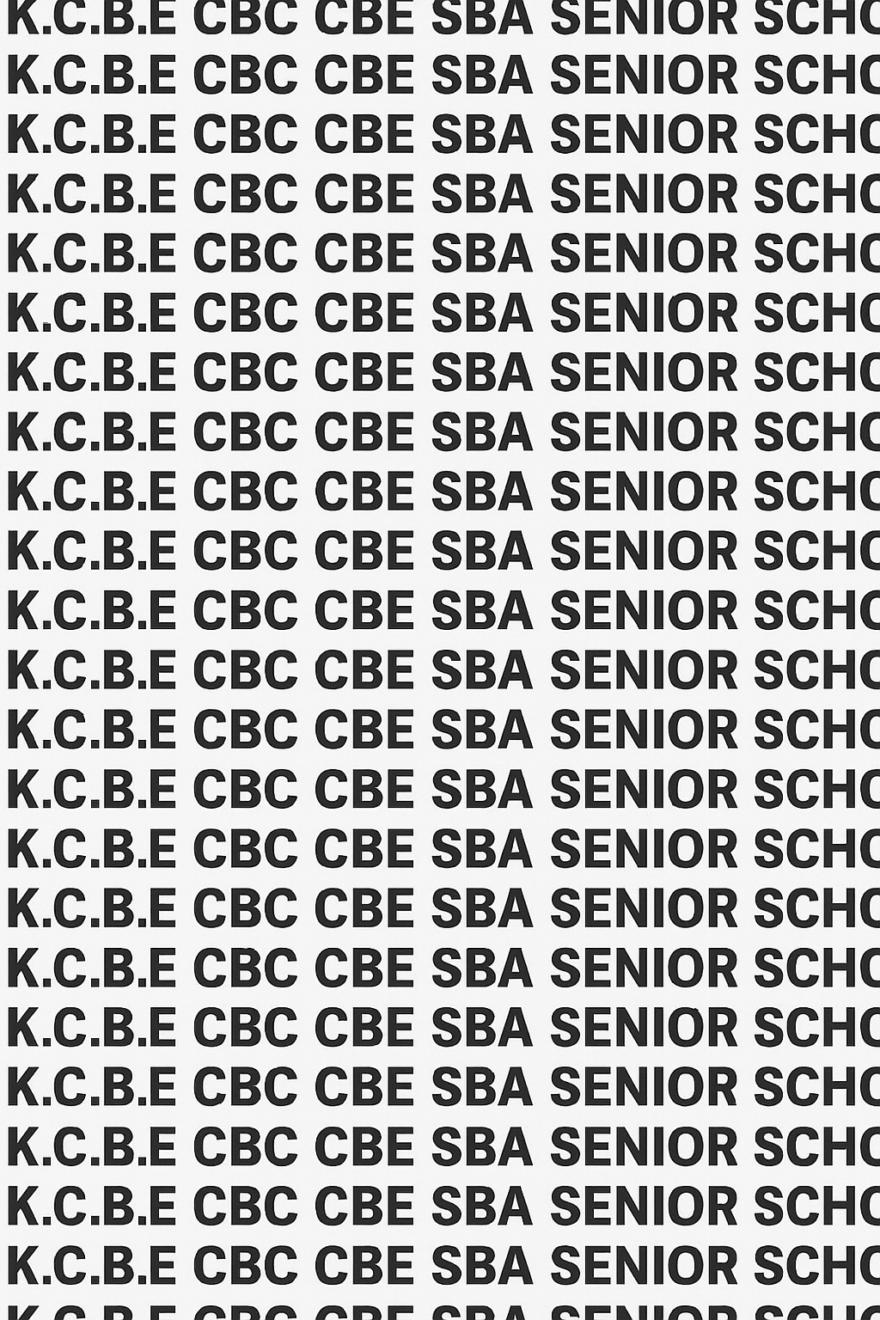
KENYA CERTIFICATE OF BASIC EDUCATION (K.C.B.E)
GRADE 10 CRE (Theory) TERM 1 JANUARY 2026
Time: 1 Hour 30 Minutes
COMPETENCE ASSESSMENT EXAMINATION CKEAB 001

LEARNER’S DETAILS
Name: _______________________________________________________________________________________.
School: ______________________________________________________________________________________.
Assessment Number: ________________________________. Date: __________________________________.
School Code: _______________________________. Signature: ________________________________.

INSTRUCTIONS TO LEARNERS
- Write your name, School, assessment number, signature and date on all the answer sheets provided.
- Answer all the questions in the spaces provided.
- Read each question carefully before writing your answer.
- Ensure your answers are clear, neat, and well-organized.
- The marks for each question are indicated at the end of the question.
- Use relevant Biblical references where necessary.
-CHRISTIAN RELIGIOUS EDUCATION- -001- -Senior School-

Performance Levels Grid
Section A | Q1a | Q1b | Q1c | Q1d | Q1e | Q2a | Q2b | Q2c | Q2d | Q3a | Q3b | Q4a | Q4b | Q4c | Q5a | Q5b | Q5c | Q5d | Q6a | Q6b | Q6c | Q7a | Q7b | Q7c | Q7d | Q8a | Q8b | Q8c | Q9a | Q9b | Q9c | Q9d | Q10a | Q10b | Q10c | Q10d | TOTAL
Max Marks | 2 | 3 | 3 | 2 | 3 | 2 | 2 | 2 | 2 | 2 | 4 | 1 | 3 | 1 | 5 | 2 | 1 | 2 | 2 | 2 | 2 | 3 | 3 | 2 | 4 | 4 | 3 | 3 | 2 | 2 | 2 | 2 | 2 | 3 | 2 | 3 | 60
Learner Score

Section B | Q11a | Q11b | Q11c | Q12a | Q12b | Q12c | Q13a | Q13b | Q13c | TOTAL (40)
Max Marks | 2 | 3 | 1 | 3 | 1 | 2 | 2 | 2 | 2 | 40
Learner Score
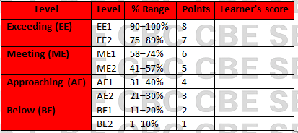
Section | Max Marks | Learner Score
A | 60
B | 40
TOTAL | 100

This paper has 9 printed pages. Please check out to ensure all pages are printed
Turn over
SECTION A: (60 Marks)
Answer all questions in this section.
1. Magdaline is preparing for a Bible study competition. She wants to explain why the Bible is considered the inspired Word of God.
a) Define what is meant by the word Bible (2 marks)
_________________________________________________________________________________________________
_________________________________________________________________________________________________
b) Name at least three authors of the Bible. (3 marks)

i. _______________________________________________________________________________________________.

ii. _______________________________________________________________________________________________.

iii. ______________________________________________________________________________________________.
c) Mention the authors of the following books. (3 marks)
 | Book | Author
i | Exodus
ii | Psalms
iii | Luke
d) Identify two reasons why Christians consider the Bible trustworthy. (2 marks)

i. _______________________________________________________________________________________________.

ii. _______________________________________________________________________________________________.
e) Give three ways in which studying the Bible can strengthen a Christian’s faith. (3 marks)

i. _______________________________________________________________________________________________.

ii. _______________________________________________________________________________________________.

iii. ______________________________________________________________________________________________.
2. A teacher asks her students to categorize the books of the Bible.
a) Name the two main divisions of the Bible. (2 marks)

i. _______________________________________________________________________________________________.

ii. _______________________________________________________________________________________________.
b) List three books found in the Old Testament. (2 marks)
i. _______________________________________________________________________________________________.

ii. _______________________________________________________________________________________________.
c) List three books found in the New Testament. (2 marks)

i. _______________________________________________________________________________________________.

ii. _______________________________________________________________________________________________.

iii. ______________________________________________________________________________________________.
d) Explain why the division into Old and New Testament is important for Christians. (2 marks)

i. _______________________________________________________________________________________________.

ii. _______________________________________________________________________________________________.
3. A Sunday school class is learning about the different categories of Bible books.
a) Name four categories of books in the Bible. (2 marks)

i. _______________________________________________________________________________________________.

ii. _______________________________________________________________________________________________.

iii. ______________________________________________________________________________________________.

iv. ______________________________________________________________________________________________.
b) Give one example of a book from each category you have named. (4 marks)
 | Category | Example
i
ii
iii
iv
4. Sara wants to study the Bible using literacy forms.
a) Define the term “literary forms.” (1 mark)

_______________________________________________________________________________________________.

_______________________________________________________________________________________________.
b) Identify three literary forms used in writing the Bible. (3 marks)

i. _______________________________________________________________________________________________.

ii. _______________________________________________________________________________________________.

iii. ______________________________________________________________________________________________.

c) Explain why understanding literary forms is important in Bible study. (1 mark)

i. _______________________________________________________________________________________________.
5. A pastor is teaching about methods of studying the Bible.
a) Name five methods of studying the Bible. (5 marks)

i. _______________________________________________________________________________________________.

ii. _______________________________________________________________________________________________.

iii. ______________________________________________________________________________________________.

iv. ______________________________________________________________________________________________.

v. _______________________________________________________________________________________________.
b) Explain how the inductive method is applied in Bible study. (2 marks)

i. _______________________________________________________________________________________________.

ii. _______________________________________________________________________________________________.
c) Give one advantage of using the biography method in Bible study. (1 mark)
_______________________________________________________________________________________________.
d) Give one limitation of the topical method. (2 marks)

_______________________________________________________________________________________________.
6. During a CRE lesson, the teacher discusses the story of Jonah.
a) State the main message of the book of Jonah. (2 marks)

_______________________________________________________________________________________________.

_______________________________________________________________________________________________.
b) Identify one character from the book of Jonah and describe their role. (2 marks)

_______________________________________________________________________________________________.
c) Explain one lesson Christians learn from Jonah’s experience. (2 marks)

_______________________________________________________________________________________________.

_______________________________________________________________________________________________.

7. A class is studying the story of the Fall of Man and God’s plan for redemption.
a) Explain the origin of sin according to the Bible. (3 marks)

_______________________________________________________________________________________________.

_______________________________________________________________________________________________.
b) State three consequences of sin. (3 marks)

i. _______________________________________________________________________________________________.

ii. _______________________________________________________________________________________________.

iii. ______________________________________________________________________________________________.
c) Define redemption. (2 marks)

_______________________________________________________________________________________________.

_______________________________________________________________________________________________.
d) Explain how God planned for the salvation of humanity after the Fall. (4 marks)

i. _______________________________________________________________________________________________.

ii. _______________________________________________________________________________________________.
8. A youth group is discussing how Christians respond to redemption.
a) List four ways in which Christians respond to God’s redemption work. (4 marks)

i. _______________________________________________________________________________________________.

ii. _______________________________________________________________________________________________.

iii. ______________________________________________________________________________________________.

iv. ______________________________________________________________________________________________.
b) Explain how faith in Jesus Christ leads to salvation. (3 marks)

i. _______________________________________________________________________________________________.

ii. _______________________________________________________________________________________________.

iii. ______________________________________________________________________________________________.

c) Give three benefits of responding positively to God’s redemption. (3 marks)

i. _______________________________________________________________________________________________.

ii. _______________________________________________________________________________________________.

iii. ______________________________________________________________________________________________.
9. Alice wants to demonstrate how to study the Bible effectively.
a) Describe the observation step in the inductive Bible study method. (2 marks)
i. _______________________________________________________________________________________________.

ii. _______________________________________________________________________________________________.
b) Explain the interpretation step of Bible study. (2 marks)

i. _______________________________________________________________________________________________.

ii. _______________________________________________________________________________________________.
c) Identify one practical application of the inductive Bible study method. (2 marks)

_______________________________________________________________________________________________.

_______________________________________________________________________________________________.
d) Mention one tool that can assist Christians in studying the Bible. (2 marks)

_______________________________________________________________________________________________.

_______________________________________________________________________________________________.
10. A group of students is asked to explore examples of sin and God’s mercy.
a) Give two examples of sins recorded in the Bible. (2 marks)

i. _______________________________________________________________________________________________.

ii. _______________________________________________________________________________________________.
b) Describe one example of God’s mercy shown after a sin. (3 marks)

_______________________________________________________________________________________________.

_______________________________________________________________________________________________.

______________________________________________________________________________________________.
c) Explain why Christians are encouraged to confess sins. (2 marks)

i. _______________________________________________________________________________________________.

ii. _______________________________________________________________________________________________.
d) State two ways studying these stories can guide a Christian’s life. (3 marks)

i. _______________________________________________________________________________________________.

ii. _______________________________________________________________________________________________.
11. During a lesson, the teacher asks about the Pentateuch.
a) Define the term “Pentateuch.” (2 marks)

_______________________________________________________________________________________________.

_______________________________________________________________________________________________.
b) Name the five books that make up the Pentateuch. (3 marks)

i. _______________________________________________________________________________________________.

ii. _______________________________________________________________________________________________.

iii. ______________________________________________________________________________________________.

iv. ______________________________________________________________________________________________.

v. _______________________________________________________________________________________________.
c) Explain the importance of the Pentateuch to Christians today. (1 mark)

_______________________________________________________________________________________________.

_______________________________________________________________________________________________.
12. A CRE club is exploring poetic books in the Bible.
a) Mention three books in the Old Testament. (3 marks)

i. _______________________________________________________________________________________________.

ii. _______________________________________________________________________________________________.

iii. ______________________________________________________________________________________________.
b) Explain the type of content generally found in poetic books. (1 mark)

_______________________________________________________________________________________________.

_______________________________________________________________________________________________.
c) There are _______________ Books in the Old Testament and ____________ Books in the New Testament. (2 marks)

13. A student is asked to study the Gospels.
a) Name the four Gospels. (2 marks)

i. _______________________________________________________________________________________________.

ii. _______________________________________________________________________________________________.
b) Give two reasons why the Gospels are important to Christians. (2 marks)

i. _______________________________________________________________________________________________.

ii. _______________________________________________________________________________________________.
c) State one key message from any one Gospel. (2 marks)

_______________________________________________________________________________________________.

_______________________________________________________________________________________________.
14. The teacher gives a scenario: “A man is struggling with sin and wants to know God’s plan for redemption.”
a) Explain the meaning of salvation. (2 marks)

_______________________________________________________________________________________________.

_______________________________________________________________________________________________.
b) Describe God’s plan for redemption through Jesus Christ. (3 marks)

i. _______________________________________________________________________________________________.

ii. _______________________________________________________________________________________________.

iii. ______________________________________________________________________________________________.
c) Give three ways Christians can live in accordance with God’s redemption plan. (3 marks)

i. _______________________________________________________________________________________________.

ii. _______________________________________________________________________________________________.

iii. ______________________________________________________________________________________________.
d) Mention two challenges Christians may face when responding to redemption. (2 marks)

i. _______________________________________________________________________________________________.

ii. _______________________________________________________________________________________________.

15. During class, students are asked:
a) State two benefits of studying the Bible. (2 marks)

i. _______________________________________________________________________________________________.

ii. _______________________________________________________________________________________________.
b) Mention two reasons why Christians should memorize Bible verses. (2 marks)

i. _______________________________________________________________________________________________.

ii. _______________________________________________________________________________________________.

©2026
All rights reserved
©COMPETENCE KENYA EXAMINATION AND ASSESSMENT BOARD
THIS IS THE LAST PRINTED PAGE

