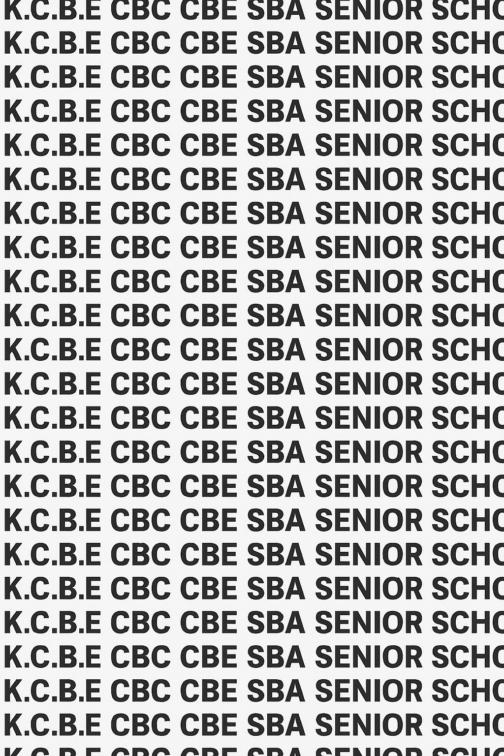
KENYA CERTIFICATE OF BASIC EDUCATION (K.C.B.E)

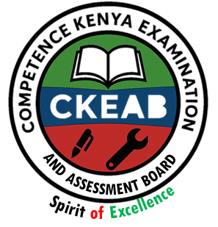
GRADE 10 COMMUNITY SERVICE LEARNING TERM 1 JANUARY 2026
Time: 2 Hours
COMPETENCY-BASED EDUCATION CKEAB 001

LEARNER’S DETAILS
Name: _______________________________________________________________________________________.
School: ______________________________________________________________________________________.
Assessment Number: ________________________________. Date: __________________________________.
School Code: _______________________________. Signature: ________________________________.

INSTRUCTIONS TO LEARNERS
- Write your name, School, assessment number, signature and date on all the answer sheets provided.
- Answer all questions in Section A and any 4 questions from Section B.
- Write your answers clearly and provide examples where necessary.
- All questions are based on practical and theoretical aspects of Community Service Learning.
- Read each question carefully before writing your answer.
- Ensure your answers are clear, neat, and well-organized.
- The marks for each question are indicated at the end of the question.
-COMMUNITY SERVICE LEARNING- -001- -Senior School-
- Do not write in the margin.

Performance Levels Grid
Q1 | Q2 | Q3 | Q4 | Q5 | Q6 | Q7 | Q8 | Q9 | Q10 | Q11 | Q12 | Q13 | Q14 | Q15 | Q16 | SECTION A TOTAL (40)
1 | 2 | 2 | 3 | 2 | 3 | 4 | 3 | 3 | 4 | 3 | 2 | 2 | 1 | 2 | 1 | 40
Score

Q17 | Q18 | Q19 | Q20 | Q21 | SECTION B TOTAL (60)
15 | 15 | 15 | 15 | 15 | 60
Score
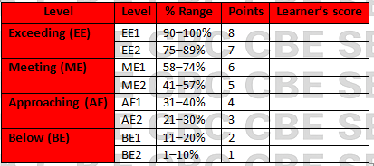
Section | Max Marks | Learner Score
A | 60
B | 40
TOTAL | 100

This paper has 8 printed pages. Please check out to ensure all pages are printed
Turn over
SECTION A: (40 Marks)
Answer all questions in this section.
1. Your school plans a tree planting project in the nearby community.
Which principle of Community Service Learning emphasizes that students should actively reflect on their service experiences? (1 mark)
________________________________________________________________________________________________
2. List two other principles of CSL. (2 marks)
i) ________________________________________________________________________________________________
ii)________________________________________________________________________________________________
3. Residents in a village are planning a clean-up campaign.
State two civic responsibilities a community member should uphold during such initiatives. (2 marks)
i) ________________________________________________________________________________________________
ii) _______________________________________________________________________________________________
3. Define Community, Community Service, and Community Service Learning. (3 marks)
- Community:
___________________________________________________________________________________________

___________________________________________________________________________________________

- Community service:
___________________________________________________________________________________________

___________________________________________________________________________________________
- Community service learning:
___________________________________________________________________________________________

___________________________________________________________________________________________
4. Highlight two differences between Community Service and Community Service Learning. (2 marks)
 | Community service | Community service learning
i
ii

5. After conducting a health awareness campaign, students are asked to evaluate the impact.
Identify two roles of reflective practice in CSL. (2 marks)
i) ________________________________________________________________________________________________
ii) _______________________________________________________________________________________________
6. Your community is facing challenges such as poor sanitation, unemployment, and lack of electricity.
Identify the type of community need for each of the following: (3 marks)
- Poor sanitation → _______________________.
- Unemployment → _______________________.
- Lack of electricity → _____________________.
7. Name four main categories of community needs. (4 marks)
i) ________________________________________________________________________________________________
ii) _______________________________________________________________________________________________
iii) _______________________________________________________________________________________________
iv) _______________________________________________________________________________________________
8. Give three examples of community stakeholders involved in service projects. (3 marks)
i) ________________________________________________________________________________________________
ii) _______________________________________________________________________________________________
iii) _______________________________________________________________________________________________
9. Your class has formed a CSL group to organize a literacy program for children.
State three qualities of an effective leader. (3 marks)
i) ________________________________________________________________________________________________
ii) _______________________________________________________________________________________________
iii) _______________________________________________________________________________________________
10. Match the leadership style to its characteristic: (4 marks)
Leadership Style | Characteristic
Transformative | Inspires change and innovation
Democratic | Encourages participation and decision-making
Servant | Prioritizes the needs of others
Situational | Adapts approach depending on context

11. List three responsibilities of a CSL group leader. (3 marks)
i) ________________________________________________________________________________________________
ii) _______________________________________________________________________________________________
iii) _______________________________________________________________________________________________
12. Describe two procedures for conducting an election in a school CSL group. (2 marks)
i) ________________________________________________________________________________________________
ii) _______________________________________________________________________________________________
13. Your CSL group is conducting weekly environmental cleanup activities.
Suggest two ways to manage rotation of roles effectively. (2 marks)
i) ________________________________________________________________________________________________
ii) _______________________________________________________________________________________________
14. Explain why leadership transition is important in CSL activities. (1 mark)
________________________________________________________________________________________________
_______________________________________________________________________________________________
15. Identify two common challenges faced by CSL groups. (2 marks)
i) ________________________________________________________________________________________________
ii) _______________________________________________________________________________________________
16. Suggest one strategy to overcome each of these challenges. (1 mark)
________________________________________________________________________________________________

SECTION B: (60 Marks)
Answer any 4 questions.
17. Your school is planning to conduct a campaign on water conservation in your community.
(a) Explain the purpose of CSL in such a project. (2 marks)
i) ________________________________________________________________________________________________
ii) _______________________________________________________________________________________________
iii) _______________________________________________________________________________________________
iv) _______________________________________________________________________________________________
v) _______________________________________________________________________________________________
(b) Identify the community needs that this project addresses.
i) ________________________________________________________________________________________________
ii) _______________________________________________________________________________________________
iii) _______________________________________________________________________________________________
iv) _______________________________________________________________________________________________
v) _______________________________________________________________________________________________
(c) Describe how you would involve community stakeholders in planning and execution.
i) ________________________________________________________________________________________________
ii) _______________________________________________________________________________________________
iii) _______________________________________________________________________________________________
iv) _______________________________________________________________________________________________
v) _______________________________________________________________________________________________
18.Your CSL group is electing new leaders for the upcoming term.
(a) Mention four different leadership styles.
i) ________________________________________________________________________________________________
ii) _______________________________________________________________________________________________
iii) _______________________________________________________________________________________________
iv) _______________________________________________________________________________________________
(a) Discuss four characteristics of one of the leadership style.
i) ________________________________________________________________________________________________
ii) _______________________________________________________________________________________________
iii) _______________________________________________________________________________________________
iv) _______________________________________________________________________________________________
(b) Explain how you would conduct elections to ensure fairness.
i) ________________________________________________________________________________________________
ii) _______________________________________________________________________________________________
iii) _______________________________________________________________________________________________
(c) Suggest how to manage leadership transitions to maintain group continuity.
i) ________________________________________________________________________________________________
ii) _______________________________________________________________________________________________
iii) _______________________________________________________________________________________________
iv) _______________________________________________________________________________________________
18. After conducting a youth mentorship program, your group wants to assess its impact.
(a) Explain the importance of reflective practice in CSL. (5 marks)
i) ________________________________________________________________________________________________
ii) _______________________________________________________________________________________________
iii) _______________________________________________________________________________________________
iv) _______________________________________________________________________________________________
v) _______________________________________________________________________________________________
(b) Describe three ways in which reflection can improve future CSL activities. (6 marks)
i) ________________________________________________________________________________________________
ii) _______________________________________________________________________________________________
iii) _______________________________________________________________________________________________
(c) Give examples of a reflection activity you could conduct after a service project. (4 marks)
i) ________________________________________________________________________________________________
ii) _______________________________________________________________________________________________
19. Your community is planning a monthly health awareness program.
(a) Discuss five civic responsibilities members should uphold during this project.(10 marks)
i) ________________________________________________________________________________________________
ii) _______________________________________________________________________________________________
iii) _______________________________________________________________________________________________
iv) _______________________________________________________________________________________________
v) _______________________________________________________________________________________________
(b) Explain how effective leadership contributes to community development. (3 marks)
i) ________________________________________________________________________________________________
ii) _______________________________________________________________________________________________
iii) _______________________________________________________________________________________________
(c) Suggest two strategies to encourage community participation in CSL projects. (2 marks)
i) ________________________________________________________________________________________________
ii) _______________________________________________________________________________________________
20. Your group identifies poor road infrastructure and limited access to clean water in your area.
(a) Classify each of the community needs (environmental, social, economic, political, technological). ( 7 marks)
 | Community challenge | Category
i. | Poor roads
ii | Limited access to clean water
iii | Lack of telephone boosters
iv | Lack of recreational centres
v | Poor leadership
vi | Lack of worship centres
vii | No computers in schools
(b) Propose two interventions to address each identified need.( 4 marks)
i) ________________________________________________________________________________________________
ii) _______________________________________________________________________________________________
(c) Discuss how involving community stakeholders enhances the effectiveness of the interventions.(4 marks)
i) ________________________________________________________________________________________________
ii) _______________________________________________________________________________________________
i) ________________________________________________________________________________________________
ii) _______________________________________________________________________________________________
21. Your group runs weekly reading sessions for primary school children.
(a) Explain how to manage the daily running of group activities efficiently. (8 marks)
i) ________________________________________________________________________________________________
ii) _______________________________________________________________________________________________
i) ________________________________________________________________________________________________
ii) _______________________________________________________________________________________________
(b) Discuss how rotation of roles ensures active participation of all members. (4 marks)
i) ________________________________________________________________________________________________
ii) _______________________________________________________________________________________________
i) ________________________________________________________________________________________________
ii) _______________________________________________________________________________________________
(c) Identify three challenges that could arise in running group activities and propose solutions for each. (3 marks)
i) ________________________________________________________________________________________________
ii) _______________________________________________________________________________________________
i) ________________________________________________________________________________________________

©2026
All rights reserved
©COMPETENCE KENYA EXAMINATION AND ASSESSMENT BOARD
THIS IS THE LAST PRINTED PAGE

