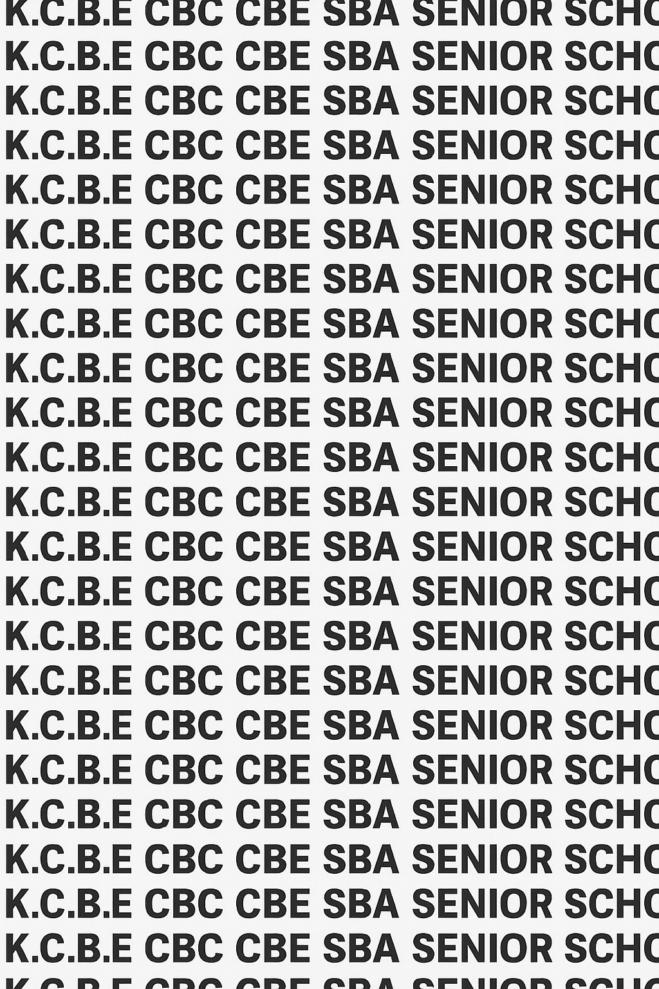
KENYA CERTIFICATE OF BASIC EDUCATION (K.C.B.E)


GRADE 10 ELECTRICAL TECHNOLOGY (Theory) TERM 1 JANUARY 2026
Time: 1 Hour 50 Minutes
COMPETENCE ASSESSMENT EXAMINATION CKEAB 001

LEARNER’S DETAILS
Name: _______________________________________________________________________________________.
School: ______________________________________________________________________________________.
Assessment Number: ________________________________. Date: __________________________________.
School Code: _______________________________. Signature: ________________________________.

INSTRUCTIONS TO LEARNERS
- Write your name, School, assessment number, signature and date on all the answer sheets provided.
- Answer all the questions in the spaces provided.
-ELECTRICAL TECHNOLOGY- -001- -Senior School-
- Read each question carefully before writing your answer.
- Ensure your answers are clear, neat, and well-organized.
- The marks for each question are indicated at the end of the question.
- Use a blue or black pen for writing. Pencils should be used only for drawings and diagrams.

SCORE GRID
Q1 | Q2 | Q3 | Q4 | Q5 | Q6 | Q7 | Q8 | Q9 | Q10 | Q11 | Q12 | Q13 | Q14 | Q15 | SECTION A TOTAL /60
6 | 6 | 8 | 6 | 6 | 6 | 6 | 6 | 8 | 8 | 8 | 10 | 8 | 10 | 5 | /60
Score

Q16 | Q17 |  | Q18 | Q19 |  | Q20 | SECTION B TOTAL /40
 |  |  |  |  |  |  | /40
Score
Section |  | Max Marks |  |  | 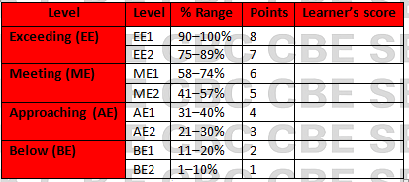  Learner Score
A |  | 60
B |  | 40
TOTAL |  | 100

Performance Levels Grid

This paper has 10 printed pages. Please check out to ensure all pages are printed
Turn over
SECTION A: (60 Marks)
Answer all questions in this section.

1. A community in Kericho has received funding to set up a technical centre offering electrical technology skills.
(a) Explain two ways electrical technology contributes to society development. (2 marks)
i) ____________________________________________________________________________________________.
ii) ____________________________________________________________________________________________.
(b) State two ways the project will improve employment in the area. (2 marks)
i) ____________________________________________________________________________________________.
ii) ____________________________________________________________________________________________.
(c) Identify two social benefits the youth will gain from the centre. (2 marks)
i) ____________________________________________________________________________________________.
ii) ____________________________________________________________________________________________.

2. A Form 4 leaver wants to pursue a career path in electrical technology.
(a) List two technical careers in electrical technology. (2 marks)
i) ____________________________________________________________________________________________.
ii) ____________________________________________________________________________________________.
(b) List two non-technical/support careers related to the field. (2 marks)
i) ____________________________________________________________________________________________.
ii) ____________________________________________________________________________________________.
(c) Explain one benefit of pursuing electrical-related careers. (2 marks)
____________________________________________________________________________________________.
____________________________________________________________________________________________.

3. A student in the school workshop is preparing to repair an extension cable.
(a) Identify four PPEs the student must wear. (4 marks)
i) ____________________________________________________________________________________________.
ii) ____________________________________________________________________________________________.
iii) ____________________________________________________________________________________________.
iv) ____________________________________________________________________________________________.
(b) State two reasons each PPE chosen is important. (4 marks)
i) ____________________________________________________________________________________________.
ii) ____________________________________________________________________________________________.

4. A construction site has several electricians working without helmets.
(a) State two safety responsibilities of the workers. (2 marks)
i) ____________________________________________________________________________________________.
ii) ____________________________________________________________________________________________.
(b) State two responsibilities of employers at the site. (2 marks)
i) ____________________________________________________________________________________________.
ii) ____________________________________________________________________________________________.
(c) State two responsibilities of government agencies like EPRA. (2 marks)
i) ____________________________________________________________________________________________.
ii) ____________________________________________________________________________________________.

5. A school is planning to increase use of electricity in its facilities.
(a) State two uses of electricity in:
i. Home (2 marks)
i) ____________________________________________________________________________________________.
ii) ____________________________________________________________________________________________.
ii. School (2 marks)
i) ____________________________________________________________________________________________.
ii) ____________________________________________________________________________________________.
(b) Give two ways electricity is used in offices. (2 marks)
i) ____________________________________________________________________________________________.
ii) ____________________________________________________________________________________________.
(c) State two industrial applications of electricity. (2 marks)
i) ____________________________________________________________________________________________.
ii) ____________________________________________________________________________________________.

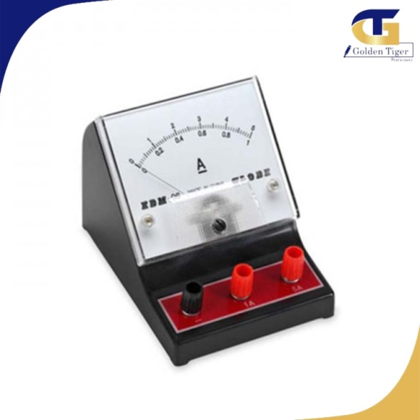
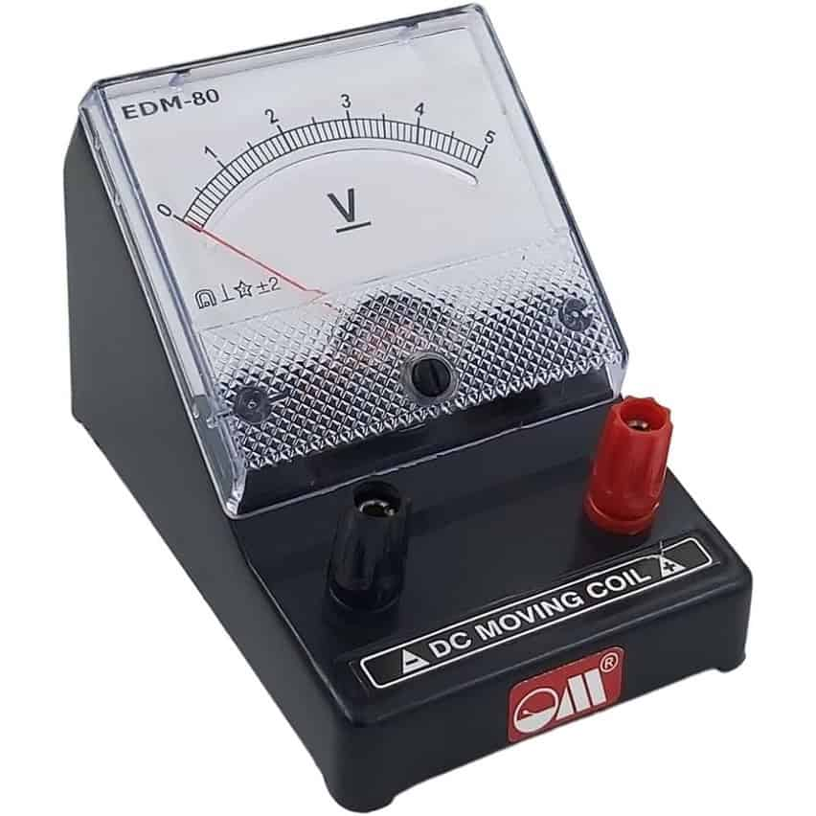
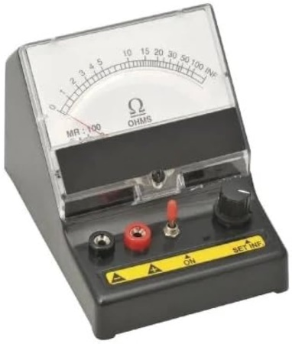
6. Study the items below
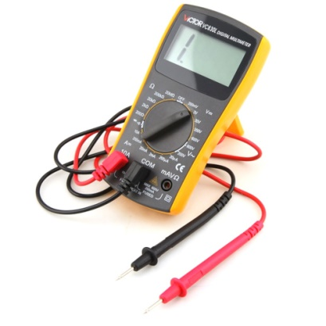

U V W X
(a) Identify two components labelled in the kettle. (4 marks)
U: ____________________________________________________________________________________________.
V: ____________________________________________________________________________________________.
W: ____________________________________________________________________________________________.
X: ____________________________________________________________________________________________.
(b) Give the role of part labelled. (2 marks)
Part | Role
U
W

7. Your class has completed a repair practical in the workshop.
(a) State two reasons for cleaning electrical tools after use. (2 marks)
i) ____________________________________________________________________________________________.
ii) ____________________________________________________________________________________________.
(b) State two methods of storing tools safely. (2 marks)
i) ____________________________________________________________________________________________.
ii) ____________________________________________________________________________________________.
(c) Explain two effects of poor tool storage on safety. (2 marks)
i) ____________________________________________________________________________________________.
ii) ____________________________________________________________________________________________.

8. (a) Define electrical technology. (2 marks)
________________________________________________________________________________________________

________________________________________________________________________________________________

(b) Differentiate between current and voltage. (2 marks)
____________________________________________________________________________________________.
____________________________________________________________________________________________.
____________________________________________________________________________________________.
____________________________________________________________________________________________.

(c) State two factors that affect electrical resistance. (2 marks)
i) ____________________________________________________________________________________________.
ii) ____________________________________________________________________________________________.

9. Study the diagram below:
+ ----[ R1 ]----[ R2 ]---- -
4Ω 6Ω
The circuit is supplied by a 10 V battery.
(a) Calculate the total resistance. (2 marks)
`

(b) Calculate the total current flowing. (2 marks)

(c) Calculate the voltage drop across R1. (2 marks)

(d) Give one application of series circuits. (2 marks)

10. A torch uses a simple DC circuit as shown:
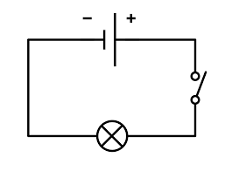
Q

R S

T
(a) Identify the components in the circuit labelled. (2 marks)
Q: ____________________________________________________________________________________________.
T: ____________________________________________________________________________________________.
(b) State the function of the switch. (2 marks)
____________________________________________________________________________________________.
____________________________________________________________________________________________.
(c) Explain why torches use DC supply. (2 marks)
____________________________________________________________________________________________.
____________________________________________________________________________________________.
(d) Give one advantage of using LEDs instead of bulbs. (2 marks)
____________________________________________________________________________________________.
____________________________________________________________________________________________.

11. Consider the junction diagram:
I1
↓
-----●-----
↙ ↘
I2 I3
Given: I1 = 6 A, I2 = 4 A
(a) State Kirchhoff’s Current Law (KCL). (2 marks)

(b) Use KCL to calculate I3. (2 marks)

(c) State Kirchhoff’s Voltage Law (KVL). (2 marks)

(d) Give two real-life applications of KCL or KVL. (4 marks)
____________________________________________________________________________________________.
____________________________________________________________________________________________.

12. A smartphone charging circuit is shown:
Charger → [Cable] → ●----[Battery]
↓
Phone
A technician finds that the phone does not charge.
(a) State two possible causes of an open circuit in the cable. (2 marks)
____________________________________________________________________________________________.
____________________________________________________________________________________________.
(b) State two signs of a short circuit. (2 marks)
____________________________________________________________________________________________.
____________________________________________________________________________________________.
(c) Explain how a multimeter can be used to trace the fault. (3 marks)
____________________________________________________________________________________________.
____________________________________________________________________________________________.
(d) State one safety precaution when using testing instruments. (1 mark)
____________________________________________________________________________________________.
____________________________________________________________________________________________.
(e) Give two examples of faulty components in DC circuits. (2 marks)
____________________________________________________________________________________________.
____________________________________________________________________________________________.

13. Your class is given a digital multimeter to test a resistor.
(a) Draw a simple diagram of a multimeter set to measure resistance.
(Use ASCII diagram—do not worry about artistic accuracy.) (2 marks)

(b) State two rules when using a multimeter. (2 marks)
____________________________________________________________________________________________.
____________________________________________________________________________________________.
(c) Explain how to measure current in a circuit using the meter. (3 marks)
____________________________________________________________________________________________.
____________________________________________________________________________________________.
____________________________________________________________________________________________.
(d) State one reason why measuring instruments must be calibrated. (1 mark)
____________________________________________________________________________________________.
____________________________________________________________________________________________.
(e) Give two other instruments used in DC circuit testing. (2 marks)
____________________________________________________________________________________________.
____________________________________________________________________________________________.

14. A boda boda rider uses a phone holder with a USB charger connected to the motorcycle battery.
(a) Explain how the DC circuit enables charging. (3 marks)
____________________________________________________________________________________________.
____________________________________________________________________________________________.
____________________________________________________________________________________________.
(b) State two advantages of DC supply in motorcycles. (2 marks)
____________________________________________________________________________________________.
____________________________________________________________________________________________.
(c) Identify two dangers of poor wiring on motorcycles. (2 marks)
____________________________________________________________________________________________.
____________________________________________________________________________________________.
(d) Suggest two safety measures for riders using electrical accessories. (3 marks)
____________________________________________________________________________________________.
____________________________________________________________________________________________.
15. A technician in a school laboratory is testing a small electronic circuit made of four resistors as shown below:
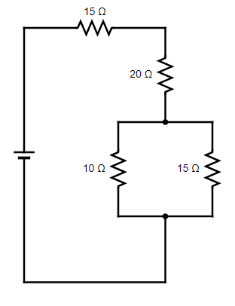
R1

R2

R3 R4

(a) Identify one resistor connected in series and one connected in parallel in the circuit. (2 marks)
____________________________________________________________________________________________.
____________________________________________________________________________________________.
(b) Calculate the total resistance of the circuit (1 mark)

(c) Calculate the total resistance of the entire circuit. (1 mark)

(d) Give one advantage of connecting resistors in parallel in an electrical system. (1 mark)
____________________________________________________________________________________________.
____________________________________________________________________________________________.

©2026
All rights reserved
©COMPETENCE KENYA EXAMINATION AND ASSESSMENT BOARD
THIS IS THE LAST PRINTED PAGE

