

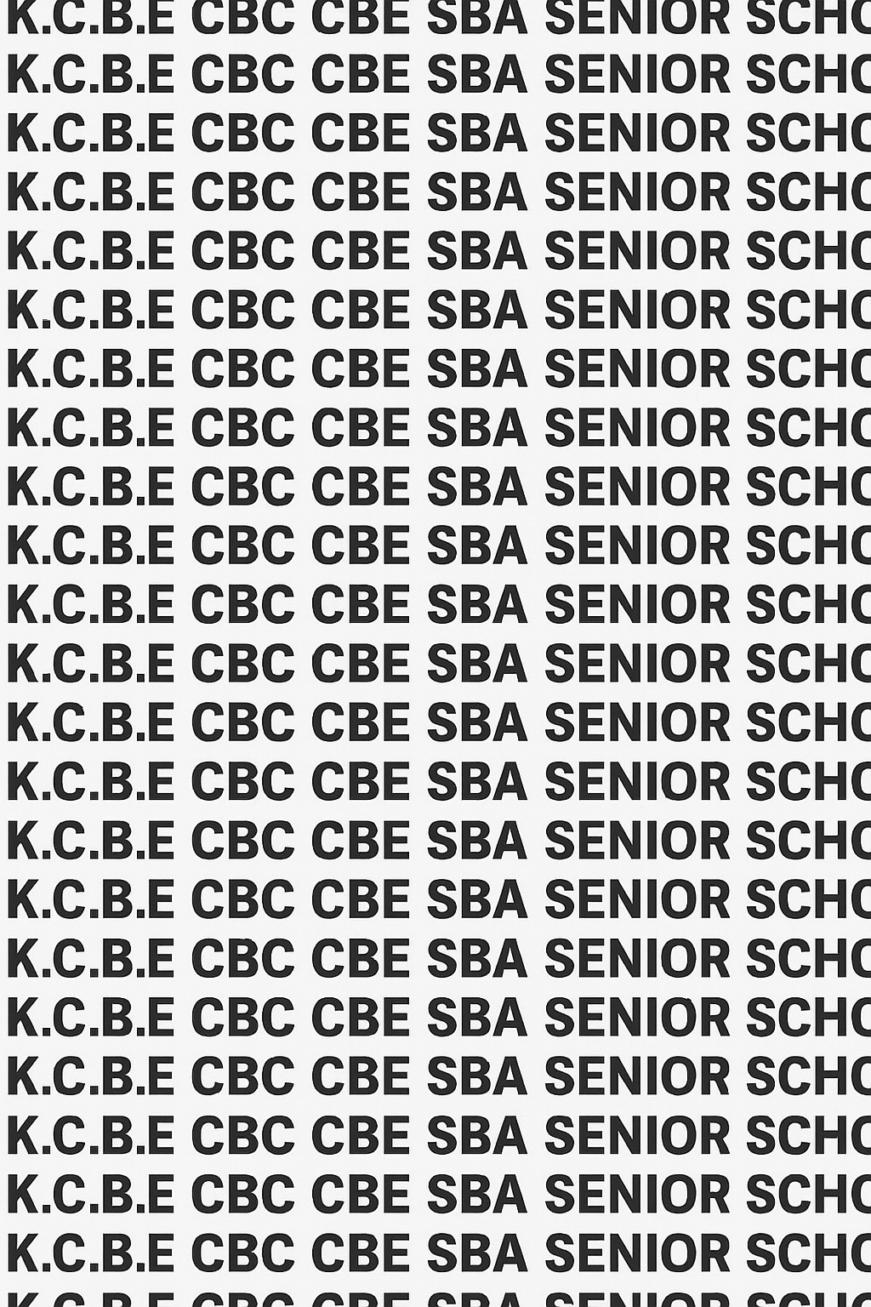
KENYA CERTIFICATE OF BASIC EDUCATION (K.C.B.E)
GRADE 10 ENGLISH (Theory) TERM 1 JANUARY 2026
Time: 1 Hour 45 Minutes
COMPETENCY BASED EDUCATION CKEAB 001

LEARNER’S DETAILS
Name: _______________________________________________________________________________________.
School: ______________________________________________________________________________________.
Assessment Number: ________________________________. Date: __________________________________.
School Code: _______________________________. Signature: ________________________________.

INSTRUCTIONS TO LEARNERS
- Write your name, school, assessment number, date, school code and sign
- Answer all questions in Section A (70 marks) and Section B (30 marks).
- Write your answers in the spaces provided.
- Ensure your writing is legible, neat, and grammatically correct.
- Manage your time well to complete both sections.
- Where a question has sub-questions (a, b, c, d), answer all parts.
- /For summary questions, stick to the number of words required.
- When rewriting sentences, follow the instructions given in brackets.
- Maintain polite language and etiquette in dialogue and communication questions.
- After finishing, recheck your work before submitting.

Performance Levels Grid
Q1 | Q2 | Q3 | Q4 | Q5 | Q6 | Q7 | Q8 | Q9 | SECTION A TOTAL /70
10 | 6 | 4 | 4 | 4 | 6 | 10 | 6 | 20 | /70
Score
/
Q10 | Q11 | Q12 | Q13 | Q14 | SECTION
3 | 6 | 8 | 6 | 7 | /30
Score

Section | Max Marks | Learner Score
ENGLISH | 70
LITERATURE | 30
TOTAL | 100

This paper has 9 printed pages. Please check out to ensure all pages are printed
Turn over
SECTION A: ENGLISH (70 Marks)
Answer all questions in this section.
- Read the passage below and answer the questions that follow.
Maria had always dreamed of becoming a journalist. Every morning before school, she listened to radio news while helping her mother prepare breakfast. One day, the school announced a writing competition where learners were required to write a short news report about an event in their community. Maria decided to report on the frequent power outages experienced in her village. She interviewed neighbours, asked the electricity company for comments, and wrote her story carefully. When the winners were announced, Maria was shocked to hear her name mentioned. She had won first place and her report was read on the school assembly microphone.
a) Identify the main problem Maria chose to write about. (2 marks)
____________________________________________________________________________________________________________________________________________________________________________________________________
b) Describe one character trait of Maria using evidence from the passage. (2 marks)
____________________________________________________________________________________________________________________________________________________________________________________________________c) State two ways in which Maria collected information for her report. (2 marks)
____________________________________________________________________________________________________________________________________________________________________________________________________d) Why do you think Maria was shocked when her name was announced? (2 marks)
____________________________________________________________________________________________________________________________________________________________________________________________________e) Suggest an appropriate title for this passage. (2 marks)
____________________________________________________________________________________________________________________________________________________________________________________________________
2. Read the story below and use it to answer the questions that follow
The world’s oceans face a mounting crisis largely driven by human activity—plastic pollution. Millions of tonnes of plastic waste, from packaging and bottles to fishing nets, enter the marine environment every year. This plastic doesn’t biodegrade; instead, it breaks down into tiny pieces called microplastics. These particles spread throughout the water, from the surface to the deep sea, contaminating every ecosystem.
One of the most immediate effects is on marine life. Whales, turtles, and seabirds often mistake plastic bags for food, leading to blockages and starvation. Smaller creatures ingest microplastics, which then move up the food chain, potentially affecting human health when we consume seafood. The pollution also smothers coral reefs and seabed habitats, disrupting the balance of these delicate ecosystems.
To combat this, a global effort is required. Individuals must reduce their reliance on single-use plastics, and governments must enforce better waste management and recycling programmes. Ultimately, protecting the ocean is not just about saving marine animals; it is about preserving the health of the entire planet, including ourselves.
In not more than 40 words, summarise the passage in your own words, keeping the main ideas but using different expressions. (6 marks)
__________________________________________________________________________________________________________________________________________________________________________________________________________________________________________________________________________________________________________________________________________________________________________________________________________________________________________________________________________________________________________________________________________________________________________________________________________________________________________________________________________________________________________________________________________________________________________________________________________________________________________________________________________________________________________________
- Use the correct homophone to complete each sentence:
a) The farmer went to _________________ (sell/sale) his produce in the market. (1 mark)
b) Our new class teacher will ______________ (meet/meat) the parents on Friday. (1 mark)
c) The boy hurt his _______________ (heel/heal) while running. (1 mark)
d) Please ________________ (right/write) your name on the form. (1 mark)
- Identify from the following a tongue twister: (4 marks)
a) As brave as a lion
b) She sells seashells by the seashore
c) A stitch in time saves nine
d) As white as snow
- Give four characteristics of tongue twisters. (4 marks)
- ____________________________________________________________________________________________
- ____________________________________________________________________________________________
- ____________________________________________________________________________________________
- ____________________________________________________________________________________________

Rewrite the sentence as instructed (6 marks)
a) The learners completed the assignment. (Rewrite in passive voice.) (2 marks) ____________________________________________________________________________________________________________________________________________________________________________________________________b) Mary said, “I will finish the work today.” (Rewrite in reported speech.) (2 marks)
____________________________________________________________________________________________________________________________________________________________________________________________________c) The teacher praised the boy. (Rewrite in negative form.) (2 marks)
____________________________________________________________________________________________________________________________________________________________________________________________________
- Read the dialogue and answer the questions that follow.
Parent: Good morning, Mr. Kibet.
Teacher: Good morning, Madam Achieng. Please have a seat. How may I help you today?
Parent: I came to discuss the progress of my son, Brian. I noticed he has been withdrawn at home.
Teacher: I have also observed that he is quieter than usual in class. However, he completes his assignments on time.
Parent: Is he getting along with other learners?
Teacher: Yes, although he prefers to work alone. I encourage him to participate in group activities.
Parent: Thank you. I will also talk to him at home.
Teacher: That is good. If the behaviour continues, please inform me so we can arrange counselling.
Parent: I appreciate your support, sir.
Teacher: You are welcome. It is important to work together for Brian’s well-being.
a) Identify one sign that Brian is withdrawn at home. (1 mark)
__________________________________________________________________________________________________b) Identify one etiquette shown in the dialogue. (1 mark)
__________________________________________________________________________________________________c) Why is it important for parents and teachers to work together? (2 marks)
____________________________________________________________________________________________________________________________________________________________________________________________________d) Give one reason why a learner may become withdrawn. (2 marks)
____________________________________________________________________________________________________________________________________________________________________________________________________

e) Rewrite the parent’s first statement in polite telephone conversation form. (4 marks)
____________________________________________________________________________________________________________________________________________________________________________________________________

Etiquette questions (6 marks)
a) State two good manners expected when talking to a waiter in a hotel. (2 marks)
____________________________________________________________________________________________________________________________________________________________________________________________________
b) Mention two polite expressions used in telephone conversations. (2 marks)
____________________________________________________________________________________________________________________________________________________________________________________________________c) State two ways of showing respect in a market when speaking to an elder. (2 marks)
____________________________________________________________________________________________________________________________________________________________________________________________________

a) Identify the adjectives in the sentence:
The tall boy carried a heavy box across the dusty field. (2 marks) ________________________________________________________________________________________________________________________________________________________________________________________
b) Use the correct form of the verb:
i. She ____________ (go) to church every Sunday. (1 mark)
ii. They ____________ (finish) their homework yesterday. (1 mark)

c) Fill in the blanks with appropriate prepositions:
i. The cat is hiding _______________ the table. (1 mark)
ii. We travelled ________________ bus to Nairobi. (1 mark)
d) Rewrite the sentence replacing the underlined word with a synonym:
The huge elephant walked slowly. (2 marks)
______________________________________________________________________

e) Rewrite the sentence in future perfect tense:
They complete their training. (2 marks)

__________________________________________________________________________________________________

SECTION B: LITERATURE (30 MARKS)
Answer all questions in this section
- a) Define oral literature. (1 marks)
_______________________________________________________________________________________________
_______________________________________________________________________________________________
b) State two importance of oral literature in society. (1 marks)
_______________________________________________________________________________________________
_______________________________________________________________________________________________
c) Identify two sources of oral literature. (1 marks)
_______________________________________________________________________________________________
_______________________________________________________________________________________________
- a) State two features of oral narratives. (2 marks)
_______________________________________________________________________________________________
_______________________________________________________________________________________________
b) Identify two functions of oral narratives in society. (2 marks)
_______________________________________________________________________________________________
_______________________________________________________________________________________________
c) Give two categories of oral narratives. (2 marks)
_______________________________________________________________________________________________
_______________________________________________________________________________________________
- a) List two elements of poetry. (2 marks)
_______________________________________________________________________________________________
_______________________________________________________________________________________________
b) Explain two functions of poems in society. (2 marks)
_______________________________________________________________________________________________
_______________________________________________________________________________________________

c) Identify two sources of poetry in African tradition. (2 marks)
_______________________________________________________________________________________________
_______________________________________________________________________________________________
d) Read the poem below and use it to answer the questions that follow
When the morning sun gently rises,
And lights the dew on fields of maize,
The village drum begins its calling,
A rhythm echoing ancient days.
It beats to wake the herders early,
To drive the cattle to the plains,
It calls the women to the river,
To fetch cool water after rains.
The drumbeat guides the eager farmers,
Who till the soil before midday heat,
And warns the children in the homestead,
Of strangers walking down the street.
At noon it slows its gentle whisper,
A resting moment for the tired,
The elders gather under palm trees,
Sharing wisdom all admired.
But when the shadows slowly lengthen,
And birds return to evening nests,
The drum grows deep with urgent warning—
A message carried on its chest.
It speaks of danger on the hillside,
A fire spreading through the grass,
The youths unite to halt its fury,
Before the flames invade the pass.
Later, when calm returns at twilight,
The drum resumes its steady tone,
Calling dancers to the courtyard,
Where songs and laughter freely roam.
And as the moon climbs bright and silver,
The drum announces history’s lore,
Stories told by village ancients,
Of heroes brave in days of yore.
For in its hide and wooden body,
The spirit of the people hums,
Uniting all in voice and purpose—
The village drum forever drums.

i) Who is the persona in the poem? Explain your answer. (2 marks)
_______________________________________________________________________________________________
_______________________________________________________________________________________________
ii) Identify two messages conveyed by the poem. (2 marks)
_______________________________________________________________________________________________
_______________________________________________________________________________________________

iii) Identify two pairs of rhyming words from Stanza 1 or Stanza 2 of the poem. (2 marks)
_______________________________________________________________________________________________
_______________________________________________________________________________________________

a) State two features of prose fiction. (2 marks)
_______________________________________________________________________________________________
_______________________________________________________________________________________________

b) Explain how history of the novel in Kenya has influenced features of Kenyan prose fiction. (2 marks)
_______________________________________________________________________________________________
_______________________________________________________________________________________________

c) Identify two elements of history reflected in prose fiction. (2 marks)
_______________________________________________________________________________________________
_______________________________________________________________________________________________

a) Give two features of non-fiction. (2 marks)
_______________________________________________________________________________________________
_______________________________________________________________________________________________

b) State two categories of non-fiction. (2 marks)
_______________________________________________________________________________________________
_______________________________________________________________________________________________

c) Explain one importance of non-fiction in society. (2 marks)
_______________________________________________________________________________________________
_______________________________________________________________________________________________

©2026
All rights reserved
©COMPETENCE KENYA EXAMINATION AND ASSESSMENT BOARD
THIS IS THE LAST PRINTED PAGE

