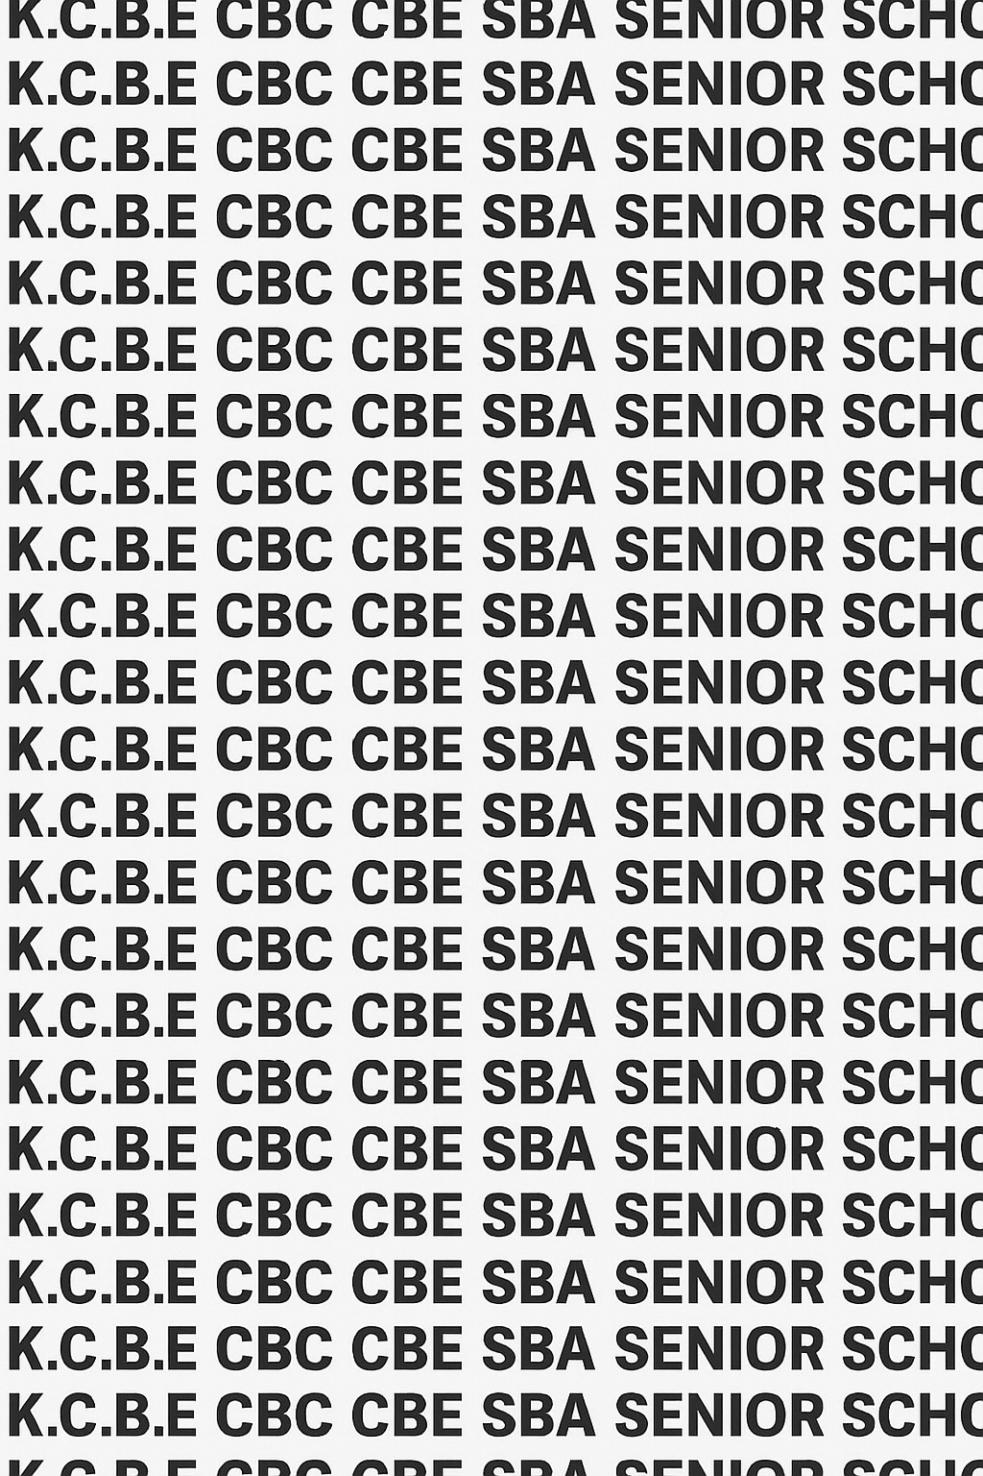
KENYA CERTIFICATE OF BASIC EDUCATION (K.C.B.E)


GRADE 10 ESSENTIAL MATHEMATICS TERM 1 JANUARY 2026
Time: 2 Hours
COMPETENCY BASED EDUCATION CKEAB 001

LEARNER’S DETAILS
Name: _______________________________________________________________________________________.
School: ______________________________________________________________________________________.
Assessment Number: ________________________________. Date: __________________________________.
School Code: _______________________________. Signature: ________________________________.

INSTRUCTIONS TO LEARNERS
- Write your name, school, assessment number, date, school code and then sign.
- Read the questions carefully before attempting them.
- This examination consists of two sections:
  - SECTION A (50 marks): Short structured questions – attempt ALL questions.
  - SECTION B (50 marks): Long structured questions – attempt ALL questions.
-ESSENTIAL MATHEMATICS- -001- -Senior School-
- Show all working clearly; marks will be awarded for correct working even if the final answer is wrong.
- Use a calculator only where necessary.

SCORE GRID
Question No. | 1 | 2 | 3 | 4 | 5 | 6 | 7 | 8 | 9 | 10 | 11 | 12 | 13 | 14 | 15 | SECTION A TOTAL | 16 | 17 | 18 | 19 | 20 | 21 | 22 | 23 | 24 | 25 | SECTION B TOTAL | EXAM TOTAL
Marks | 2 | 3 | 3 | 2 | 2 | 2 | 2 | 2 | 3 | 2 | 1 | 3 | 2 | 3 | 3 | 50 | 5 | 5 | 6 | 5 | 6 | 5 | 5 | 4 | 4 | 5 | 50 | 100

Section | Max Marks | 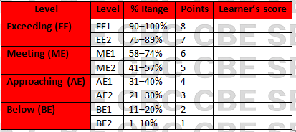  Learner Score
A | 50
B | 50
TOTAL | 100

Performance Levels Grid

This paper has 10 printed pages. Please check out to ensure all pages are printed
Turn over
SECTION A: (50 Marks)
Answer all questions in this section.

1. A school canteen sells one chapati at KSh 18. A student buys chapati for 5 consecutive days and pays using the money saved from doing chores.
If the student uses even numbers only of chapatis per day, list two possible even numbers greater than 10 that the student can buy in a single purchase. (2 marks)

2. A class project involves identifying prime numbers used as password codes for a computer system.
Give three prime numbers between 30 and 50. (3 marks)

3. A farmer divides his land equally among his 4 children. The total land size is
$\frac{25}{3}$ hectares.
Find the land each child receives. (3 marks)

4. A village water tank has a cylindrical base whose radius measurement recorded by learners is irrational.
If the radius is $\sqrt{3}$ m, write down two other irrational numbers the learners may encounter in similar measurements.
(2 marks)

5. A shopkeeper buys sugar totalling $4\frac{1}{2}$ kg. Express this in improper fraction. (2 marks)

6. A teacher asks learners to find the reciprocal of the number of hours they spend online each day.
If a learner spends $\frac{5}{6}$ hours online daily, find the reciprocal. (2 marks)

7. A school science club uses a value of $2.5×{10}^{3}$ J of energy.
Write this energy in ordinary form. (2 marks)

8. A digital thermometer records temperatures as integers.
List any four consecutive integers between –3 and 3. (2 marks)

9. A rectangular garden has an area expressed as a quadratic expression:
$A=x^{2}+7x+6$.
Factorize the expression. (3 marks)

10. A carpenter calculates the height of a storage shelf using the expression
$9x^{2}-1$.
Factorize completely. (2 marks)

11. A student multiplies two numbers and expresses the result in index notation:
Write $5×5×5×5×5$ using indices. (1 mark)

12. A chemical storage label shows an expression
$\frac{a^{3}b^{5}}{ab^{2}}$.
Simplify using laws of indices. (3 marks)

13. A school purchases a solar battery with a voltage that varies according to
$v=4x^{2}+4x$.
Factorize the expression. (2 marks)

14. A football team scores “n” goals in a match. The total points earned follow the quadratic equation:
$n^{2}+n-20=0$.
Solve for n. (3 marks)

15. A tailor uses the expression $\left(3x+2\right)\left(x-4\right)$ to compute the size of cloth needed.
Expand the expression. (3 marks)

SECTION B: (50 MARKS)
Attempt ALL questions. Show all working.

16. A water company records daily water usage of a household as follows:
Day 1: $\sqrt{5}$ litres
Day 2: $2\sqrt{5}$ litres
Day 3: $3\sqrt{5}$ litres

(a) Combine the total water used in 3 days in simplest form. (3 marks)

(b) If the cost per litre is KSh 15, find the total cost. (2 marks)

17. A phone manufacturer records the battery life of a new device as an irrational number $t=\sqrt{11}$ hours.
To test reliability, technicians record the battery life of 8 phones.

(a) Express the total time for 8 phones in simplest surd form. (2 marks)

(b) Rationalize the denominator of $\frac{4}{\sqrt{11}}$. (3 marks)

18. A construction company uses the expression
$$h=2x^{2}-13x+20$$
to determine the height of a concrete pillar.

(a) Factorize the expression completely. (3 marks)

(b) Hence solve the equation $2x^{2}-13x+20=0$. (3 marks)

19. A delivery company models fuel consumption using the rule:
$$F=\frac{64a^{7}b^{9}}{8a^{3}b^{3}}$$

(a) Simplify using index laws. (3 marks)

(b) If $a=2$ and $b=3$, find the numerical value. (2 marks)

20. A student plans to fence a rectangular kitchen garden whose area is given by:
$$A=x^{2}-4x-21$$

(a) Factorize and determine the dimensions of the garden. (3 marks)

(b) If the student buys fencing wire at KSh 150 per metre, find the cost of fencing the garden. (3 marks)

21. A drone's height above the ground after t seconds follows the function:
$$h\left(t\right)=t^{2}-6t+8$$

(a) Determine the height at t = 4 seconds. (2 marks)

(b) Find the minimum height of the drone by completing the square. (3 marks)

22. A manufacturing company uses the quadratic equation
$$x^{2}-2x-8=0$$
to determine the dimensions of a metal sheet.

(a) Solve the equation using factorization. (3 marks)

(b) State the two possible dimensions. (2 marks)

23. Learners at a robotics club record the robot's wheel rotation as
$$w=3x^{3}y^{2}×4x^{5}y^{4}$$

(a) Simplify using index laws. (2 marks)

(b) If $x=2$, $y=3$, find the robot’s wheel rotation value. (2 marks)

24. A football coach analyses players’ sprint times. He assigns each player a number that must be composite.

(a) List any four composite numbers between 20 and 40. (2 marks)

(b) For one of the numbers selected, find its prime factorization. (2 marks)

25. A company models profit using the equation
$P=5x^{2}-20x$.

(a) Factorize the expression. (2 marks)

(b) If $x$ represents thousands of items sold, determine the profit when x = 7. (3 marks)

©2026
All rights reserved
©COMPETENCE KENYA EXAMINATION AND ASSESSMENT BOARD
THIS IS THE LAST PRINTED PAGE

