
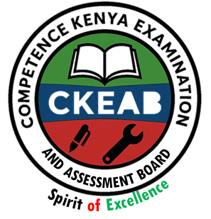
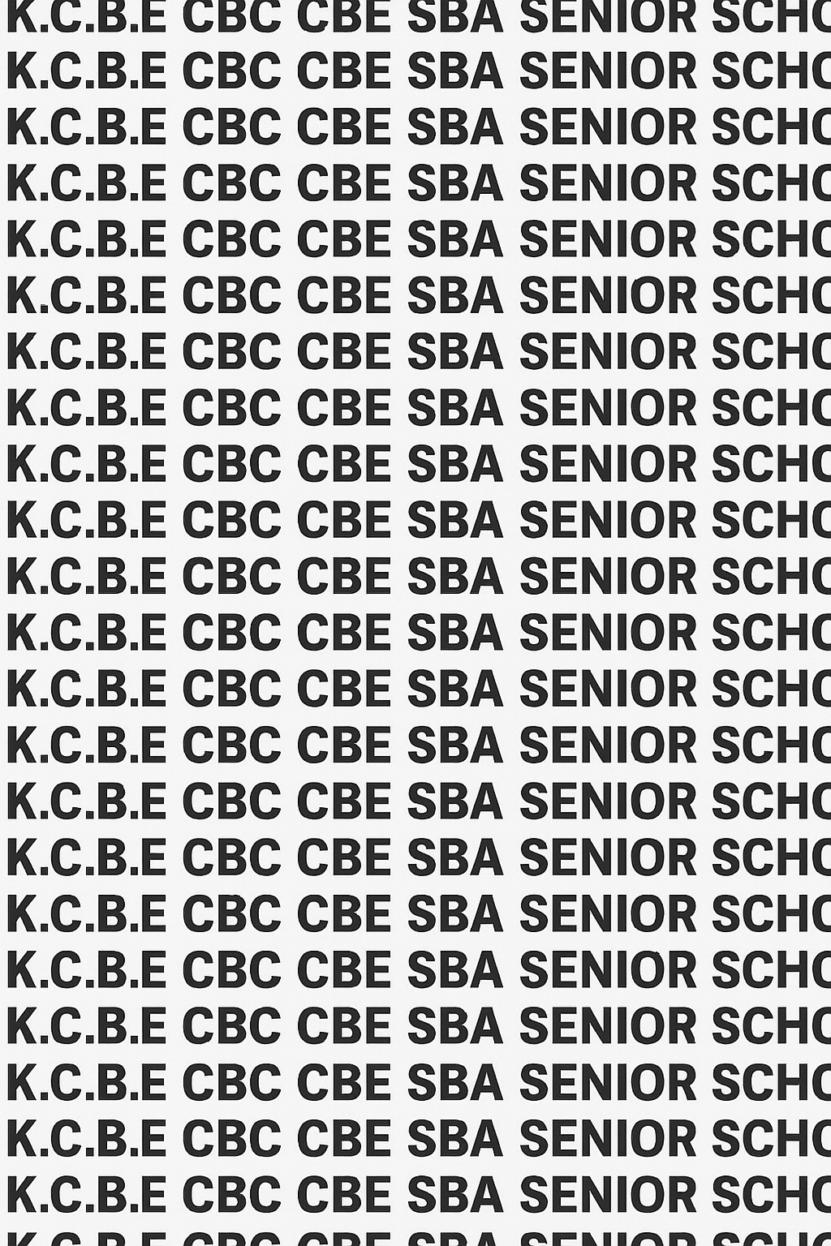
KENYA CERTIFICATE OF BASIC EDUCATION (K.C.B.E)


GRADE 10 FINE ARTS (Theory) TERM 1 JANUARY 2026
Time: 2 Hours 10 Minutes
COMPETENCE ASSESSMENT EXAMINATION CKEAB 001

LEARNER’S DETAILS
Name: _______________________________________________________________________________________.
School: ______________________________________________________________________________________.
Assessment Number: ________________________________. Date: __________________________________.
School Code: _______________________________. Signature: ________________________________.

INSTRUCTIONS TO LEARNERS
- Write your name, School, assessment number, signature and date on all the answer sheets provided.


- This examination consists of Section A (25 marks) and Section B (75 marks), totaling 100 marks.
- Answer all questions in Section A.
- In Section B, answer Question 6 and any other two questions.
- Answer all the questions in the spaces provided.
- Read each question carefully before writing your answer.
- Ensure your answers are clear, neat, and well-organized.
- Do not write in the margin.
- Check your work before submitting the exam.
- Manage your time well to complete all questions.
-FINE ARTS- -001- -Senior School-

Performance Levels Grid
SECTION | SECTION A  75 MARKS |  |  |  |  | SECTION B  75 MARKS |  |  |  | Total Marks (100) | PERFORMANCE LEVEL
NUMBER | Q1 | Q2 | Q3 | Q4 | Q5 | Q6 | Q7 | Q8 | Q9
MARKS | 6 | 5 | 5 | 3 | 6 | 25 | 25 | 25 | 25
LEARNERS SCORE |  |  |  |  |  | 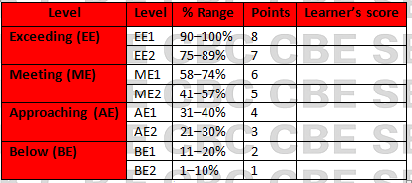

Section | Max Marks | Learner Score
A | 25
B | 75
TOTAL | 100

This paper has 9 printed pages. Please check out to ensure all pages are printed
Turn over
SECTION A: (25 Marks)
Answer all questions in this section.

During an art lesson, learners are asked to arrange objects on a class table and draw as they appear during still-life composition lesson.

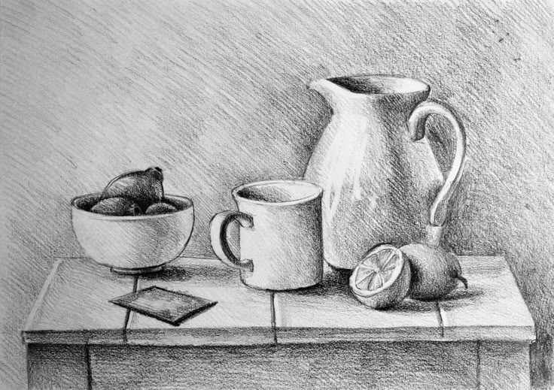

a) Define still life composition. (2 marks)

_____________________________________________________________________________________________

____________________________________________________________________________________________
b) State two reasons why objects are overlapped when arranging a still-life composition. (2 marks)

_________________________________________________________________________________________

_________________________________________________________________________________________

c) Name two types of texture that can be shown when drawing the metallic mug. (2 marks)

_________________________________________________________________________________________

_________________________________________________________________________________________

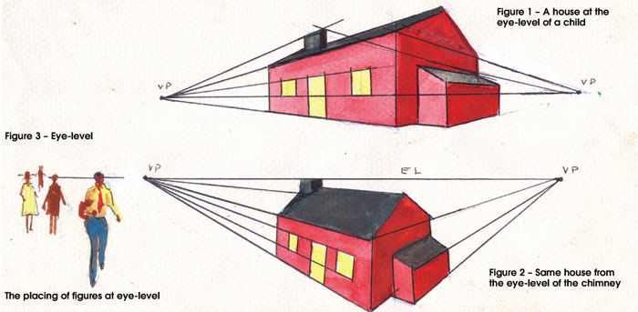

A learner is making a drawings as shown below

A B

a) Identify the type of perspective used. (2 marks)

_________________________________________________________________________________________

_________________________________________________________________________________________

b) State two components of perspective. (2 marks)

_________________________________________________________________________________________

_________________________________________________________________________________________

c) Explain why the horizon line is important in perspective drawing. (1 mark)

_________________________________________________________________________________________

_________________________________________________________________________________________

In a class project, students were evaluating artworks using the elements of 2-dimensional art.
a) Define contour lines. (2 marks)

_______________________________________________________________________________________________

______________________________________________________________________________________________

b) Name three elements of 2-dimensional art evaluated in this activity. (3 marks)

_________________________________________________________________________________________

________________________________________________________________________________________

_________________________________________________________________________________________

Your teacher asks you to identify the principles of 2-dimensional art used in a painting showing repeated plant patterns with equal spacing.
a) Name the principle used to create repetition. (1 mark)
________________________________________________________________________________

b) State two reasons why balance is important in a 2-dimensional artwork. (2 marks)

_________________________________________________________________________________________

_________________________________________________________________________________________

A Grade 10 learner wants to create a portfolio using recycled materials.
a) Give two recycled materials that can be used to make an art portfolio. (2 marks)

_________________________________________________________________________________________

_________________________________________________________________________________________

b) State one advantage of using recycled materials in art. (1 mark)

_________________________________________________________________________________________

_________________________________________________________________________________________

SECTION B (75 MARKS)
Answer Question 6 and ANY OTHER TWO questions.

You are given three objects: a flower vase, an orange, and a folded cloth. You are required to draw a still-life composition using pencil.
a) Describe the five stages of executing a still-life drawing from observation. (10 marks)

_________________________________________________________________________________________

_________________________________________________________________________________________

_________________________________________________________________________________________

_________________________________________________________________________________________

_________________________________________________________________________________________
b) Explain four shading techniques you would use to show form and texture on the objects. (8 marks)

_________________________________________________________________________________________

_________________________________________________________________________________________

________________________________________________________________________________________

_________________________________________________________________________________________
c) State three safety measures to observe when working in the art room during the drawing exercise. (3 marks)

_________________________________________________________________________________________

_________________________________________________________________________________________

_________________________________________________________________________________________
d) Give two reasons why adding details and refining is important in the final stages of a drawing. (4 marks)

_________________________________________________________________________________________

_________________________________________________________________________________________

During an outdoor sketching activity, students were required to draw a simple building using one-point perspective at normal eye-level.
a) Describe the meaning of one-viewpoint perspective. (2 marks)

_________________________________________________________________________________________

_________________________________________________________________________________________
b) Draw a box in bird’s eye view. (2 marks)

c) Explain the role of each of the following components in perspective drawing: (8 marks)
i. Vanishing point
____________________________________________________________________________________________________________________________________________________________________________________________________
ii. Horizon line ____________________________________________________________________________________________________________________________________________________________________________________________________ iii. Convergence lines ____________________________________________________________________________________________________________________________________________________________________________________________________ iv. Viewpoint
____________________________________________________________________________________________________________________________________________________________________________________________________
d) Differentiate between:
i. hue and colour value (4 marks)
________________________________________________________________________________________________
________________________________________________________________________________________________
________________________________________________________________________________________________
________________________________________________________________________________________________
ii. Tinting and shading (4 marks)
________________________________________________________________________________________________
________________________________________________________________________________________________
________________________________________________________________________________________________
d) Outline five characteristics of a good perspective drawing. (5 marks)

_________________________________________________________________________________________

_________________________________________________________________________________________

_________________________________________________________________________________________

_________________________________________________________________________________________

_________________________________________________________________________________________

A local museum invites students to analyze a mural made using recycled paper, fabric, and charcoal.
a) Explain four ways in which recycled materials can be used to create artworks or portfolios. (8 marks)

_________________________________________________________________________________________

_________________________________________________________________________________________

________________________________________________________________________________________

_________________________________________________________________________________________
b) Discuss three principles of art that can be observed in a mural showing human figures dancing in a rhythmic pattern. (9 marks)

_________________________________________________________________________________________

_________________________________________________________________________________________

_________________________________________________________________________________________
c) Using examples, describe three types of texture that can be shown in 2-dimensional artworks. (3 marks)

_________________________________________________________________________________________

_________________________________________________________________________________________

_________________________________________________________________________________________
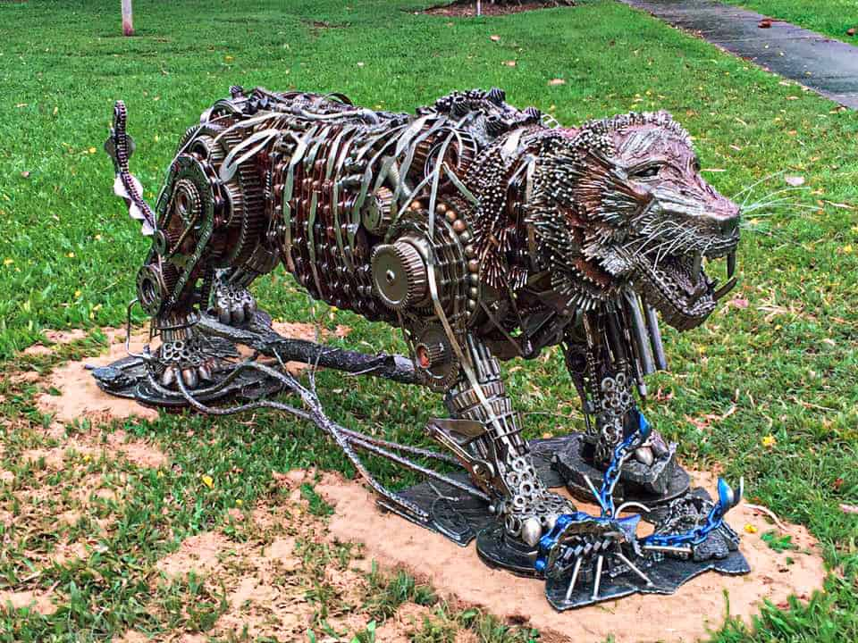
d) Name the material that has been recycled to create the following art work. (3 marks)
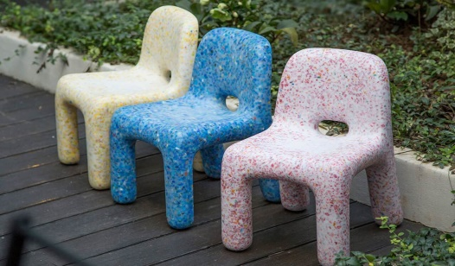
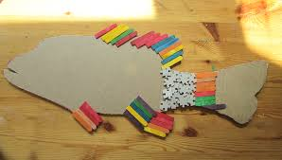

X Y Z
Art work | Materials recycled
X
Y
Z

e) Give two advantages of incorporating recycled materials in fine arts. (2 marks)

_________________________________________________________________________________________

_________________________________________________________________________________________

A Grade 10 learner of Alliance Senior School is created a poster of a wildlife scene while applying elements and principles of 2-dimensional art.

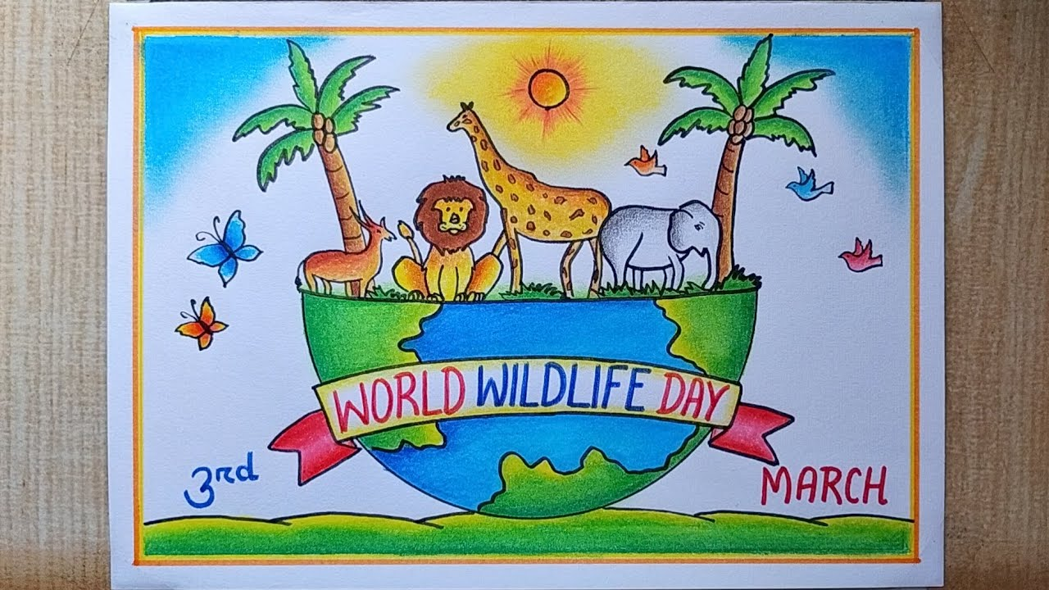
a) Discuss three elements and show how each has been applied in the poster. (6 marks)

_________________________________________________________________________________________

_________________________________________________________________________________________

_________________________________________________________________________________________
b) Explain two principles and how they help improve the composition. (4 marks)

_________________________________________________________________________________________

_________________________________________________________________________________________

_________________________________________________________________________________________
c) Describe three methods of showing value in 2-D drawing. (6 marks)

_________________________________________________________________________________________

_________________________________________________________________________________________

_________________________________________________________________________________________
d) State one reason why proportion is important when drawing animals. (2 marks)

_________________________________________________________________________________________

_________________________________________________________________________________________

_________________________________________________________________________________________
e) What is a 2D SHAPE? (3 marks)
____________________________________________________________________________________________________________________________________________________________________________________________________
f) Name the following 2D shapes. (4 marks)

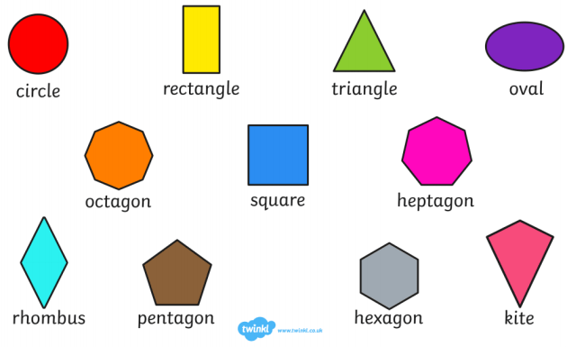

E F G H
E: _______________________________________
F: _______________________________________
G: _______________________________________
H: _______________________________________

©2026
All rights reserved
©COMPETENCE KENYA EXAMINATION AND ASSESSMENT BOARD
THIS IS THE LAST PRINTED PAGE

