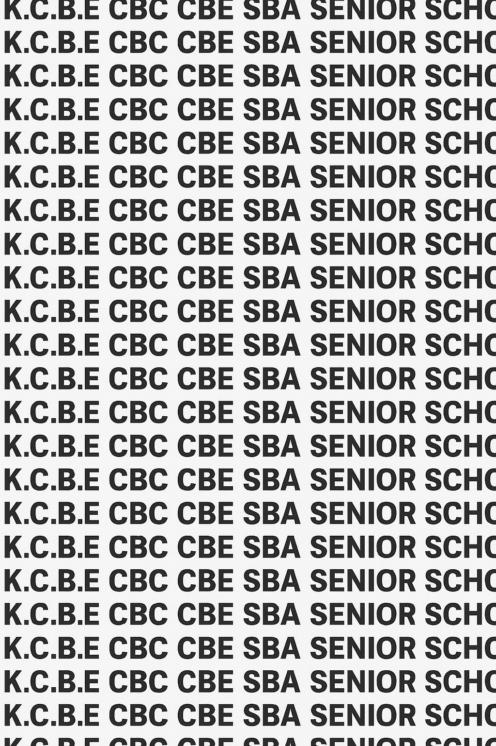
KENYA CERTIFICATE OF BASIC EDUCATION (K.C.B.E)
GRADE 10 GENERAL SCIENCE (Theory) TERM 1 JANUARY 2026
Time: 1 Hour 30 Minutes
COMPETENCY BASED EDUCATION CKEAB 001

LEARNER’S DETAILS
Name: _______________________________________________________________________________________.
School: ______________________________________________________________________________________.
Assessment Number: ________________________________. Date: __________________________________.
School Code: _______________________________. Signature: ________________________________.

INSTRUCTIONS TO LEARNERS
- Write your name, School, assessment number, signature and date on all the answer sheets provided.
- Answer all the questions in the spaces provided.
- Read each question carefully before writing your answer.
- Ensure your answers are clear, neat, and well-organized.
- The marks for each question are indicated at the end of the question.
- Use relevant Biblical references where necessary.

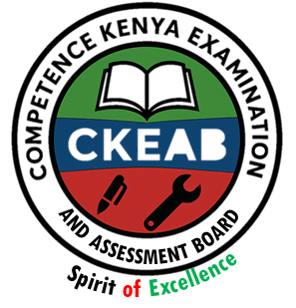
- Do not write in the margin.
- Check your work before submitting the exam.
- Manage your time well to complete all questions.
-GENERAL SCIENCE- -001- -Senior School-

Performance Levels Grid
Q1 | Q2 | Q3 | Q4 | Q5 | Q6 | Q7 | Q8 | Q9 | Q10 | SECTION A TOTAL /40
3 | 4 | 4 | 3 | 4 | 3 | 5 | 3 | 4 | 7 | /40
Score

Q11 | Q12 | Q13 | Q14 | Q15 | Q16 | Q17 | SECTION B TOTAL /60
6 | 8 | 6 | 8 | 8 | 10 | 14 | /60
Score
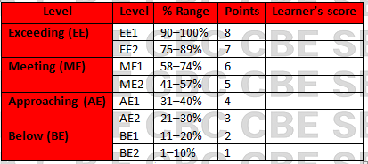
Section | Max Marks | Learner Score
A | 40
B | 60
TOTAL | 100

This paper has 9 printed pages. Please check out to ensure all pages are printed
Turn over
SECTION A: (40 Marks)
Answer all questions in this section.

1. During a career mentorship session at your school, the facilitator asked the learners to explain what General Science entails.
a) Define General Science as a learning area. (2 marks)
_________________________________________________________________________________________________

_________________________________________________________________________________________________

b) Mention one reason why it is taught in Senior School. (1 mark)

_________________________________________________________________________________________________

_________________________________________________________________________________________________

2. At a science exhibition held at County Level, learners were grouped according to the branch of science they were showcasing.
a) Name the three major branches of General Science. (3 marks)

____________________________________________________________________________________________

____________________________________________________________________________________________

____________________________________________________________________________________________

b) State one area each branch deals with. (1 mark)

_________________________________________________________________________________________________

_________________________________________________________________________________________________

3. A local community group wants to reduce environmental pollution and seeks help from your school’s science club.
Explain two ways in which knowledge of General Science could help solve the pollution problem. (4 marks)

____________________________________________________________________________________________

____________________________________________________________________________________________

4. A Grade 10 learner is passionate about solving health problems.
a) Identify two career opportunities related to General Science that the learner may pursue. (2 marks)

____________________________________________________________________________________________

____________________________________________________________________________________________

b) Name the branch of science associated with each career. (1 mark)

___________________________________________________________________________________________

5. During a school investigation on water quality, learners were asked to collect information for drawing conclusions.
a) State two methods of collecting scientific evidence. (2 marks)

____________________________________________________________________________________________

____________________________________________________________________________________________

b) Explain why evidence is important in making scientific conclusions. (2 marks)

____________________________________________________________________________________________

____________________________________________________________________________________________

6. A teacher demonstrated that salt dissolves faster in warm water than cold water.
Explain what is meant by inference in scientific investigations. (3 marks)

____________________________________________________________________________________________

____________________________________________________________________________________________

____________________________________________________________________________________________

7. During a practical on germination, students collected data on seed growth for 7 days.
a) State two methods of collecting data. (2 marks)

____________________________________________________________________________________________

____________________________________________________________________________________________

b) Mention three methods of analysing scientific data. (3 marks)

____________________________________________________________________________________________

____________________________________________________________________________________________

____________________________________________________________________________________________

8. In a biology class, the teacher displayed several microscopic images.
a) Define a cell. (1 mark)
____________________________________________________________________________________________________________________________________________________________________________________________________

b) Name two types of cells commonly found in living organisms. (2 marks)

____________________________________________________________________________________________

____________________________________________________________________________________________

9. The science laboratory has recently acquired a new electron microscope.
a) Name two places where microscopes are used. (2 marks)

____________________________________________________________________________________________

____________________________________________________________________________________________

b) Give two differences between a light microscope and an electron microscope. (2 marks)
Light microscope | Electron microscope

10. The human body is described as a complex, organised structure.
Arrange the following in order from the simplest to the most complex:
Tissue, Cell, Organ, Organ System, Organism (3 marks)

Simple Complex

SECTION B (60 MARKS)
Answer ALL questions in this section.

11. Your school laboratory received a damaged light microscope and students were asked to identify the missing parts for repair.
a)

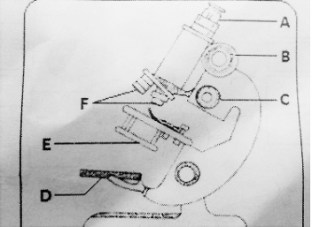

i) Name each parts labelled A and B (2marks)

A: ____________________________________________________.

B: ____________________________________________________

ii) State the functions of each of the parts labelled E and F (2marks)

E: ____________________________________________________________________________________________.

F: _____________________________________________________________________________________________.

b) Give a reason for each of the following precautions when using a light microscope.

i) The microscope must be carried with both hands (1mark)

_______________________________________________________________________________________________

ii) The lenses and mirrors must never be touched with bare fingers (1mark)

____________________________________________________________________________________________________________________________________________________________________________________________________

12. A biologist examining a sample from a pond observed various structures inside the plant cells.
a) Name two examples of plant cells. (4 marks)

____________________________________________________________________________________________

____________________________________________________________________________________________

b) Name two cell components present in plant cell but absent in animal cells

____________________________________________________________________________________________

____________________________________________________________________________________________

c) State one function of each organelle. (4 marks)

i) Mitochondrion ____________________________________________________________________________________________________________________________________________________________________________________________________

ii) Nucleus ____________________________________________________________________________________________________________________________________________________________________________________________________

13. During a field study, students collected leaf tissues and cheek cells for comparison.

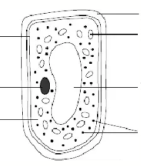
a) With reasons, name the type of cell below. (2 marks)

M

N O

P Q

R

S

___________________________________________________________________________________________

________________________________________________________________________________________

b) Identify the parts of a cell labelled. (2 marks)
M:_________________________________

Q: _________________________________

c) Give the function of the parts labelled O and R. (2 marks)

O:____________________________________________________________________________________________

R: ___________________________________________________________________________________________

14. A student wanted to differentiate between cell cytology and cell physiology for a science presentation.
a) Define cell cytology. (2 marks)
____________________________________________________________________________________________________________________________________________________________________________________________________

b) Define cell physiology. (2 marks) ____________________________________________________________________________________________________________________________________________________________________________________________________c) Name the part of a cell that. (4 marks)

Gives the plant cell its shape and support. (1 mark)

____________________________________________________

Is the site of protein synthesis. (1 mark)

____________________________________________________

15. A community health worker wants to determine whether a local river is contaminated.
a) Describe three methods the worker would use to collect evidence. (3 marks)

____________________________________________________________________________________________

____________________________________________________________________________________________

____________________________________________________________________________________________

b) Explain two reasons why proper data collection is important in scientific investigations. (4 marks)

____________________________________________________________________________________________

____________________________________________________________________________________________

c) State one method of analysing the collected data. (1 mark)

____________________________________________________________________________________________

____________________________________________________________________________________________

16. A manufacturing company consulted a team of scientists to help reduce accidents in the workplace and improve efficiency.
a) Explain three ways knowledge from General Science can be used to improve safety in industries. (6 marks)

____________________________________________________________________________________________

____________________________________________________________________________________________

____________________________________________________________________________________________

b) Describe two ways General Science contributes to technological advancements. (4 marks)

____________________________________________________________________________________________

____________________________________________________________________________________________

17. During a career day, learners from your class were asked to choose science-related careers based on their interests.
a) Define . (5 marks)

Biology

____________________________________________________________________________________________

____________________________________________________________________________________________

Chemistry

____________________________________________________________________________________________

____________________________________________________________________________________________

Physics

____________________________________________________________________________________________

____________________________________________________________________________________________

b) Name at least two careers in the field of. (5 marks)
Biology | Chemistry | Physics

©2026
All rights reserved
©COMPETENCE KENYA EXAMINATION AND ASSESSMENT BOARD
THIS IS THE LAST PRINTED PAGE

