

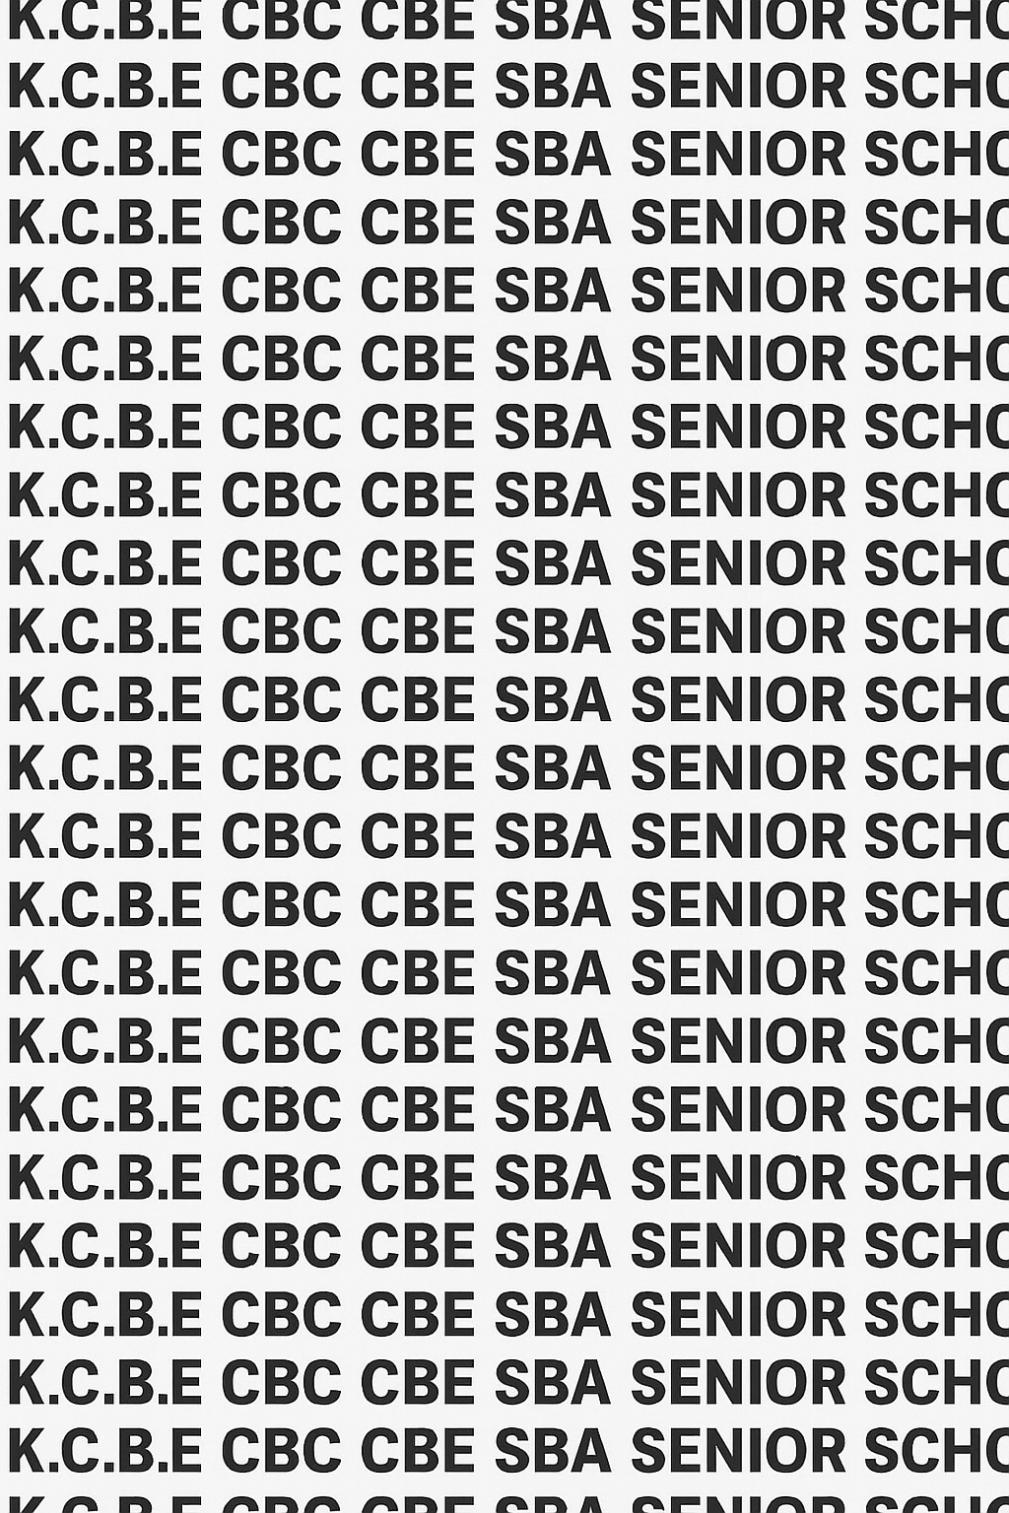
KENYA CERTIFICATE OF BASIC EDUCATION (K.C.B.E)


GRADE 10 GEOGRAPHY (Theory) TERM 1 JANUARY 2026
Time: 1 Hour 50 Minutes
COMPETENCY BASED EDUCATION CKEAB 001

LEARNER’S DETAILS
Name: _______________________________________________________________________________________.
School: ______________________________________________________________________________________.
Assessment Number: ________________________________. Date: __________________________________.
School Code: _______________________________. Signature: ________________________________.

INSTRUCTIONS TO LEARNERS
- Write your name, School, assessment number, signature and date on all the answer sheets provided.
- Answer all the questions in the spaces provided.
- Read each question carefully before writing your answer.
- Ensure your answers are clear, neat, and well-organized.
- The marks for each question are indicated at the end of the question.


- Manage your time well to complete all questions.
-GEOGRAPHY- -001- -Senior School-

Performance Levels Grid
Q1 | Q2 |  | Q3 |  | Q4 |  |  | Q5 | Q6 | Q7 |  |  | Q8 | Q10 | SECTION A TOTAL /35
4 | 4 |  | 2 |  | 7 |  |  | 2 | 2 | 5 |  |  | 6 | 3 | /35
Score
Q11 | SECTION B TOTAL /25
25 | /25
Score | ____
Q12 | Q13 |  |  | Q14 |  | Q15 |  |  | Q16 |  | Q17 |  | Q18 | Q19 | SECTION C TOTAL /50
8 | 10 |  |  | 10 |  | 10 |  |  | 10 |  | 10 |  | 10 | 10 | /50
Score
Section |  | Max Marks |  |  |  |  | 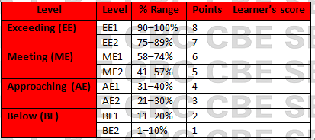  Learner Score
A |  | 25
B |  | 25
C |  | 50
TOTAL |  | 100

This paper has 11 printed pages. Please check out to ensure all pages are printed
Turn over
SECTION A: (35 Marks)
Answer all questions in this section.

1. A group of Grade 10 learners from Mwangaza School visited Lake Nakuru National Park to study the surrounding environment.
(a) Define Geography as a learning area. (2 marks)
________________________________________________________________________________________________
________________________________________________________________________________________________
(b) Mention two branches of Geography they are likely to study during the trip. (2 marks)
- ____________________________________________________________________________________________
- ____________________________________________________________________________________________

2. During a lesson on the school field, the Geography teacher asked students to identify any feature created by nature.
(a) Name two physical features they might identify. (2 marks)
- ____________________________________________________________________________________________
- ____________________________________________________________________________________________
(b) State two aspects studied under Human Geography. (2 marks)
- ____________________________________________________________________________________________
- ____________________________________________________________________________________________

3. The school career counsellor advised students to choose careers based on their strengths and personal interests.
List two factors learners should consider when choosing a career. (2 marks)

_________________________________________________________________________________

_________________________________________________________________________________

_________________________________________________________________________________

_________________________________________________________________________________

4. A map of Kisumu County was given to students to identify social amenities.
(a) Define a map. (1 mark)
____________________________________________________________________________________________________________________________________________________________________________________________________
b) Identify the following types of maps. (3 mks)
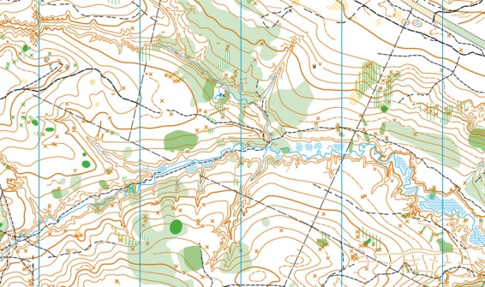
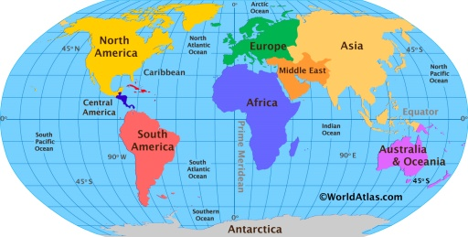
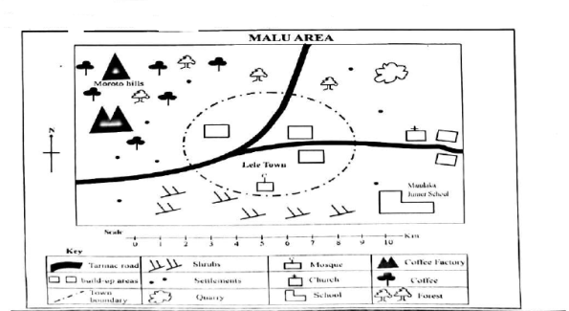
A B C
A: ____________________________________________.
B: ____________________________________________.
C: ____________________________________________.
c) Explain one use of map scales. (1 mark)
i)_________________________________________________________________________________________.
ii)_________________________________________________________________________________________.
e) Madam Nicole asked her Grade10 learners to convert the following representative fraction scales to direct statement scale. Work out their conversions.
1:50000 (2mks)

e) A person who designs and reads map in known as a? (1 mk)

_____________________________________________________

5. During a mapping activity, students identified highland and lowland areas on a topographical map of Nyandarua County.
State two methods of representing relief on topographical maps. (2 marks)
- ____________________________________________________________________________________________
- ____________________________________________________________________________________________

6. A researcher conducting a community survey used questionnaires to gather information.
State two methods of data collection OTHER THAN questionnaires. (2 marks)
- ____________________________________________________________________________________________
- ____________________________________________________________________________________________

7. Learners in a Geography statistics lesson were asked to classify sets of numbers using measures of central tendency.
The table below shows the number of mangoes harvested by a farmer from his orchard over nine consecutive days.

Day | Mangoes harvested
1 | 25
2 | 30
3 | 20
4 | 25
5 | 30
6 | 40
7 | 25
8 | 35
9 | 20
Use the information in the table to answer the following:
a) Calculate the mean number of mangoes harvested. (2 marks)

b) Determine the median of the data. (2 marks)

c) Identify the mode of the number of mangoes harvested. (1 mark)

8.The table below shows the population of four towns in Nakuru County in the year 2023.
Town | Population (‘000)
Molo | 45
Njoro | 60
Naivasha | 85
Gilgil | 35
Using the information provided:

a) Construct a simple bar graph to represent the population distribution of the four towns. (4 marks)


b) State two merits of using a bar graph to present the above data. (2 marks)
- ____________________________________________________________________________________________
- ____________________________________________________________________________________________

10. Students were assigned to identify ways in which Geography contributes to technological advancement.
Give two importance of studying Geography. (2 marks)
- ____________________________________________________________________________________________
- ____________________________________________________________________________________________

SECTION B: MAPWORK. (25 marks)

11. Study the map of TAMBACH (1:50,000 Sheet 90/3) provided and answer the following questions.

a) i) Identify two types of scale used in the map. (2 marks)
- ____________________________________________________________________________________________
- ____________________________________________________________________________________________
ii) Name the title of the map. (1 mark)
_______________________________________________________________________________________
iii) Give the longitudinal extent of the area covered by the map. (2 marks)

____________________________________________________________________________

b) i) Identify three relief features found at grid square 0581. (3 marks)
- ____________________________________________________________________________________________
- ____________________________________________________________________________________________
- ____________________________________________________________________________________________
ii) Measure the length of the dry weather road D329 from the junction at Chebokokwa to the northern edge of the map.
(2 marks)

__________________________________________________________________________________

c) Explain how the following factors have influenced settlement in the area covered by the map:
- Relief (1 mark)
________________________________________________________________________________________________________________________________________________________________________________________
- Drainage (1 mark)
________________________________________________________________________________________________________________________________________________________________________________________

- Transport (1 mark)
________________________________________________________________________________________________________________________________________________________________________________________

d) Draw a rectangle measuring 16 cm by 8 cm to represent the area enclosed by
- Easting 89 and Easting 05
- Northings 70 and Northings 78
On the rectangle, mark and name the following:
- River Kerio — (1 mark)
- Lake Kamorock — (1 mark)
- Dry weather road — (1 mark)
- Papyrus swamp — (1 mark))

e) Citing evidence from the map, give two economic activities carried out in the area covered by the map. (2 marks)
- ____________________________________________________________________________________________
- ____________________________________________________________________________________________

SECTION C (50 MARKS)
Answer ANY FOUR questions in this section.

12. During an inter-school Geography contest, students were challenged to explore the relationship between Geography and other subjects.
(a) Explain the relationships between:-
- Geography and Biology. (2 marks)
____________________________________________________________________________________________
____________________________________________________________________________________________
- Geography and Computer studies. (2 marks)
____________________________________________________________________________________________
____________________________________________________________________________________________
- Geography and Agriculture. (2 marks)
____________________________________________________________________________________________
____________________________________________________________________________________________
(b) Give two reasons Geography is considered significant in understanding environmental issues. (4 marks)
- ____________________________________________________________________________________________
- ____________________________________________________________________________________________

13. Students from Baraka High School used an atlas to study East African countries.
(a) Describe two characteristics of a topographical map. (4 marks)
- ____________________________________________________________________________________________
- ____________________________________________________________________________________________
(b) Explain three uses of maps in daily life. (6 marks)
- ____________________________________________________________________________________________
- ____________________________________________________________________________________________
- ____________________________________________________________________________________________

14. A topographical map of Mt. Kenya region was issued for interpretation during a class test.
(a) Describe three steps followed when drawing a cross-section from a topographical map. (6 marks)
- ____________________________________________________________________________________________
- ____________________________________________________________________________________________
- ____________________________________________________________________________________________
(b) Explain four limitations of using statistics to explain geographical facts. (4 marks)
- ____________________________________________________________________________________________
- ____________________________________________________________________________________________
- ____________________________________________________________________________________________
- ____________________________________________________________________________________________

15. Learners in a Geography project analysed rainfall and temperature data for Kisii County.
(a) Using statistical tools, explain three ways in which data can be presented. (6 marks)
- ____________________________________________________________________________________________
- ____________________________________________________________________________________________
- ____________________________________________________________________________________________
(b) Describe four methods of analysing and interpreting collected data. (4 marks)
- ____________________________________________________________________________________________
- ____________________________________________________________________________________________
- ____________________________________________________________________________________________
- ____________________________________________________________________________________________

16. During career week, a guest speaker introduced career paths for Geography students.
(a) Explain four careers related to the study of Geography. (8 marks)
- ____________________________________________________________________________________________
- ____________________________________________________________________________________________
- ____________________________________________________________________________________________
- ____________________________________________________________________________________________
(b) State two reasons Geography is important in career development. (2 marks)
- ____________________________________________________________________________________________
- ____________________________________________________________________________________________

17. Learners at Kimathi School prepared bar graphs showing population changes.
(a) Differentiate between:
i. Simple bar graph and multiple bar graph (2 marks)
____________________________________________________________________________________________
____________________________________________________________________________________________
____________________________________________________________________________________________
____________________________________________________________________________________________
ii. Line graph and compound line graph (2 marks)
____________________________________________________________________________________________
____________________________________________________________________________________________
____________________________________________________________________________________________
(b) Explain three advantages of using line graphs. (6 marks)
- ____________________________________________________________________________________________
- ____________________________________________________________________________________________
- ____________________________________________________________________________________________

18. Students compared various maps during a group discussion.
(a) Explain two differences between sketch maps and topographical maps. (4 marks)
 | Sketch maps | Topographical maps
i
ii
(b) Name four marginal information found in topographical maps. (4 marks)
- ____________________________________________________________________________________________
- ____________________________________________________________________________________________
- ____________________________________________________________________________________________
- ____________________________________________________________________________________________

(b) Describe two reasons why map reading is important to learners. (2 marks)
- ____________________________________________________________________________________________
- ____________________________________________________________________________________________

19. While compiling their fieldwork report, students presented the results using graphs.
(a) Describe the steps in drawing a combined bar graph. (4 marks)
- ____________________________________________________________________________________________
- ____________________________________________________________________________________________
- ____________________________________________________________________________________________
- ____________________________________________________________________________________________
(b) Explain three advantages of presenting geographical data using graphs. (3 marks)
- ____________________________________________________________________________________________
- ____________________________________________________________________________________________
- ____________________________________________________________________________________________
(c) Outline three branches of geography. (3 marks)
- ____________________________________________________________________________________________
- ____________________________________________________________________________________________
- ____________________________________________________________________________________________
- ____________________________________________________________________________________________

©2026
All rights reserved
©COMPETENCE KENYA EXAMINATION AND ASSESSMENT BOARD
THIS IS THE LAST PRINTED PAGE

