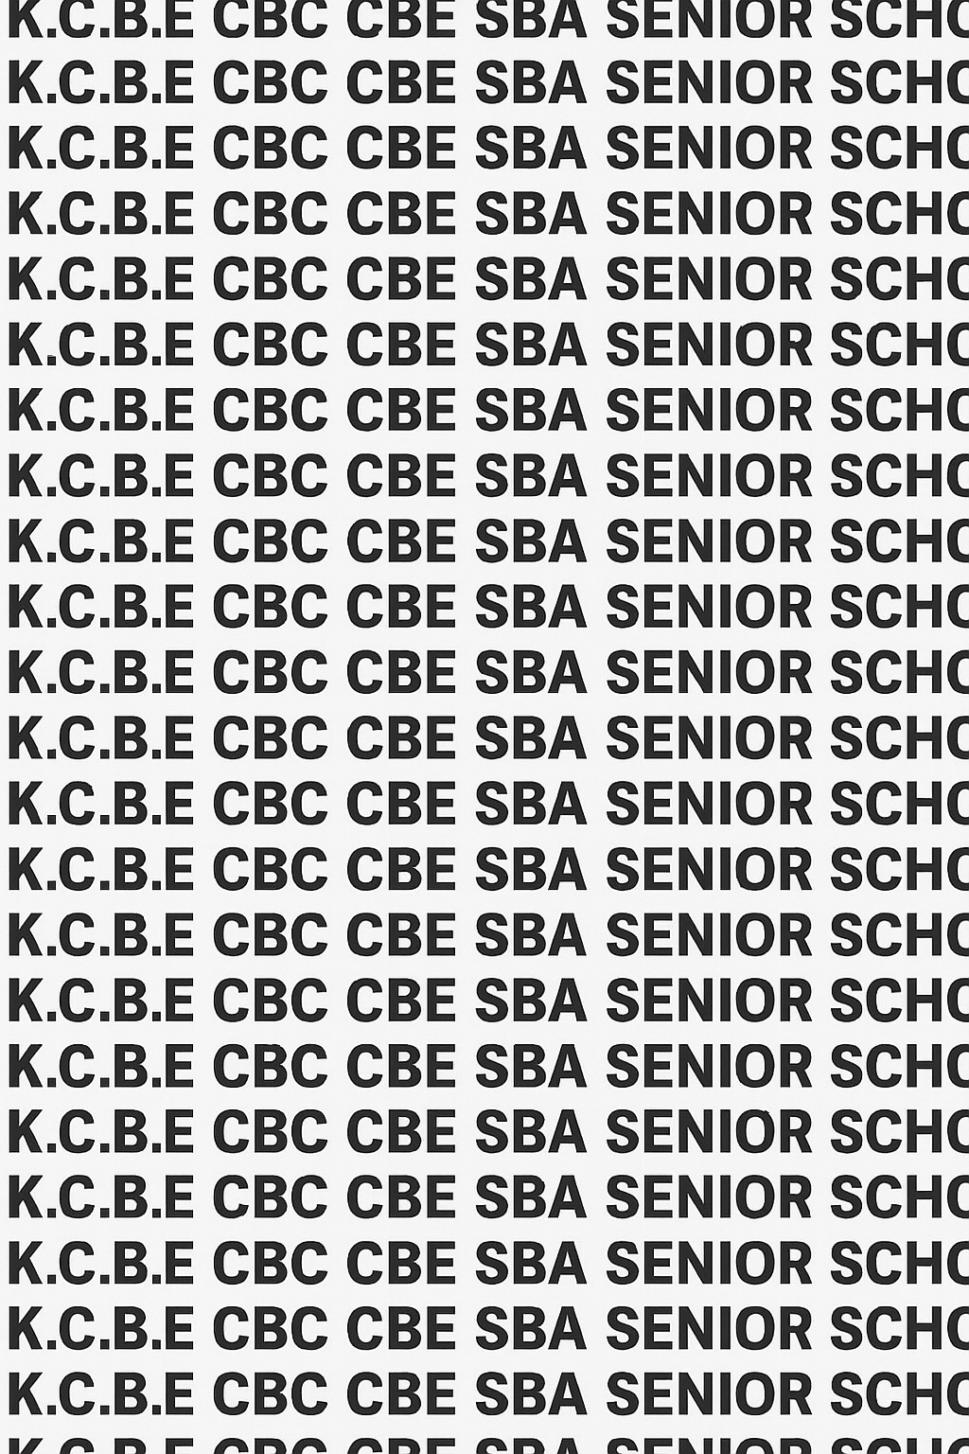
KENYA CERTIFICATE OF BASIC EDUCATION (K.C.B.E)

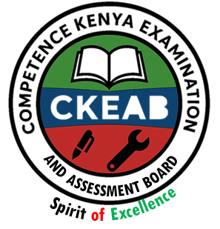
GRADE 10 HISTORY AND CITIZENSHIP TERM 1 JANUARY 2026
Time: 1 Hour 30 Minutes
COMPETENCY BASED EDUCATION CKEAB 001

LEARNER’S DETAILS
Name: _______________________________________________________________________________________.
School: ______________________________________________________________________________________.
Assessment Number: ________________________________. Date: __________________________________.
School Code: _______________________________. Signature: ________________________________.

INSTRUCTIONS TO LEARNERS
- Write your name, School, assessment number, signature and date on all the answer sheets provided.
- Answer all the questions in the spaces provided.
- Read each question carefully before writing your answer.
- Ensure your answers are clear, neat, and well-organized.
- Do not write in the margin.
-HISTORY AND CITIZENSHIP- -001- -Senior School-
- Check your work before submitting the exam.
- Manage your time well to complete all questions.

Performance Levels Grid

Section | Q1 (7) | Q2 (6) | Q3 (6) | Q4 (6) | Q5 (4) | Q6 (6) | Section A Total (35) | Q7 (20) | Q8 (20) | Q9 (20) | Q10 (20) | Q11 (20) | Section B Total (60) | Grand Total (95)
Marks Obtained

Section | Max Marks | 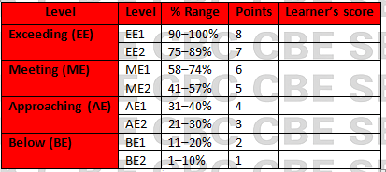  Learner Score
A | 40
B | 60
TOTAL | 100

This paper has 6 printed pages. Please check out to ensure all pages are printed
Turn over
SECTION A: (35 Marks)
Answer all questions in this section.

1. A team of Form 2 students from Kisiwa Secondary School visited the National Museums of Kenya to study different communities and their early movements into Kenya.
a) Define the term history. (2 marks)
________________________________________________________________________________________________
________________________________________________________________________________________________
b) Identify three major linguistic groups found in Kenya. (3 marks)
- ____________________________________________________________________________________________
- ____________________________________________________________________________________________
- ____________________________________________________________________________________________
c) State two reasons why it is important to study linguistic groups in Kenya today. (2 marks)

____________________________________________________________________________________________

____________________________________________________________________________________________

2. While preparing a history exhibition, learners discovered that the Cushites were among the earliest groups to migrate into Kenya.
a) Identify two original homelands of the Cushites before migrating to Kenya. (2 marks)

____________________________________________________________________________________________

____________________________________________________________________________________________
b) Give three reasons that led to the migration of Cushitic communities into Kenya. 2 marks)

____________________________________________________________________________________________

____________________________________________________________________________________________
- Use the map of Kenya to answer the following question.
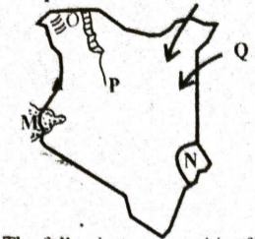

Which community followed the route marked Q (1 mark)

___________________________________________

3. A documentary released about the “Nilotic People of East Africa” highlighted their journeys into Kenya.
a) Identify the Original homeland of the following communities. (3 marks)

Bantu: ________________________________________________________________

Cushites: ______________________________________________________________

Nilotes: _______________________________________________________________
b) Name one community found in each of the following classes: (3 marks)
i. Plain Nilotes: _____________________________________
ii. River-lake Nilotes_____________________________________
iii. Highland Nilotes _____________________________________

4. Students in an interschool debate discussed the expansion of the Bantu communities in Kenya.
a) Mention three original homelands of the Bantu before entering Kenya. (3 marks)

____________________________________________________________________________________________

____________________________________________________________________________________________

___________________________________________________________________________________________
b) Identify any three Eastern Bantu communities in Kenya. (3 marks)

____________________________________________________________________________________________

____________________________________________________________________________________________

___________________________________________________________________________________________

5. A geography teacher displayed a migration map showing the movement of different African groups.
a) State two effects of migration on the communities that moved. (2 marks)

____________________________________________________________________________________________

____________________________________________________________________________________________
b) Give two effects of migration on the communities that received migrants. (2 marks)

____________________________________________________________________________________________

____________________________________________________________________________________________

6. During a lesson on colonial history, Mr. Ochieng asked learners to research how the British established colonial rule in Kenya.
a) State two reasons why the British established colonial rule in Kenya. (2 marks)

____________________________________________________________________________________________

____________________________________________________________________________________________
b) Identify two methods used by the British to establish colonial rule in Kenya. (2 marks)

____________________________________________________________________________________________

____________________________________________________________________________________________

SECTION B (60 MARKS)
Answer ANY THREE questions from this section.

7. A group of learners from Samburu were assigned a project to study migration routes and settlement patterns of early communities in Kenya.
a) Describe any five routes taken by the Bantu as they migrated into Kenya. (10 marks)

____________________________________________________________________________________________

____________________________________________________________________________________________

____________________________________________________________________________________________

____________________________________________________________________________________________

___________________________________________________________________________________________
b) Explain five factors that influenced the settlement patterns of migrating communities in Kenya. (10 marks)

____________________________________________________________________________________________

____________________________________________________________________________________________

____________________________________________________________________________________________

____________________________________________________________________________________________

___________________________________________________________________________________________

8. The Elimu TV History Club prepared a short film on the causes and effects of migration in East Africa.
a) Explain five causes of migration among early communities in Kenya. (10 marks)

____________________________________________________________________________________________

____________________________________________________________________________________________

____________________________________________________________________________________________

____________________________________________________________________________________________

___________________________________________________________________________________________
b) Describe five social and economic effects of migration on Kenyan communities. (10 marks)

____________________________________________________________________________________________

____________________________________________________________________________________________

____________________________________________________________________________________________

____________________________________________________________________________________________

___________________________________________________________________________________________

9. Your school is competing in a national history symposium. The assigned theme is "The Establishment of Colonial Rule in Kenya."
a) Explain five reasons why the British established colonial rule in Kenya. (10 marks)

____________________________________________________________________________________________

____________________________________________________________________________________________

____________________________________________________________________________________________

____________________________________________________________________________________________

___________________________________________________________________________________________
b) Describe five methods used by the British to establish colonial rule in Kenya. (10 marks)

____________________________________________________________________________________________

____________________________________________________________________________________________

____________________________________________________________________________________________

____________________________________________________________________________________________

___________________________________________________________________________________________

10. During a county history quiz, learners were asked to analyze the process of establishing British colonial rule in Kenya.
a) Outline five steps followed by the British in establishing colonial rule in Kenya. (10 marks)

____________________________________________________________________________________________

____________________________________________________________________________________________

____________________________________________________________________________________________

____________________________________________________________________________________________

___________________________________________________________________________________________
b) Explain five challenges faced by some Kenyan communities during the establishment of colonial rule. (10 marks)

____________________________________________________________________________________________

____________________________________________________________________________________________

____________________________________________________________________________________________

____________________________________________________________________________________________

___________________________________________________________________________________________

11. Your class is preparing a museum display on the classification of Bantu and Nilotic communities in Kenya.
a) Describe five features of the Bantu communities. (10 marks)

____________________________________________________________________________________________

____________________________________________________________________________________________

____________________________________________________________________________________________

____________________________________________________________________________________________

___________________________________________________________________________________________
b) Discuss five characteristics of the Nilotes. (10 marks)

____________________________________________________________________________________________

____________________________________________________________________________________________

____________________________________________________________________________________________

____________________________________________________________________________________________

___________________________________________________________________________________________

©2026
All rights reserved
©COMPETENCE KENYA EXAMINATION AND ASSESSMENT BOARD
THIS IS THE LAST PRINTED PAGE

