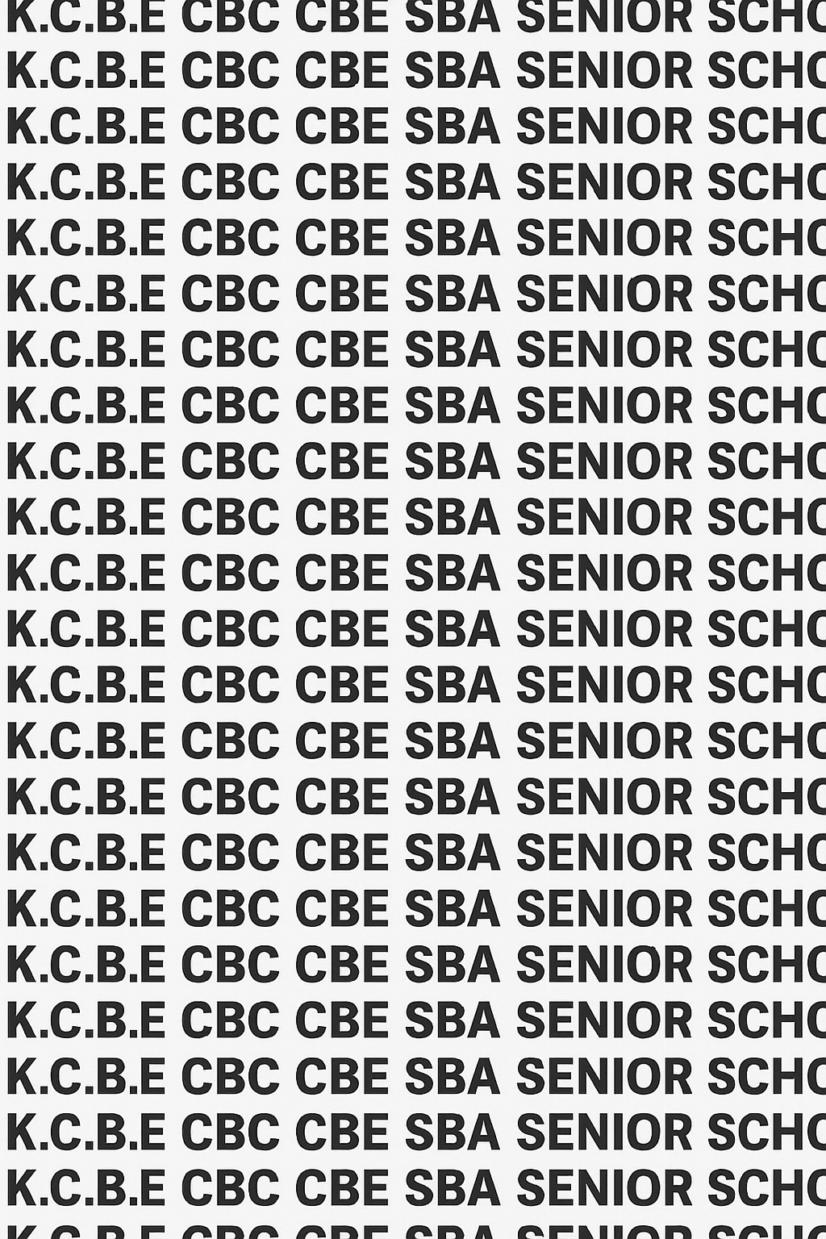
KENYA CERTIFICATE OF BASIC EDUCATION (K.C.B.E)
GRADE 10 HOMESCIENCE (Theory) TERM 1 JANUARY 2026
Time: 2 Hours
COMPETENCY BASED EDUCATION CKEAB 001

LEARNER’S DETAILS
Name: _______________________________________________________________________________________.
School: ______________________________________________________________________________________.
Assessment Number: ________________________________. Date: __________________________________.
School Code: _______________________________. Signature: ________________________________.

INSTRUCTIONS TO LEARNERS
- Write your name, School, assessment number, signature and date on all the answer sheets provided.
- Answer all the questions in the spaces provided.
- Read each question carefully before writing your answer.
-HOMESCIENCE- -001- -Senior School-
- Ensure your answers are clear, neat, and well-organized.
- Do not write in the margin.
- Check your work before submitting the exam.
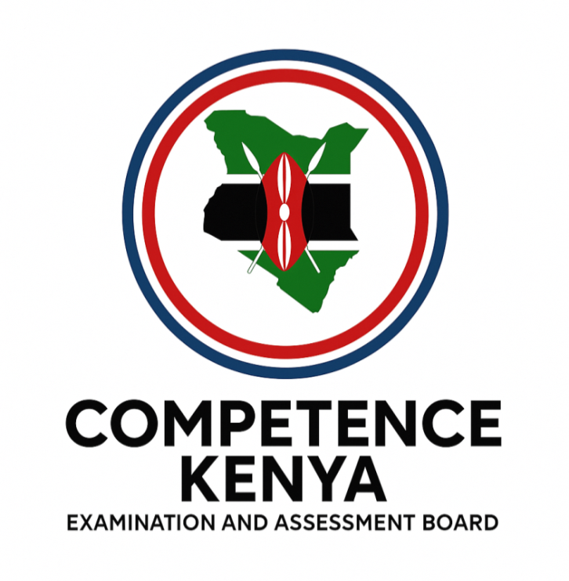
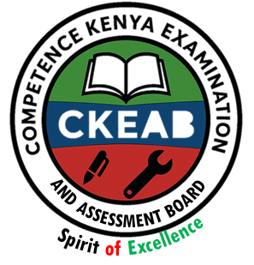
- Manage your time well to complete all questions.

Performance Levels Grid
Q1 | Q2 | Q3 | Q4 | Q5 | Q6 | Q7 | Q8 | Q9 | Q10 | Q11 | Q12 | SECTION A TOTAL /35
9 | 4 | 3 | 3 | 4 | 3 | 3 | 2 | 3 | 2 | 2 | 2 | /40
Score

Q13 | Q14 | Q15 | Q16 | Q17 | Q18 | SECTION B TOTAL /60
15 | 15 | 15 | 15 | 15 | 15 | /60
Score

Section | Max Marks | 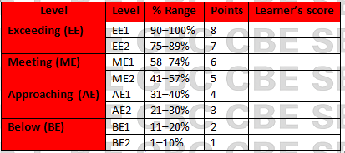  Learner Score
A | 40
B | 60
TOTAL | 100

This paper has 9 printed pages. Please check out to ensure all pages are printed
Turn over

SECTION A: (35 Marks)
Answer all questions in this section.

1. During a Home Science lesson, the teacher asks learners to define basic concepts in Foods and Nutrition.
a) Define nutrition. (2 marks)
________________________________________________________________________________________________
________________________________________________________________________________________________
b) Define nutrients. (2 marks)

________________________________________________________________________________________________

________________________________________________________________________________________________

c) Mention three examples of nutrients that you learnt before

____________________________________________________________________________________________

____________________________________________________________________________________________

____________________________________________________________________________________________

d) Name any two food groups you have learnt before

____________________________________________________________________________________________

____________________________________________________________________________________________

2. Mary has been skipping meals during school days, which affects her concentration in class.
Explain two importances of Food and Nutrition to Mary. (4 marks)

____________________________________________________________________________________________

____________________________________________________________________________________________

3. A career mentorship programme was held at your school where professionals from different fields were invited.
State three careers related to Foods and Nutrition that the learners may have learnt about. (3 marks)

____________________________________________________________________________________________

____________________________________________________________________________________________

____________________________________________________________________________________________

4. You are helping your parents reorganize the kitchen at home.
Identify three types of kitchen layouts they may choose from. (3 marks)

____________________________________________________________________________________________

____________________________________________________________________________________________

____________________________________________________________________________________________

____________________________________________________________________________________________

5. A new kitchen is being constructed at Tenwek High School. The contractor wants advice on kitchen tools and equipment.
Mention four materials used to make kitchen tools and equipment. (4 marks)

____________________________________________________________________________________________

____________________________________________________________________________________________

____________________________________________________________________________________________

____________________________________________________________________________________________

6. A school cook wants to replace some worn-out utensils.
State three tools or equipment used in the kitchen. (3 marks)

____________________________________________________________________________________________

____________________________________________________________________________________________

____________________________________________________________________________________________

7. The Home Science teacher emphasizes care for kitchen tools and equipment.
Explain three ways of caring for kitchen tools and equipment. (3 marks)

____________________________________________________________________________________________

____________________________________________________________________________________________

____________________________________________________________________________________________

8. Learners preparing a practical session were reminded about food hygiene.
Give two importance of maintaining hygiene and food safety when handling food. (2 marks)

____________________________________________________________________________________________

____________________________________________________________________________________________

9. Brian noticed a strange smell from the school refrigerator.
State three signs of food spoilage he might have observed. (3 marks)

____________________________________________________________________________________________

____________________________________________________________________________________________

____________________________________________________________________________________________

10. During an awareness talk, the school nurse differentiated food spoilage from food poisoning.
State two differences between food spoilage and food poisoning. (2 marks)

____________________________________________________________________________________________

____________________________________________________________________________________________

11. A student accidentally left cooked rice uncovered.
Give two precautions when handling foods to avoid contamination. (2 marks)

____________________________________________________________________________________________

____________________________________________________________________________________________

12. Poor hygiene and careless handling of food can promote food poisoning.
State three causes of food poisoning. (3 marks)

____________________________________________________________________________________________

____________________________________________________________________________________________

____________________________________________________________________________________________

SECTION B (60 MARKS)
Answer ANY FOUR questions from this section.

13. Your school kitchen is being redesigned.
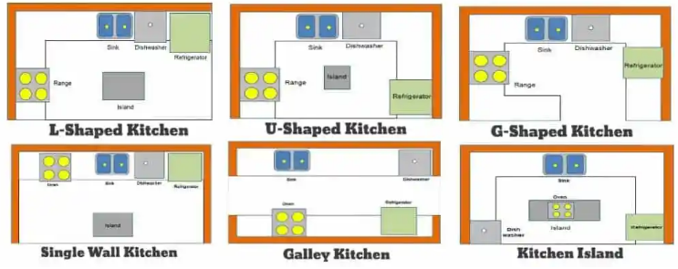


a) Identify the following types of kitchen layout. (5 marks)

Q R S



T U
Q: ______________________________________________.
R: ______________________________________________.
S: ______________________________________________.
T: ______________________________________________.
U: ______________________________________________.
b) Explain three advantages of the selected layout. (3 marks)

____________________________________________________________________________________________

____________________________________________________________________________________________

____________________________________________________________________________________________

c) State three factors to consider when selecting a kitchen layout. (3 marks)

____________________________________________________________________________________________

____________________________________________________________________________________________

____________________________________________________________________________________________

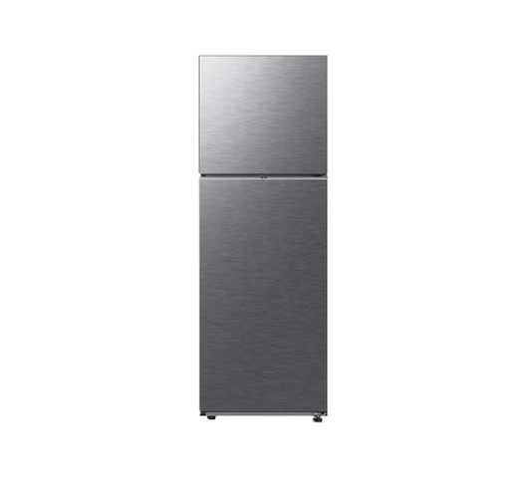
d) The following are some kitchen tools and equipment.
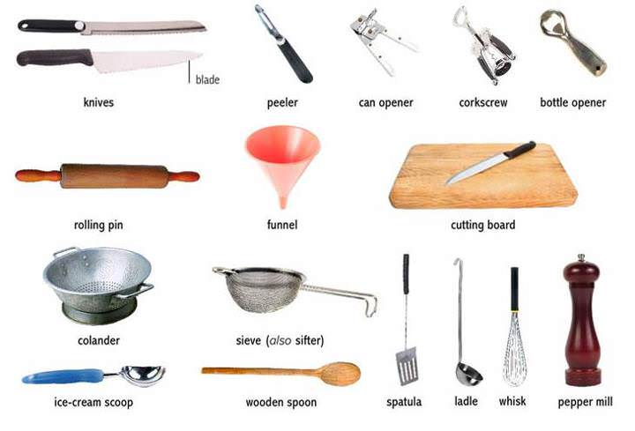



E F G H

Identify them. (4 marks)

E: ______________________________________________.

F: ______________________________________________.

G: ______________________________________________.

H: ______________________________________________.

14. Food hygiene is critical in any institution such as hospitals and schools.
a) Explain four importance of maintaining food hygiene and food safety in a school environment. (8 marks)

____________________________________________________________________________________________

___________________________________________________________________________________________

____________________________________________________________________________________________

____________________________________________________________________________________________
b) Describe three precautions when handling kitchen tools and equipment. (6 marks)

____________________________________________________________________________________________

____________________________________________________________________________________________

____________________________________________________________________________________________
c) State one personal hygiene practice that prevents food contamination. (1 mark)

____________________________________________________________________________________________

____________________________________________________________________________________________

15. You are placed on attachment in a restaurant as part of your Foods and Nutrition studies.
a) Define:
Food spoilage (2 marks)

____________________________________________________________________________________________

____________________________________________________________________________________________

Food poisoning (2 marks)

____________________________________________________________________________________________

____________________________________________________________________________________________
b) Explain four causes of food spoilage. (8 marks)

____________________________________________________________________________________________

____________________________________________________________________________________________

____________________________________________________________________________________________

____________________________________________________________________________________________
c) State three effects of food poisoning on individuals. (3 marks)

____________________________________________________________________________________________

____________________________________________________________________________________________

____________________________________________________________________________________________

16. A newly opened hotel has hired you as a consultant to advise on food safety.
a) Describe four microorganisms that cause food spoilage or poisoning. (8 marks)

____________________________________________________________________________________________

____________________________________________________________________________________________

____________________________________________________________________________________________

____________________________________________________________________________________________
b) Explain three ways of preventing food spoilage in a commercial kitchen. (6 marks)

____________________________________________________________________________________________

____________________________________________________________________________________________

____________________________________________________________________________________________
c) Give one reason why proper storage prevents spoilage. (1 mark)

____________________________________________________________________________________________

____________________________________________________________________________________________

17. A community health officer is training families on healthy food practices.
a) Outline five signs of food spoilage that families should watch out for. (5 marks)

____________________________________________________________________________________________

____________________________________________________________________________________________

____________________________________________________________________________________________

___________________________________________________________________________________________

____________________________________________________________________________________________
b) Explain four methods of safe food storage used at home. (8 marks)

____________________________________________________________________________________________

____________________________________________________________________________________________

____________________________________________________________________________________________

____________________________________________________________________________________________
c) State two reasons why insects and pests lead to food spoilage. (2 marks)

____________________________________________________________________________________________

____________________________________________________________________________________________

18. During a career expo, Grade 10 learners were curious about opportunities in Foods and Nutrition.
a) Discuss four career opportunities related to Foods and Nutrition. (8 marks)

____________________________________________________________________________________________

____________________________________________________________________________________________

___________________________________________________________________________________________

____________________________________________________________________________________________
b) Explain three importance of studying Foods and Nutrition in senior school. (6 marks)

____________________________________________________________________________________________

____________________________________________________________________________________________

___________________________________________________________________________________________
c) State one competency developed through Foods and Nutrition practicals. (1 mark)

____________________________________________________________________________________________

____________________________________________________________________________________________

©2026
All rights reserved
©COMPETENCE KENYA EXAMINATION AND ASSESSMENT BOARD
THIS IS THE LAST PRINTED PAGE

