
KENYA CERTIFICATE OF BASIC EDUCATION (K.C.B.E)
GRADE 10 H.R.E. (Theory) TERM 1 JANUARY 2026
Time: 1 Hour 40 Minutes
COMPETENCY BASED EDUCATION CKEAB 001

LEARNER’S DETAILS
Name: _______________________________________________________________________________________.
School: ______________________________________________________________________________________.
Assessment Number: ________________________________. Date: __________________________________.
School Code: _______________________________. Signature: ________________________________.

INSTRUCTIONS TO LEARNERS
- Write your name, School, assessment number, signature and date on all the answer sheets provided.
- Answer all the questions in the spaces provided.
- Read each question carefully before writing your answer.
- Ensure your answers are clear, neat, and well-organized.
- Do not write in the margin.
-HINDU RELIGIOUS EDUCATION- -001- -Senior School-
- Check your work before submitting the exam.
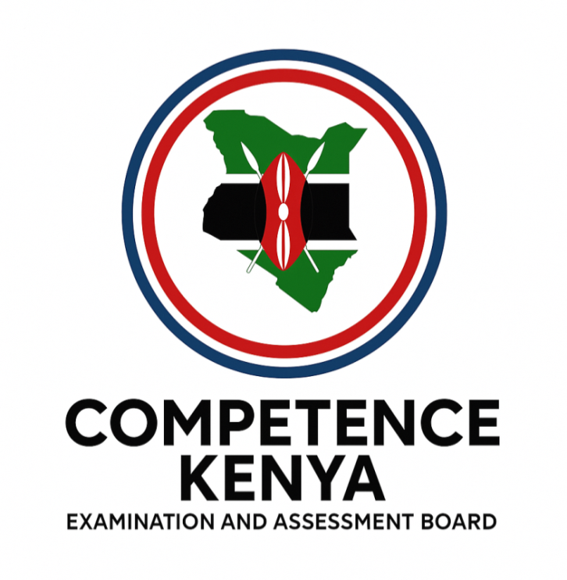
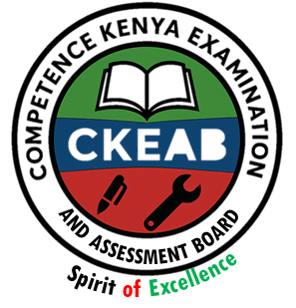
- Manage your time well to complete all questions.

Performance Levels Grid
Q1 | Q2 | Q3 | Q4 | Q5 | Q6 | Q7 | Q8 | Q9 | Q10 | SECTION A TOTAL /40
6 | 5 | 5 | 3 | 3 | 3 | 3 | 3 | 3 | 3 | /40
Score

Q11 | Q12 | Q13 | Q14 | Q15 | SECTION B TOTAL /60
20 | 20 | 20 | 20 | 20 | /60
Score
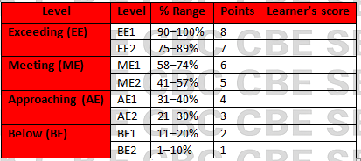
Section | Max Marks | Learner Score
A | 40
B | 60
TOTAL | 100

This paper has 7 printed pages. Please check out to ensure all pages are printed
Turn over
SECTION A: (40 Marks)
Answer all questions in this section.

1. (a) Learners at Arya Senior School visited a local Hindu temple where the priest explained the concept of the Trimurti.
i. Name the three deities of the Trimurti. (3 marks)

____________________________________________________________________________________________

____________________________________________________________________________________________

___________________________________________________________________________________________
ii. State one role of each deity identified above. (3 marks)

____________________________________________________________________________________________

____________________________________________________________________________________________

___________________________________________________________________________________________

___________________________________________________________________________________________

____________________________________________________________________________________________

2. During a class discussion on creation, the teacher narrated how Brahma emerged from the lotus growing from Vishnu’s navel.
a) Explain the meaning of the manifestation of Paramatma in this story. (3 marks)

____________________________________________________________________________________________

____________________________________________________________________________________________
b) State two lessons learners can draw from this manifestation. (2 marks)

____________________________________________________________________________________________

____________________________________________________________________________________________

3. While watching a cultural documentary, the learners saw images of the Dasha Avatars.
a) Define the term “Dasha Avatars.” (2 marks)

____________________________________________________________________________________________

____________________________________________________________________________________________

b) List any three Dasha Avatars of Lord Vishnu. (3 marks)

____________________________________________________________________________________________

____________________________________________________________________________________________

___________________________________________________________________________________________

4. The headteacher invited a guest speaker to narrate the story of Varah saving the Earth.
State three virtues demonstrated in the Varah avatar. (3 marks)

____________________________________________________________________________________________

____________________________________________________________________________________________

___________________________________________________________________________________________

5. During group presentations, one group explained the courage of Narasimha in protecting Prahlad.
Give three lessons youth can learn from the Narasimha avatar. (3 marks)

____________________________________________________________________________________________

____________________________________________________________________________________________

___________________________________________________________________________________________

6. A student club staged a short skit showing Vaman humbling King Bali.
a) Mention two qualities of Vaman displayed in the skit. (2 marks)

____________________________________________________________________________________________

____________________________________________________________________________________________

___________________________________________________________________________________________
b) State one moral lesson from the story. (1 mark)

____________________________________________________________________________________________

____________________________________________________________________________________________

7. At a school seminar on discipline, the facilitator used the story of Parshurama to emphasize the dangers of anger.
Name any three values demonstrated by Parshurama. (3 marks)

____________________________________________________________________________________________

____________________________________________________________________________________________

___________________________________________________________________________________________

8. Learners read a story about Bhagwan Rama rescuing Sita.
State three qualities of Bhagwan Rama seen in the Ramayana. (3 marks)

____________________________________________________________________________________________

____________________________________________________________________________________________

___________________________________________________________________________________________

9. A teacher used the life of Bhagwan Krishna to teach about righteousness.
State any three roles of Bhagwan Krishna in promoting dharma. (3 marks)

____________________________________________________________________________________________

____________________________________________________________________________________________

___________________________________________________________________________________________

10. Students researched the lives of Jain Tirthankaras.
List any three contributions of Jain Tirthankaras to society. (3 marks)

____________________________________________________________________________________________

____________________________________________________________________________________________

___________________________________________________________________________________________

SECTION B (60 MARKS)
Answer Question 11 and any other TWO questions.

11. Learners at Lotus Valley Senior School are preparing an exhibition on “Unity of Divine Manifestations” focusing on the Trimurti and the Dasha Avatars.

(a) Describe the relationship among Brahma, Vishnu and Mahesh in maintaining cosmic order. (6 marks)

____________________________________________________________________________________________

____________________________________________________________________________________________

___________________________________________________________________________________________

___________________________________________________________________________________________

____________________________________________________________________________________________

(b) Using relevant examples, explain four reasons why Lord Vishnu takes multiple avatars. (8 marks)

____________________________________________________________________________________________

____________________________________________________________________________________________

___________________________________________________________________________________________

___________________________________________________________________________________________

(c) Explain three emerging issues in contemporary society that can be addressed using lessons from the Dasha Avatars. (6 marks)

____________________________________________________________________________________________

____________________________________________________________________________________________

___________________________________________________________________________________________

12. A local radio station hosted a discussion about the relevance of avatars such as Varah, Narasimha, Vaman, and Parshurama in today’s world.

(a) Explain the symbolic significance of each of the four avatars named above. (8 marks)

____________________________________________________________________________________________

____________________________________________________________________________________________

___________________________________________________________________________________________

___________________________________________________________________________________________

(b) Discuss four moral lessons modern youth can learn from Rama and Krishna. (8 marks)

____________________________________________________________________________________________

____________________________________________________________________________________________

___________________________________________________________________________________________

___________________________________________________________________________________________

(c) Suggest two ways schools can integrate teachings from avatars in character formation. (4 marks)

____________________________________________________________________________________________

____________________________________________________________________________________________

13. During a humanities symposium, Grade 10 learners presented on “Manifestation of Paramatma in the Universe.”

(a) Explain the concept of manifestation of Paramatma. (6 marks)

____________________________________________________________________________________________

____________________________________________________________________________________________

___________________________________________________________________________________________

(b) Describe four ways in which the Paramatma manifests in living beings. (8 marks)

____________________________________________________________________________________________

____________________________________________________________________________________________

___________________________________________________________________________________________

___________________________________________________________________________________________

(c) Give three solutions to challenges learners face when trying to practice values taught in Hindu scriptures. (6 marks)

____________________________________________________________________________________________

____________________________________________________________________________________________

___________________________________________________________________________________________

14. A Grade 10 class explored Jainism, focusing on five selected Tirthankaras: Rishabdeva, Parshvanath, Neminath, Mallinath, and Bhagwan Mahavir.

(a) Describe the contributions of EACH of the five selected Tirthankaras. (10 marks)

____________________________________________________________________________________________

____________________________________________________________________________________________

___________________________________________________________________________________________

___________________________________________________________________________________________

____________________________________________________________________________________________

(b) Explain three impacts of the teachings of these Tirthankaras on modern society. (6 marks)

____________________________________________________________________________________________

____________________________________________________________________________________________

___________________________________________________________________________________________

(c) Suggest two ways youth can apply these teachings in community service. (4 marks)

____________________________________________________________________________________________

____________________________________________________________________________________________

15. Your school is holding an interfaith dialogue on peace and ethical living.

(a) Explain four Hindu teachings derived from the Dasha Avatars that promote peace and justice. (8 marks)

____________________________________________________________________________________________

____________________________________________________________________________________________

___________________________________________________________________________________________

___________________________________________________________________________________________

(b) Discuss three emerging social issues that Hindu teachings can help solve. (6 marks)

____________________________________________________________________________________________

____________________________________________________________________________________________

___________________________________________________________________________________________

(c) Suggest three practical activities that students can undertake to promote values taught by Hindu and Jain traditions. (6 marks)

____________________________________________________________________________________________

____________________________________________________________________________________________

___________________________________________________________________________________________

©2026
All rights reserved
©COMPETENCE KENYA EXAMINATION AND ASSESSMENT BOARD
THIS IS THE LAST PRINTED PAGE

